Ashfield District Local Plan

Examination

Updated Housing Trajectory

October 2025



Disclaimer

This document or some parts of it may not be accessible when using adaptive technology.

If you require assistance with accessing the content of the document, please contact us and quote the document name and the web page you found it on:
- email: Planning – planning.admin@ashfield.gov.uk

Contents

Overview 1
Schedule of Anticipated Annual Housing Delivery by Site Allocation 2
Summary of Annual Housing Delivery from All Sources 9
Trajectory Table 2023- 2040 as at October 2025 10
Trajectory Chart 2023-2040 as at October 2025 11
Dwelling Requirement and Provision 2023-2040 at October 2025 12

Overview

This Paper updates estimates of annual housing delivery at Appendix 2 of the Ashfield Local Plan 2023-2040 [SD.01] and those included within the Housing Land Supply Position Statement, October 2024 [ADC.04].
The 13 additional proposed housing sites consulted upon in February to April 2025 are now included within housing supply figures. Information is also drawn from the latest Housing Land Monitoring Report 2025 [ADC.13] with respect to annual completions and commitments, alongside new activity on major sites (10 or more dwellings) which has occurred between April 2025 and October 2025 in order to present the most up to date information available.
The resulting updated trajectory informs the latest position as set out in the Council’s Hearing Statements with regard to overall housing supply and the 5-year housing land supply.
For information it should be noted that the Trajectory Table, the Trajectory Chart and the Schedule of Anticipated Annual Housing Delivery by Site do not include assumptions for non-implementation of planning permissions which are included in the overarching Dwelling Requirement and Provision 2023-2040 calculation.

Schedule of Anticipated Annual Housing Delivery by Site Allocation

Hucknall Area

Kirkby Area

Sutton Area

Rurals Area

Summary of Annual Housing Delivery from All Sources

Trajectory Table 2023- 2040 as at October 2025

Trajectory Chart 2023-2040 as at October 2025
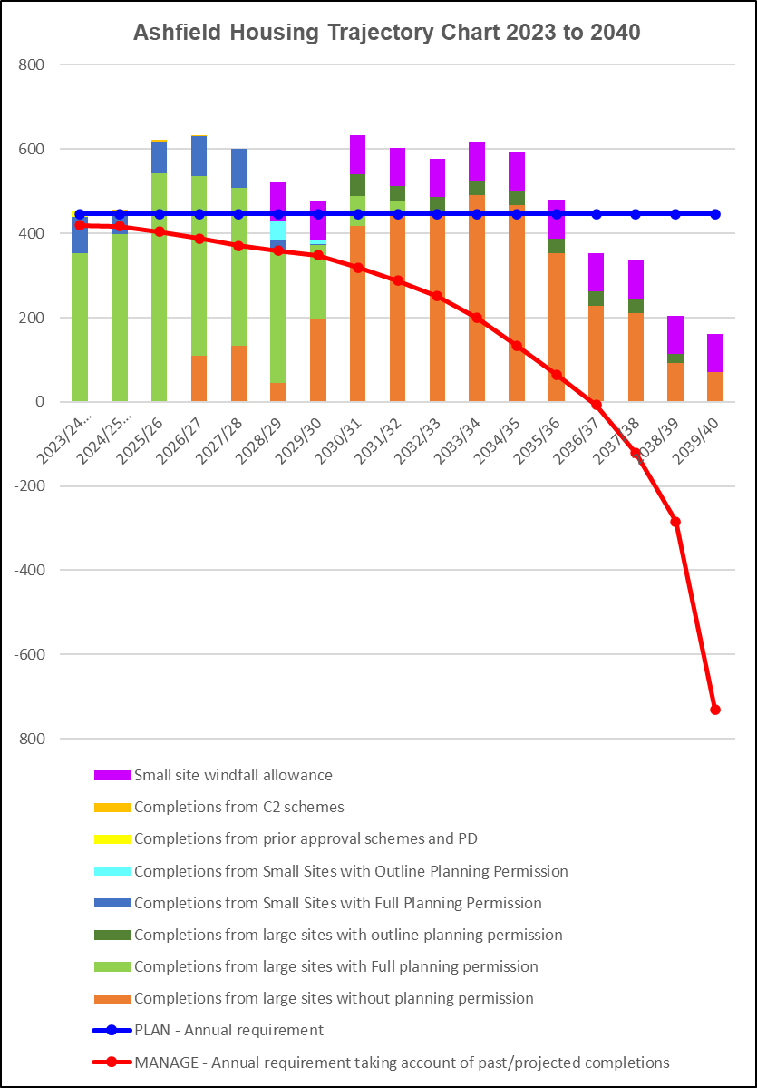

Dwelling Requirement and Provision 2023-2040 at October 2025

Housing Requirement | Dwellings
Annual Local Housing Need based on Standard Methodology at April 2024 | 446
Houses needed to meet requirement, 1/4/2023 to 31/4/2040 | 7582
Net Homes delivered* 1/4/2023 to 31/3/2025 | 907
Houses needed to meet requirement, 1/4/2025 to 31/4/2040 | 6675
Future Supply Source | Dwellings
Houses deliverable on small sites, 1/4/2025 to 31/3/2040
· With planning permission (including new build, net conversions and change of use) at 1st April 2025 | 342
· Known permitted development/prior notification schemes not yet implemented at 1st April 2025 | 1
· Demolitions and other losses with planning permission at 1/4/25 | -3
· Deduction to account for potential lapsed permissions | -92
· Windfall allowance beyond 3 years (91 dpa) - 1/4/2028 to 1/4/2040 | 1092
Houses deliverable on large sites 1/4/2024 to 31/3/2040
· With planning permission at 1st October 2025* | 2256
· Demolitions and other losses with planning permission at 1/4/25 | 0
· Deduction to account for potential lapsed permissions | -47
· Delivery from H1 allocated sites without planning permission | 3710
Provision from C2 residential institutions (dwelling equivalent) at 1/4/25 | 7
Total housing supply 1/4/2025 to 31/3/2040 | 7266
Net Under or Over Provision | Dwellings
Provision against Local Housing Need 2023 to 2040 | 591

* This figure includes 4 sites where s106 has been signed since 4/25 (all in Sutton)

Note: The version of this table as included within the Council’s submitted Matter 2 Hearing Statement [HS2.1a] at paragraph 2.7.7 varies marginally from that shown above. Whereas there is no change in the overall quantum of supply, the site allocation for 18 dwellings at Land between Redcliffe Street/Leyton Avenue (H1Saj) now has planning permission, with a Section 106 agreement having been signed in August 2025. The site’s current status is reflected in this Paper.

