

Disclaimer
This document or some parts of it may not be accessible when using adaptive technology.
If you require assistance with accessing the content of the document, please contact Us and quote the document name, website and web page you found it on:
- email: asbduty@ashfield.gov.
- telephone: 01623 450000

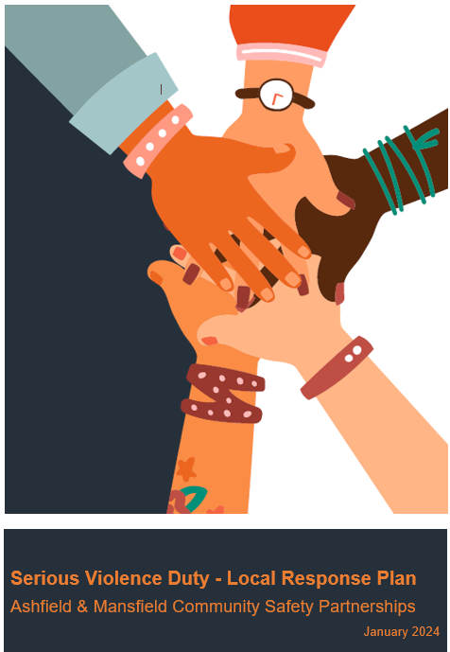

Serious Violence Response Planning

Context
Legislative requirements under the Police, Crime, Sentencing and Courts Act 2022 provides statutory duties for council’s and local services to work together to share information and undertake measures to prevent and reduce serious violence.
This requirement includes identifying types of serious violence that occur in responsible areas, the causes of that violence, and prepare and implement a strategy for preventing and reducing it. It was confirmed the duty would commence from 31 January 2023, with area response plans being completed by 1st January 2024.
The specified authorities are required to develop:
- An understanding of local issues: the partnership should work together to establish the local ‘strategic needs assessment’ of serious violence.

- A strategy that sets out how the proposed actions will enhance and complement existing local arrangements responding to serious violence. This may include consideration of joint funding or investment to support local early interventions and responses. Partnerships will also need to consult with any and all educational institutions, prisons and secure settings situated in the local area as part of this process.

- Annual reviews that consider how the interventions and solutions have impacted on serious violence within their area.

Defining Serious Violence

Serious violence is a national priority due to its growing prevalence and impact. The term “serious violence” is most often used to define crimes that are considered ‘high harm’ offences where violence has occurred, often culminating in serious harm and/or injury.
Statutory guidance requires specified authorities to focus on public space youth violence that involves crime types of homicide, violence against the person which may include both knife crime and gun crime, and areas of criminality where serious violence or its threat is inherent, such as county lines and drug dealing etc.
Agencies are required to consider themes and trends by conducting annual evidence-based strategic needs assessment which focuses types of serious violence, which can also incorporate domestic abuse, sexual offences, and other related crime types.

Response plan
Responsible authorities are required to produce response plans to enhance work to address serious violence at a local level.
This will require an agreed set of actions with mechanisms and resources in place to enable delivery key priorities identified.
The Serious Violence Partnership and Community Safety Partnerships will take responsibility for the development and implementation of these response plans.

Considerations when developing SVD response plan

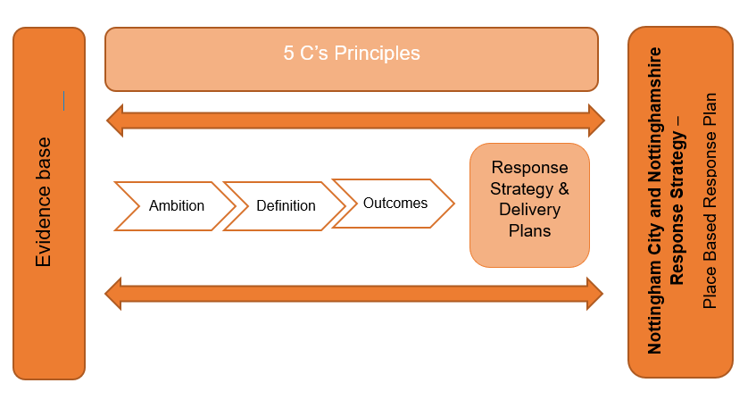

Public Health Approach
The purpose of the ‘Place Based/District’ response plans will aim to set out the priorities and actions for each district in supporting the implementation of the response strategy.
They should be developed within the context of the evidence base (Strategic Needs Assessments) and support the agreed ambition/vision; definitions and overall outcomes of reduction of serious violence and improving population health. It should be clear how the response plan connects into the implementation of the response Strategy through the focus on delivery to meet local needs.
The following illustration provides considerations to support the development of a local response plan
Preparation considerations
Who to involve in the response planning and how this will be achieved
Access to and familiarisation of the evidence base and overarching response strategic priorities
Understanding of what is already being implemented
Partner familiarisation of their responsibilities and roles

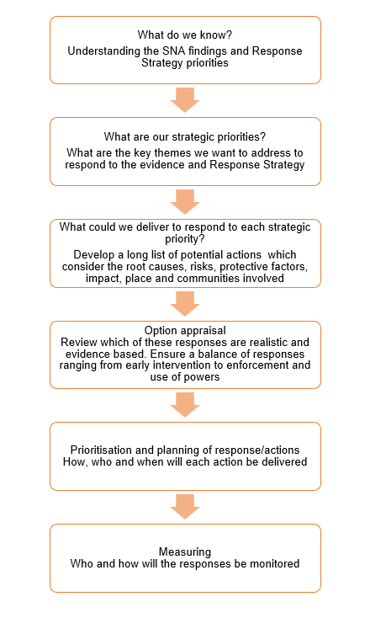

Reducing Serious Violence Response Plan

Ashfield and Mansfield Districts, Nottinghamshire
Background and Vision

On 9th April 2018, the government published its Serious Violence Strategy setting out an ambitious programme of work to respond to increases in knife crime, gun crime and homicide.

This response plan aligns to the priorities and ambitions set out in Nottingham and Nottinghamshire’s Violence Reduction Partnership’s (NNVRP) Serious Violence Response Strategy, of which the Ashfield and Mansfield Community Partnerships are active partners of.

The NNVRP brings together specialists from the PCC, public health, clinical commissioning, police, local authorities, community safety partnerships, criminal justice partnerships, education, and voluntary and community sector organisations with a shared goal to reduce serious violent crime and the underlying causes countywide. It provides strategic leadership and coordination of the countywide response to preventing and reducing serious violence.

The ‘Serious Violence Response Strategy’ is underpinned by a multi-agency public health approach to understanding the drivers and impacts of serious violence, with a focus on early intervention and prevention, tackling the root causes of violence and preventing young people from becoming involved in crime in the first place.

The duty was introduced in the context of an increase in violence over the last decade and recognition of the impact it has on victims and their families. It requires organisations to work together to share information, analyse the situation locally and come up with solutions, including the publication of local plans.

The plan outlines a solid commitment to investing in prevention and early intervention activities that deals with underlying causes, rather than the consequences, of crime and anti-social behaviour (ASB).

The plan will be subject to annual review to ensure it continues to be responsive to national policy and wider community safety landscape, and equally data sets at a macro and micro level.

Governance and oversight will be through existing frameworks via reporting to the Safer Nottinghamshire Board and Community Safety Partnership boards on a quarterly basis.

The vision, mission and focus is set out below:

Our Vision:

Our vision is for Nottinghamshire communities (Ashfield and Mansfield) to feel safe from violence and the fear of violence.

Our Mission:

We will work with communities to prevent violence and reduce its harmful impacts through developing a detailed understanding of its causes and investment in evidence-based interventions that make a lasting difference.

Our Focus:

Our definition of Serious Violence recognises the complexity of violence, with a focus on all incidents (including domestic violence) that cause serious harm. It also focuses on other offending that drives violence, so currently includes organised criminality and child exploitation.

Accompanying this document is local area needs assessments for both areas, this has been used to support the development of localised action plans.

Priorities

Community Safety Partnership key thematic priorities:

- Place and priority-based focus
- Systems approach
- Children and young people focused.
- Better use of information and data to inform decision making.

Measures of success

- A reduction in hospital admissions for assaults with a knife or sharp object
- A reduction in knife enabled serious violence
- A reduction in all non-domestic homicides

(Set to national guidance)

Indicator  (as below) | Baseline  Date of baseline | Update  Quarterly figure and end of year reporting via PCC | Percentage change  RAG the change
Reduction in hospital admissions for assaults with a knife/sharp object. | 01/01/23 to 31/03/24
Reduction in knife enabled violence (Ashfield) | 01/01/23 to 31/03/24
Reduction in knife enabled violence (Mansfield) | 01/01/23 to 31/03/24
Reduction in all non-domestic homicides (Ashfield) | 01/01/23 to 31/03/24
Reduction in all non-domestic homicides (Mansfield) | 01/01/23 to 31/03/24
Reduction in knife related robbery (business) – (Ashfield) | 01/01/23 to 31/03/24
Reduction in Rape and Serious Sexual Offences (RASSO) crimes (Ashfield) | 01/01/23 to 31/03/24
Reduction in violence with injury (excluding ABH) – (Ashfield) | 01/01/23 to 31/03/24
Reduction in knife related robbery (business) – (Mansfield) | 01/01/23 to 31/03/24
Reduction in violence with injury (excluding ABH) – (Mansfield) | 01/01/23 to 31/03/24

Note:
whilst performance indicators provided above will used to support benchmarking as part of quarterly and annual reporting; the CSP recognises analysis of objective safety alone only forms part of the data picture, and therefore analysis will also be provided on the fear of crime via perception surveys.

Plan Considerations
Our action plan will focus on key areas of practice:
1) Developing knowledge / evidence
2) Strategy, tactical and operational delivery
3) A whole systems and public health approach
4) Communications, consultation & community engagement
5) Partnerships, performance and accountability
This plan does not aim to address areas of work that are already underway and does not allocate work to services and agencies without full consideration of resource implications. For example: domestic abuse. The Domestic Abuse Partnership provides co-ordinated strategic response with its own developed plans, but recognition and due regard should be taken to each of these different plans.
This plan takes into consideration a place-based multi-agency approach to serious violence prevention work across Ashfield and Mansfield, and responsible organisations to reduce silo working by bringing partners together to focus on providing long term sustainable outcomes. This will place emphases on area problem solving, as illustrated below:
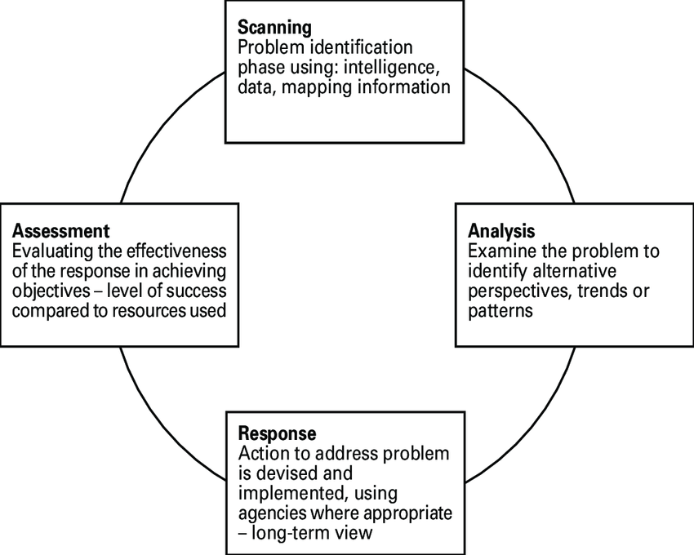

- Scanning - problem identification phase using intelligence, data, mapping information
- Analysis - Examine the pronblem to identify alternative perspectives, trends or patterns
- Response - Action to address problems is devised and implemented, using agencies where appropriate long term view
- Assessment - Evaluating the effectiveness of the response in acheiving objectives - level of success compared to resources used
This includes collaboration, co-production (supports consensus and shared accountability), cooperation in data and intelligence sharing, counter-narrative (identify risk and protective factors at local level and identify and create option to pursue alternatives to criminal activities), and community consensus.

Priority 1: Place and Priority-Based Focus
 | Action | Lead | Timescale | Progress update | RAG
 | Public Health Funding – money for Citizen’s Advice to support Bellamy and Oak Tree Estate. | Mansfield District Council (ADC) | 2024/25 | Update required from MDC | Red
 | Support to vulnerable adults and children via Vulnerable Adult Support Scheme and Complex Case Panels | Mansfield and Ashfield Community Safety Partnerships. | Ongoing and embedded service. | In place and actively supporting customers. | Green
 | Health initiative via Place Board Partnership/Health led activities to focus areas with Family Hubs (Nottinghamshire County Council / Mid Notts Health Partnerships). | Mansfield and Ashfield Community Safety Partnerships. | 2024/25 | Requires update from CSP Board | Red
 | Tasking - Identification of hotspots through the review of relevant data to support the co-ordination of area problem solving | Nottinghamshire Police led Multi-agency Local Tasking Meetings. | Ongoing and embedded within partner agencies. | In place and actively supporting the CSP | Green
 | Oaktree Development Worker to support community and bring partners together. | Mansfield District Council (MDC) | 2024/2025 | Update required from MDC | Red
 | The Safer Streets 5 Project – OPCC led and funded. | Mansfield and Ashfield Community Safety Partnerships. | Up to 31/03/25 | Project has commenced across both authorities and updates will continue via the project’s Strategic Board. | Yellow
 | Immediate Justice Scheme - OPCC led and funded. | Mansfield and Ashfield Community Safety Partnerships. | Up to 31/03/25 | Project has commenced across both authorities and updates will continue via the project’s Strategic Board. | Yellow
 | Project ‘KIA’. – Multi-agency support/enforcement meeting currently focussed on the Coxmoor estate in Kirkby-In-Ashfield. | Ashfield District Council | Ongoing and embedded. | This project has commenced and is embedded within the partnership. Updates will come via the lead at ADC. | Yellow
 | Work with partners to support the development of safe places for young people and wider residents across target areas (business premises) | Mansfield and Ashfield Community Safety Partnerships. | 2024/25 | Both authorities have commenced the development in particular locations. Expansion to be considered and implemented with partner assistance. | Yellow
 | Bespoke licensing operations to support safer districts including the night-time economy i.e Licensing security and vulnerability initiative (licensing SAVI) | Mansfield and Ashfield Community Safety Partnerships | 2024/25 | Development of initiative / programme required | Red
 | Trade Waste and Environmental Crime operations to support cleaner and greener districts including education provisional for young people to drive behavioural change and safer districts (Broken Widows Theory) | Mansfield and Ashfield Community Safety Partnerships | 2024/25 | Updates required from ADC and MDC | Red

Priority 2: System Approach
 | Action | Lead | Timescale | Progress update | RAG
 | Review of sharing agreements and Community Safety Accreditation Scheme Agreements to enhance partnership delivery and governance, | Mansfield and Ashfield Community Safety Partnerships | 2024/25 | Ongoing review required | Red
 | Meetings (cross cutting agendas):  - Neighbourhood Tasking Meetings  - Complex Case Panels (MDC and ADC)  - Community Safety Partnerships (MDC and ADC)  - MARAC ( All partners)  - Serious Violence tasking Groups  - Youth Violence and Exploitation Panel  - Concerns Networks  - Child in Neet / Protection (adhoc)  - Serious and Organised Crime Panel  - Channel Panel (Prevent)  - Modern Slavery  - Health and Wellbeing Board  - Regeneration / Economic Growth  - Child Sexual Exploitation | Mansfield and Ashfield Community Safety Partnerships | These meetings are embedded business for partner agencies. | These meetings are imbedded in the partnership and will continue. They will report back via their individual authorities. | Green
 | Review connectivity and operating models with social care, third sector, education, YOT etc to support health based approach to tackling SV. | Mansfield and Ashfield Community Partnership Joint Strategic Board | 2024/25 | Update required from the joint strategic board and accountability framework | Red
 | Review an approach or action plan for communications to reduce fear of SV. | Mansfield and Ashfield Community Partnership Joint Strategic Board | 2024/25 | Update required from the joint strategic board and accountability framework | Red

Priority 3: Children and Young Person Focus
 | Action | Lead | Timescale | Progress update | RAG
 | Diversion of young persons: including the correct diversions, education and trauma informed practice. | NCC Youth Services | 2024/25 | Update required from NCC | Red
 | Joint working with Youth Services to prevent cross-over of services. Including service developments and referral processes | Mansfield and Ashfield Community Safety Partnerships. | 2024/25 | Update required from ADC/MDC | Red
 | Victim Support Service - “Got Your Back” partnership involvement. | Nottinghamshire Victim Care /Remedi | 2024/25 | Update from Remedi/Victim Care | Red
 | Education: What do you need to feel safe in school? Include whole family and community. | NCC | 2024/25 | Update from NCC | Red
 | School exclusion and narrowing the attainment gap. | NCC/schools | 2024/25 | Update from NCC | Red
 | Education awareness programme for key themes in schools: child criminal exploitation, knife crime and hate crime. | Nottinghamshire Police via the Schools Officers. | 2024/25 | Update from Nottinghamshire Police (subject to approval) | Red
 | Continued review and implementation of DAHA to ensure domestic abuse prevention, awareness and engagement. | MDC and ADC | 2024/25 | Commenced at ADC, MDC has DAHA accreditation. | Yellow
 | Delivery of GREAT (Healthy Relationship Programme in target schools to drive behavioural change / male behaviour / safeguarding etc. | NCC | 2024/25 | Works undertaken in 2023/2024 via Commissioned domestic abuse service equation - Update required from NCC | Yellow
 | Engage wider stakeholders i.e transport. Faith and community groups and consider interventions for SV prevention | Mansfield and Ashfield Community Safety Partnerships | 2024/25 | Ongoing review required | Red

Priority 4: Better use of information and data to inform decision making (Public Health Approach)
 | Action | Lead | Timescale | Progress update | RAG
 | Undertake annual CSP assessment as part of Crime and Disorder Act requirements to inform CS Plan | Mansfield and Ashfield Community Safety Partnerships | Ongoing embedded process. | Annual Review | Yellow
 | Develop a CSP Performance Framework to improve effectiveness of partnership delivery against agreed priorities and thematic areas | Mansfield and Ashfield Community Safety Partnerships | 2024/25 | Framework in progress | Yellow
 | Serious Violence Awareness Training | Mansfield and Ashfield Community Safety Partnerships | 2024/25 | Training and Skills Audit and delivery of training to allocated staff required | Red
 | Dice (Data Initiative Community Engagement)  Safe and well data – vulnerability  Arson data – Child and Young people referrals I,e fire setting. | Nottinghamshire Fire and Rescue Service | Ongoing embedded process. | This is a regular part of the Fire Service’s business. | Green
 | Neighbourhoods/Themes/Communities – Hotspot Targeting. | Mansfield and Ashfield Community Safety Partnerships | 2024/25  Ongoing and embedded process. | Target hardening processes in progress. | Yellow
 | Collection of data from a variety of sources: EMAS Data, Deprivation, Unemployment, Mental Health, School Attendance , etc. Include suspect address as well as incident address. | OPCC | 2024/25 | Update from OPCC | Yellow
 | Information sharing is appropriately provided to support integration of offenders and to reduce reoffending via partnership meetings. | HMP and Probation Services. | 2024/25 | Update from HMP and Probation. | Yellow
 | Ensure data sharing agreements which incorporate arrangements to protect identifiable individual level data.  Understand what data is routinely collected by different organisations and determine what role it could play in preventative and operational interventions.  Use data and intelligence to achieve a shared understanding of current local issues, opportunities to implement interventions and evaluate their impact Identify and overcome barriers to effective data and information sharing to inform and mobilise effective preventative and operational interventions. | Mansfield and Ashfield Community Safety Partnerships. | 2024/25 | Update required from CSP on updated developments | Yellow

