Green Belt Harm Assessment

July 2021

Disclaimer
Parts of this document may not be accessible when using adaptive technology.

If you require assistance with accessing the content of the document, please contact:

- online form
- email: dutyplanner@ashfield.gov.uk or planning.admin@ashfield.gov.uk

This page is intentionally left blank.

Contents
1. Introduction 1
Study Aim and Scope 1
2. Methodology 3
Relationship with Stage 1: Strategic Green Belt Review (SGBR) 3
Scope of Stage 2: Green Belt Harm Assessment 3
Stage 2: Green Belt Harm Assessment Steps 4
Step 2: Assess the contribution of land to the Green Belt purposes 6
Step 3: Assess the overall harm to the Green Belt from the release of land 7
3: Summary of Harm Assessment Findings 8
4: Mitigation to reduce harm to Green Belt 9
5. Beneficial Use of Green Belt 11
6. Conclusion 13
Appendix 1: List of assessed Green Belt sites and location map 15
Appendix 2: New Green Belt Assessments 22
Appendix 3: Hucknall – Assessment Table and Map showing harm rating for each assessed parcel of land 40
Appendix 4: Kirkby in Ashfield - Assessment Table and Map showing harm rating for each assessed parcel of land 46
Appendix 5: Rural Villages - Assessment Table and Map showing harm rating for each assessed parcel of land 54

1. Introduction
1.1 Ashfield District Council has identified a number of potentially suitable development sites within the Green Belt. These were identified through a ‘Call for Sites’ undertaken in 2019 and their subsequent assessment through the Strategic Housing and Economic Land Availability Assessment (SHELAA).

  - This Study (Stage 2) has assessed the potential harm to the Green Belt purposes that release of these identified sites would cause. It is not the purpose of this report to allocate sites, but to help inform site selection. Site selection will be done on the basis of a wide range of considerations, including the outputs of the earlier (Stage 1) Strategic Green Belt study, various other environmental/sustainability considerations and the Council’s Spatial Strategy and Location of Development work which will be undertaken as part of the ongoing preparation of the Local Plan.

  - The National Planning Policy Framework (NPPF) states in paragraphs 139 and 140 that “Green Belt boundaries should only be altered where exceptional circumstances are fully evidenced and justified, through the preparation or updating of plans”.

  - Case law, as established in Calverton Parish Council v Greater Nottingham Councils & others (2015), indicates that planning judgments setting out the ‘exceptional circumstances’ for the amendment of Green Belt boundaries require consideration of the ‘nature and extent of harm’ to the Green Belt and ‘the extent to which the consequent impacts on the purposes of the Green Belt may be ameliorated or reduced to the lowest reasonably practicable extent’.

Study Aim and Scope
1.4 The overall purpose of this Study (Stage 2) is to provide a robust and transparent assessment of the potential harm of releasing Green Belt land in line with national policy, guidance and case law. It also considers potential mitigation measures to minimise harm (see Chapter 4).

1.5 The two Green Belt Assessment Stages include:

- Stage 1: Strategic Green Belt Review (SGBR), 2016 An assessment of the whole of Ashfield’s Green Belt and provides a means of identifying the most important areas, when assessed against the purposes of Green Belt as set out in national policy - National Planning Policy Framework (NPPF); and

- Stage 2: Green Belt Harm Assessment (this report) An assessment of the potential harm to the Green Belt when assessed against the purposes of Green Belt as set out in the NPPF.

1.6 The Stage 1 study provided a rating for each identified Green Belt parcel for ‘harm of release’, but this was a basic measure that did not reflect a detailed analysis. This Stage 2 study provides a more refined assessment of harm.

2. Methodology
2.1 This chapter sets out the methodology used to undertake an assessment of the harm that would result from the release of a site for development within the Green Belt. It should be read in conjunction with the Stage 1 study, which sets out the relevant planning policy context and The Framework methodology against which sites were assessed.

Relationship with Stage 1: Strategic Green Belt Review (SGBR)
2.2 The Stage 1 study was a comprehensive analysis of all Green Belt land within Ashfield District. It assessed the contribution of land against the purposes of Green Belt as set out in the NPPF, which are:

- Purpose 1 - To check the unrestricted sprawl of large built-up areas.
- Purpose 2 - To prevent neighbouring towns merging into one another.
- Purpose 3 - To assist in safeguarding the countryside from encroachment.
- Purpose 4 - To preserve the setting and special character of historic towns.
- Purpose 5 - To assist in urban regeneration, by encouraging the recycling of derelict and other urban land.

2.3 The review provided ratings and supporting text to assess the relative contribution of land against the above five Green Belt purposes.

Scope of Stage 2: Green Belt Harm Assessment
2.4 The extent of the assessment and the identification of sites where the release of land for development might potentially be considered, was defined by the call for sites undertaken in 2019 and their assessment through the Strategic Housing and Economic Land Availability Assessment (SHELAA).

2.5 It should be noted that certain sites submitted to the SHELAA were ‘ruled out’ at an early stage. This is where the whole site was affected by a ‘major constraint’. Major constraints include the following:

- Sites of Special Scientific Interest (SSSI)
- Special Area of Conservation (SAC)
- Special Protection Areas (SPA)
- possible potential Special Protection Areas (ppSPA)
- Scheduled Monuments
- Historic Parks and Gardens
- Designated Local Green Space

2.6 Although these constrained areas have not been assessed for harm, it is important to note that they can perform as areas of open land and/or as boundary features – which can have a bearing on the assessment of harm that would be caused from the release of adjacent unconstrained Green Belt land.

2.7 Several other key constraints to development were identified through the SHELAA process which also excluded sites from this Stage 2 harm study. These include:
- Confirmation from the landowner(s) that the site is not available
- The whole or the majority of the site is affected by one or more locally designated natural asset (Local Wildlife Site, Local Nature Reserve, Tree Preservation Order or a regional Important Geological Site)
- There is the potential for substantial harm to or total loss of significance to a Heritage Asset (e.g. Listed Building, Conservation Area, Scheduled Monument)
- Significant highway access constraints
- Site is isolated from the public highway
- Severe topographical constraints
- High level of flood risk – Zone 3
- Neighbouring / adjoining use would be incompatible with the proposed development type with no scope for mitigation
- Development of the site would result in the loss of an existing use which is not surplus to requirements and cannot be located locally
- Delivery is beyond 15 years

2.8 This Stage 2 study assesses the remaining SHELAA sites in respect of the potential degree of harm that their release would cause to the purposes of the Green Belt. A full list of sites can see in Appendix 1, together with a map showing their location.

Stage 2: Green Belt Harm Assessment Steps
2.9 The harm assessment process was subdivided into two steps: 2 and 3:

- Step 2: Assess the contribution of land to the Green Belt purposes, with reference to the Stage 1 study.

- Step 3: Assess the overall harm to the Green Belt from the release of land.

2.10 This follows on from Step 1: The Strategic Green Belt Review (SGBR), the methodology for which is set out below for information (please refer to the SGBR report for further details and the findings of that study):

Assessment 1 – Contribution of broad areas of land to Green Belt Purposes
- The Green Belt land surrounding all settlements (see Appendix 1 in the SGBR) was divided into broad areas (such as north, south, east and west of the settlement) based on their similar characteristics in terms of size, structure and form. The boundaries of these broad areas were chosen using Ordnance Survey maps, topographical maps, historical maps, aerial photographs and professional judgment.

- These broad areas were then assessed using both the Assessment Criteria (figure 1 in the SGBR), and Assessment Matrix (figure 2 in the SGBR) which are based on the five purposes of the Green Belt as set out in the NPPF (see paragraph 2.2 of this report). The assessments were made using Ordnance Survey maps, topographical maps, historical maps, aerial photographs, professional judgment and site visits.

- Assessment 1 therefore gives a broad overview of the performance of the Green Belt at a strategic level. The joint Framework enables authorities to remove an assessment 1 area from further assessment at this point if it is deemed appropriate. For instance, if the whole area is found to be of significantly high importance in respect of all five purposes of Green Belt, or because no suitable defensible boundaries exist which would allow for part of the area to be removed without significant detriment to the overall purpose.

- Each site assessed was given an overall score ranging between 4 (low) and 20 (high). It should be noted that whilst a site may have a low overall score, it may score particularly high for one single Green Belt purpose. In these instances, it could be considered to be of sufficient importance on that one single purpose for the site to be retained as Green Belt. This is particularly important for the following Green Belt purposes:

  - Purpose 1 - Check the unrestricted sprawl of settlements.
  - Purpose 2 - Prevent neighbouring towns from merging into one another.
  - Purpose 4 - Preserve the setting and special character of historic settlements.

Assessment 2 - Contribution of smaller sub-areas of land to Green Belt Purposes

- The broad areas from Assessment 1 were then divided into smaller sites, using defined physical feature such as roads, railways, watercourses, tree belts, woodlands, ridgelines or field boundaries to determine suitable sites for assessment. This was done in the first instance using Ordnance Survey maps, topographical maps, historical maps, aerial photographs and professional judgement.

- Sites were then assessed again, using the Criteria (figure 1 in the SGBR) and Matrix (figure 2 in the SGBR), in the same way as at Assessment 1. An integral part of Assessment 2 was an on-site appraisal. In some circumstances it was necessary to amend a site’s boundary to reflect what was actually on the ground following the on-site appraisal.

- Each site assessed was given an overall score ranging between 4
(low) and 20 (high). It should be noted that whilst a site may have a low overall score, it may score particularly high for one single Green Belt purpose. In these instances, it could be considered to be of sufficient importance on that one single purpose for the site to be retained as Green Belt. This is particularly important for the following Green Belt purposes:

  - Purpose 1 - Check the unrestricted sprawl of settlements.
  - Purpose 2 - Prevent neighbouring towns from merging into one another.
  - Purpose 4 - Preserve the setting and special character of historic settlements.

Step 2: Assess the contribution of land to the Green Belt purposes
2.11 The analysis of contribution draws on the assessment carried out in the Stage 1 Strategic Green Belt study, but further analysis was carried out where necessary. In circumstances where a significant difference exists between the extent of the assessment parcels defined in Stage 1, and the extent of the proposed land (potentially suitable SHELAA sites) to be released to accommodate development, a new assessment has been undertaken. These new assessments are in included in Appendix 2.

2.12 Consistent with the Stage 1 study, there is no individual assessment of contribution to the fifth Green Belt purpose – assisting with urban regeneration – as it is not possible to draw a meaningful distinction between the availability of brownfield land within individual settlements.

2.13 Contribution to the other four Green Belt purposes (see paragraph 2.2) is rated on a five-point scale of:

5 | High
4 | Relatively High
3 | Moderate
2 | Relatively Low
1 | Low

Step 3: Assess the overall harm to the Green Belt from the release of land
2.14 The loss of contribution to the Green Belt purposes as a result of the release of a parcel of land equates to the contribution ratings assessed for that parcel in the Stage 1 study and the new assessment undertake as part of this study (see Appendix 2).

2.15 Each site assessment area was given an overall harm rating based on the combined score of all Green Belt purposes. The overall harm rating is based on the following scale:

17 - 20 | High
14 - 16 | Relatively High
11 - 13 | Moderate
8 - 10 | Relatively Low
4 - 7 | Low

2.16 Where release of a parcel would also necessitate the release of intervening land, the loss of contribution is that associated with the highest-contributing parcel. If, for example, a potential release includes land that makes a relatively high contribution to Purpose 3 (To assist in safeguarding the countryside from encroachment) and land which makes a moderate contribution to Purpose 3, the overall contribution is relatively high, and there would be a relatively high loss of contribution were it to be released.

3: Summary of Harm Assessment Findings
3.1 The Stage 2 Harm Assessment Findings are organised by area as follows:

- Appendix 3 - Hucknall

- Appendix 4 - Kirkby In Ashfield

- Appendix 5 - Rural Villages (including Selston, Jacksdale, Underwood and Brinsley)

3.2 For each area the findings comprises:

- An OS map showing:

- The relevant Green Belt parcels identified in the Stage 1 Study;
- The new parcels identified as part of this study, to reflect the extent of the submitted SHELAA sites; and
- The potential degree of harm to the Green Belt that would result from release of land.

- A table showing the harm assessment comprising:

- The site address, site area and SHELAA reference number;
- A description of the release scenario;
- A rating of between 1 (Low) and 5 (High) for each of the Green Belt purposes (see para. 2.13 above);
- An overall harm score of between 4 (Low) and 20 (High), and an overall harm rating for each parcel of land; and
- For ease of reference, the Green Belt Assessment Area reference number (see either the Stage 1 SGBR or Appendix 2 of this report for the full assessment details).

3.2 In each location where alterations to Green Belt boundaries are being considered, a planning judgement is required to establish whether the sustainability benefits of Green Belt release and the associated development outweigh the harm to the Green Belt designation. In light of this, this assessment of harm to the Green Belt purposes does not draw conclusions as to where land should be released to accommodate development but identifies relative variations in harm to the designation.

4: Mitigation to reduce harm to Green Belt
4.1 One of the factors to consider when making a judgement on the level of harm resulting from the release of a Green Belt area, is the impact that the loss of openness would have on other Green Belt land. For example: a site might in itself be small but its development could represent a more significant change than its physical area might suggest if, for example, it resulted in the breaching of a strong boundary feature, or an increase in the built containment of adjacent land.

4.2 There is the potential to reduce harm to the remaining Green Belt by implementing measures which will affect the relationship between the remaining Green Belt land and urban areas. Measures which increase the contribution that land is judged to make to Green Belt purposes, offsetting to some degree the predicted reduction in contribution, could strengthen the case for release of a particular area. However, any release of Green Belt land will still require 'exceptional circumstances' to be demonstrated.

4.3 Mitigation could apply either to land being released or land being retained as Green Belt. There is an overlap between the latter and the concept of beneficial use of Green Belt land as set out in the NPPF, in that mitigation can also present an opportunity to enhance beneficial use.

4.4 The extent to which harm can be mitigated will vary from site to site. The Green Belt purposes are considered to relate to the relationship between the land area in question, developed land, and the countryside. This relationship is influenced by:
- the location of the area;
- the extent of openness within it; and
- the role of landscape/physical elements, including boundary features (in either separating the area from, or connecting it to) built-up areas and the wider countryside.

4.5 Table 4.1 below lists some mitigation measures (please note this is not an exhaustive list) that could be considered as part of the planning and development process. Which mitigation measures are the most appropriate will vary, depending on local circumstances and will need to be defined as part of the master planning process.

Table 4.1: Potential measures to mitigate harm to Green Belt
Mitigation measure | Benefits | Considerations
Define Green Belt edge using a strong, natural element which forms a visual barrier, e.g. a woodland belt. | Reducing perception of urbanisation, and may also screen residents from intrusive landscape elements within the Green Belt, e.g. major roads. | Boundaries that create visual and movement boundaries can potentially have detrimental effects on the character of the enclosed urban areas and the amenity of residents.
Use of landscape to help integrate a new Green Belt boundary with the existing edge, aiming to maximise consistency over a longer distance. | Maintaining sense of  separation between urban  and open land. | A boundary that is relatively homogenous over a relatively log distance, such as a main road, is likely to be stronger than one which has more variation. Landscaping works can help to minimise the impact.
Create a transition from urban to rural, using built density, height, materials and landscaping to create a more permeable edge. | Reducing the perception of urbanisation. | This may however have implications I terms of reducing housing yield.
Consider ownership and management of landscape elements which contribute to Green Belt purposes. | Ensuring permanence of Green Belt. | Trees and hedgerows require management to maintain their value in Green Berm terms, and the visual screening value that can be attributed to them is more limited if they are under private control (e.g. within back gardens).
Design and locate buildings, landscaping and green spaces to minimise intrusion on settlement settings. | Maintaining perceived settlement separation by minimising the extent to which new development intrudes on the setting of other settlements. | Analysis of settlement settings, including consideration of viewpoints and visual receptors, can identify key locations where maintenance of openness and retention of landscape features would have the most benefit.
Improve management practices to enhance countryside character. | Increase strength of countryside character. | Landscape character assessments can help to identify valued characteristics that should be retained and where possible strengthened, and intrusive elements that should be diminished and where possible removed.
Use sustainable drainage features to define/enhance separation between settlement and countryside. | Strengthening separation between urban and open land. | Need to determine if local topography and ground conditions are suitable.

5. Beneficial Use of Green Belt
5.1 The purposes of the Green Belt do not make any reference to the quality or use of land falling within the designation, but Paragraph 145 of the NPPF, states that:
“Once Green Belts have been defined, local planning authorities should plan positively to enhance the beneficial use of the Green Belt, such as looking for opportunities to provide access; to provide opportunities for outdoor sport and recreation; to retain and enhance landscapes, visual amenity and biodiversity; or to improve damaged and derelict land.”

5.2 Furthermore, Paragraph 142 of the NPPF states that where it has been concluded that it is necessary to release Green Belt land for development, plans should set out ways in which the impact of removing land from the Green Belt can be offset through compensatory improvements to the environmental quality and accessibility of remaining Green Belt land”. This could be achieved through legal agreements in conjunction with the release of land and planning consent for development, or through strategic enhancement initiatives e.g., creation of community woodland.

5.3 The updated Planning Policy Guidance (PPG) also endorses the preparation of supporting landscape, biodiversity or recreation evidence to identify appropriate compensatory improvements, including:

- new or enhanced green infrastructure;
- woodland planting;
- landscape and visual enhancements (beyond those needed to mitigate the immediate impacts of the proposal);
- improvements to biodiversity, habitat connectivity and natural capital;
- new or enhanced walking and cycle routes; and
- improved access to new, enhanced or existing recreational and playing field provision.

5.5 Some of the mitigation measures listed in Table 4.1 above which relate to Green Belt land can also be considered beneficial uses, but there is broader scope for introducing or enhancing uses of Green Belt land that (by adding to its value) will strengthen the case for that land’s future protection, regardless of whether it is classified as Green Belt. Some examples are provided in Table 5.1 below.

5.6 Beneficial uses could potentially be achieved through planning conditions, section 106 obligations and/or the Community Infrastructure Levy. The PPG stresses the need for early engagement with landowners and other interested parties to obtain the necessary local consents, establishing a detailed scope of works and identifying a means of funding their design, construction and maintenance.

Table 5.1: Potential beneficial uses of Green Belt
Beneficial use | Considerations
Improving access | Enhancing the coverage and condition of the rights of way network and increasing open space provision.
Providing locations for outdoor sport | Some outdoor sports can represent an urbanising influence; an emphasis on activities which do not require formal facilities is less likely to harm Green Belt purposes.
Landscape and visual enhancement | Using landscape character assessment as guidance, intrusive elements can be reduced and positive characteristics reinforced.
Increasing biodiversity | Most Green Belt land has potential for increased biodiversity value – e.g. the management of hedgerows and agricultural field margins, and provision of habitat connectivity, planting of woodland. There may also be opportunities to link enhancements with requirements to deliver ‘biodiversity net gain’ associated with development proposals.
Improving damaged and derelict land | Giving land a functional, economic value is a key aspect in avoiding damage and dereliction through lack of positive management, but this needs to be achieved with minimum harm to characteristics/qualities which help it contribute to Green Belt purposes.

5.7 Many of the beneficial uses outlined in the table above could be identified via a Green Infrastructure (GI) Study. This would identify the key opportunities for landscape, access, recreation and biodiversity enhancement within the Green Belt and beyond.

5.8 It is noted however, that Local Authorities may still be able to protect features such as open spaces, leisure facilities, burial grounds and nature conservation sites through other policy approaches / designations.

6. Conclusion
6.1 This study has assessed the harm to the Green Belt purposes of potentially releasing land for development within sites/areas of search to facilitate the expansion of the Ashfield Main Urban Area and existing Named Settlements within Ashfield. The findings of this study will form an important piece of evidence for Ashfield emerging Local Plan.

6.2 However, as outlined within the study there are other important factors that need to be considered when establishing ‘exceptional circumstances’ for making alterations to Green Belt boundaries, most notably sustainability, viability and deliverability issues. Whilst the ideal would be to minimise harm to the Green Belt, it may be that the most sustainable locations for development will result in high harm to the Green Belt.

6.3 In each location where alterations to Green Belt boundaries are being considered, planning judgement is required to establish whether the sustainability benefits of Green Belt release and the associated development outweigh the harm to the Green Belt designation. In addition, consideration will also need to be given to potential measures to mitigate harm to the Green Belt, as well as potential opportunities to enhance the beneficial use of the Green Belt. It is noted that many potential enhancement opportunities may relate to land which is in private ownership and therefore careful consideration will need to be given to how and if these opportunities can be delivered.

6.4 Should the Council decide to release land from the Green Belt, it is suggested that outline policy guidance or masterplans could be prepared as part of, or following on from, the Local Plan process. Masterplans could draw on the findings of the Green Belt Study and any detailed site-based Green Belt assessment work to indicate precise development areas, new permanent Green Belt boundaries (existing or new features) and appropriate considerations for the layout and design of new developments and opportunities to enhance beneficial use. Such an approach, together with specific policies for the development of the land, may help to minimise harm to the remaining Green Belt.

This page is intentionally left blank.

Appendix 1: List of assessed Green Belt sites and location map

This page is intentionally left blank.

Hucknall
SHELAA Ref. | Site Address | Release Scenario | Area (ha)
HK013 | Linby Boarding Kennels, East of Church Lane | Release of HK013 as an expansion to Hucknall North | 3.32
HK022 | Land adj. Stubbin Wood Farm, Watnall Road | Release of HK022 as an expansion to HucknallSouth/ West | 8.82
HK028 | Whyburn Farm | Release of HK028 as a New Settlement | 205.80
HK046 | West of Moor Road, Bestwood | Release of HK046 as an expansion of Bestwood North | 5.95
HK047 | Common Lane, Hucknall  (Site includes HK001, HK002, HK003 & HK004) | Release of HK047 as an expansion of Hucknall North/West | 17.69
HK051 | Land north of A611/south of Broomhill Farm  (Site includes HK016, HK034, HK043 & HK050) | Release of HK051 as an expansion of Hucknall South | 31.02

Kirkby
SHELAA Ref. | Site Address | Release Scenario | Area (ha)
KA002 | Beacon Farm, Derby Road | Release of KA002 as an expasion of Kirkby South | 2.36
KA004 | Land off Thorsby Ave | Release of KA004 as an expansion of Kirkby East | 3.23
KA015 | Adj, 53 Blidworth Road | Release of KA015 an an expansion of Kirkby East | 2.44
KA016 | West of Derby Road | Release of KA016 an an expansion of Kirkby East | 12.68
KA017 | West of Derby Road / south of Diamond Ave. | Release of KA017 an an expansion of Kirkby East | 5.96
KA019 | Rear of 257 – 275 Nuncargate Road | Release of KA019 as an expansion of Annesley Woodhouse North | 0.49
KA020 | North east of J27 M1 | Release of KA020 as a strategic employment site off Junction 27 of the M1 | 20.47
KA024 | Land off Abbey Road/ Richmond Road | Release of KA004 as an expansion of Kirkby East | 1.69
KA025 | South east of J27 M1 | Release of KA025 as a strategic employment site off Junction 27 of the M1 | 36.79
KA039 | Land off Main Road, Nuncargate | Release of KA019 as an expansion of Annesley Woodhouse North | 1.50

The Rurals
SHELAA Ref. | Site Address | Release Scenario | Area (ha)
SJU001 | Land at Plainspot Farm, New Brinsley | Release of SJU001 as an expansion of Brinsley West | 1.56
SJU002 | Rear of 105 Cordy Lane, Underwood | Release of SJU002 as open countryside. The site is isolated from the settlement of Underwood | 1.47
SJU004 | Land off Barrows Hill Lane, Westwood | Release of SJU004 as an expansion of Jacksdale East | 24.27
SJU012 | Church Lane, Selston | Release of SJU012 as an expansion of Selston North | 0.69
SJU013 | East of Station Road, New Selston | Release of SJU013 as open countryside. The site is isolated from the settlement of Selston | 4.23
SJU014 | Land adj, Bull and Butcher PH, Selston | Release of SJU014 as an expansion of Selston/New Selston | 6.60
SJU016 | Land adj. 149 Stoney Lane, Selston | Release of SJU016 as an expansion of Selston West | 0.20
SJU017 | East / North Stoney Lane, Selston | Release of SJU017 as an expansion of Selston North/West | 8.43
SJU018 & SJU020 | Land off Park lane / South West of M1, Selston | Release of SJU016 as an expansion of Selston North East | 12.49
SJU021 | Land off Stoney Lane, Selston | Release of SJU021 as an expansion of New Selston North/East | 0.72
SJU022 | Land off Stoney Lane, Selston | Release of SJU022 as open countryside. The site is isolated from the settlement of Selston/New Selston | 7.23
SJU023 | Rear 18 Stoney Lane, Selston | Release of SJU023 as an expansion of Selston/New Selston | 4.01
SJU027 | Between 106 – 132 Main Road, Underwood | Release of SJU027 as an expansion of Underwood North | 0.51

The Rurals continued.
SHELAA Ref. | Site Address | Release Scenario | Area (ha)
SJU028 | Rear of 101 Cordy Lane, Underwood | Release of SJU028 as open countryside. The site is isolated from the settlement of Underwood | 1.98
SJU029 | Land adj. 82 Mansfield Road, Underwood | Release of SJU029 as an expansion of Underwood East | 1.43
SJU031 | Land north of Larch Close, Underwood | Release of SJU031 as an expansion of Underwood North/East | 1.63
SJU033 | Land off Felley Mill Lane North, Underwood | Release of SJU033 as an expansion of Underwood East | 0.69
SJU037 -E | Land south of Alfreton Road, Jubilee | Release of SJU037-E as an expansion of Jacksdale North | 34.35
SJU039 | Land at Church Lane, Underwood | Release of SJU039 as an expansion of Underwood North | 0.44
SJU040 | Land south of Annesley Lane, Selston | Release of SJU040 as an expansion of Selston South/East | 10.36
SJU041 | Land off 48 Plainspot Road, New Brinsley | Release of SJU041 as an expansion of Brinsley North/East | 2.68

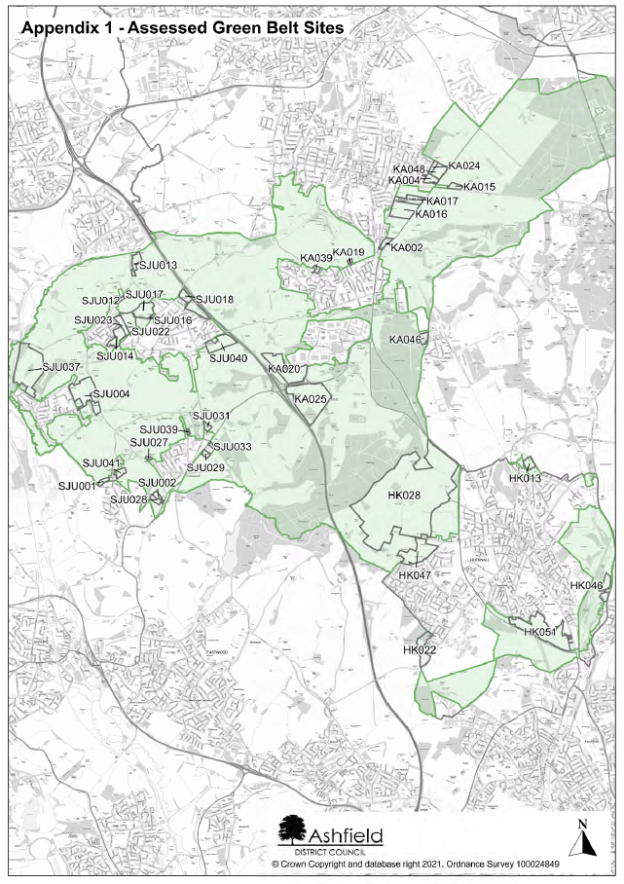

Appendix 2: New Green Belt Assessments

This page is intentionally left blank.

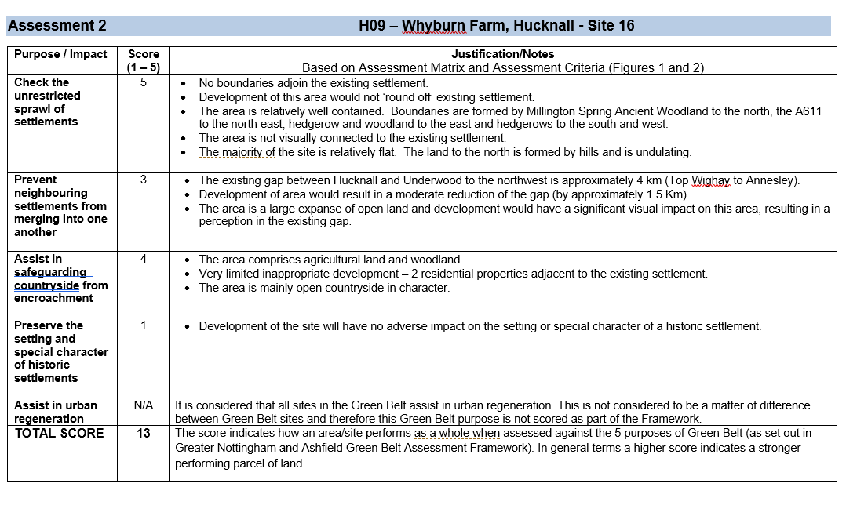

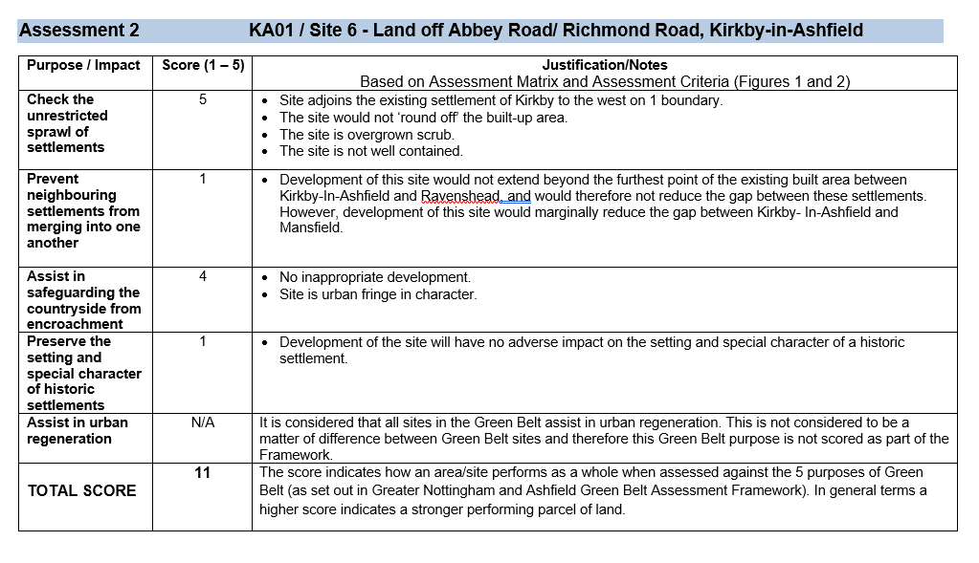

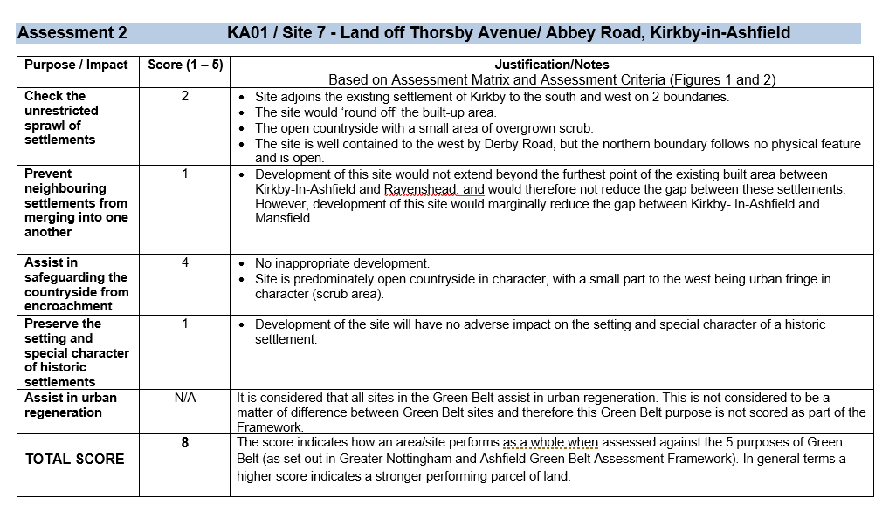
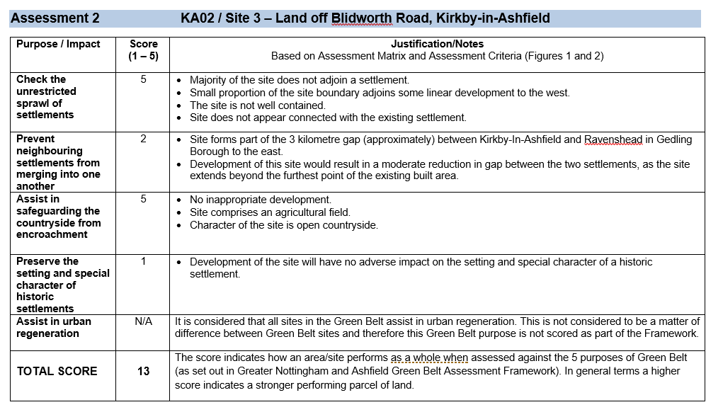
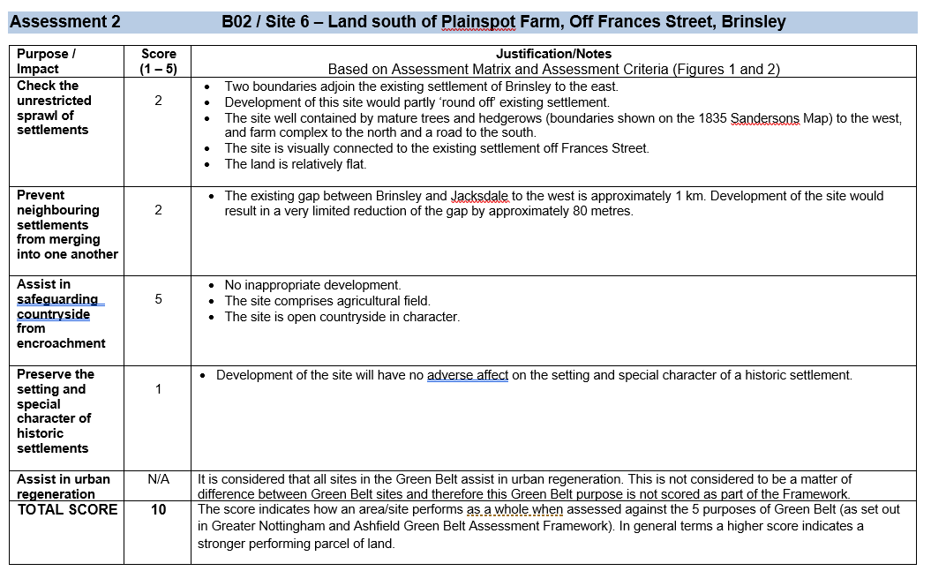
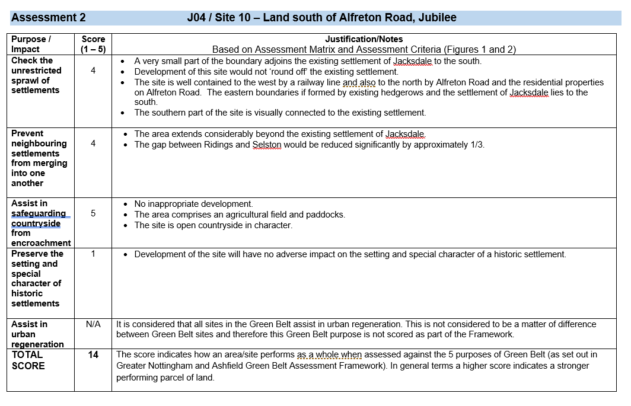
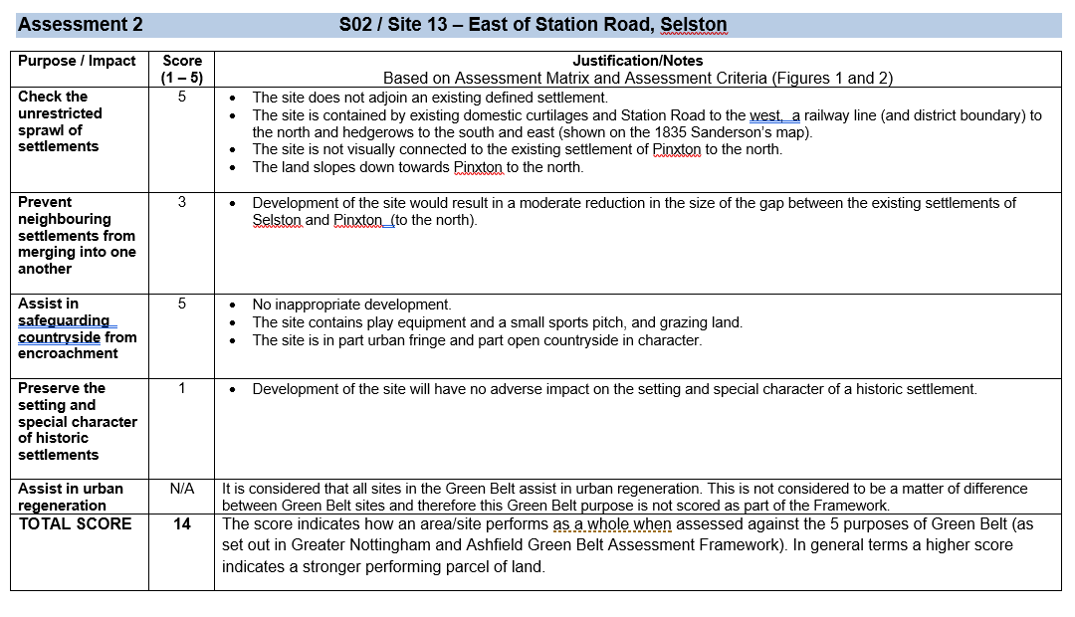
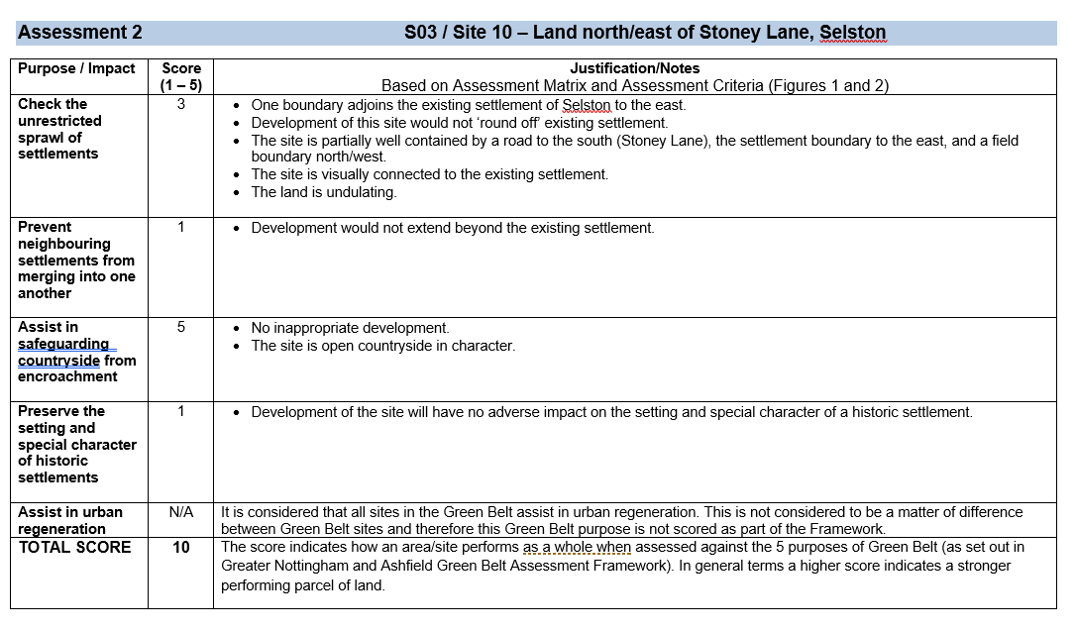
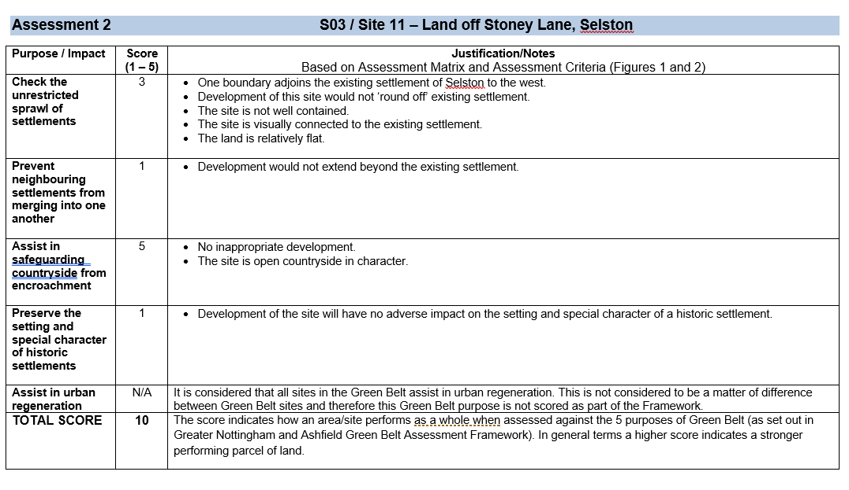
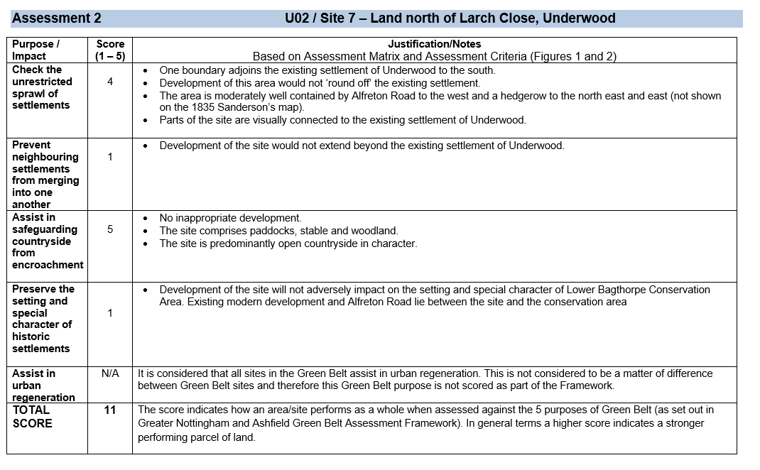
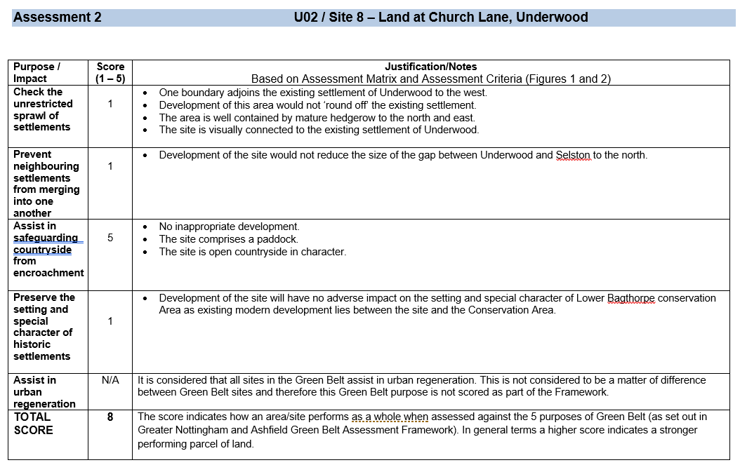
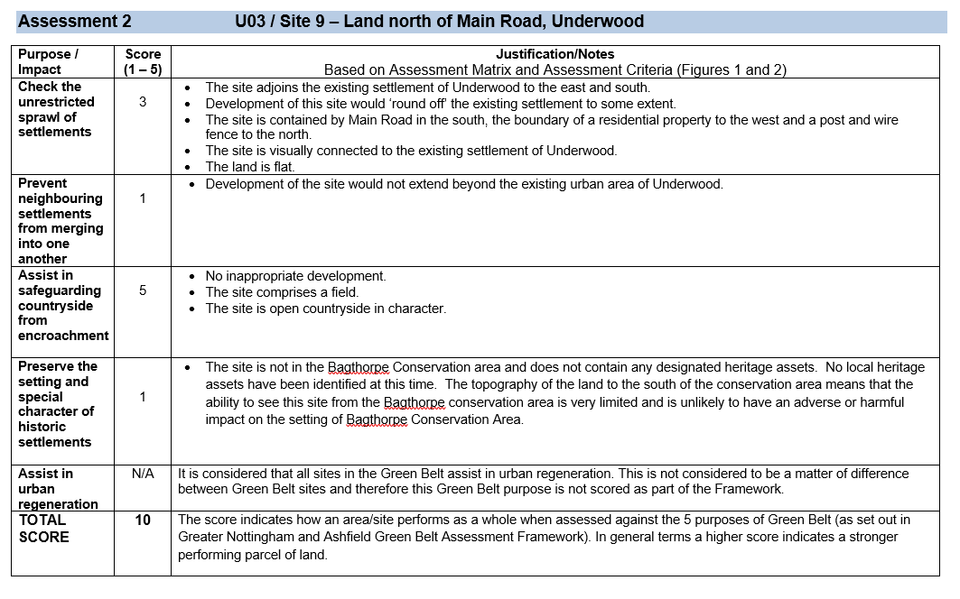
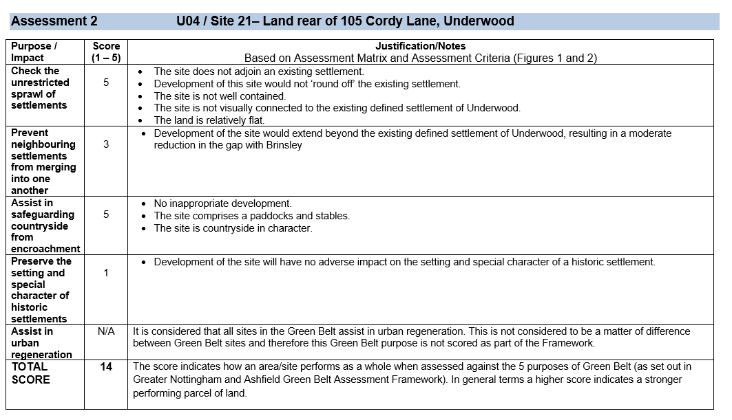
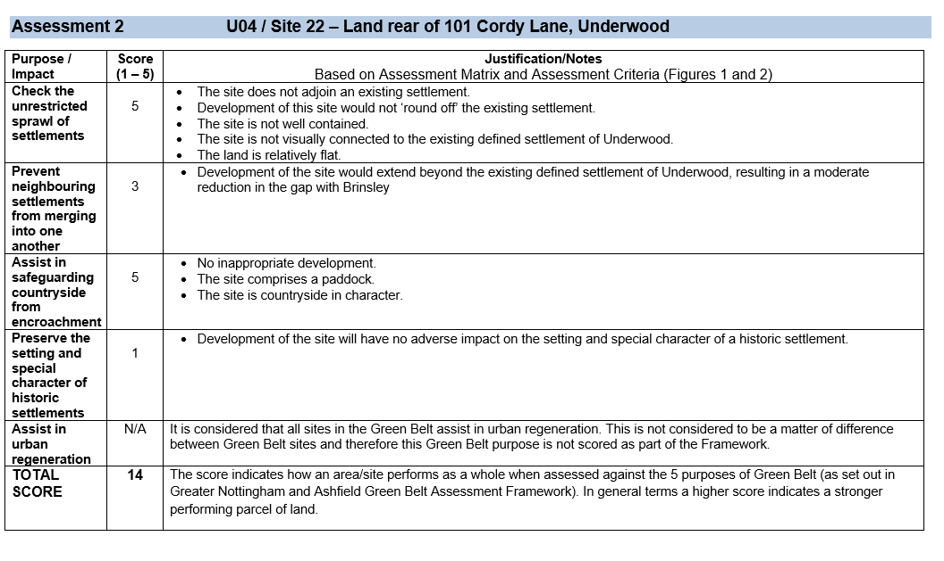
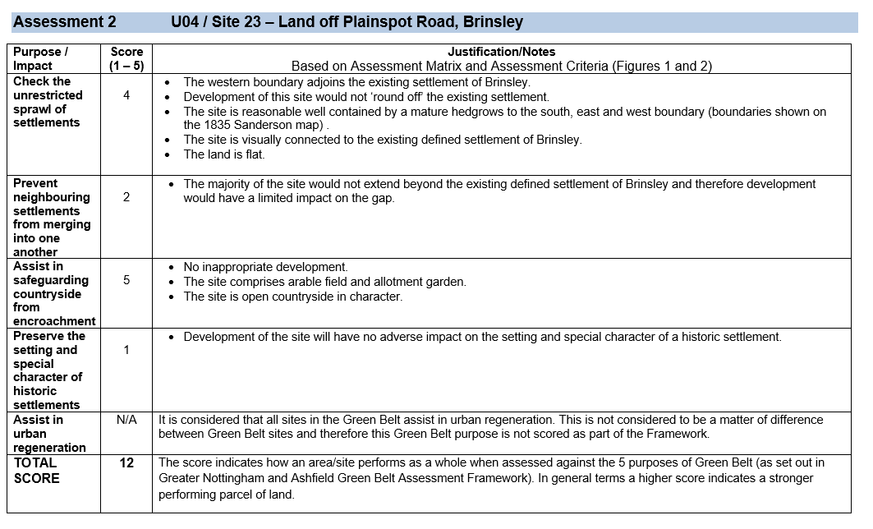

This page is intentionally left blank.

Appendix 3: Hucknall – Assessment Table and Map showing harm rating for each assessed parcel of land

This page is intentionally left blank.

Hucknall

SHELAA Ref. | Site Address | Site Area (ha) | Release Scenario | Purpose 1 (Unresticted Sprawl) | Purpose 2 (Prevent Settlements Merging) | Purpose 3 (Safeguard from Encroachment) | Purpose 4 (Preserve Historic Settlements) | Purpose 5 (Urban Regeneration) | Overall Harm Score | Overall Harm Rating | Green Belt Assessment Area (* Please refer to Stage 1: SGBR)
HK013 | Linby Boarding Kennels, East of Church Lane | 3.32 | Release of HK013 as an expansion to Hucknall North | Relatively High | High | Relatively High | Relatively Low | N/A | 15 | Relatively High | H01 / 2*
HK022 | Land adj. Stubbin Wood Farm, Watnall Road | 8.82 | Release of HK022 as an expansion to HucknallSouth/ West | Relatively Low | Low | High | Low | N/A | 9 | Relatively Low | H08 / 1 & 2*
HK028 | Whyburn Farm | 205.80 | Release of HK028 as a New Settlement | High | Moderate | Relatively High | Low | N/A | 13 | Moderate | HK09 / 16 (New Assessment in Appendix 2)
HK046 | West of Moor Road, Bestwood | 5.95 | Release of HK046 as an expansion of Bestwood North | Relatively High | High | Moderate | Low | N/A | 13 | Moderate | Part of H04 / 1*
HK047 | Common Lane, Hucknall  (Site includes HK001, HK002, HK003 & HK004) | 17.69 | Release of HK047 as an expansion of Hucknall North/West | Moderate | Low | High | Low | N/A | 10 | Relatively Low | Majority of H09 / 4*
HK051 | Land north of A611/south of Broomhill Farm (Site includes HK016, HK034, HK043 & HK050) | 31.02 | Release of HK051 as an expansion of Hucknall South | Low | Moderate | Relatively High | Low | N/A | 9 | Relatively Low | H05*

This page is intentionally left blank.

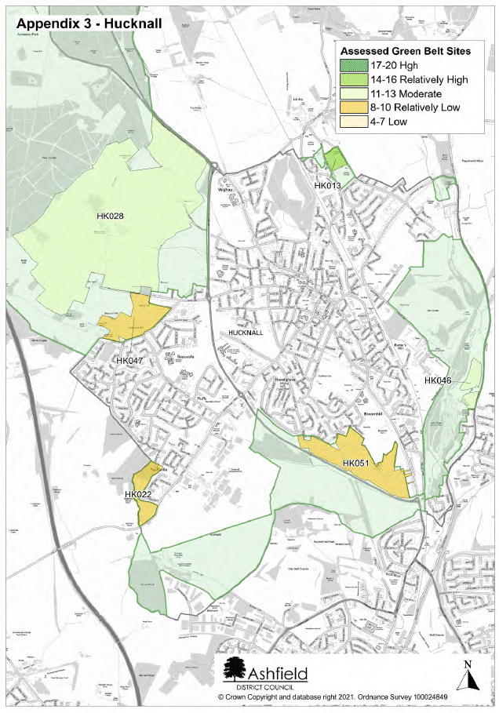
This page is intentionally left blank.

Appendix 4: Kirkby in Ashfield - Assessment Table and Map showing harm rating for each assessed parcel of land
This page is intentionally left blank.

Kirkby
SHELAA Ref. | Site Address | Site Area (ha) | Release Scenario | Purpose 1 (Unresticted Sprawl) | Purpose 2 (Prevent Settlements Merging) | Purpose 3 (Safeguard from Encroachment) | Purpose 4 (Preserve Historic Settlements) | Purpose 5 (Urban Regeneration) | Overall Harm Score | Overall Harm Rating | Green Belt Assessment Area (* Please refer to Stage 1: SGBR)
KA002 | Beacon Farm Derby Road | 2.36 | Release of KA002 as an expansion of Kirkby South | Relatively Low | Low | Relatively Low | Low | N/A | 6 | Low | KA03 / 5*
KA004 | Land off Thorsby Ave | 3.23 | Release of KA004 as an expansion of Kirkby East | Low | Low | High | Low | N/A | 8 | Relatively Low | Majority of KA01 / 1*
KA015 | Adj, 53 Blidworth Road | 2.44 | Release of KA015 an expansion of Kirkby East | High | Relatively Low | High | Low | N/A | 13 | Moderate | KA02 / 3 (New Assessment in Appendix 2)
KA016 | West of Derby Road | 12.68 | Release of KA016 an expansion of Kirkby East | Relatively High | Low | Relatively Low | Low | N/A | 8 | Relatively Low | Majority of KA03 / 2 when assessed with KA017*
KA017 | West of Derby Road / south of Diamond Avenue | 5.96 | Release of KA017 an expansion of Kirkby East | Relatively High | Low | Relatively Low | Low | N/A | 8 | Relatively Low | Majority of KA03 / 2 when assessed with KA016*
KA019 | Rear of 257 – 275 Nuncargate Road | 0.49 | Release of KA019 as an expansion of Annesley Woodhouse North | Moderate | Moderate | Moderate | Low | N/A | 10 | Relatively Low | KA06 / 7*
KA020 | North east of J27 M1 | 20.47 | Release of KA020 as a strategic employment site off Junction 27 of the M1 | High | Moderate | High | Low | N/A | 14 | Relatively High | Majority of KA17*
KA024 | Land off Abbey Road/ Richmond Road | 1.69 | Release of KA004 as an expansion of Kirkby East | High | Low | Relatively High | Low | N/A | 11 | Moderate | KA01 / 6 (New Assessment in Appendix 2)
KA025 | South east of J27 M1 | 36.79 | Release of KA025 as a strategic employment site off Junction 27 of the M1 | High | Moderate | High | Relatively High | N/A | 17 | High | M01*
KA039 | Land off Main Road, Nuncargate | 1.50 | Release of KA019 as an expansion of Annesley Woodhouse North | Relatively Low | Low | High | Low | N/A | 9 | Relatively Low | KA07 / 6*
KA046 | Land off Hucknall Road, Newstead | 2.50 | Release of KA046 as an expansion of Newstead West | Relatively High | Low | Relatively High | Moderate | N/A | 12 | Moderate | Majority of KA12 / 4*
KA048 | Land off Thorsby Avenue / Abbey Road (Site includes KA004, KA023 & KA024) | 10.03 | Release of KA004 as an expansion of Kirkby East | Relatively Low | Low | Relatively High | Low | N/A | 8 | Relatively Low | KA01 / 7 (New Assessment in Appendix 2)

The Rurals
SHELAA Ref. | Site Address | Site Area (ha) | Release Scenario | Purpose 1 (Unresticted Sprawl) | Purpose 2 (Prevent Settlements Merging) | Purpose 3 (Safeguard from Encroachment) | Purpose 4 (Preserve Historic Settlements) | Purpose 5 (Urban Regeneration) | Overall Harm Score | Overall Harm Rating | Green Belt Assessment Area (* Please refer to Stage 1: SGBR)
SJU001 | Land at Plainspot Farm, New Brinsley | 1.56 | Release of SJU001 as an expansion of Brinsley West | Relatively Low | Relatively Low | High | Low | N/A | 10 | Relatively Low | B02 / 6 (New Assessment in Appendix 2)
SJU002 | Rear of 105 Cordy Lane, Underwood | 1.47 | Release of SJU002 as open countryside. The site is isolated from the settlement of Underwood | High | Moderate | High | Low | N/A | 14 | Relatively High | U04 / 21 (New Assessment in Appendix 2)
SJU004 | Land off Barrows Hill Lane, Westwood | 24.27 | Release of SJU004 as an expansion of Jacksdale East | Low | Relatively High | Moderate | Low | N/A | 9 | Relatively Low | Majority of J03*
SJU012 | Church Lane, Selston | 0.69 | Release of SJU012 as an expansion of Selston North | Relatively Low | Low | High | Low | N/A | 9 | Relatively Low | S03 / 3*
SJU013 | East of Station Road, New Selston | 4.23 | Release of SJU013 as open countryside. The site is isolated from the settlement of Selston | High | Moderate | High | Low | N/A | 14 | Relatively High | S02 / 13 (New Assessment in Appendix 2)
SJU014 | Land adj, Bull and Butcher PH, Selston | 6.60 | Release of SJU014 as an expansion of Selston/New Selston | Low | Low | High | Low | N/A | 8 | Relatively Low | S03 / 6*
SJU016 | Land adj. 149 Stoney Lane, Selston | 0.20 | Release of SJU016 as an expansion of Selston West | Low | Low | High | Low | N/A | 8 | Relatively Low | S03 / 9*
SJU017 | East / North Stoney Lane, Selston | 8.43 | Release of SJU017 as an expansion of Selston North/West | Moderate | Low | High | Low | N/A | 10 | Relatively Low | S03 / 10 (New Assessment in Appendix 2)
SJU018 & SJU020 | Land off Park lane / South West of M1, Selston | 12.49 | Release of SJU016 as an expansion of Selston North East | Low | Low | Relatively High | Low | N/A | 7 | Low | S01*
SJU021 | Land off Stoney Lane, Selston | 0.72 | Release of SJU021 as an expansion of New Selston North/East | Moderate | Low | High | Low | N/A | 10 | Relatively Low | S03 / 2 (New Assessment in Appendix 2)
SJU022 | Land off Stoney Lane, Selston | 7.23 | Release of SJU022 as open countryside. The site is isolated from the settlement of Selston/New Selston | Relatively High | Low | High | Low | N/A | 11 | Moderate | Majority of S03 / 4*

The Rurals continued.
SHELAA Ref. | Site Address | Site Area (ha) | Release Scenario | Purpose 1 (Unresticted Sprawl) | Purpose 2 (Prevent Settlements Merging) | Purpose 3 (Safeguard from Encroachment) | Purpose 4 (Preserve Historic Settlements) | Purpose 5 (Urban Regeneration) | Overall Harm Score | Overall Harm Rating | Green Belt Assessment Area (* Please refer to Stage 1: SGBR)
SJU023 | Rear 18 Stoney Lane, Selston | 4.01 | Release of SJU023 as an expansion of Selston/New Selston | Relatively Low | Low | High | Low | N/A | 9 | Relatively Low | S03 / 5*
SJU027 | Between 106 – 132 Main Road, Underwood | 0.51 | Release of SJU027 as an expansion of Underwood North | Relatively High | Relatively High | High | Low | N/A | 14 | Relatively High | U03 / 9 (New Assessment in Appendix 2)
SJU028 | Rear of 101 Cordy Lane, Underwood | 1.98 | Release of SJU028 as open countryside. The site is isolated from the settlement of Underwood | High | Moderate | High | Low | N/A | 14 | Relatively High | U04 / 22 (New Assessment in Appendix 2)
SJU029 | Land adj. 82 Mansfield Road, Underwood | 1.43 | Release of SJU029 as an expansion of Underwood East | Relatively High | Low | High | Low | N/A | 11 | Moderate | U01 / 5
SJU031 | Land north of Larch Close, Underwood | 1.63 | Release of SJU031 as an expansion of Underwood North/East | Relatively High | Low | High | Low | N/A | 11 | Moderate | U02 / 7 (New Assessment in Appendix 2)
SJU033 | Land off Felley Mill Lane North, Underwood | 0.69 | Release of SJU033 as an expansion of Underwood East | Moderate | Low | High | Low | N/A | 10 | Relatively Low | U01 / 6*
SJU037 -E | Land south of Alfreton Road, Jubilee | 34.35 | Release of SJU037-E as an expansion of Jacksdale North | Relatively High | Relatively High | High | Low | N/A | 14 | Relatively High | J04 / 10 (New Assessment in Appendix 2)
SJU039 | Land at Church Lane, Underwood | 0.44 | Release of SJU039 as an expansion of Underwood North | Low | Low | High | Low | N/A | 8 | Relatively Low | U02 / 8 (New Assessment in Appendix 2)
SJU040 | Land south of Annesley Lane, Selston | 10.36 | Release of SJU040 as an expansion of Selston South/East | Moderate | Relatively Low | Relatively High | Low | N/A | 10 | Relatively Low | S09 / 2*
SJU041 | Land off 48 Plainspot Road, New Brinsley | 2.68 | Release of SJU041 as an expansion of Brinsley North/East | Relatively High | Relatively Low | High | Low | N/A | 12 | Moderate | U04 / 23 (New Assessment in Appendix 2)

This page is intentionally left blank.

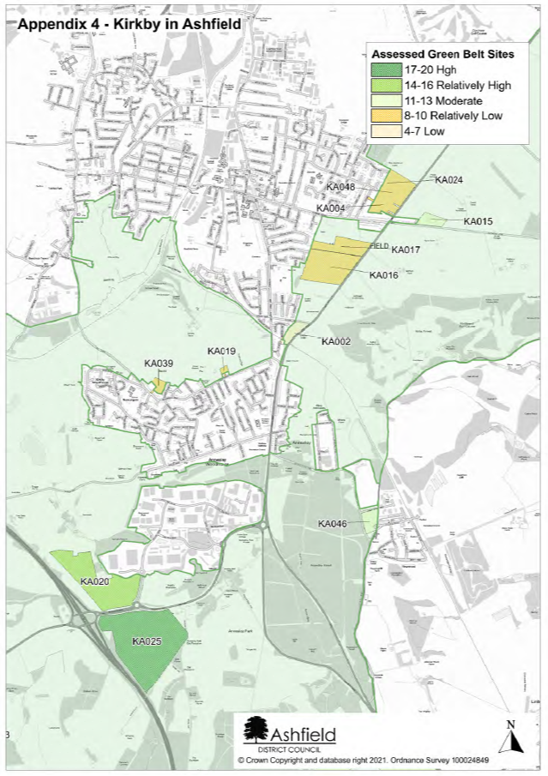
This page is intentionally left blank.

Appendix 5: Rural Villages - Assessment Table and Map showing harm rating for each assessed parcel of land

This page is intentionally left blank.

