

Disclaimer
This document or some parts of it may not be accessible when using adaptive technology.

If you require assistance with accessing the content of the document, please contact us and quote the document name and the web page you found it on:

- email: Regeneration – place@ashfield.gov.uk

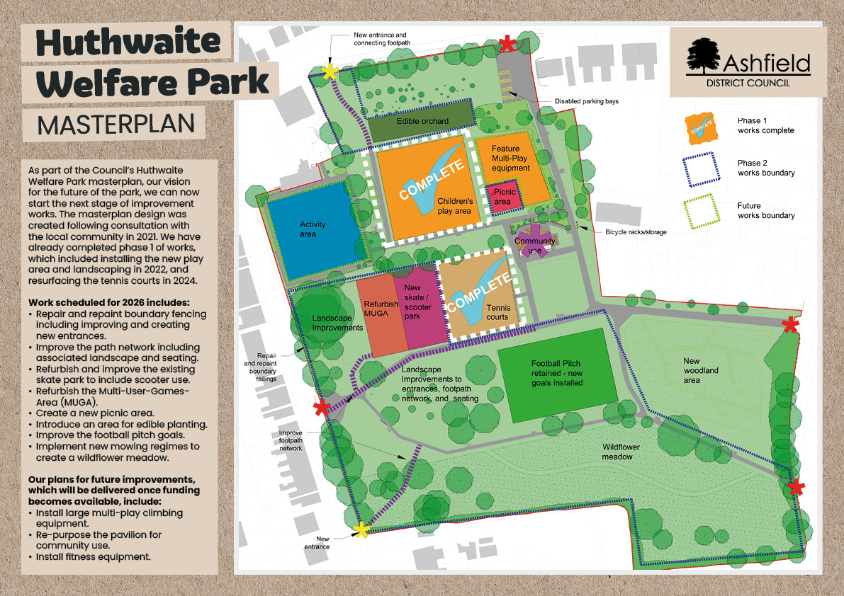

Text as shown on image:
As part of the Council’s Huthwaite Welfare Park masterplan, our vision for the future of the park, we can now start the next stage of improvement works. The masterplan design was created following consultation with the local community in 2021. We have already completed phase 1 of works, which included installing the new play area and landscaping in 2022, and resurfacing the tennis courts in 2024.
Work scheduled for 2026 includes:
• Repair and repaint boundary fencing including improving and creating new entrances
• Improve the path network including associated landscape and seating
• Refurbish and improve the existing skate park to include scooter use
• Refurbish the Multi-User-Games- Area (MUGA)
• Create a new picnic area
• Introduce an area for edible planting
• Improve the football pitch goals.
• Implement new mowing regimes to create a wildflower meadow.
Our plans for future improvements, which will be delivered once funding
becomes available, include:
• Install large multi-play climbing equipment
• Re-purpose the pavilion for community use
• Install fitness equipment.

