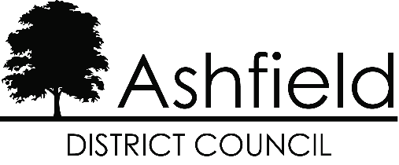

**Ashfield District Council**

PEOPLE STRATEGY

**Contents**

Introducing our People Strategy 3

Our People Strategy 5

What does it mean for the communities of Ashfield? 5

What does it mean for employees? 5

How is the Strategy’s contribution assessed? 5

What are the Corporate Values? 6

What is the Competency Framework? 6

Our Strategic People Objectives – Three Themes 8

Key Theme 1 – Valuing Our People 9

Key Theme 2 – Transforming Our Organisation 11

Key Theme 3 – Developing Our People 13

Our Commitment to Employees 14

Key Influences and Challenges 15

# Introducing our People Strategy



The Council recognises and values the people as their greatest asset and the People Strategy details how we attract, retain and develop within the Council. It also drives cultural and organisational change, leadership, talent management along with continuous development of both the people and the organisation. Linked to the objectives set down in the Corporate Plan and Transformation Programme, it identifies the people management implications and makes it clear that all employees are vital to the delivery of improving services for local communities.

To be effective, the People Strategy cannot operate in isolation. It will need to reflect external influences such as the Local Government Pay and Workforce Strategy, national employment negotiations and trends in the marketplace.



The People Strategy is an integral part of the council’s performance management framework. It provides the link between valuing and developing people, with improving and developing services and enabling local leadership.

# Our People Strategy

## What does it mean for the communities of Ashfield?



The People Strategy ensures that we deploy the right number of trained, skilled and motivated people to deliver high quality services within the community.

## What does it mean for employees?

It clearly demonstrates that the council is committed to its employees and their ongoing development. As an employee, linking your own development to the development of your role and service will ensure that you contribute to the achievement of the objectives within the People Strategy. As these are linked directly to the Corporate Plan and Transformation Programmes of the council, your contribution will enable the Council to achieve its objectives.

## How is the Strategy’s contribution assessed?

Central to the People Strategy is an action plan for each council that includes milestones with measurable targets which are monitored on a quarterly basis by corporate management and embedded within the performance management framework via service

plans and employee personal development review (PDR) process which embed the Competencies and Values of the organisation.

## What are the Corporate Values?

To ensure we deliver high-quality public services we have adopted a set of Corporate Values which underpin the successful delivery of our priorities. How we work is as important as what we do.

* People Focussed - Putting people at the heart of what we do
* Honest - Being honest with people in an open and professional way
* Proud - Being proud that Ashfield is a positive place to live, work and visit
* Ambitious - We are ambitious about Ashfield's future

## What is the Competency Framework?

The competency framework covers two areas Leadership and employees both support the delivery of People Strategy and sets out how we want people to behave at work and puts the Corporate Values at the heart of everything we do.

The Competency Framework for employees includes five competencies: Seeing the bigger picture, Changing, learning and improving, Communicating, Team working and Delivering value for money and quality services.

The framework for Leadership competencies is made up of three themes: Strategic, People and Performance with ten competencies listed:

|  |  |
| --- | --- |
| **Theme** | **Competency** |
| Strategic | * Seeing the bigger picture * Changing and improving * Making effective decisions |
| People | * Leading and communicating * Collaborating and partnering * Building capacity for all. |
| Performance | * Achieving commercial outcomes * Delivering value for money * Managing a quality service * Delivering at pace |

# Our Strategic People Objectives – Three Themes

The ‘People Objectives’ have been grouped under three broad themes. They are:-

* Valuing our People
* Transforming our Organisation
* Developing our People

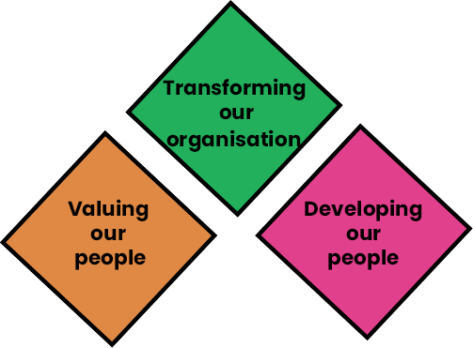

It is important to understand that all the themes are interlinked and cannot be viewed in isolation. As a result, progress in one area will have an impact on other themes.

The three themes are underpinned by effective communication, supporting the principles of effective local leadership, valuing the service users and the community and equality and diversity.

### Key Theme 1 – Valuing Our People

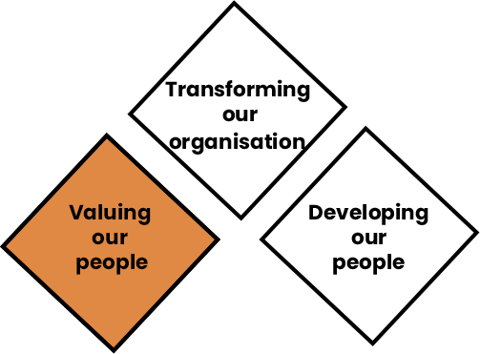

Ashfield aims to be an employer of choice by providing a balanced approach through:



* Recruiting and retaining excellent people
* Recognising and developing our existing talent pool
* Recognising changing skill requirements and developing people to meet the changing needs of the Authority
* Ensuring our people are best placed to take advantage of the career progression opportunities that arise
* Ensuring equality and diversity is reflected in service provision and employment practices
* Fair and equitable treatment of employees in pay, grading and reward structures
* Developing and maintaining a range of flexible working options
* Motivating employees and valuing their contribution to organisational objectives
* Ensuring we fulfil our duty of care to our employees, including actively promoting Health and Well Being and Attendance strategies
* Employing a workforce that reflects the diversity of the local population
* Ensuring an engaged workforce

### Key Theme 2 – Transforming Our Organisation

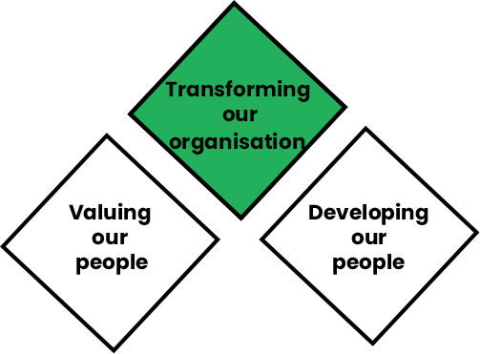

We aim to create a framework that provides clarity and structure whilst promoting flexibility and empowers employees at all levels to achieve their potential within a constantly changing environment by:

* Effectively engaging and listening to our employees
* Ensuring performance management including competency framework is embedded throughout the organisations
* Developing required organisational culture to drive transformation change programmes
* Developing and delivering the Shared Service and partnership working Agendas, exploring various options for future service delivery, adopting a more commercial approach to conducting business and other council initiatives specific to transform

services and the overall organisation to be more efficient, resilient and customer focused

* Addressing issues that inhibit or prevent flexibility and accountability
* Inviting and welcoming challenge, because we recognise that through challenging organisations improve
* Empowering employees at all levels to make informed choices that ensure the delivery of effective and sustainable services to the communities
* Working in partnership with employees, their Trade Unions and representatives, other organisations and the communities to ensure services are robust, resilient and sustainable; meet the needs of the local communities and are valued by service users



### Key Theme 3 – Developing Our People

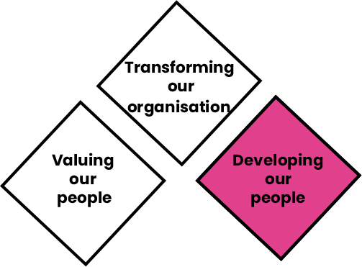

In Developing our People, we aim to develop our employees to deliver excellent, effective and sustainable services by:

* Enabling regular discussions on performance and development with employees
* Working with employees to enable them to identify the need for, and to source, appropriate development opportunities
* Ensure evaluation of learning and development considers cost benefit analysis and return on investment
* Provide a range of learning opportunities for employees
* Embed and maintain a leadership and management competency framework to inform both our recruitment, development and succession planning activity
* Provide opportunities for all employees to enhance key skills
* Develop opportunities for cross service and partnership working
* Ensure effective leadership and management programmes are in place for managers and elected members
* Ensure employees are developed in line with key competencies and skills to ensure we can effectively meet customer needs

## Our Commitment to Employees



Underpinning the key themes of our People Strategy is our commitment to Employees:

* We will value our employees and will recognise their efforts and commitment.
* The Council will treat employees fairly and respectfully.
* The Council will engage with and consult with employees and Trade Unions on key issues affecting our organisation.
* The Council will maintain its commitment to workforce development and support employees through challenging changes.
* The Council will maintain its commitment to workplace health and wellbeing support for all employees.

## Key Influences and Challenges

The People Strategy is about supporting delivery of forward-looking council visions and priorities. Whilst it is impossible to accurately predict what the requirements of the workforce for each council is going to be over the next few years, it is important to take into account a range of issues that will influence future needs. These are identified below under very broad headings.

|  |  |
| --- | --- |
| National Factors | Local Factors |
| These include issues such as:-   * Financial pressures / need for improved efficiencies / need to be accountable for public expenditure. * Shared services and partnership working * Financial Strategies * Competitive labour market across a number of key roles * Image of the public sector as an employer * Advancement in technology and E- government agenda * Government Strategy and Policy * Social responsibility to decrease the number of unemployed people within local communities. * Potential new employment legislation and new legal requirements | These include issues such as:-   * Priorities identified in Corporate Plans * Priorities identified in the Transformation Programmes * Customer expectations identified through consultation and surveys * Business transformation and process improvements, including customer first, improvements in efficiencies and organisational restructure. * Employing a workforce that reflects the local community * Development of local service plans * As major employers in the districts of Mansfield and Ashfield, explore ways in which we can improve the employability of our residents. |

## Contact us

If you have any comments, ideas or suggestions to develop the People Strategy in the future please email: [kbarke@mansfield.gov.uk](mailto:kbarke@mansfield.gov.uk)