

Disclaimer
This document or some parts of it may not be accessible when using adaptive technology.

If you require assistance with accessing the content of the document, please contact us and quote the document name and the web page you found it on:

- email: Regeneration – place@ashfield.gov.uk

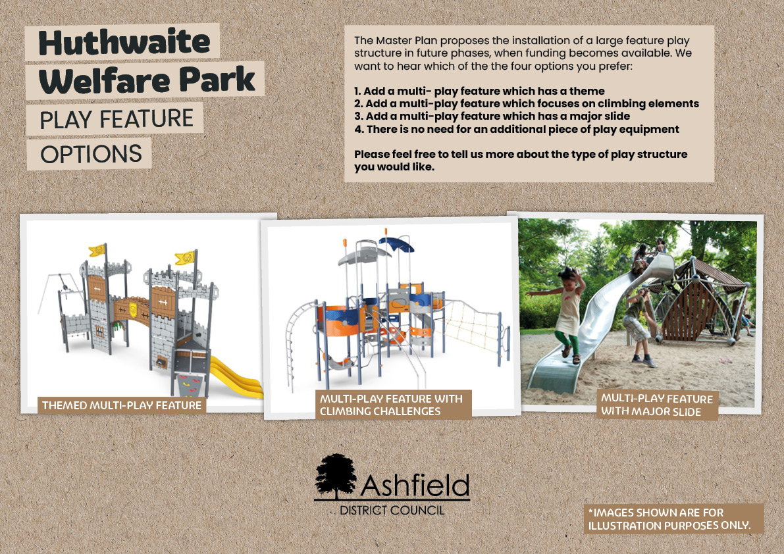
Images of play feature options for Huthwaite Welfare Park.
There are 4 choices to choose from:
- a themed multi-play feature,
- a feature with climbing challenges,
- a feature with a major slide, or
- no additional play equipment required.
Images show examples of each type of multi-play structure for illustration purposes only.

