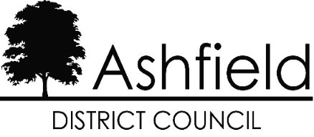

Modern Slavery & Human Trafficking Transparency Statement
2024/2025

This statement sets out the steps Ashfield District Council (“the Council”) has taken during 2024/2025 and the steps the Council will be taking to ensure that slavery and human trafficking is not taking place in any of its supply chains and in any part of its own business.

The Council is committed to ensuring there is transparency in its own business and in its approach to tackling modern slavery throughout its supply chains. The Council expects the same standards from its contractors, suppliers and other partners and as part of its procurement processes. The Council will ensure that when pre-contract questionnaires are distributed to potential contractors, that they include questions in relation to the contractor/supplier’s Modern Slavery and Human Trafficking policies, processes and responsibilities, to ensure the Council only enters into contracts with those organisations who are fulfilling their statutory responsibilities.

In addition the Council has already included anti-slavery clauses in its standard contract terms and conditions and tender documents, to ensure that the Council is only entering into contracts with suppliers who are committed to complying with requirements under the anti-slavery and human trafficking laws, including but not limited to the Modern Slavery Act 2015.

Organisationally the Council takes its responsibilities for safeguarding extremely seriously. The organisation, through its HR practices and employment checks, will ensure that anyone offered work as an employee will be scrutinised to ensure that they are legally entitled to work in the U.K. The Council through its pay policies will adhere to appropriate legislation that determines and prescribes levels of minimum payment for work undertaken as an employee.

The co-ordination of training and disseminating further information to staff in respect of Modern Slavery will be dealt with by the Council’s Corporate Safeguarding Group. Through staff briefings via the intranet and handouts, staff will be advised of the impact of modern slavery both locally and nationally. They will be advised of the potential signs that slavery or human trafficking may be occurring and where to report their concerns. In depth training will be given to staff, in particular those staff working in
front facing services who may be more likely to encounter instances of modern slavery, such as Housing and Community Safety.

