

Disclaimer

This document or some parts of it may not be accessible when using adaptive technology.

If you require assistance with accessing the content of the document, please contact us and quote the document name and the web page you found it on:
- email: Planning – planning.admin@ashfield.gov.uk

Schedule of Policies Map Modifications (PMM) - Ashfield District Local Plan 2023 to 2040

The Policies Map Modifications Schedule is a supporting document to the Main Modifications consultation.

The Policies Map Modifications Schedule is published for information and the changes shown are either as a result of the Modifications proposed or are factual updates. The schedule should be read in conjunction with the Main Modifications Schedule, on which comments can be submitted. For more information and to view all the consultation documents please visit the Local Plan Examination Webpages.

The modifications below are expressed in diagrammatic form with the Submission and Modifications versions shown alongside each other for ease of reference in relation to each Policies Map Modification.

PMM Ref. |  |  | Local Plan Policy Ref. |  |  |  | Proposed Policies Map Modification
PMM1 |  |  | H1: Housing |  |  |  | Add new housing site allocation H1Kl: Central Avenue, Kirkby In Ashfield
Submission Plan Version  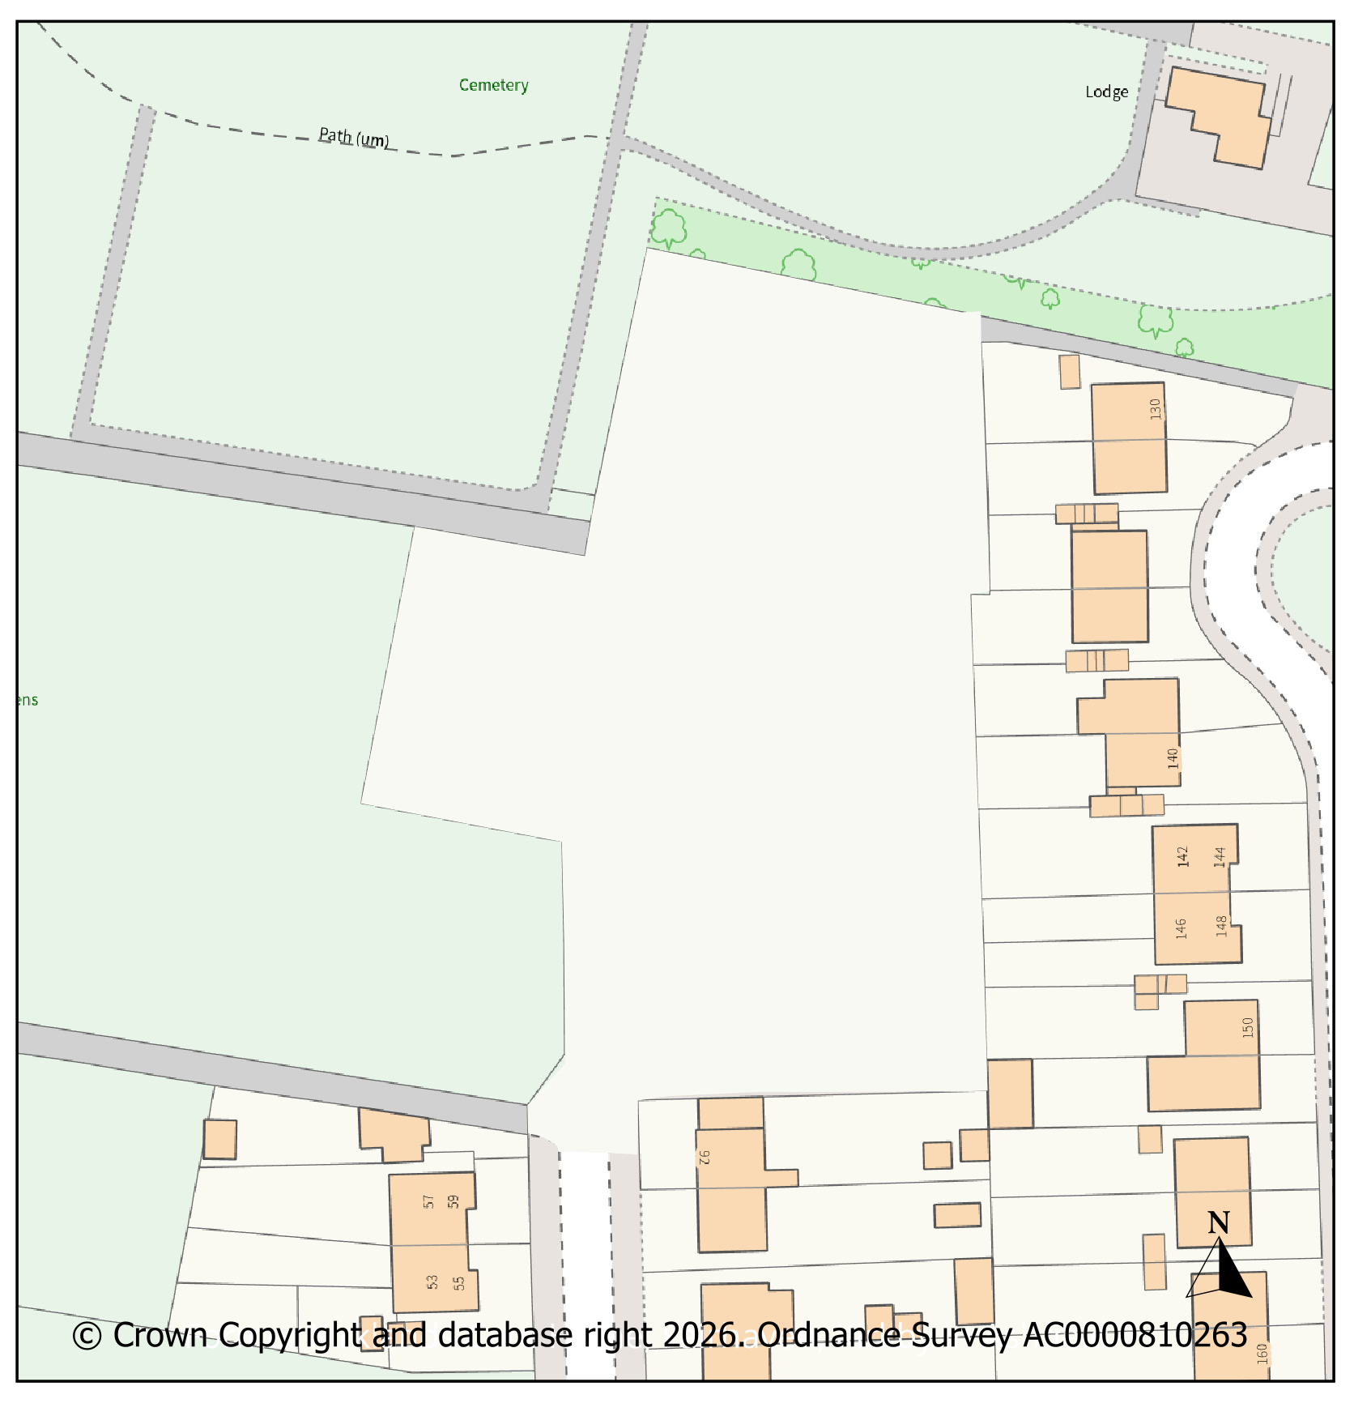 |  |  |  |  |  |  |  |  |  |  | Modifications Version  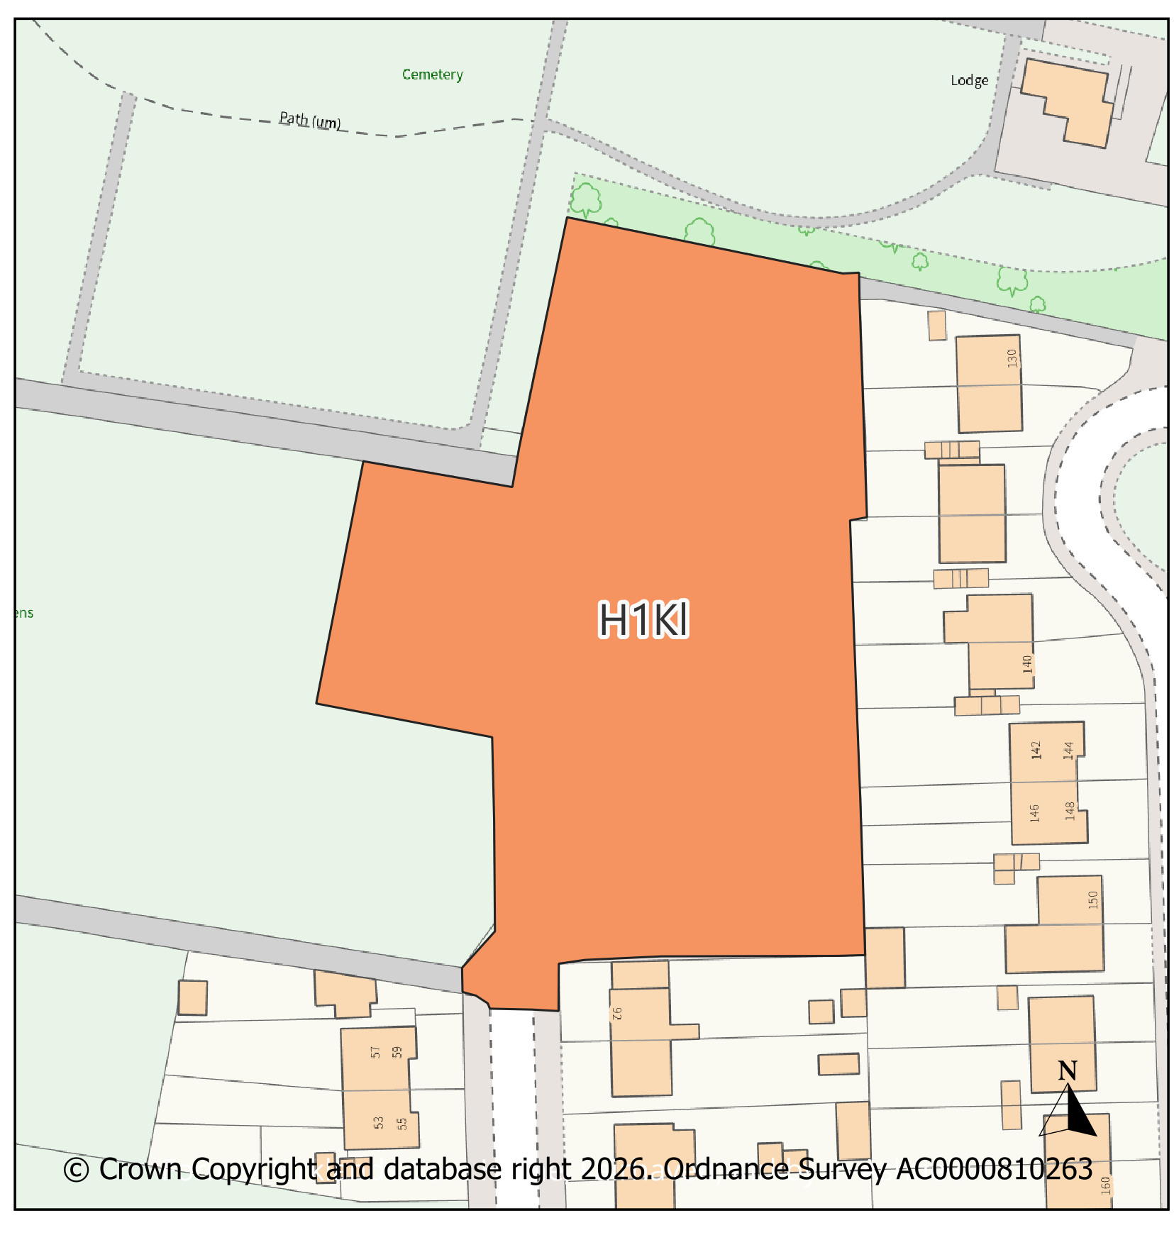
PMM Ref. |  |  | Local Plan Policy Ref. |  |  |  | Proposed Policies Map Modification
PMM2 |  |  | H1: Housing |  |  |  | Add new housing site allocation H1Km: Abbey Road, Kirkby In Ashfield
Submission Plan Version  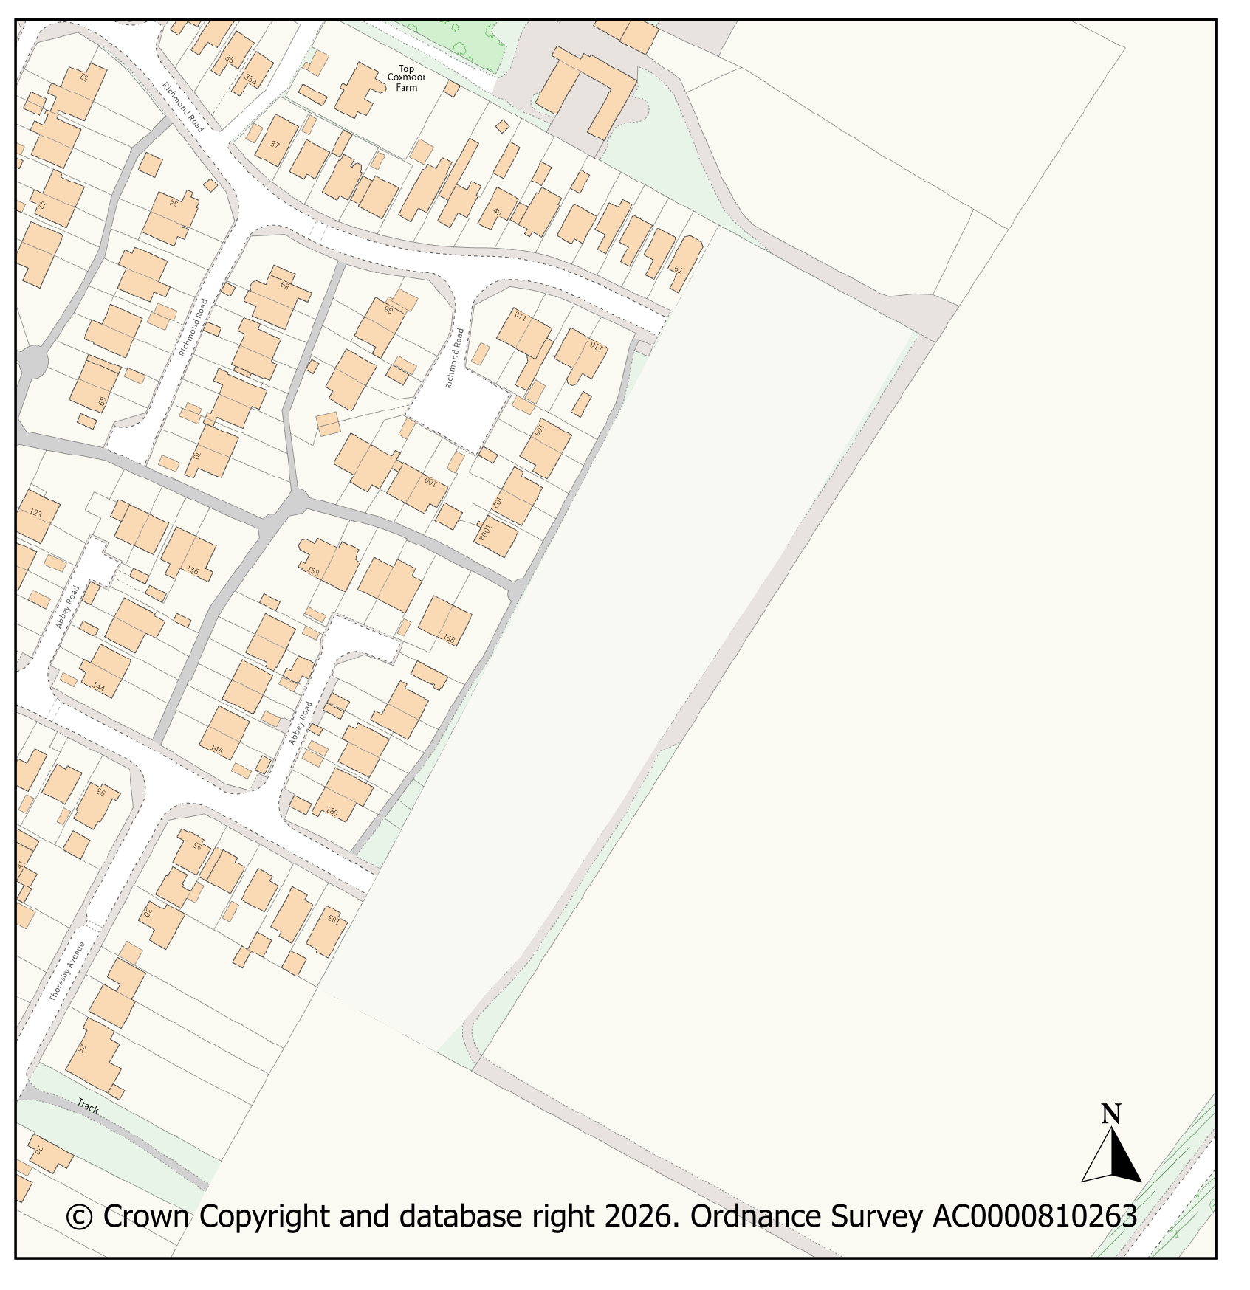 |  |  |  |  |  |  |  |  |  |  | Modifications Version  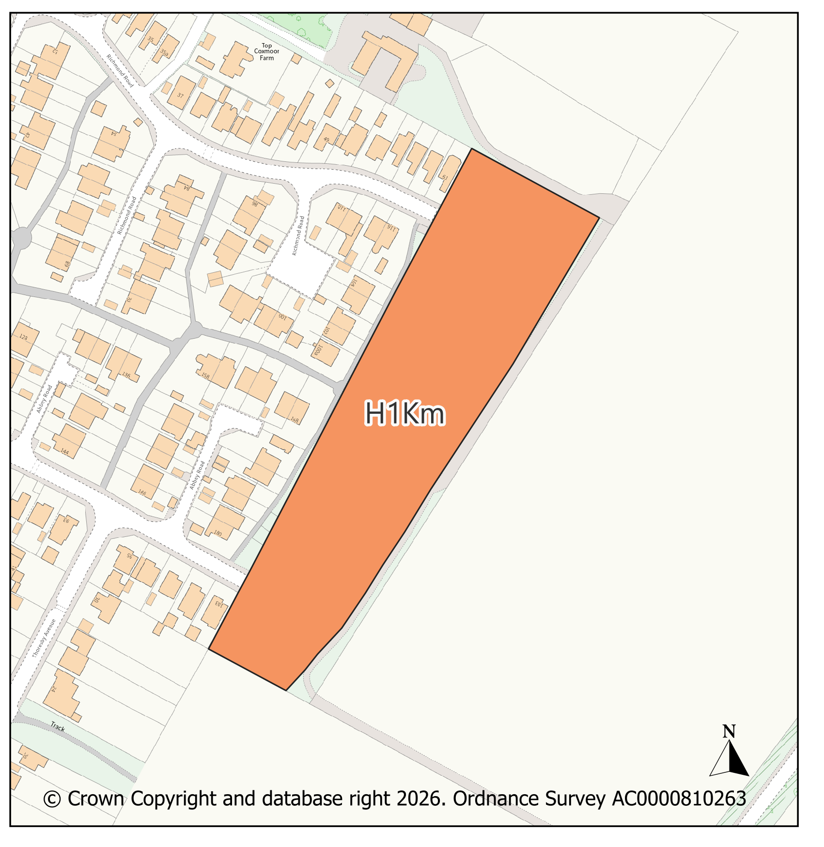
PMM Ref. |  |  | Local Plan Policy Ref. |  |  |  | Proposed Policies Map Modification
PMM3 |  |  | H1: Housing |  |  |  | Add new housing site allocation H1Kn: Southwell Lane, Kirkby In Ashfield
Submission Plan Version  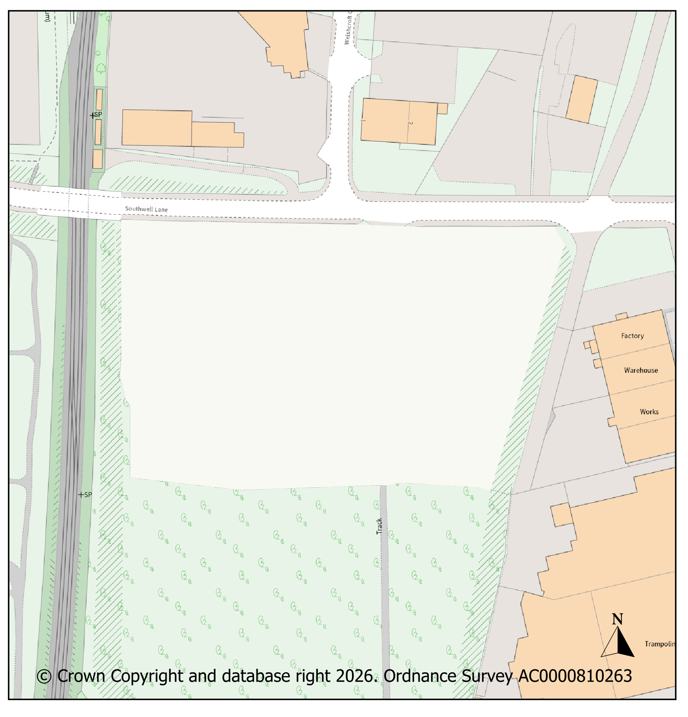 |  |  |  |  |  |  |  |  |  |  | Modifications Version  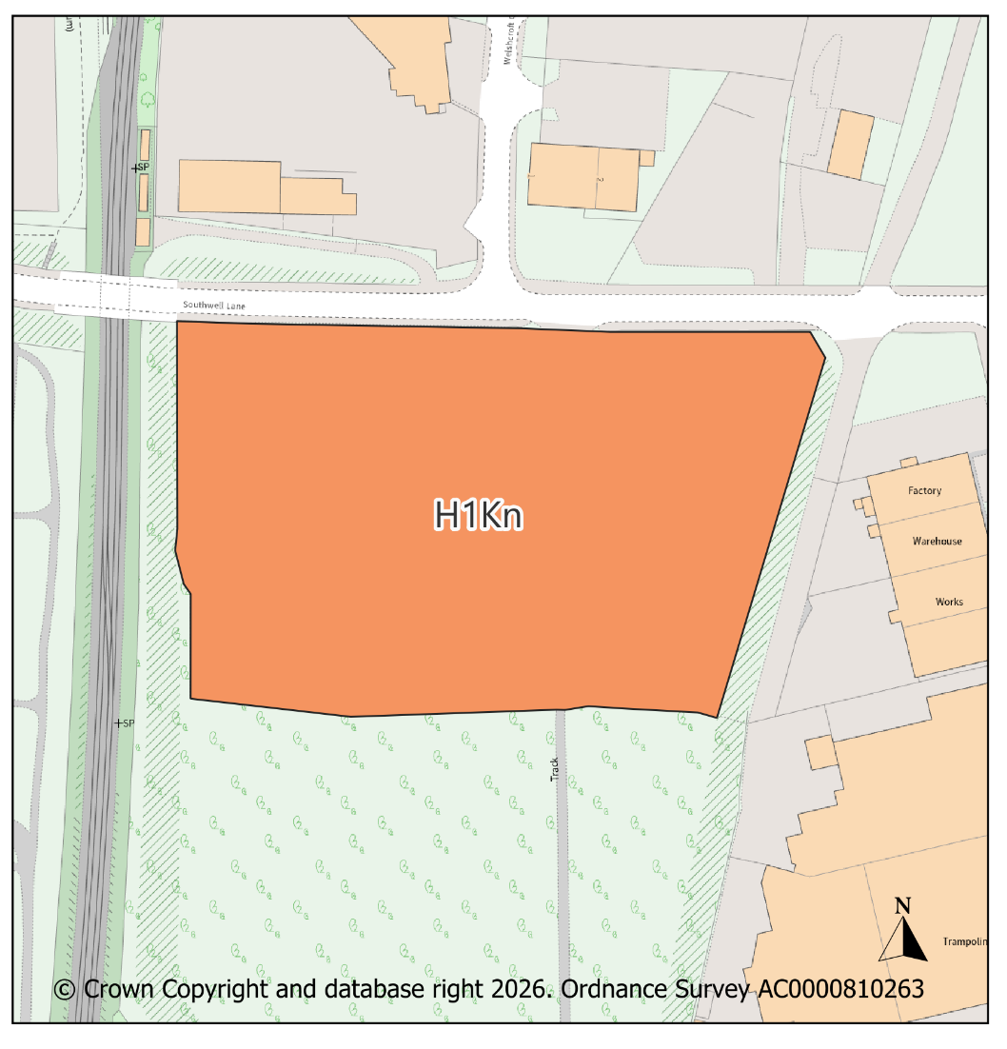
PMM Ref. |  |  | Local Plan Policy Ref. |  |  |  | Proposed Policies Map Modification
PMM4 |  |  | H1: Housing |  |  |  | Add new housing site allocation H1Ko: Former Kirkland’s Care Home, Fairhaven, Kirkby In Ashfield
Submission Plan Version  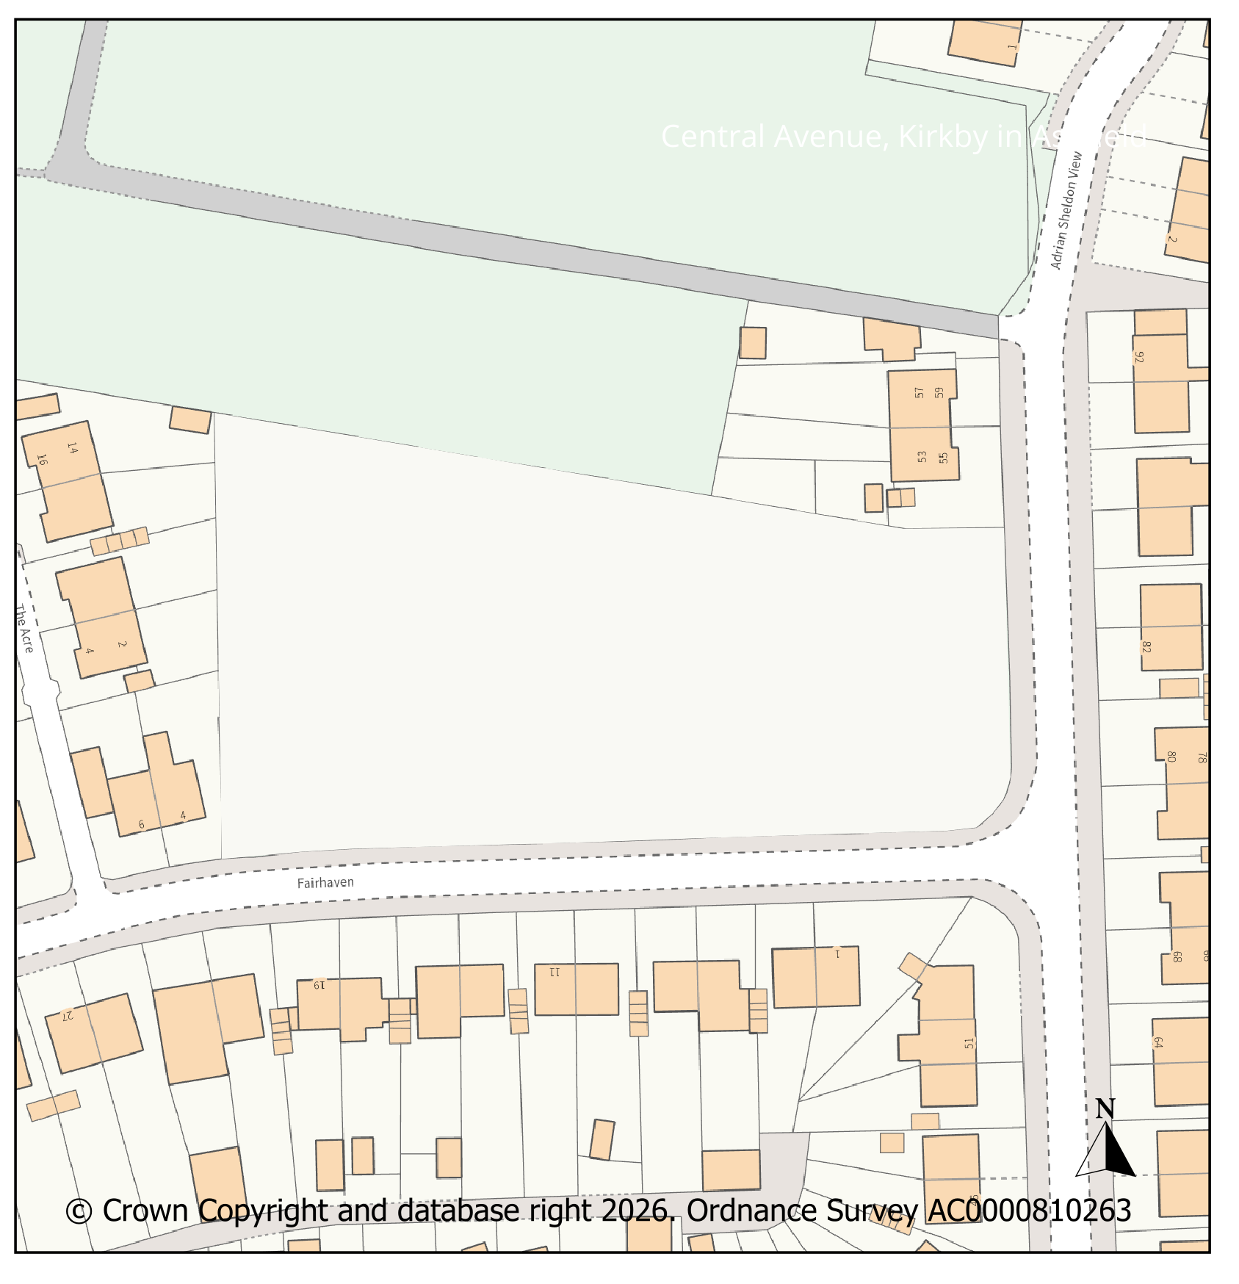 |  |  |  |  |  |  |  |  |  |  | Modifications Version  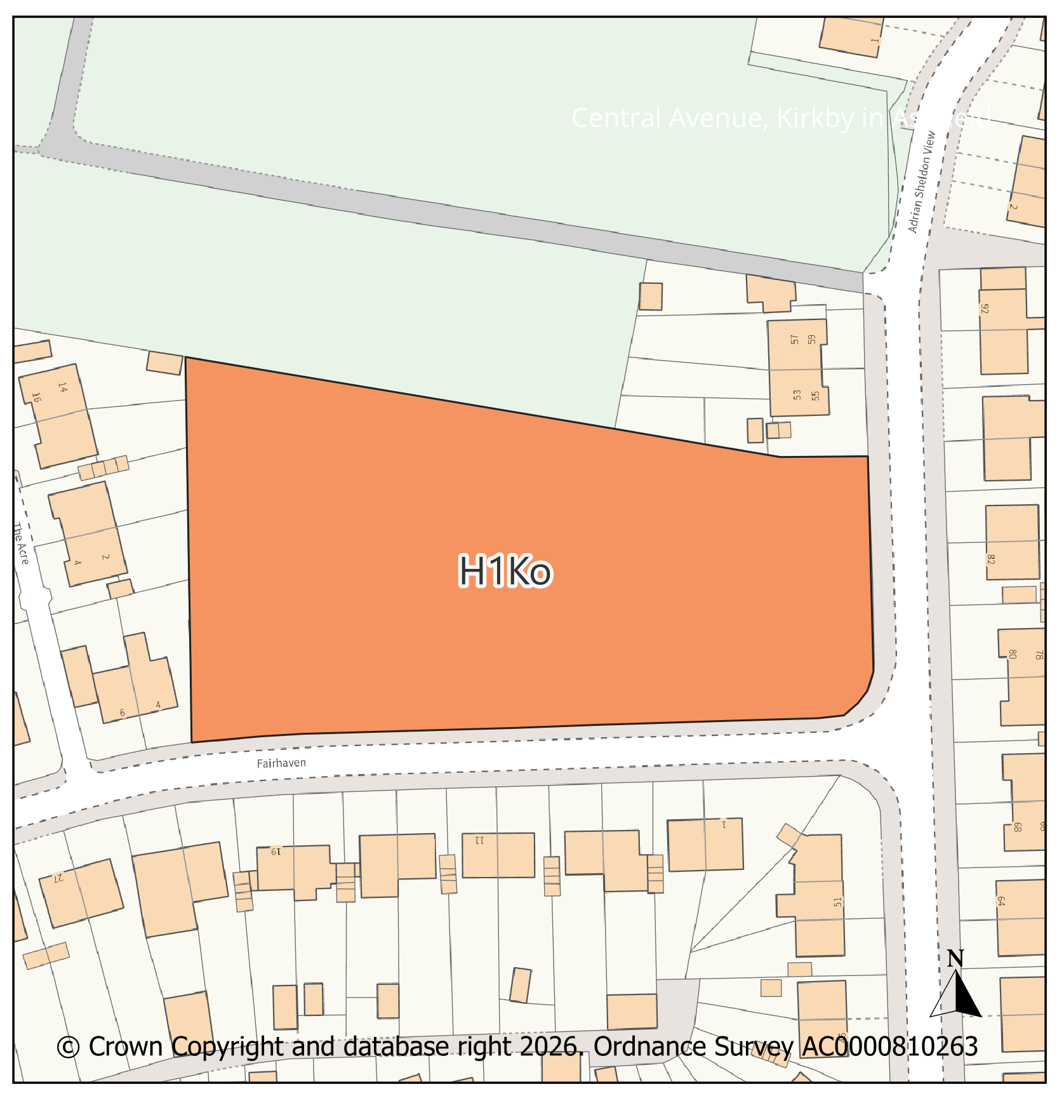
PMM Ref. |  |  | Local Plan Policy Ref. |  |  |  | Proposed Policies Map Modification
PMM5 |  |  | H1: Housing |  |  |  | Add new housing site allocation H1Kp: Pond Hole, Kirkby In Ashfield
Submission Plan Version  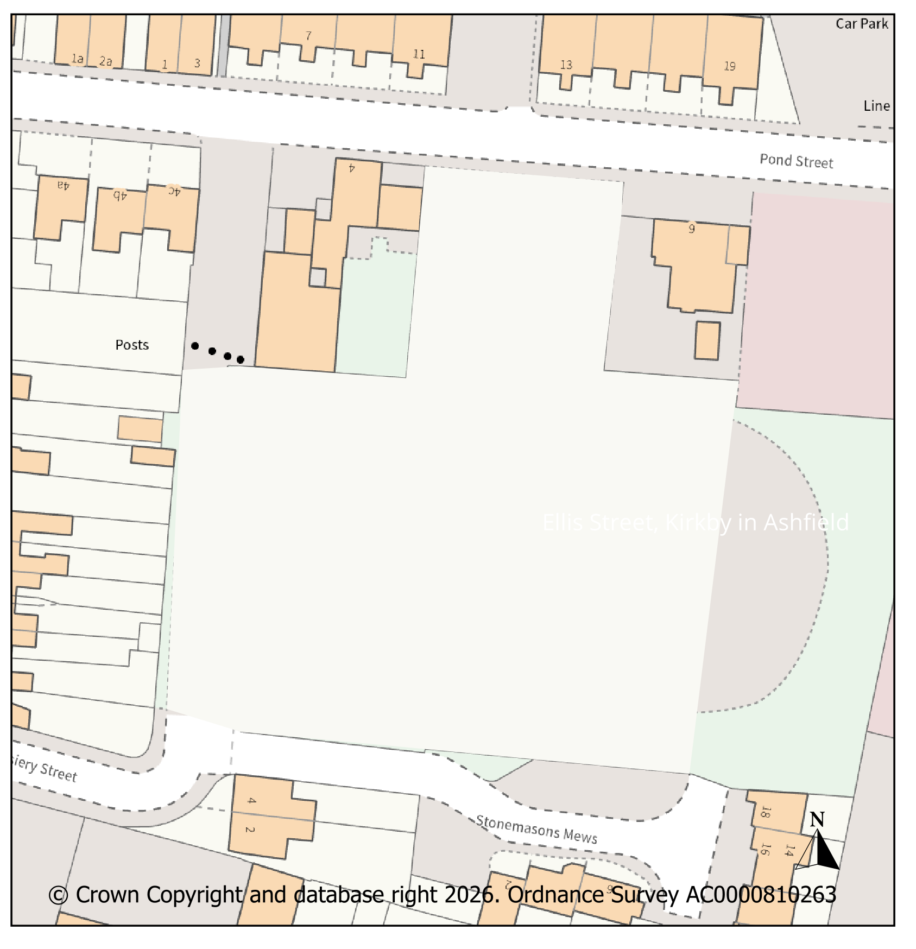 |  |  |  |  |  |  |  |  |  |  | Modifications Version  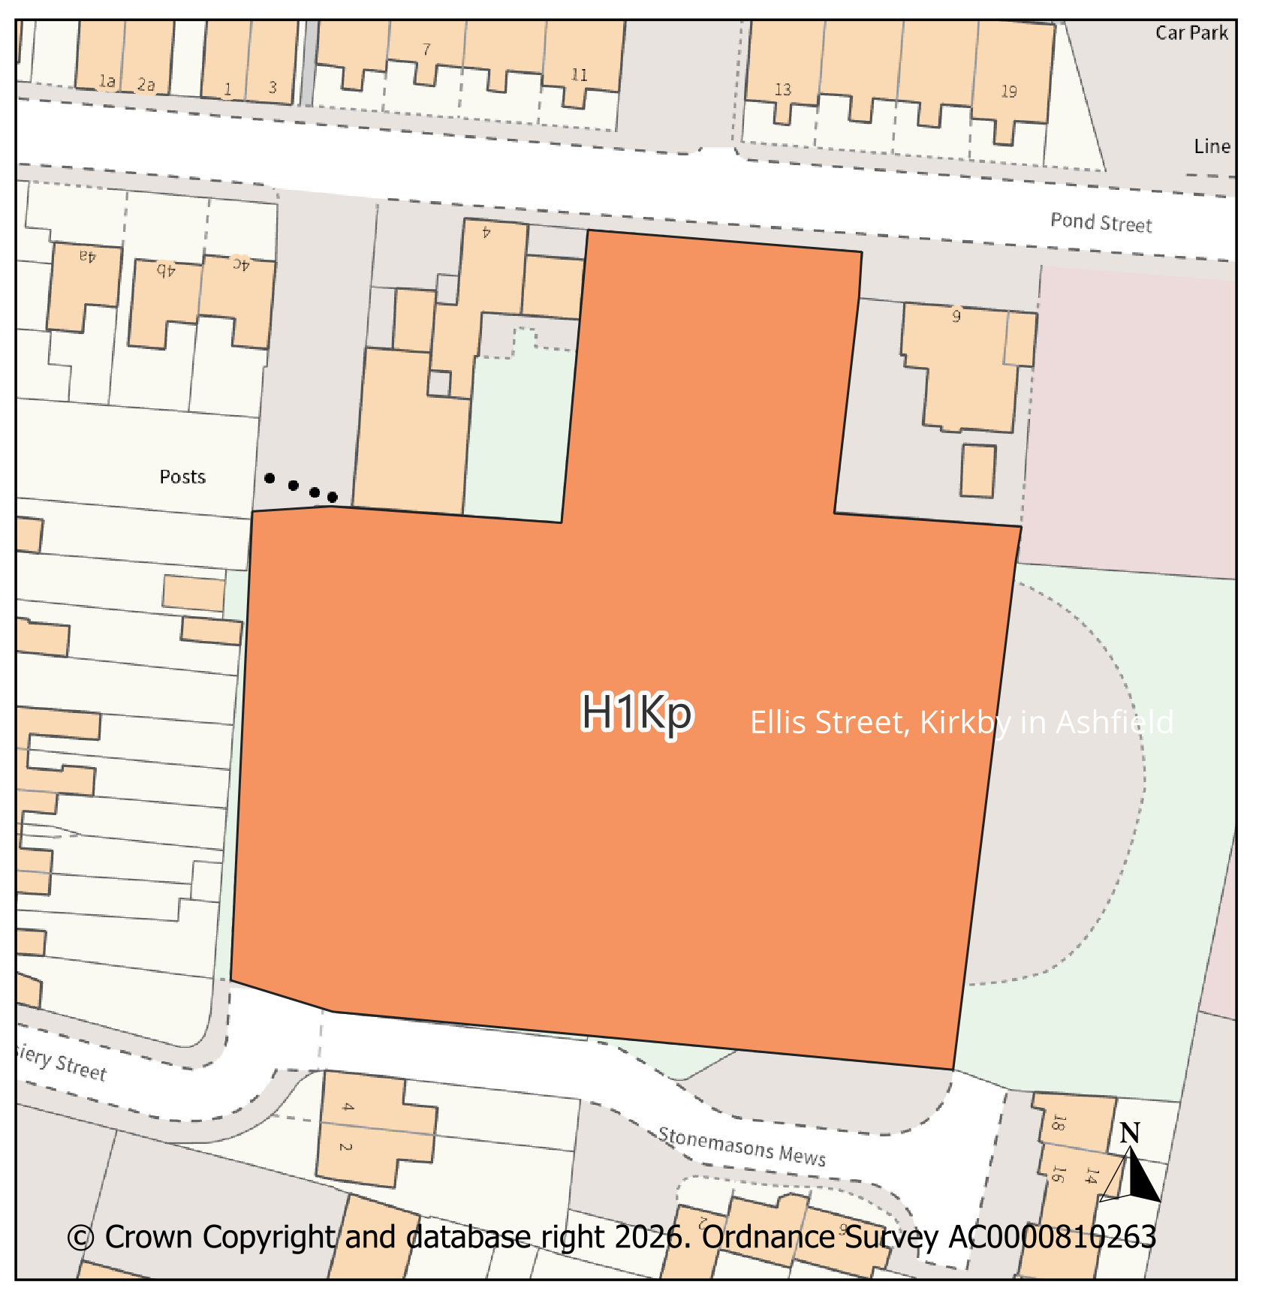
PMM Ref. |  |  | Local Plan Policy Ref. |  |  |  | Proposed Policies Map Modification
PMM6 |  |  | H1: Housing |  |  |  | Add new housing site allocation H1Kq: Former Wyvern Club Site, Lane End, Kirkby In Ashfield
Submission Plan Version  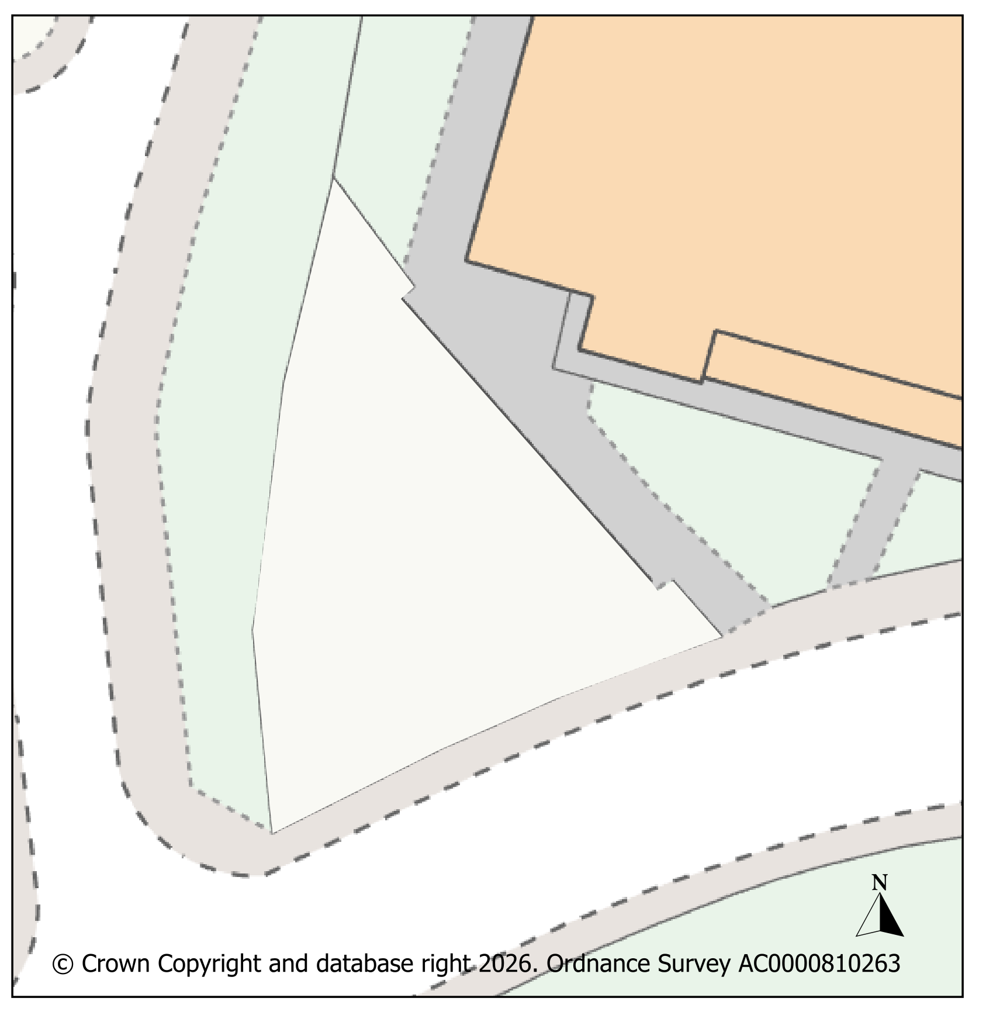 |  |  |  |  |  |  |  |  |  |  | Modifications Version  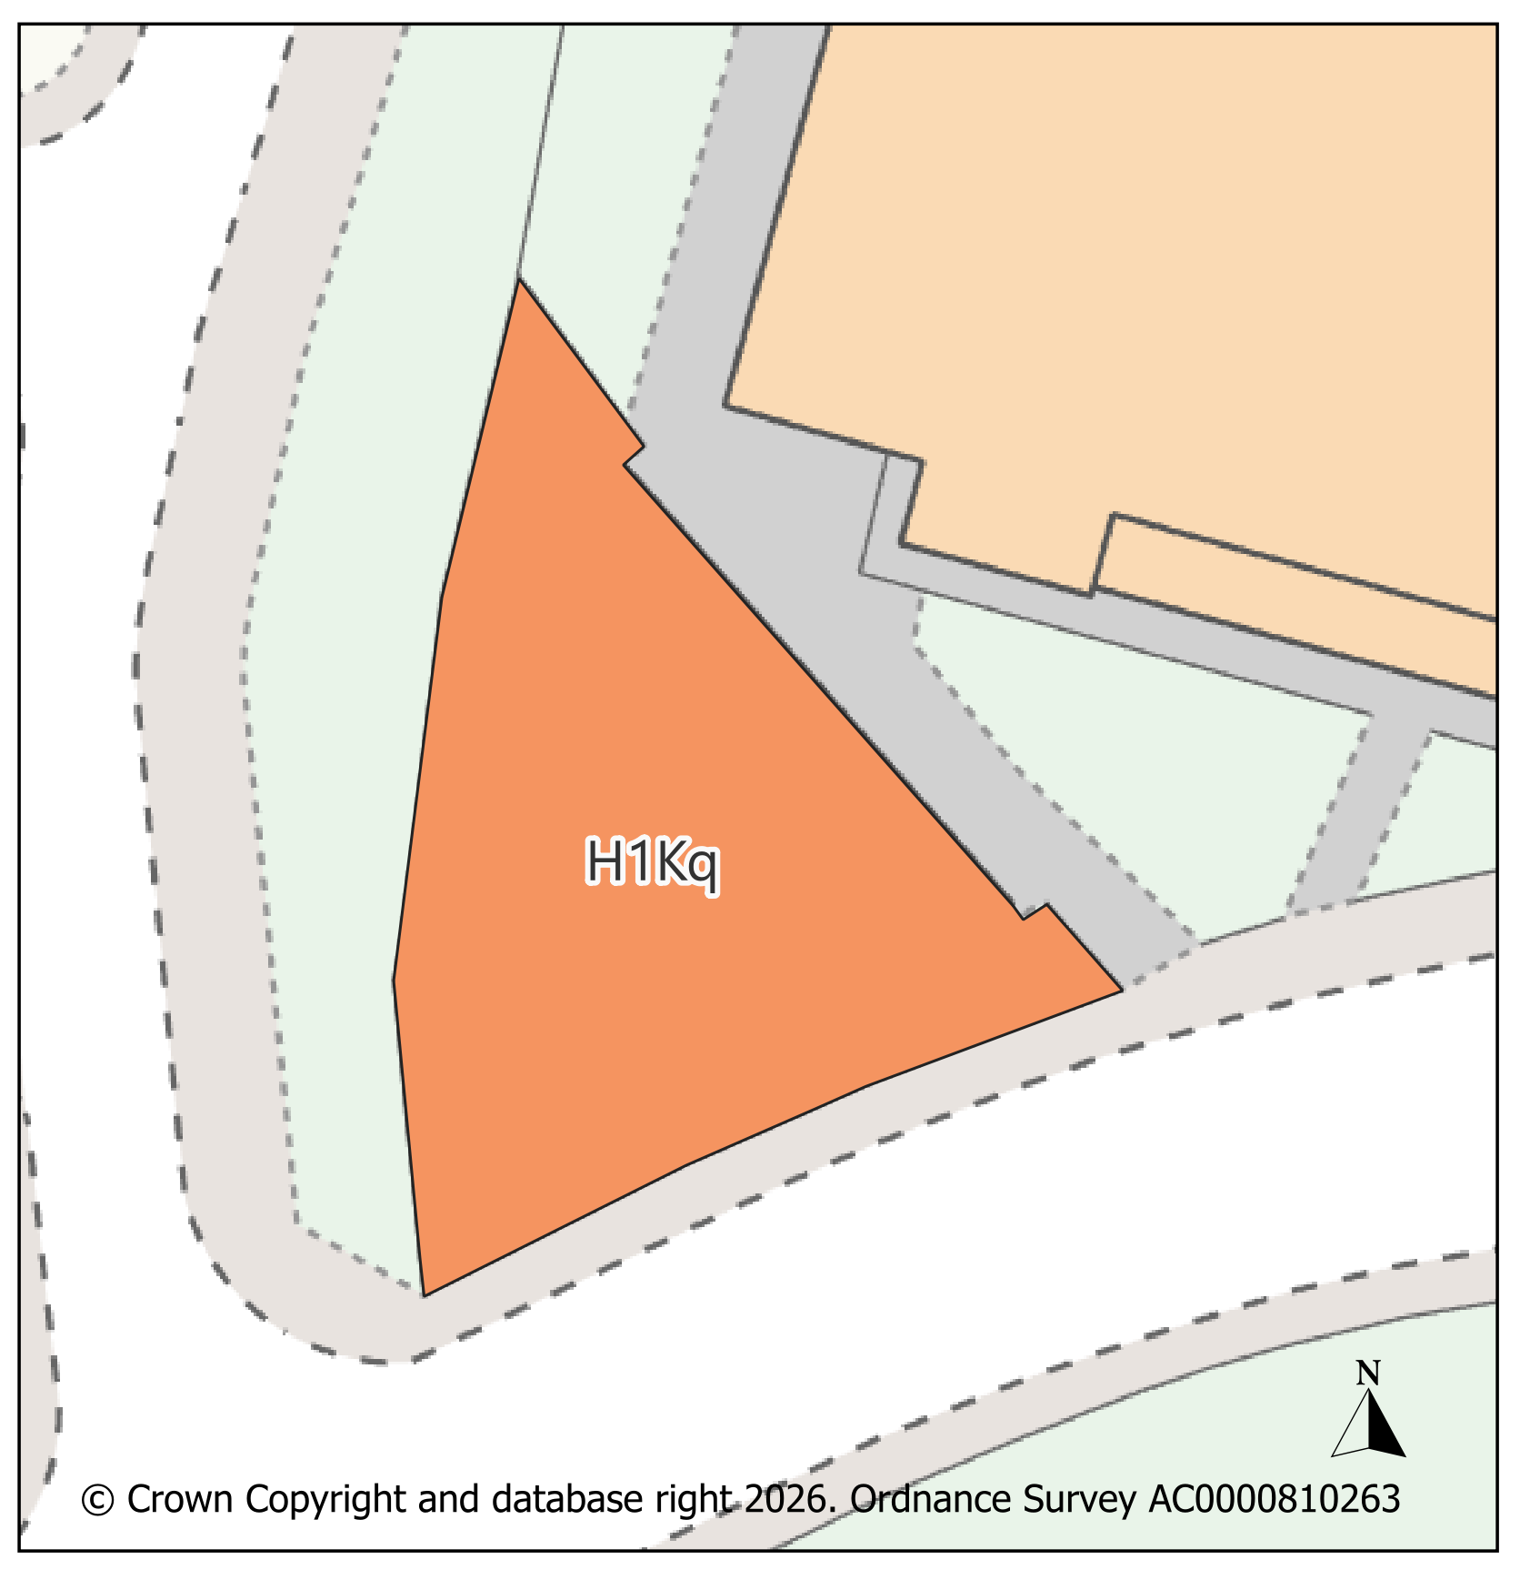
PMM Ref. |  |  | Local Plan Policy Ref. |  |  |  | Proposed Policies Map Modification
PMM7 |  |  | H1: Housing |  |  |  | Add new housing site allocation H1Kr: Ellis Street, Kirkby In Ashfield  .
Submission Plan Version  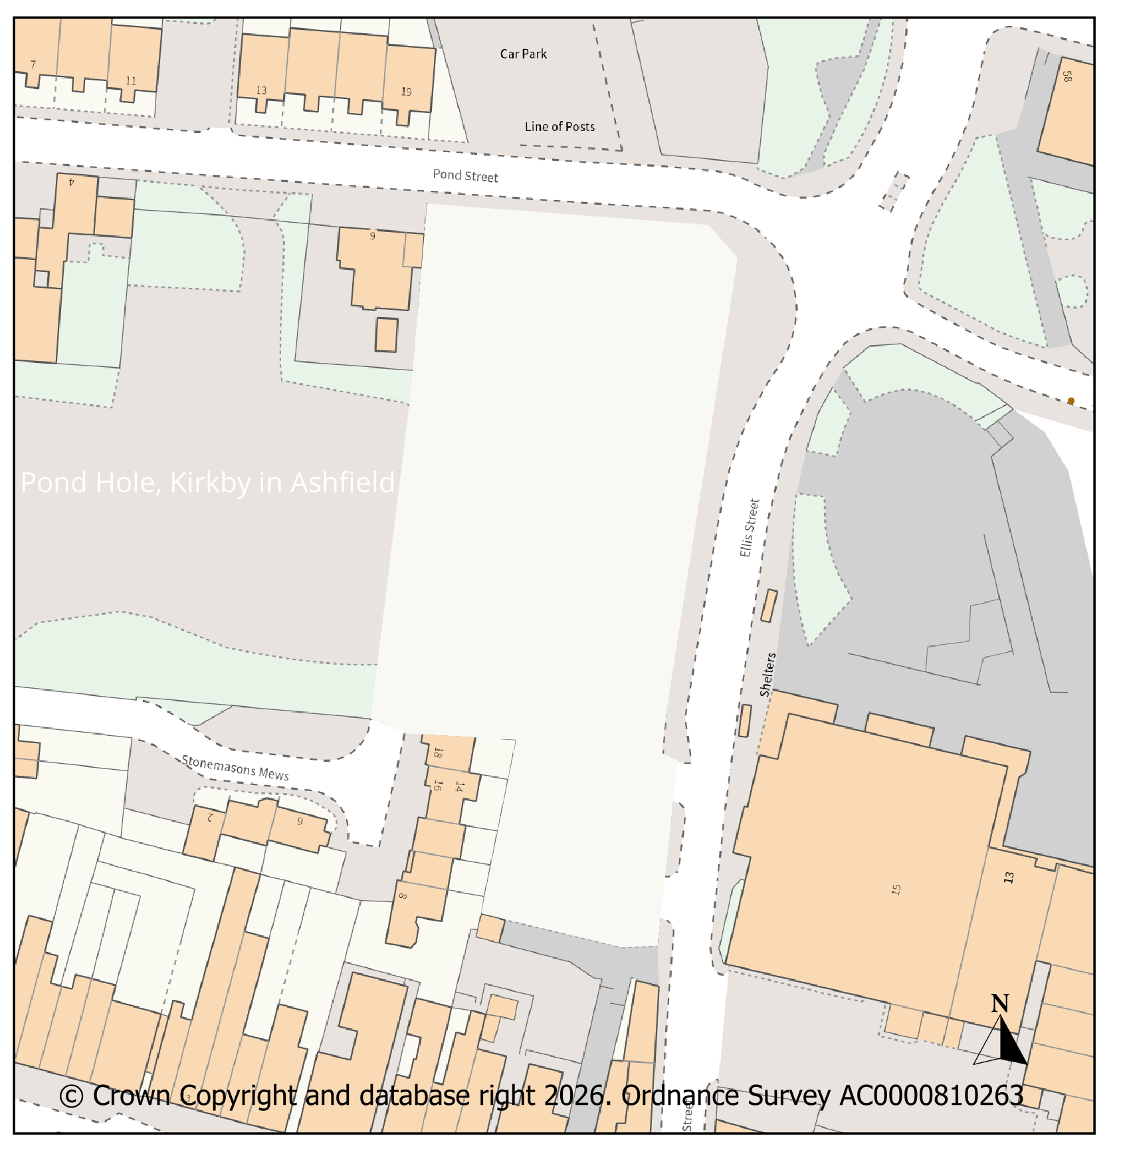 |  |  |  |  |  |  |  |  |  |  | Modifications Version  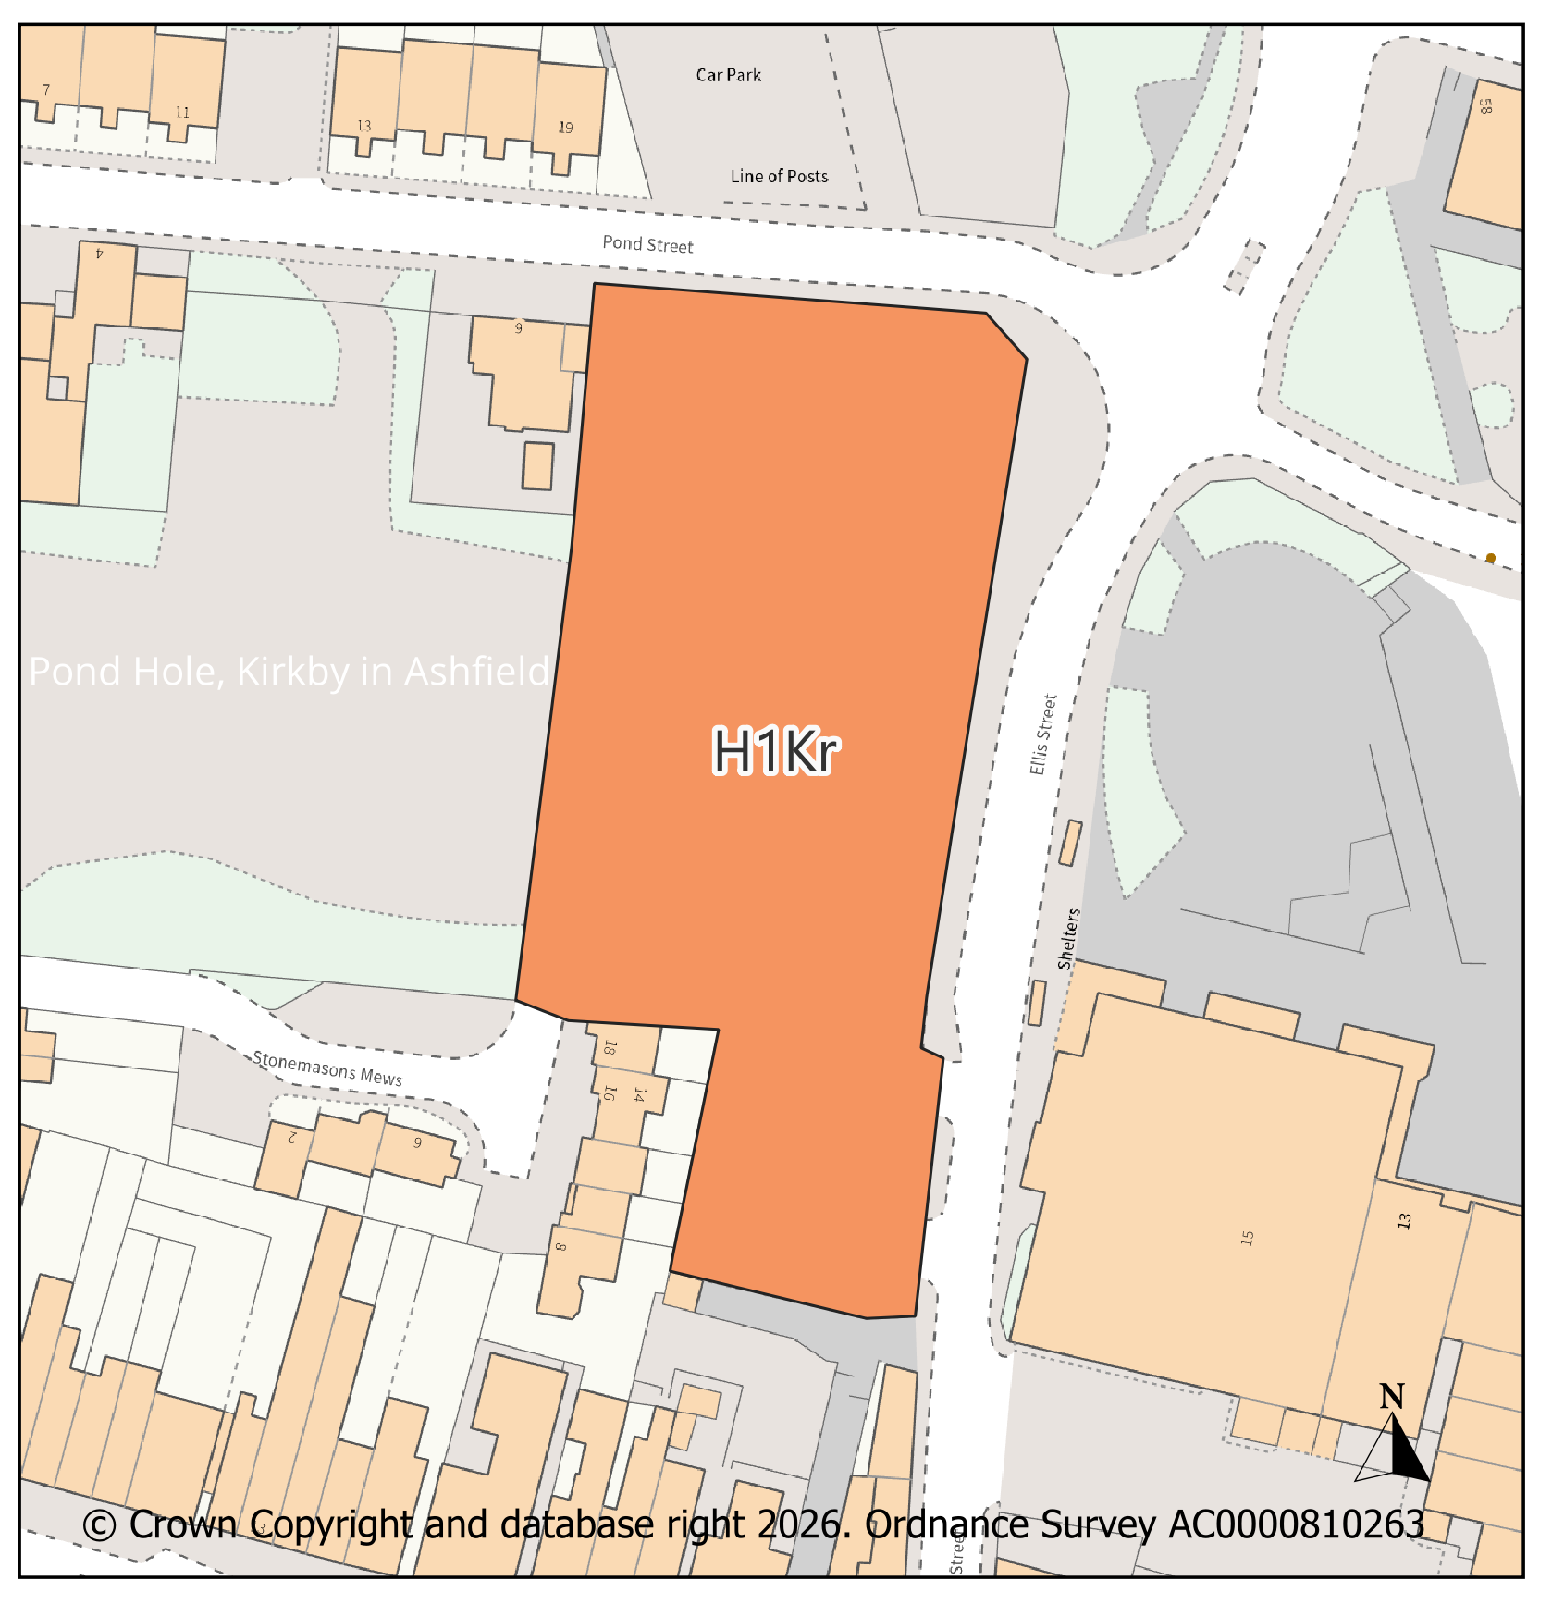
PMM Ref. |  |  | Local Plan Policy Ref. |  |  |  | Proposed Policies Map Modification
PMM8 |  |  | H1: Housing |  |  |  | Add new housing site allocation H1Sai: Pendean Way, Sutton In Ashfield.
Submission Plan Version  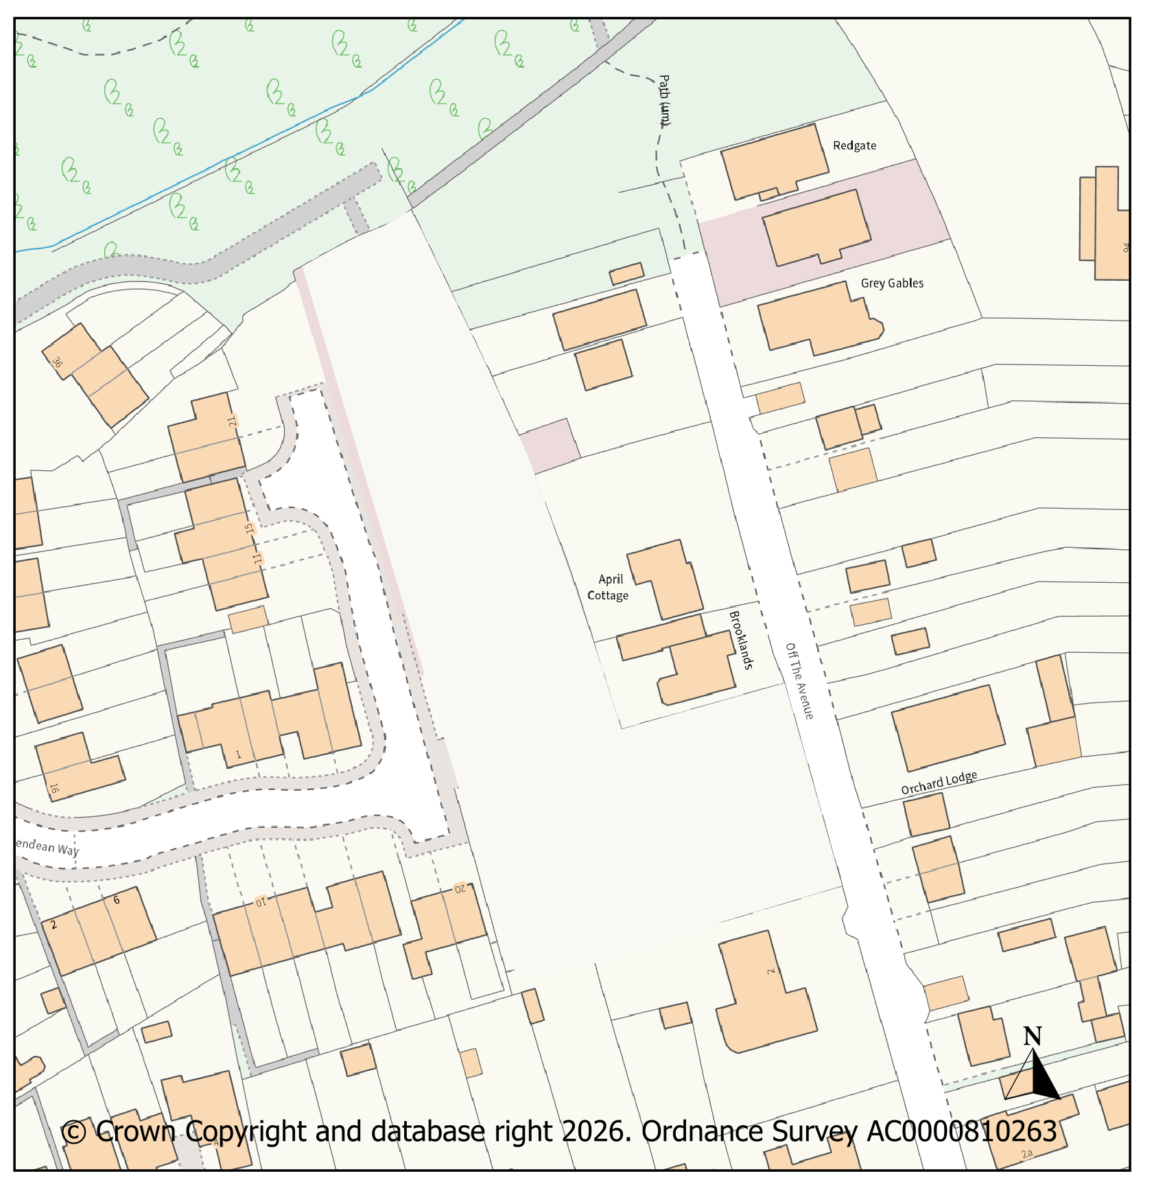 |  |  |  |  |  |  |  |  |  |  | Modifications Version  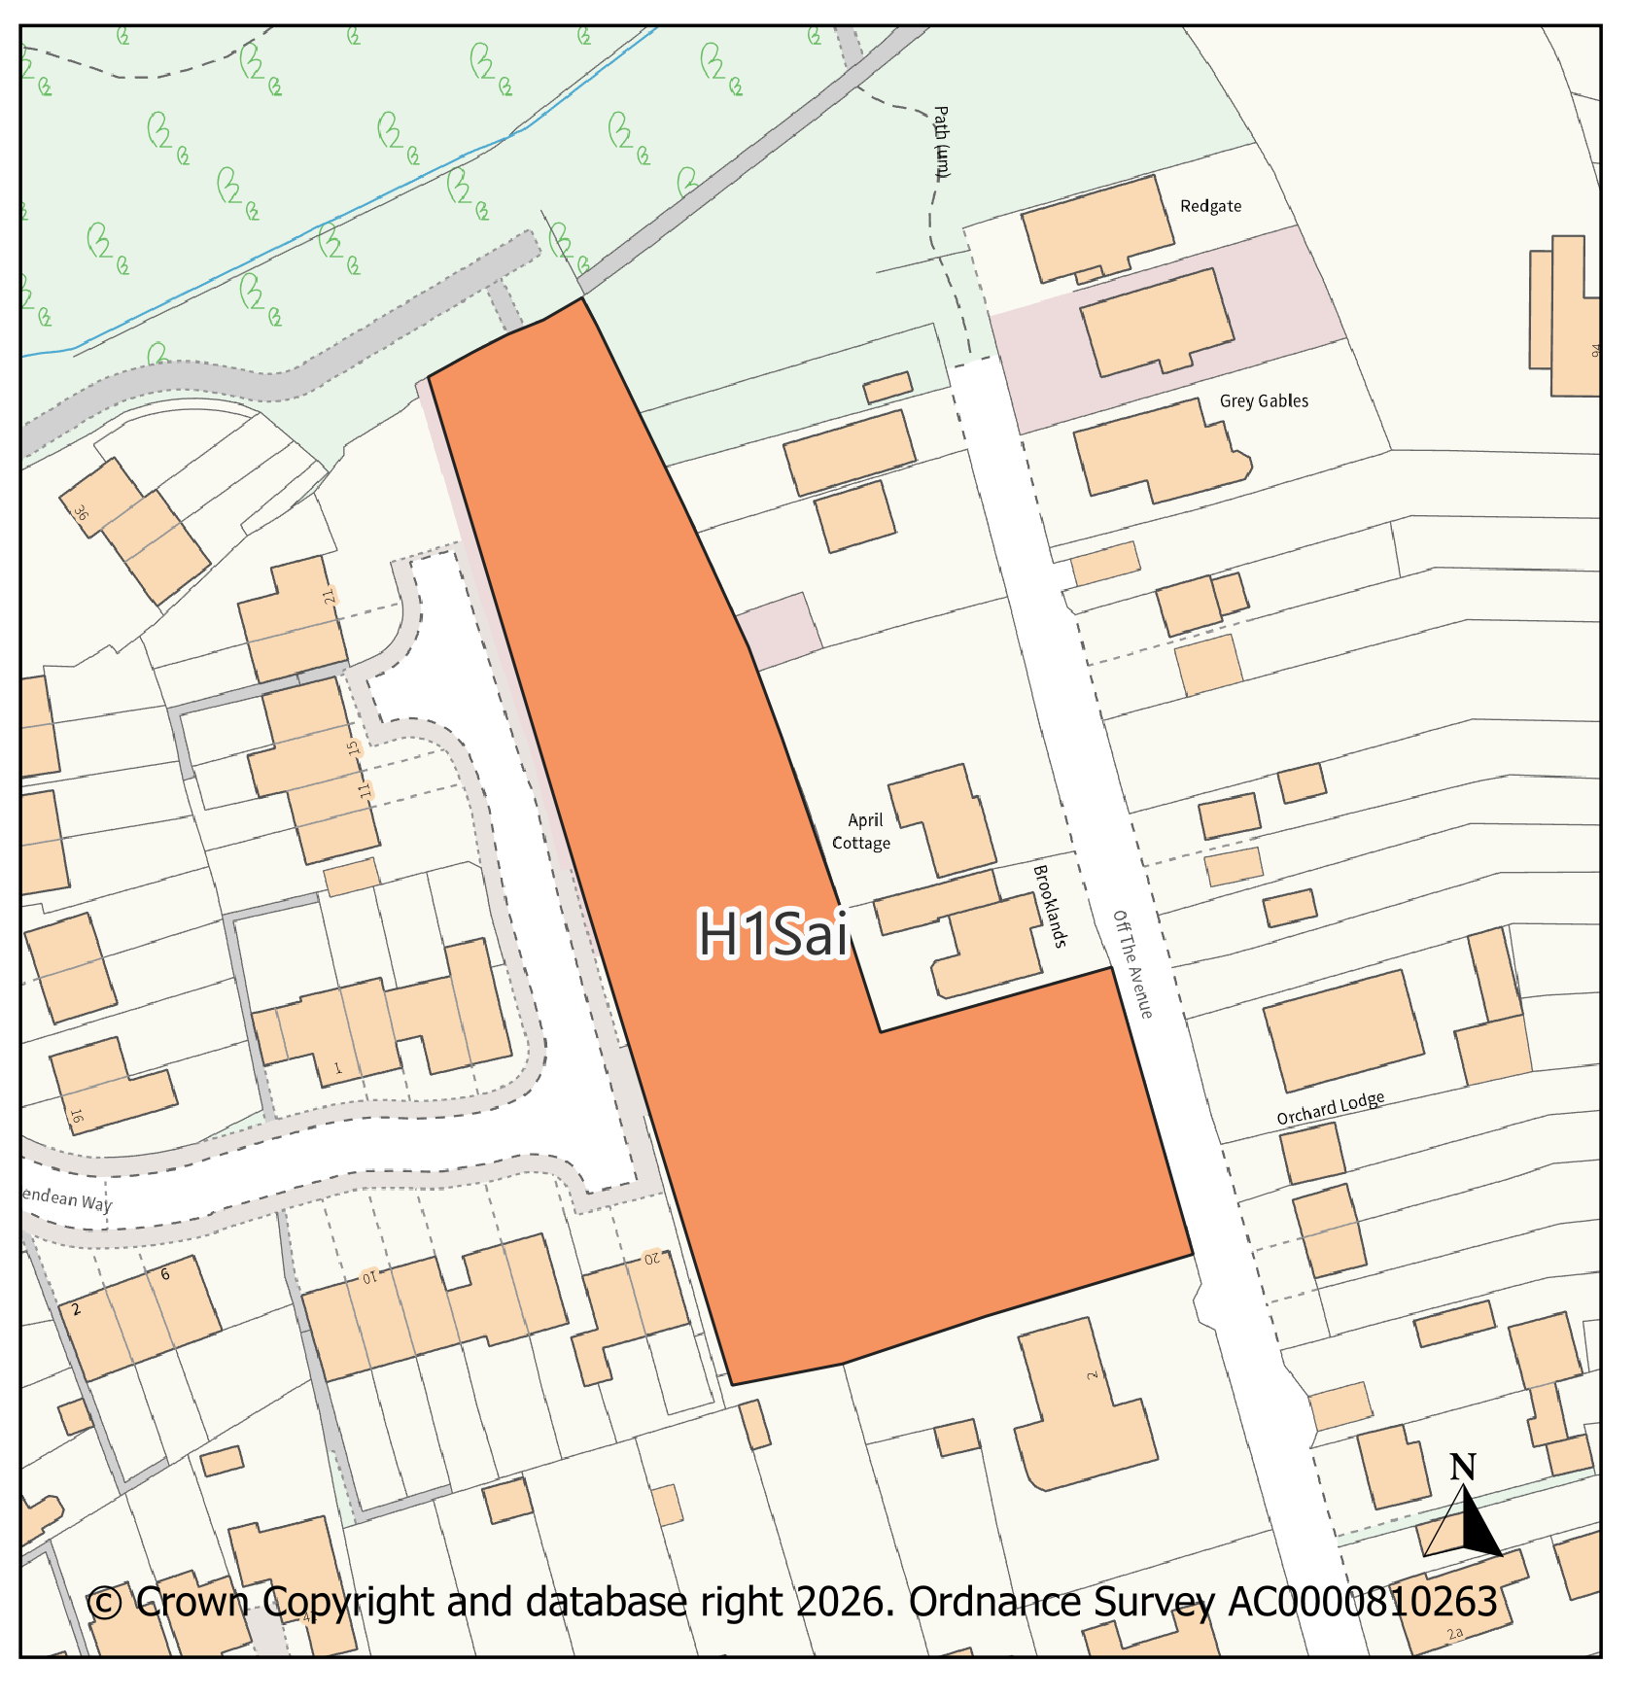
PMM Ref. |  |  | Local Plan Policy Ref. |  |  |  | Proposed Policies Map Modification
PMM9 |  |  | H1: Housing |  |  |  | Add new housing site allocation H1Saj: Between Redcliffe Street & Leyton Avenue, Sutton In Ashfield
Submission Plan Version  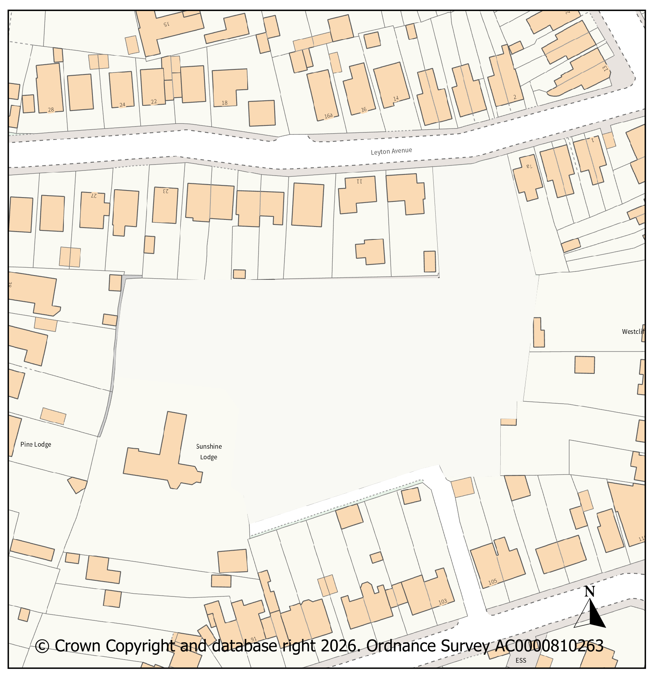 |  |  |  |  |  |  |  |  |  |  | Modifications Version  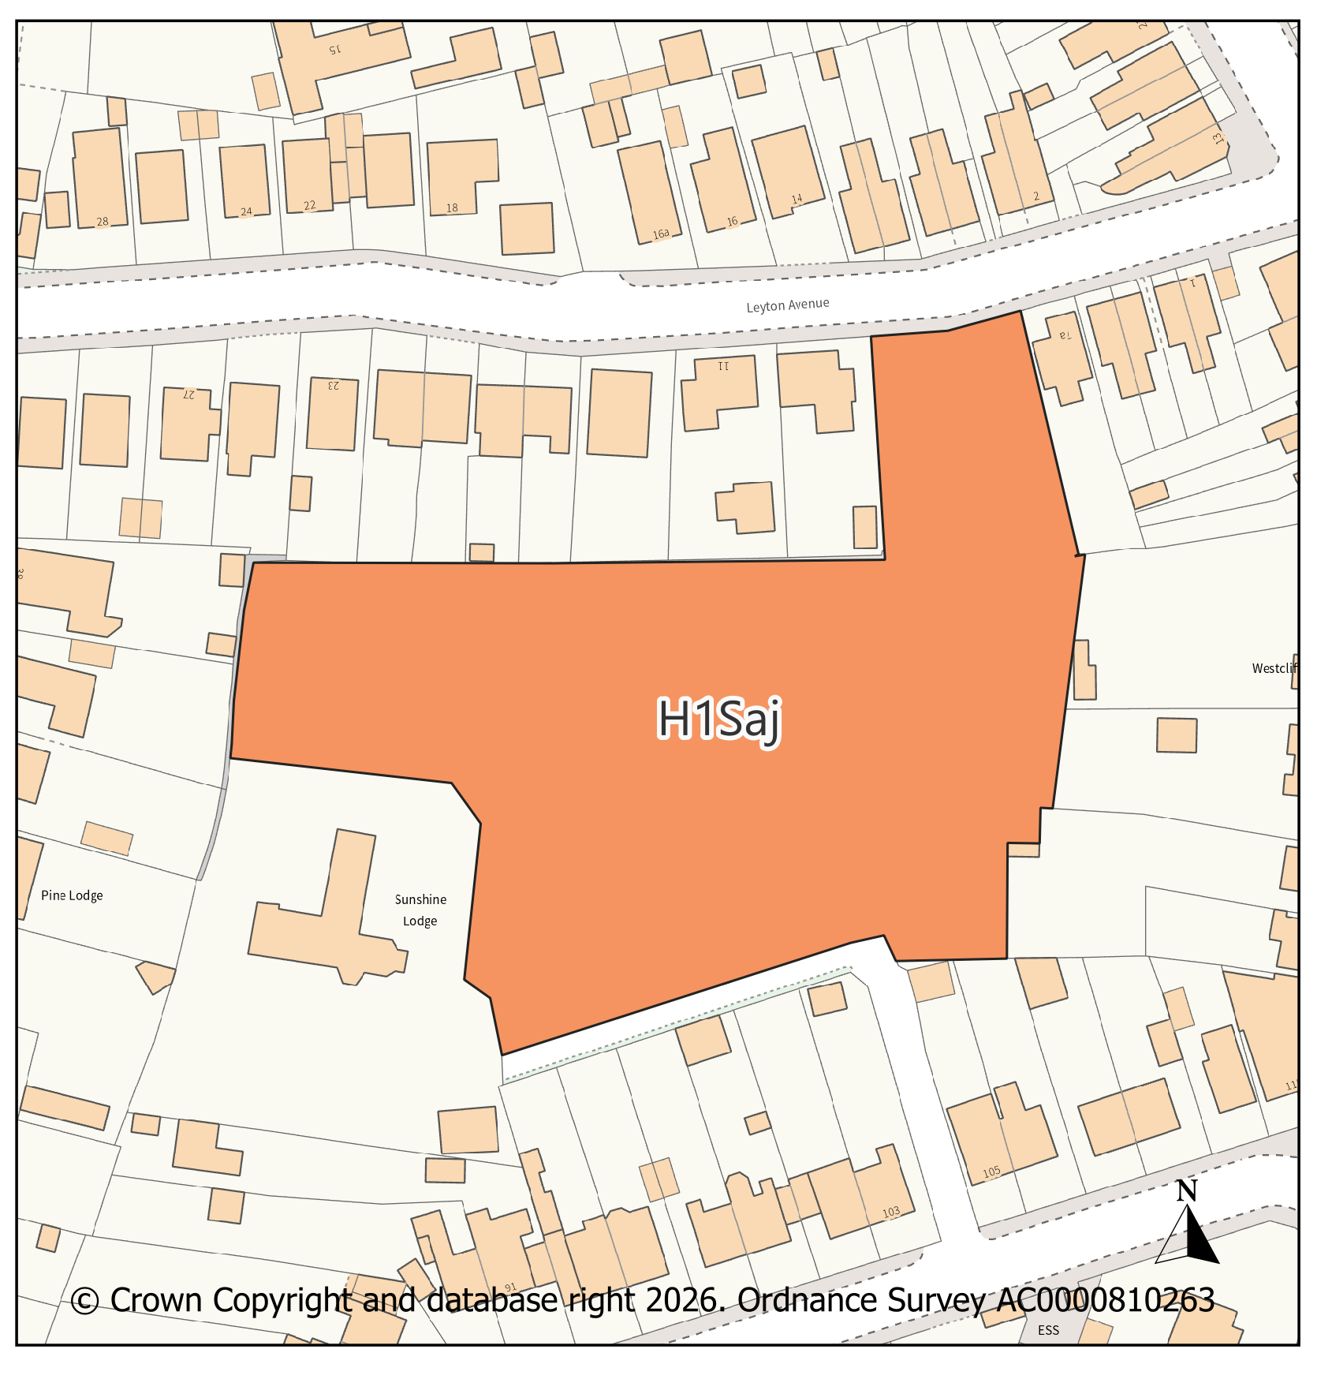
PMM Ref. |  |  | Local Plan Policy Ref. |  |  |  | Proposed Policies Map Modification
PMM10 |  |  | H1: Housing |  |  |  | Add new housing site allocation H1Sak: Rookery Lane, Sutton In Ashfield
Submission Plan Version  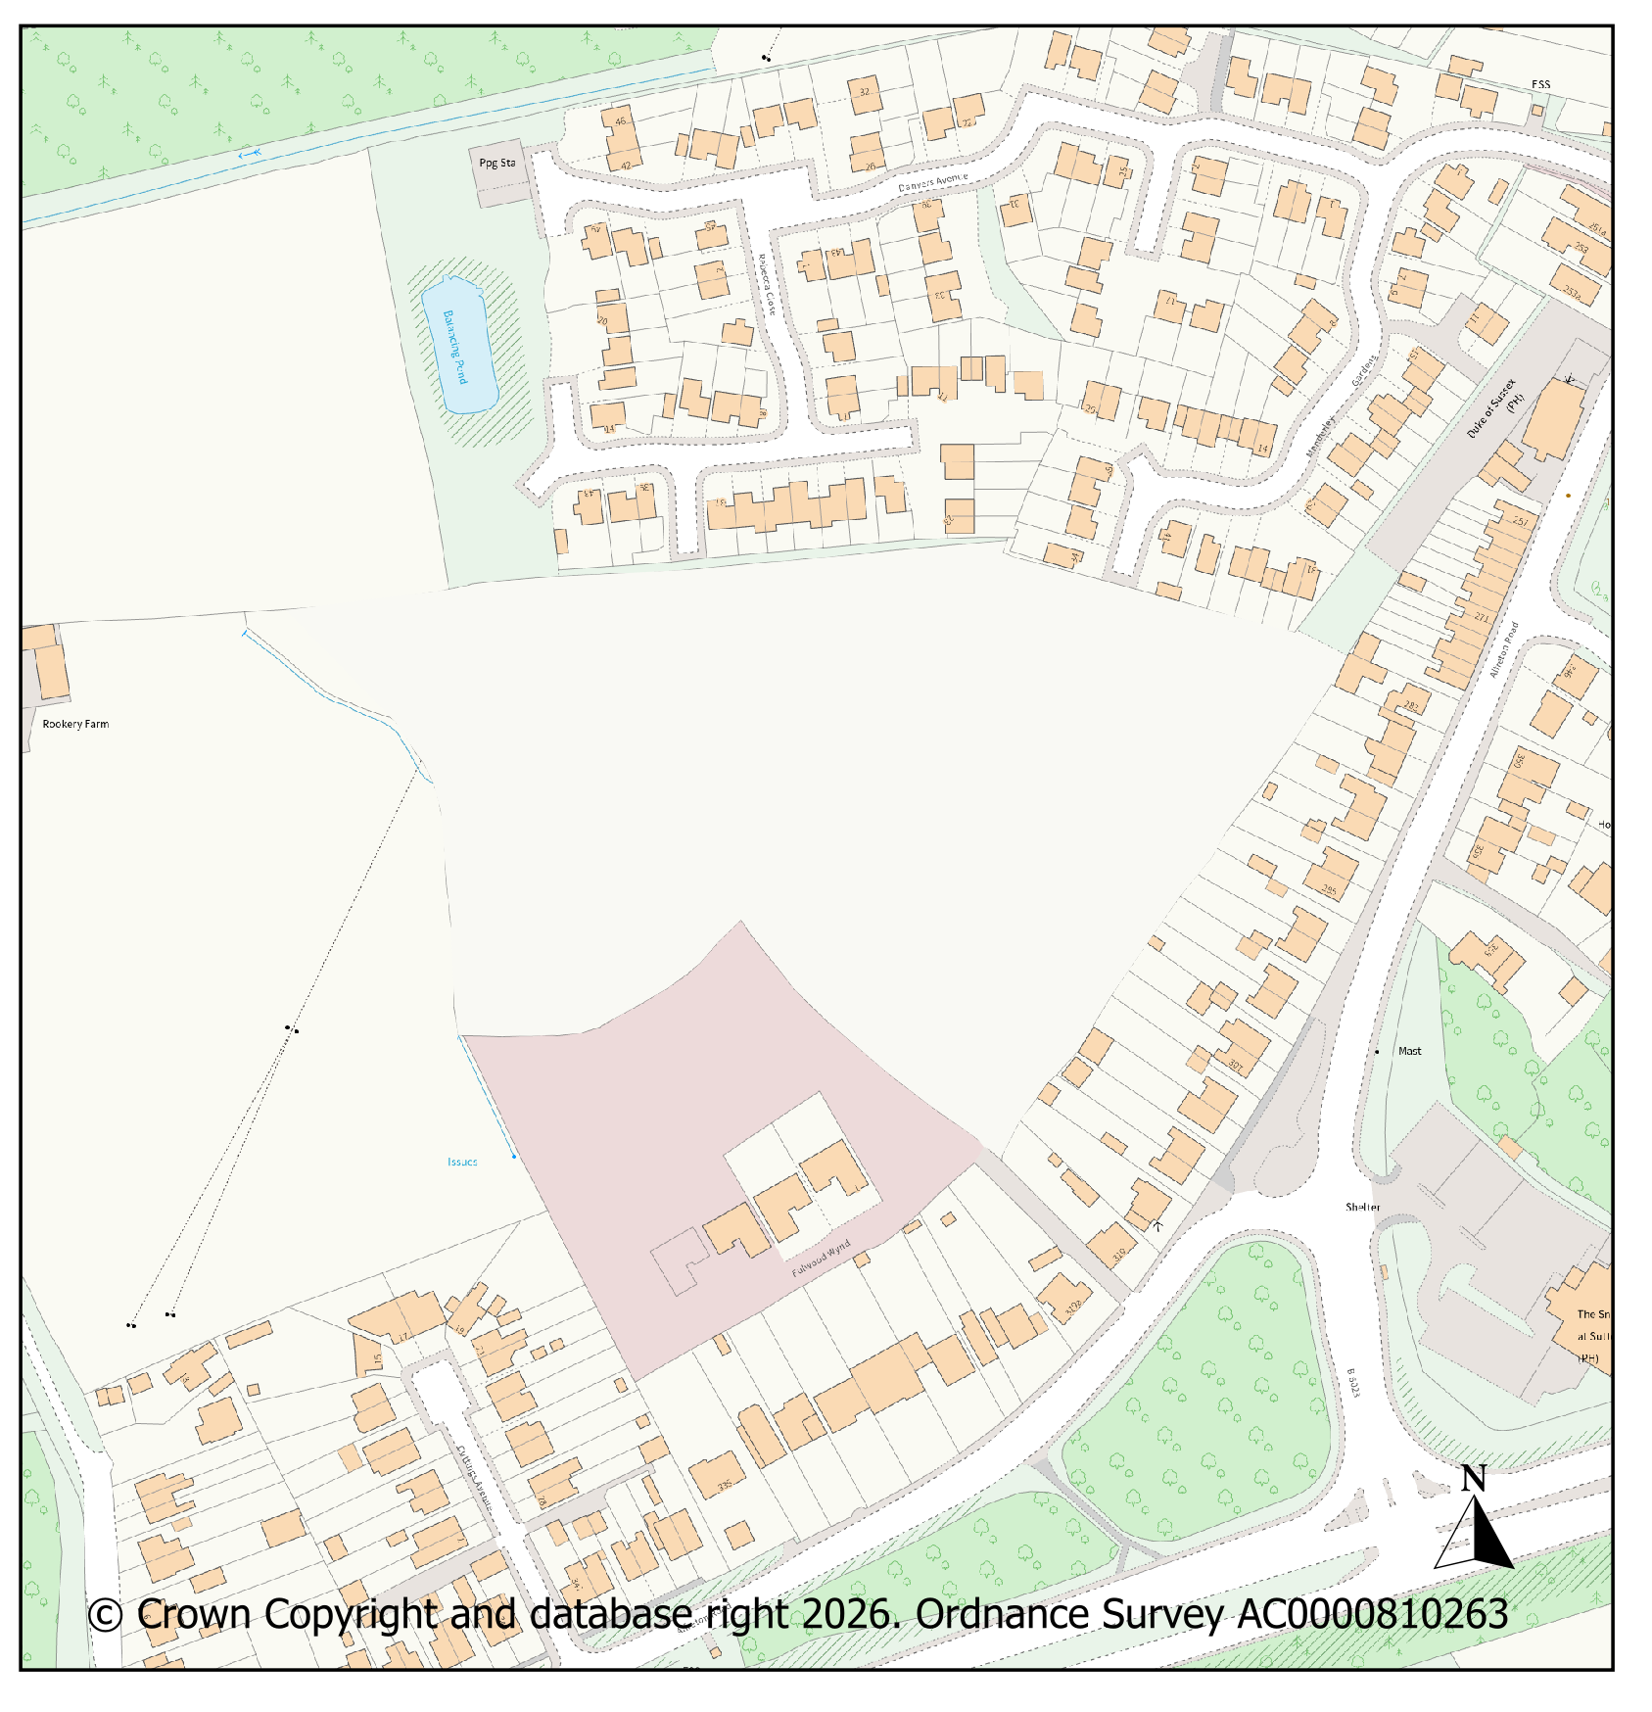 |  |  |  |  |  |  |  |  |  |  | Modifications Version  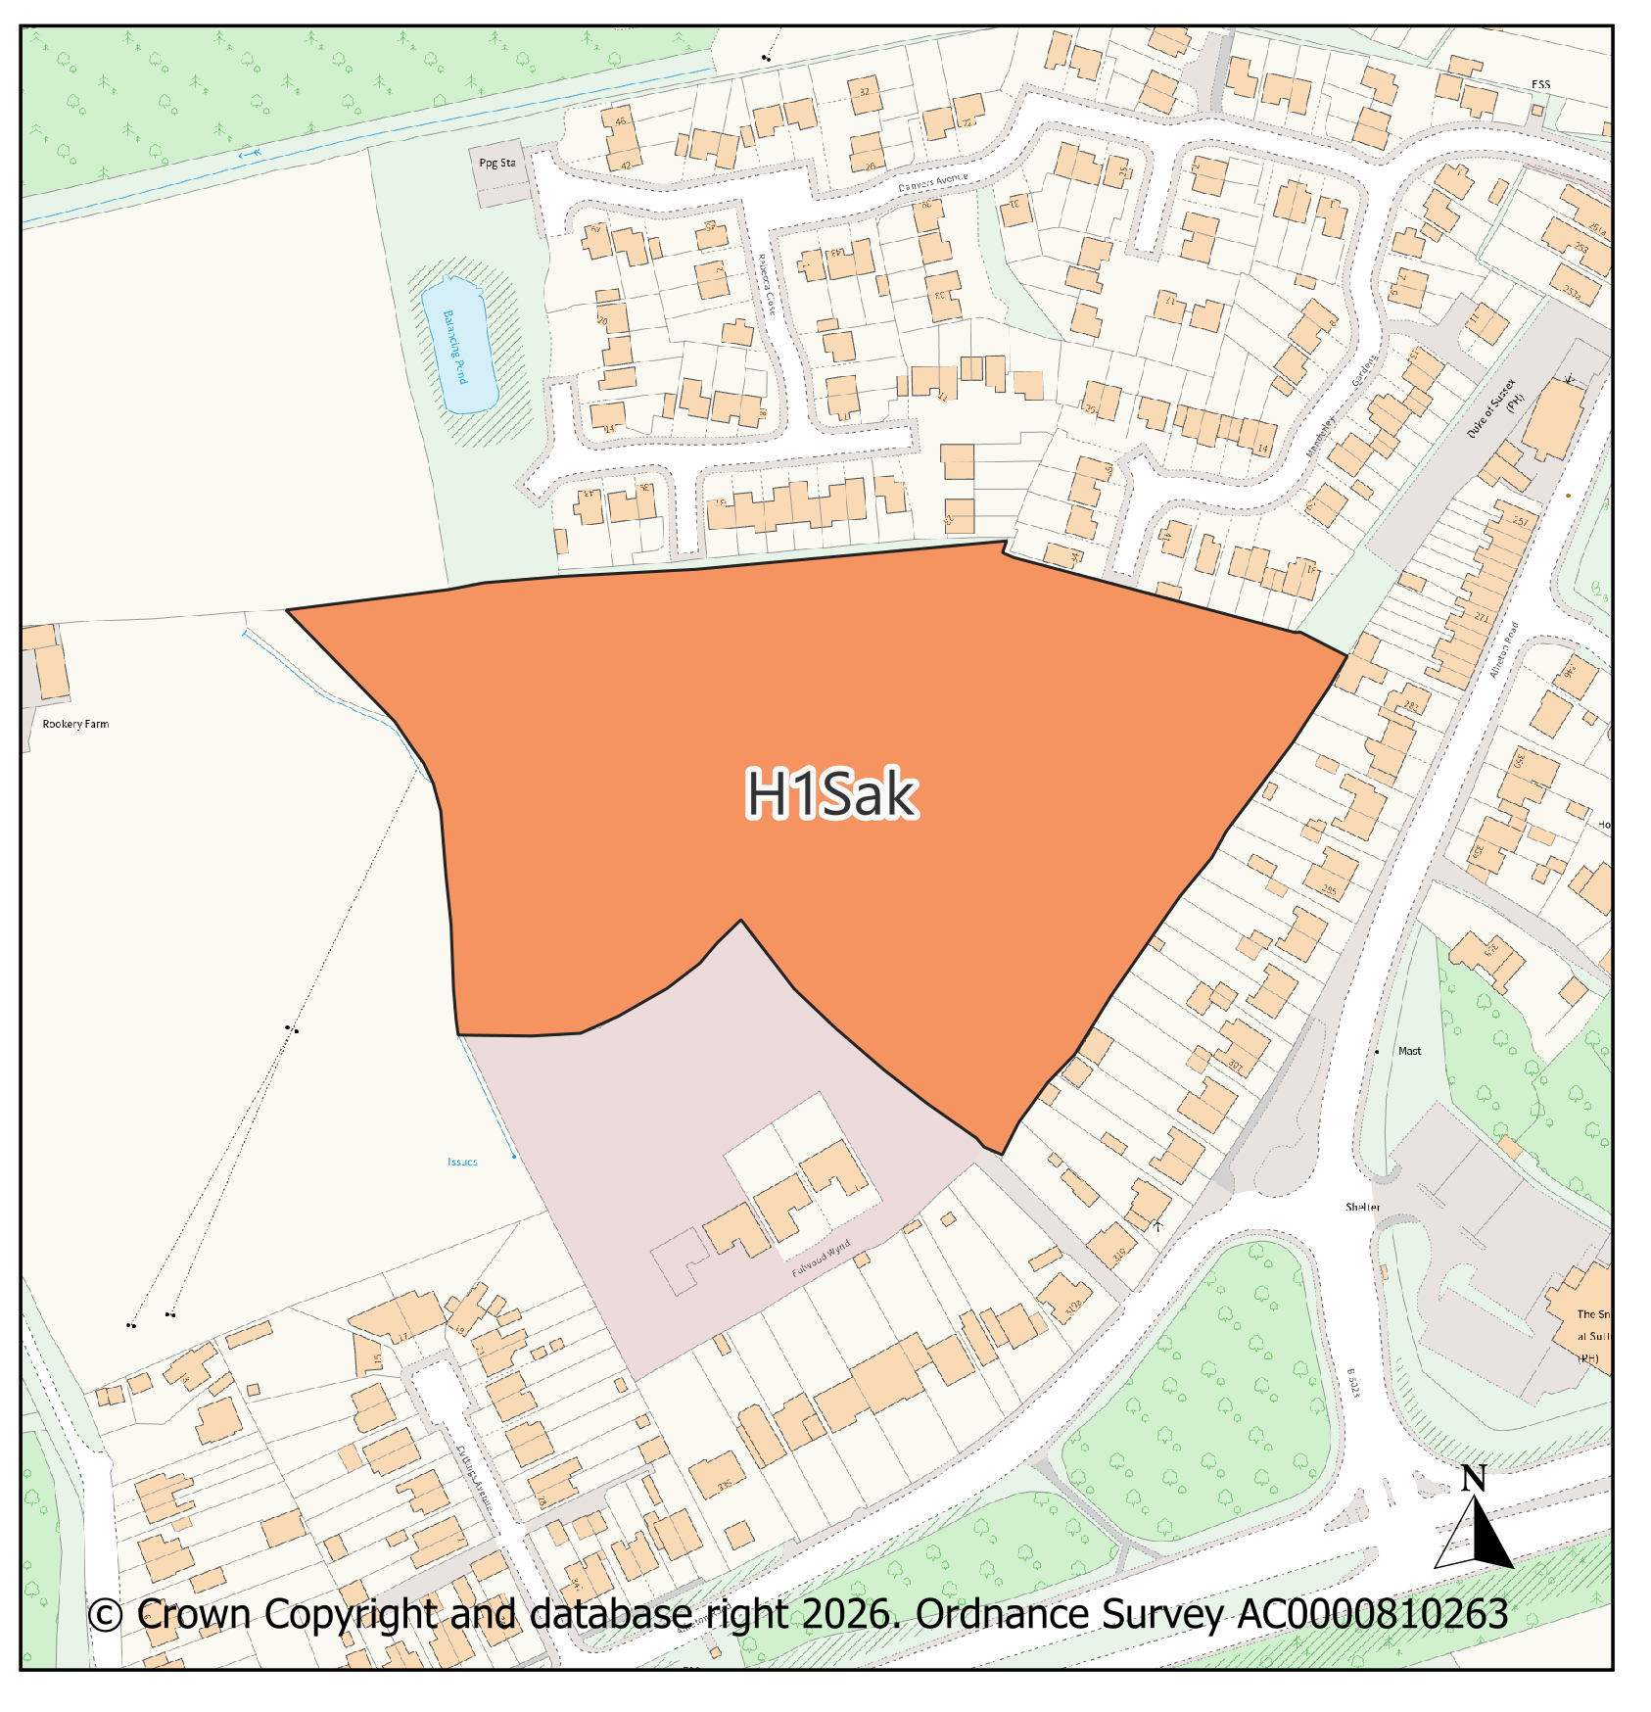
PMM Ref. |  |  | Local Plan Policy Ref. |  |  |  | Proposed Policies Map Modification
PMM11 |  |  | H1: Housing |  |  |  | Add new housing site allocation H1Sal: Newark Road/Coxmoor Road, Sutton In Ashfield
Submission Plan Version  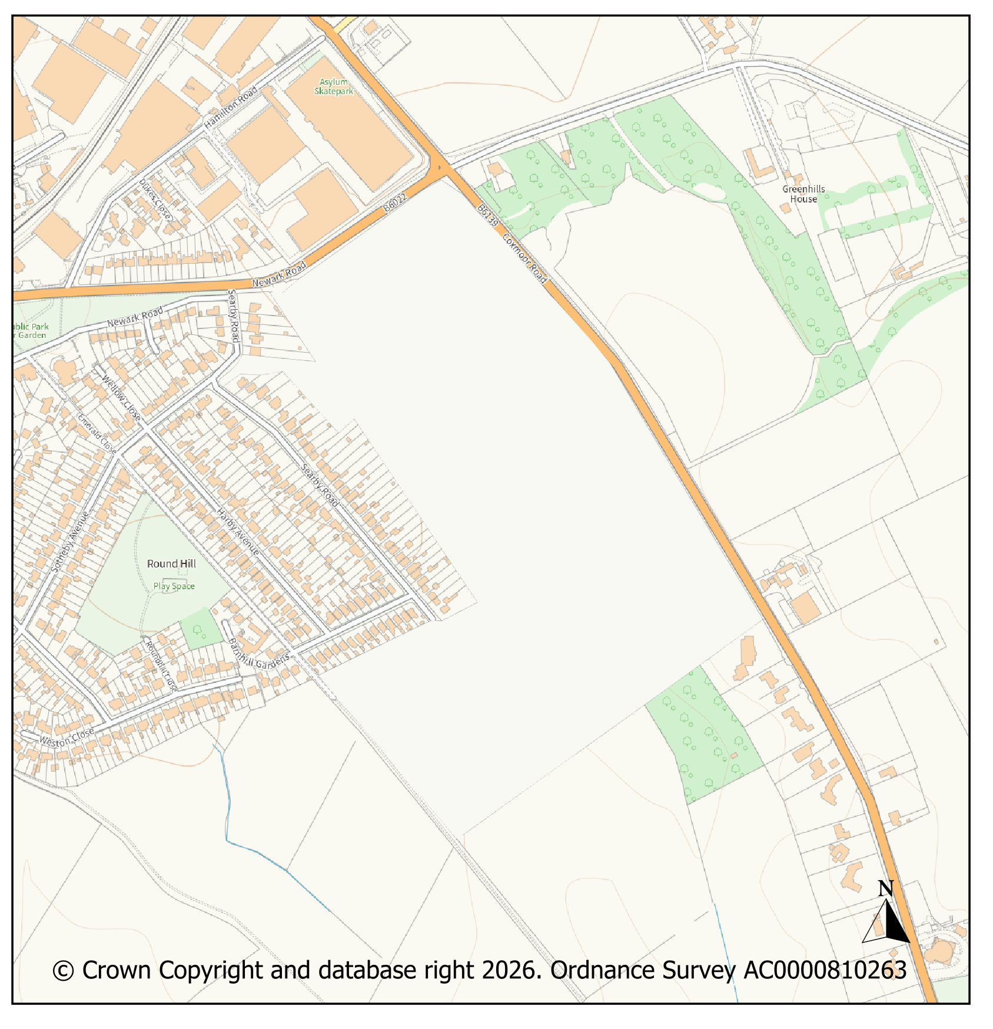 |  |  |  |  |  |  |  |  |  |  | Modifications Version  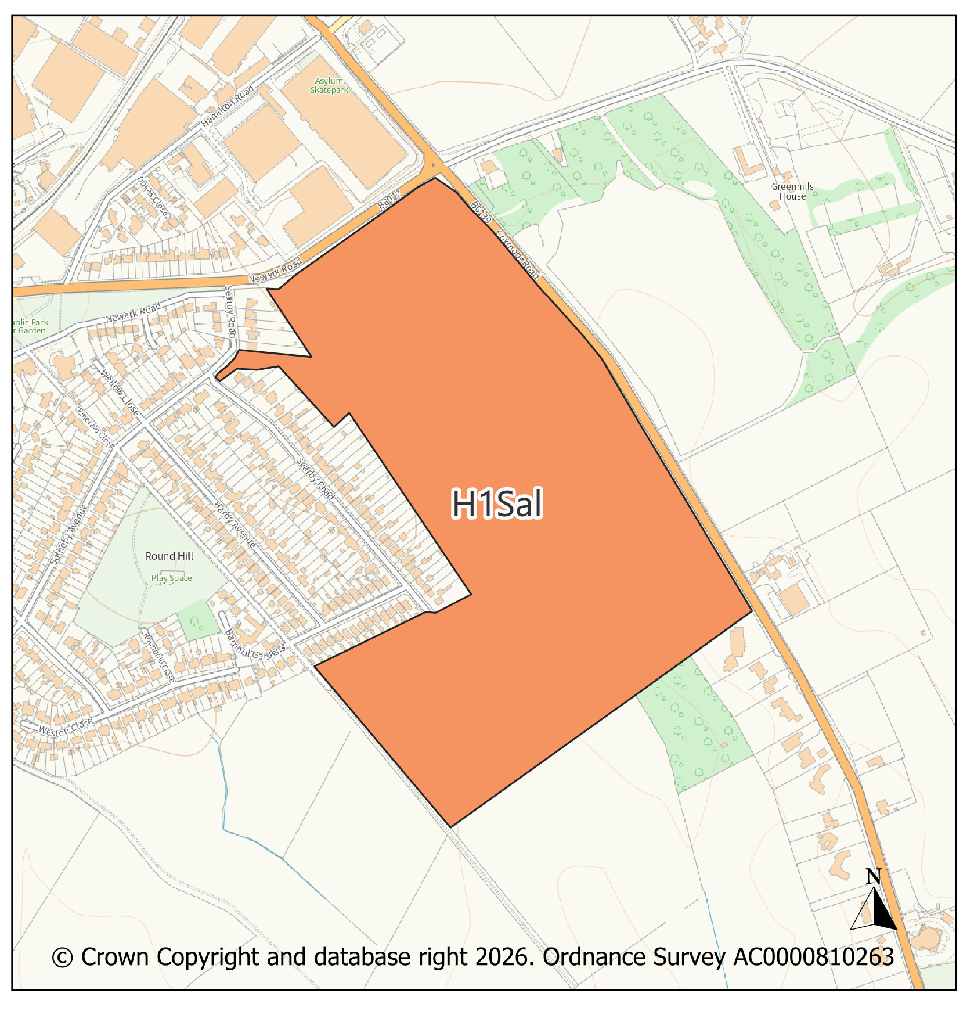
PMM Ref. |  |  | Local Plan Policy Ref. |  |  |  | Proposed Policies Map Modification
PMM12 |  |  | H1: Housing |  |  |  | Add new housing site allocation H1Sam: Beck Lane South, Skegby
Submission Plan Version  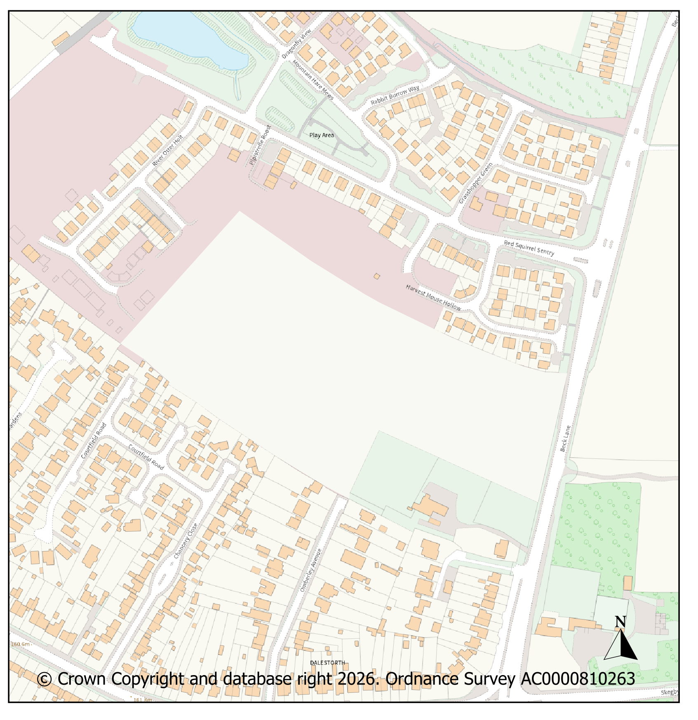 |  |  |  |  |  |  |  |  |  |  | Modifications Version  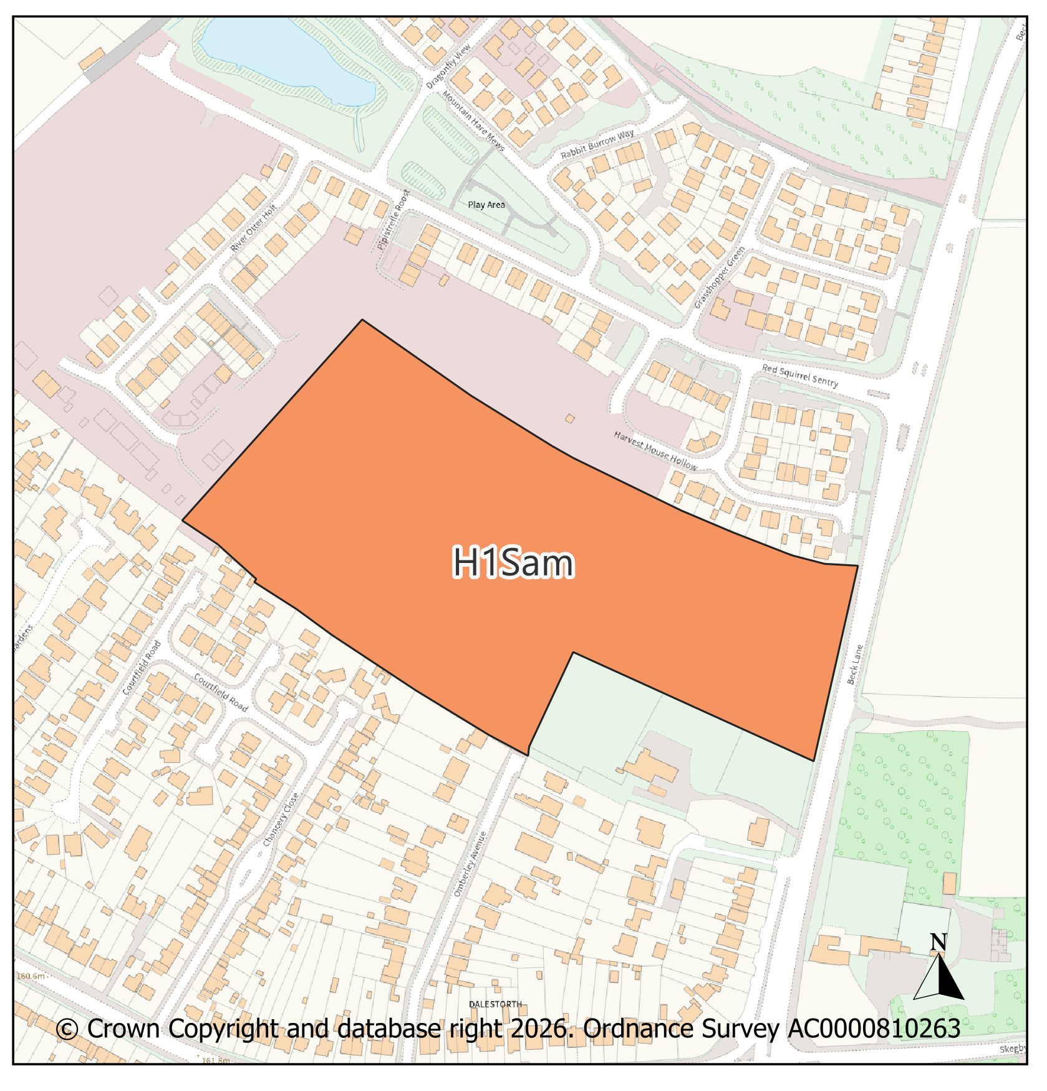
PMM Ref. |  |  | Local Plan Policy Ref. |  |  |  | Proposed Policies Map Modification
PMM13 |  |  | H1: Housing |  |  |  | Add new housing site allocation H1San: Radford’s Farm, Dawgates Lane, Skegby
Submission Plan Version  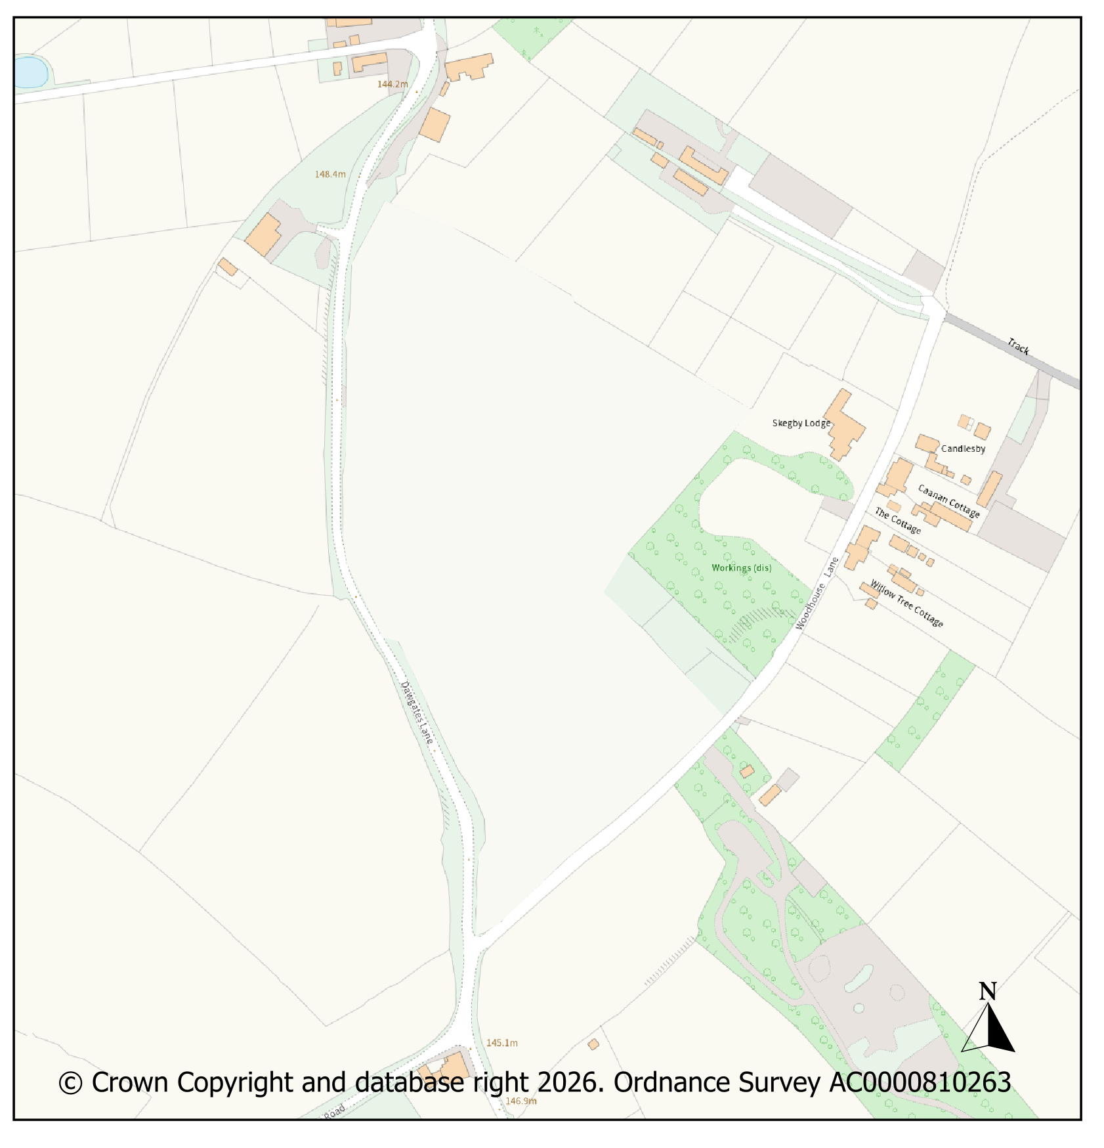 |  |  |  |  |  |  |  |  |  |  | Modifications Version  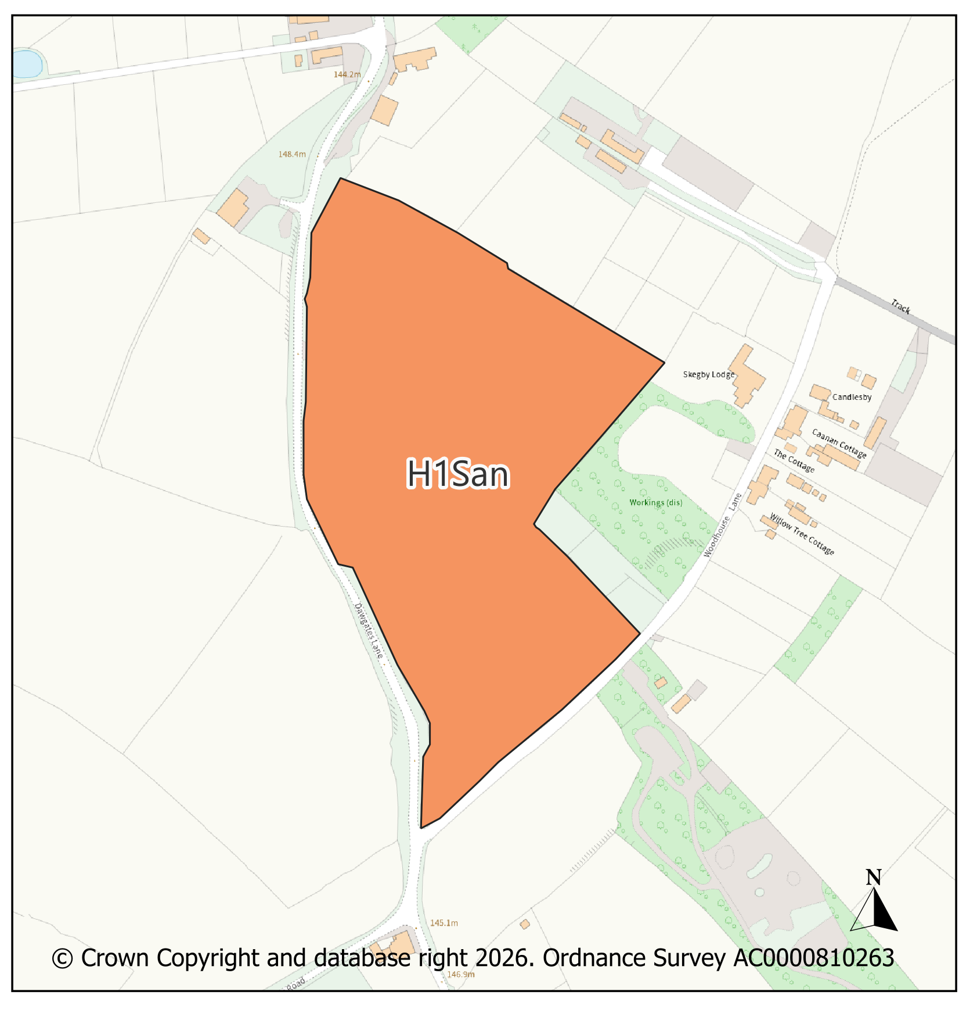
PMM Ref. |  |  |  |  |  | Local Plan Policy Ref. |  | Proposed Policies Map Modification
PMM14 |  |  |  |  |  | H1: Housing |  | Remove housing allocation H1Kj, Southwell Lane, Kirkby. This site was built-out prior to the Regulation 19 iteration of the emerging Local Plan and was included on the Policies Map in error.
Submission Plan Version  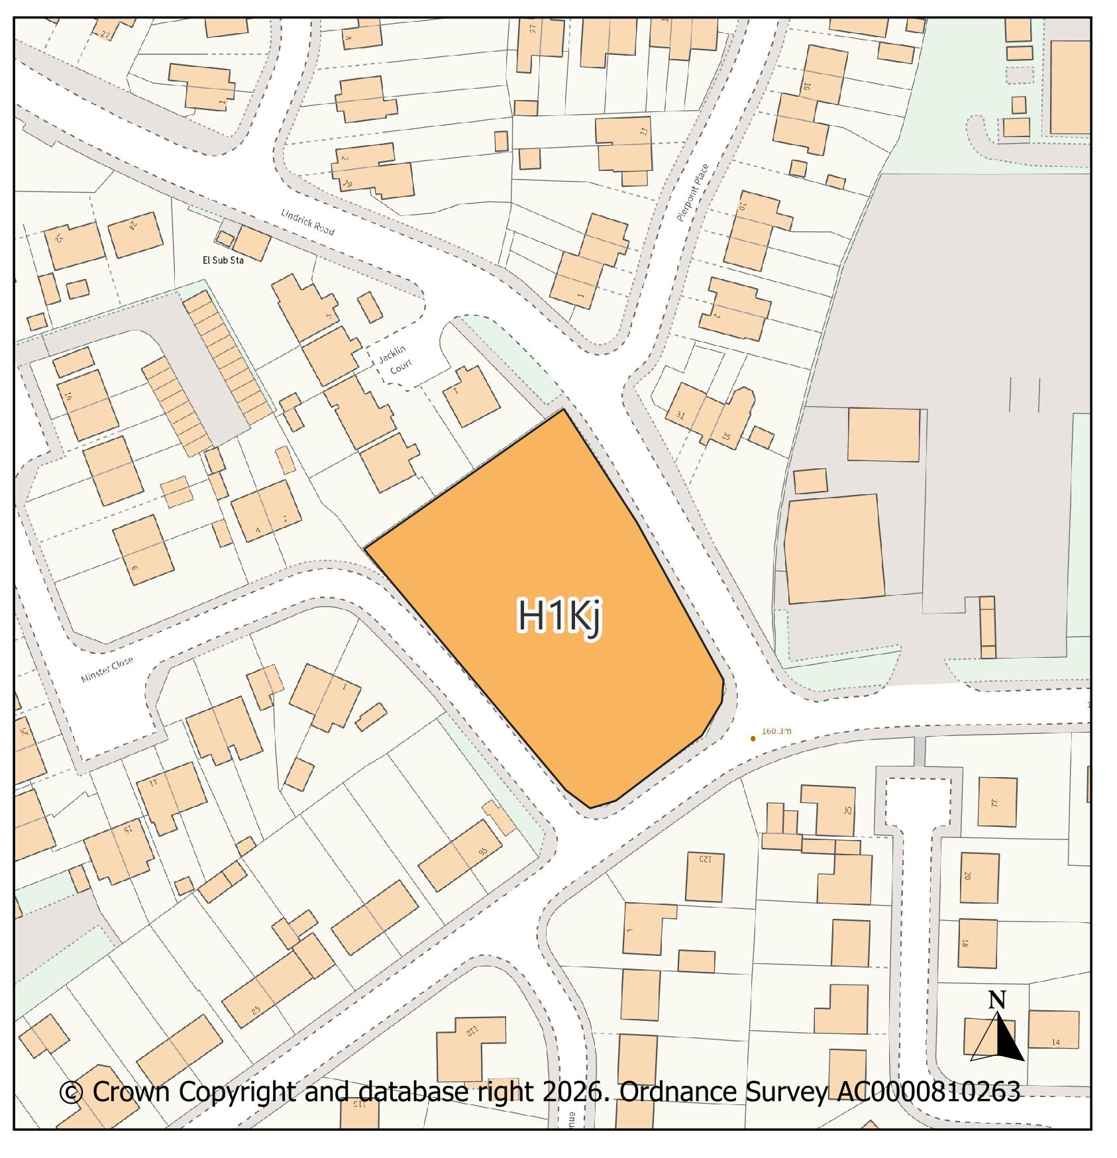 |  |  |  |  |  |  |  |  | Modifications Version  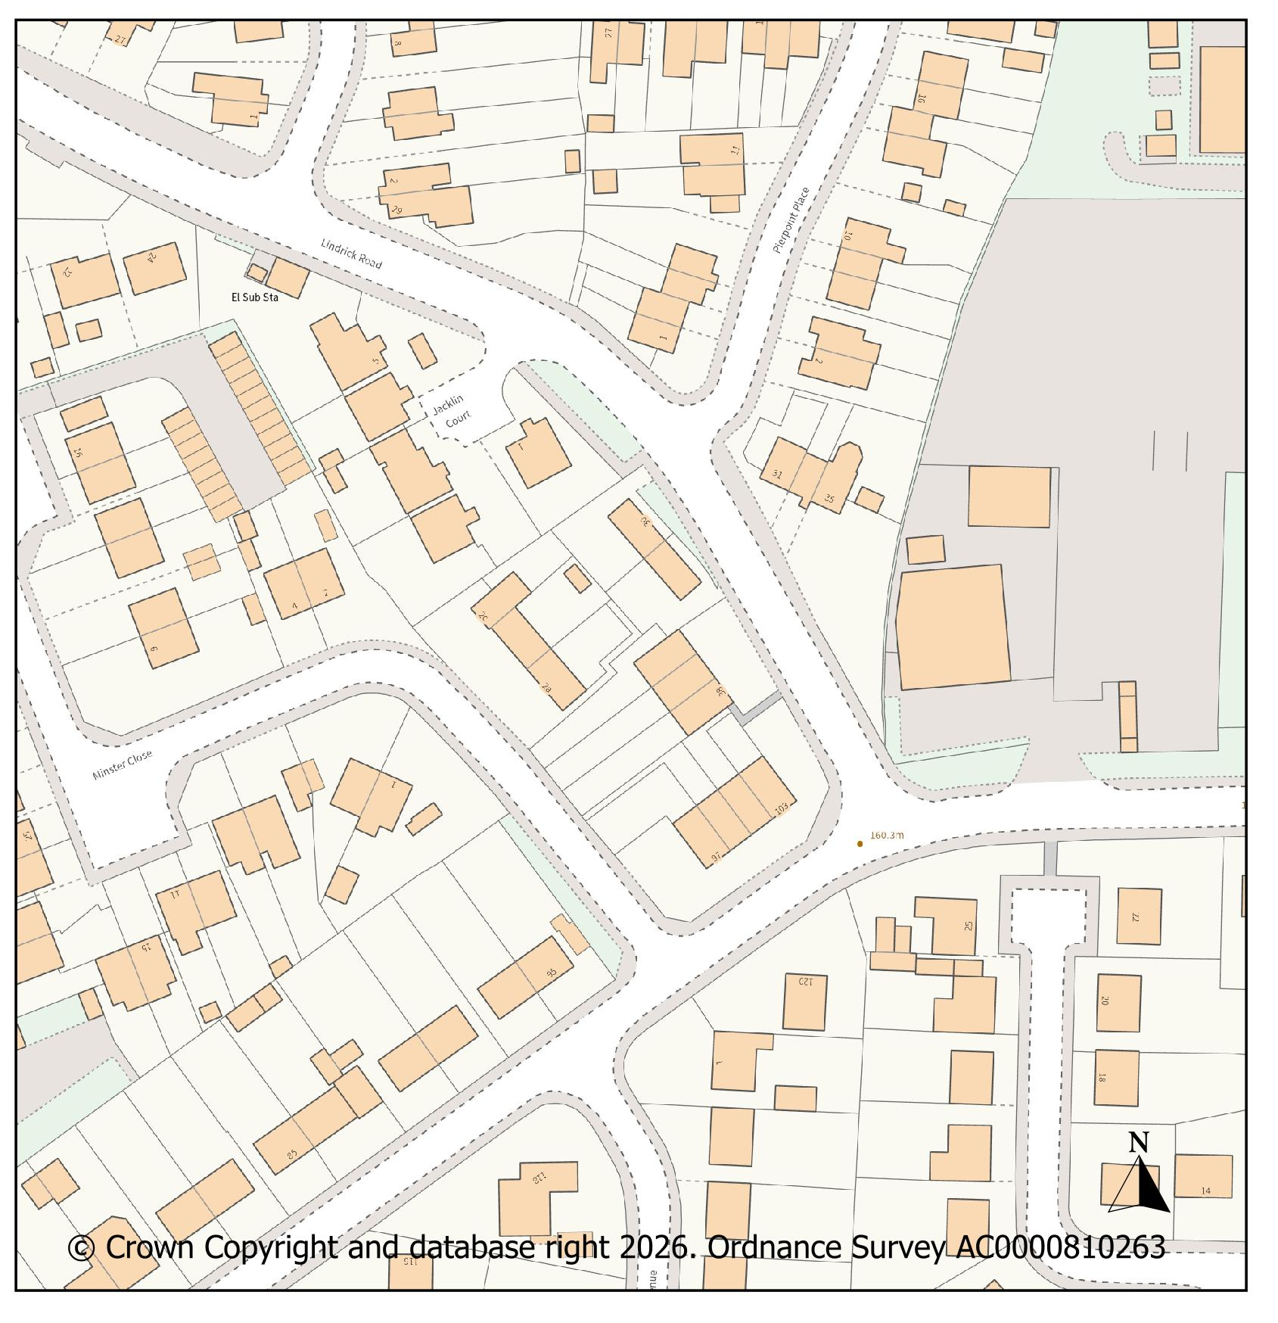
PMM Ref. |  |  |  |  |  | Local Plan Policy Ref. |  | Proposed Policies Map Modification
PMM15 |  |  |  |  |  | H1: Housing |  | Remove housing allocation H1Vd due to the potential yield being below the 10-dwelling threshold and to avoid double-counting with small site windfall allowance.
Submission Plan Version  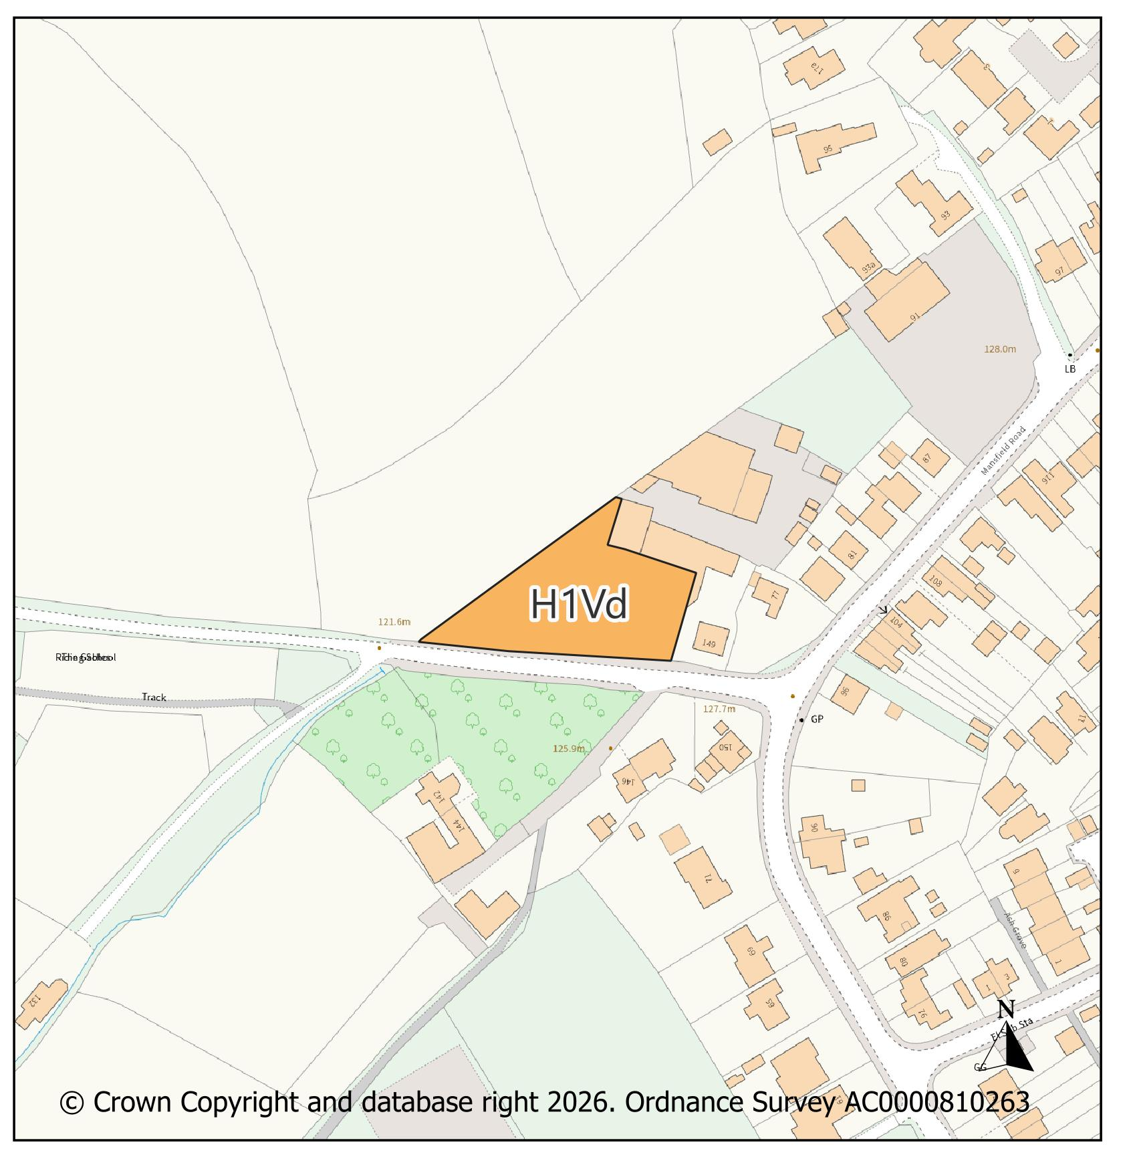 |  |  |  |  |  |  |  |  | Modifications Version  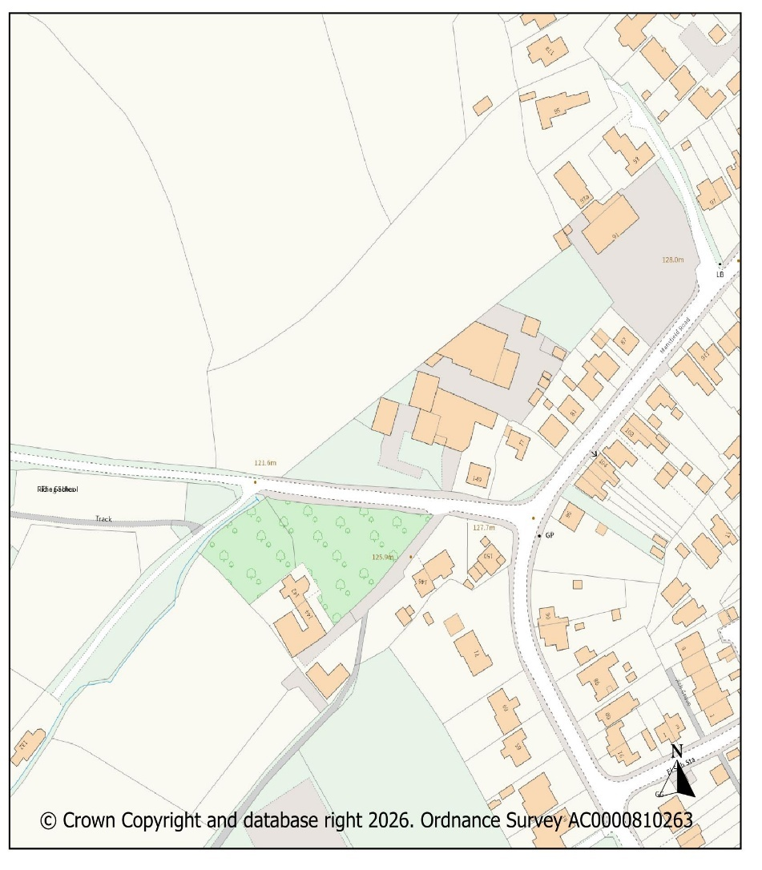
PMM Ref. |  |  |  |  |  | Local Plan Policy Ref. |  | Proposed Policies Map Modification
PMM16 |  |  |  |  |  | EM1: Employment |  | Extend the hashed area for EM1: Business and Economic Development, to reflect the existing employment land use on the south side of Sidings Road, Kirkby in Ashfield.
Submission Plan Version  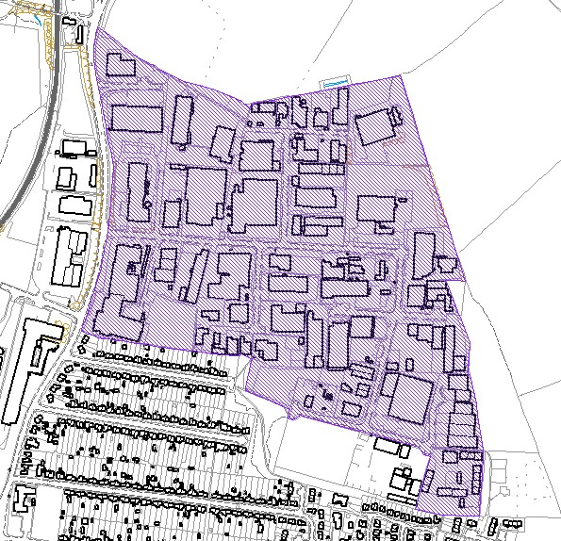 |  |  |  |  |  |  |  |  | Modifications Version  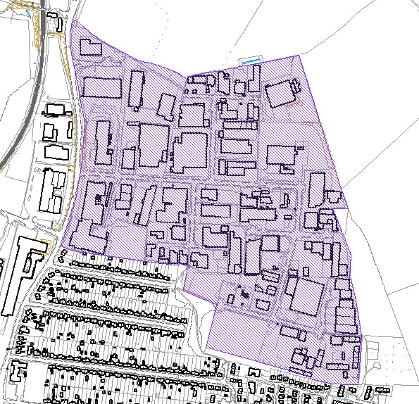
PMM Ref. |  |  |  |  |  | Local Plan Policy Ref. |  | Proposed Policies Map Modification
PMM17 |  |  |  |  |  | HS2 -Safeguarded Route |  | Remove the High Speed 2 (HS2) safeguarded railway route following Government Advice.
Submission Plan Version  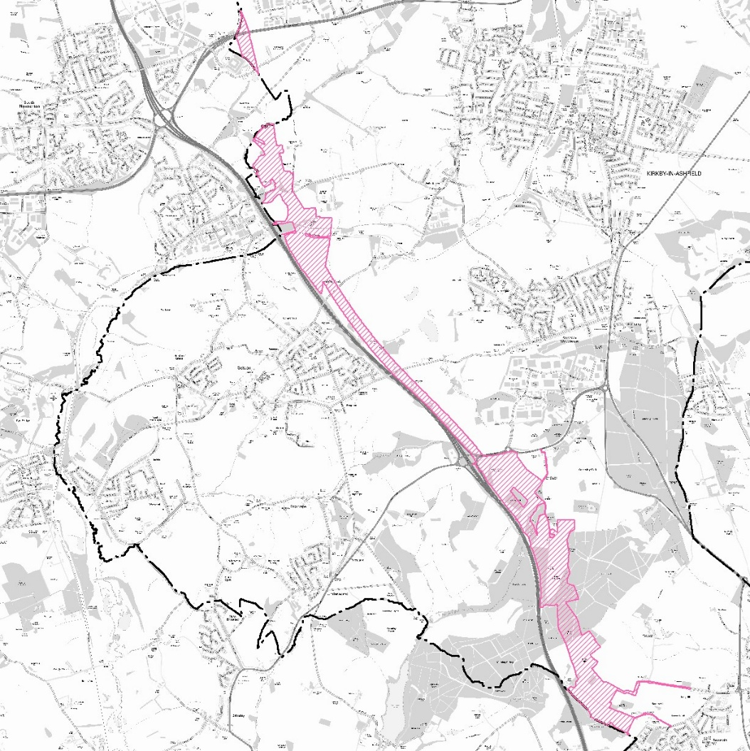 |  |  |  |  |  |  |  |  | Modifications Version  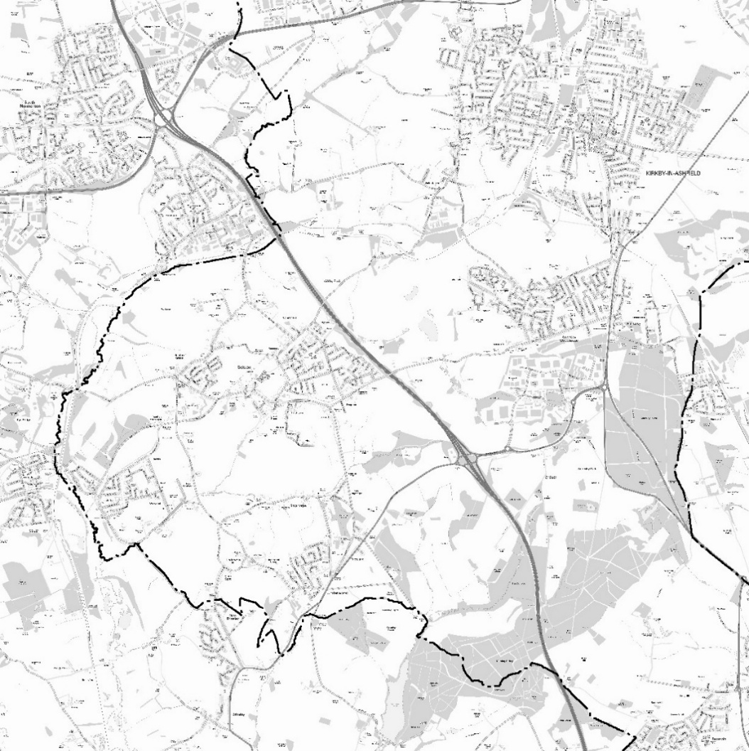
PMM Ref. |  |  |  |  |  | Local Plan Policy Ref. |  | Proposed Policies Map Modification
PMM18 |  |  |  |  |  | N/A |  | Amend the Key to put the policy reference number before the name of the policy, e.g. S1(a) - Main Urban Area. (Below shows only part of the key as an example. PMM18 is applicable to the whole of the key)
Submission Plan Version  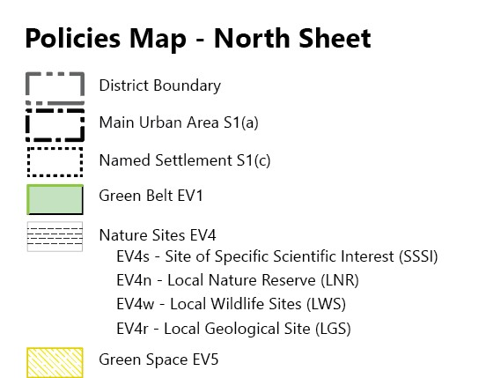 |  |  |  |  |  |  |  |  | Modifications Version  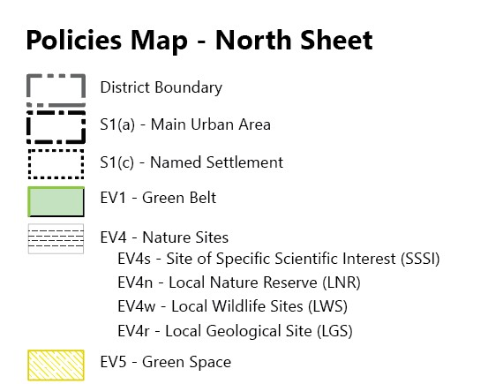
PMM Ref. |  | Local Plan Policy Ref. |  |  | Proposed Policies Map Modification
PMM19 |  | N/A |  |  | Remove policy references S4 and EV2 to ensure the list is factually correct.
Submission Plan Version  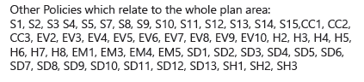 |  |  |  |  |  |  |  |  |  | Modifications Version  Other Policies which relate to the whole plan area:  S1, S2, S3, S5, S7, S8, S9, S10, S11, S12, S13, S14, S15, CC1, CC2, CC3, EV3, EV4, EV5, EV6, EV7, EV8, EV9, EV10, H2, H3, H4, H5, H6, H7, H8, EM1, EM3, EM4, EM5, SH1, SH2, SH3, SD1, SD2, SD3, SD4, SD5, SD6, SD7, SD8, SD9, SD10, SD11, SD12, SD13.
PMM Ref. |  | Local Plan Policy Ref. |  |  | Proposed Policies Map Modification
PMM20 |  | N/A |  |  | Add new text to key to clarify where Policy EV2 will apply.
Submission Plan Version  N/A |  |  |  |  |  |  |  |  |  | Modifications Version  Policy EV2: Countryside will apply to all areas outside of the areas listed below as identified under Policy S1:  - Main Urban Areas S1 (a)  - Strategic Employment Areas S1 (b)  - Named Settlements S1 (c)  - Blenheim Industrial Estate S1 (d)
PMM Ref. |  | Local Plan Policy Ref. |  |  | Proposed Policies Map Modification
PMM21 |  | N/A |  |  | Amend South Sheet Policies Map Key as follows:
Submission Plan Version  Strategic Employment Allocation S6, S1(b) |  |  |  |  |  |  |  |  |  | Modifications Version  S6 - Strategic Employment Allocation
PMM Ref. |  | Local Plan Policy Ref. |  |  | Proposed Policies Map Modification
PMM22 |  | N/A |  |  | Amend South Sheet Policies Map and key to correct a mapping error for the M1 Junction 27 Strategic Employment Sites S6a & S6b, Sherwood Business Park, and the Strategic Employment Area as identified in the Settlement Hierarchy (Policy S1b) as follows:
Submission Plan Version  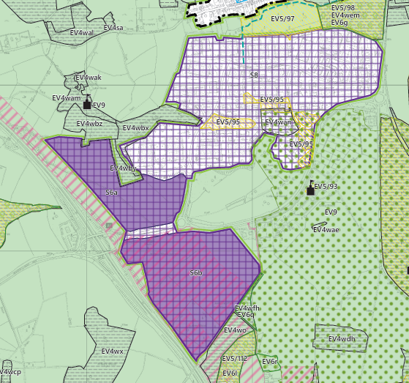  S6, S1(b) - Strategic Employment Allocation  EM2 - Employment Land Allocation |  |  |  |  |  |  |  |  |  | Modifications Version  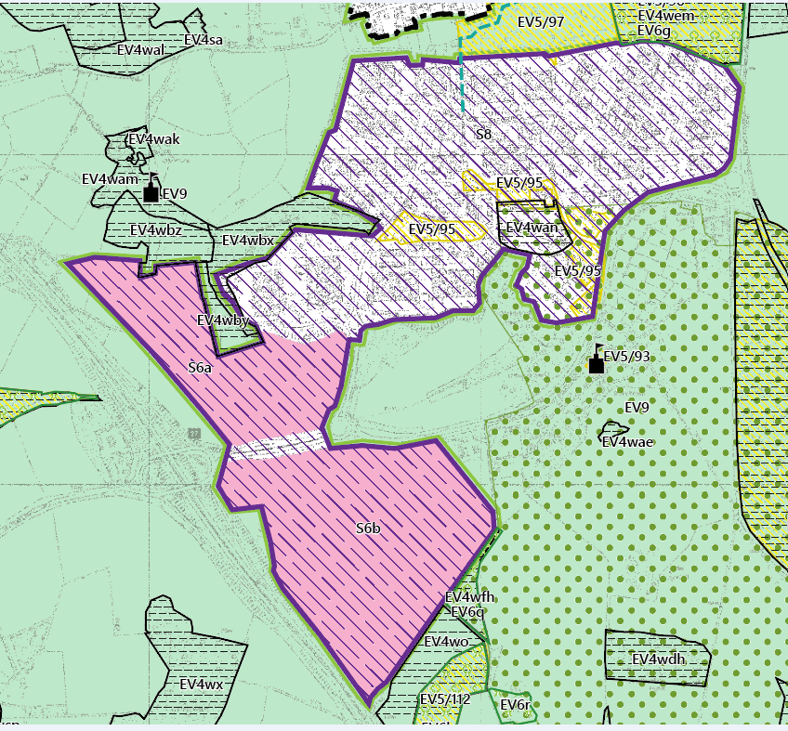  S6 - Strategic Employment Allocation  EM2 - Employment Land Allocation    S8, EM1 - Key Employment Area  S1(b) – Strategic Employment Area
PMM Ref. | Local Plan Policy Ref. |  |  | Proposed Policies Map Modification
PMM23 | EV4: GI, Biodiversity & Geodiversity |  |  | Amend site boundary of Local Wildlife Site(s) EV4wa to reflect more up to date information provided by the Nottinghamshire Biodiversity and Geodiversity Records Centre.  (Note: Any comments made in respect of this modification will be required to quote the PMM reference number and the relevant LWS reference number)
Submission Plan Version  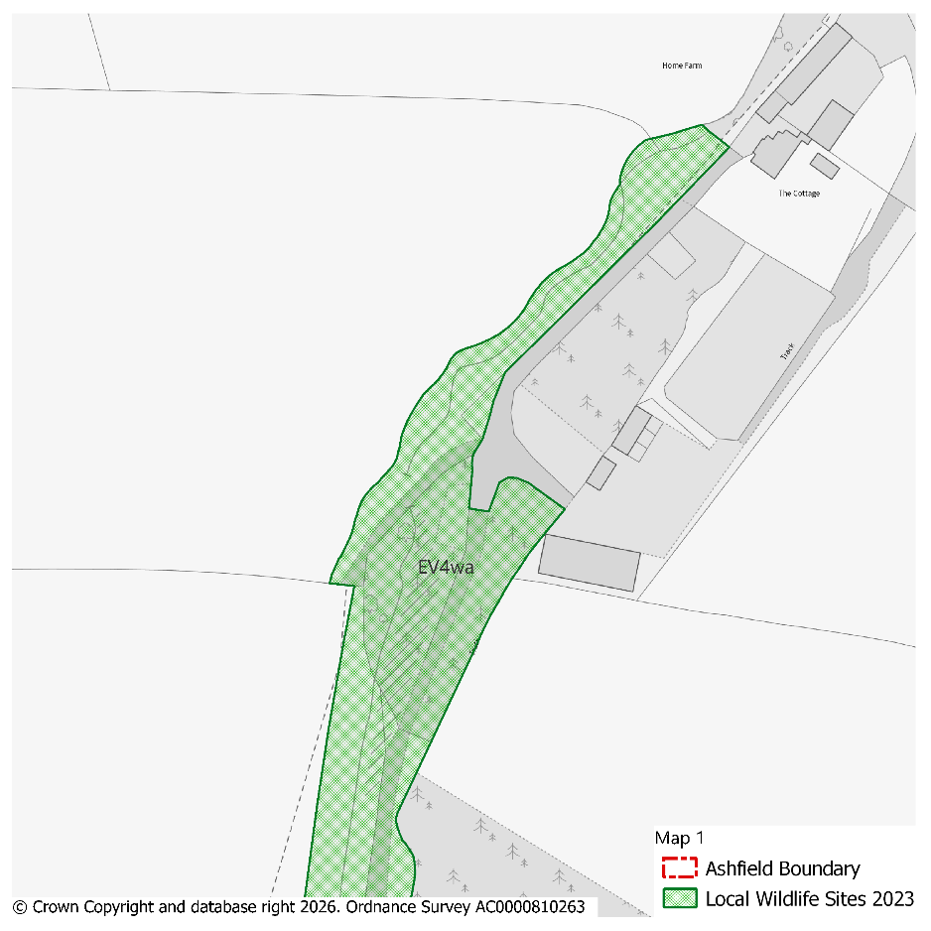 |  |  |  |  |  |  |  |  | Modifications Version  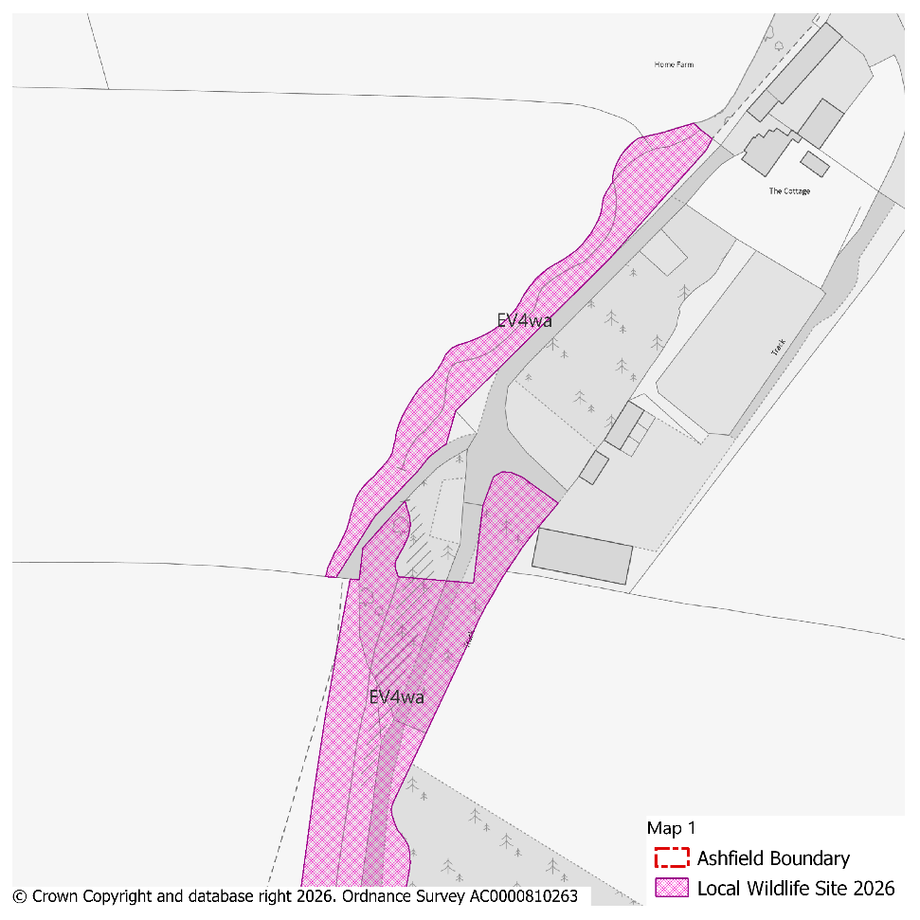
PMM Ref. | Local Plan Policy Ref. |  |  | Proposed Policies Map Modification
PMM24 | EV4: GI, Biodiversity & Geodiversity |  |  | Amend site boundary of Local Wildlife Site(s) EV4wge, EV4wgy and EV4wgl to reflect more up to date information provided by the Nottinghamshire Biodiversity and Geodiversity Records Centre.  (Note: Any comments made in respect of this modification will be required to quote the PMM reference number and the relevant LWS reference number)
Submission Plan Version  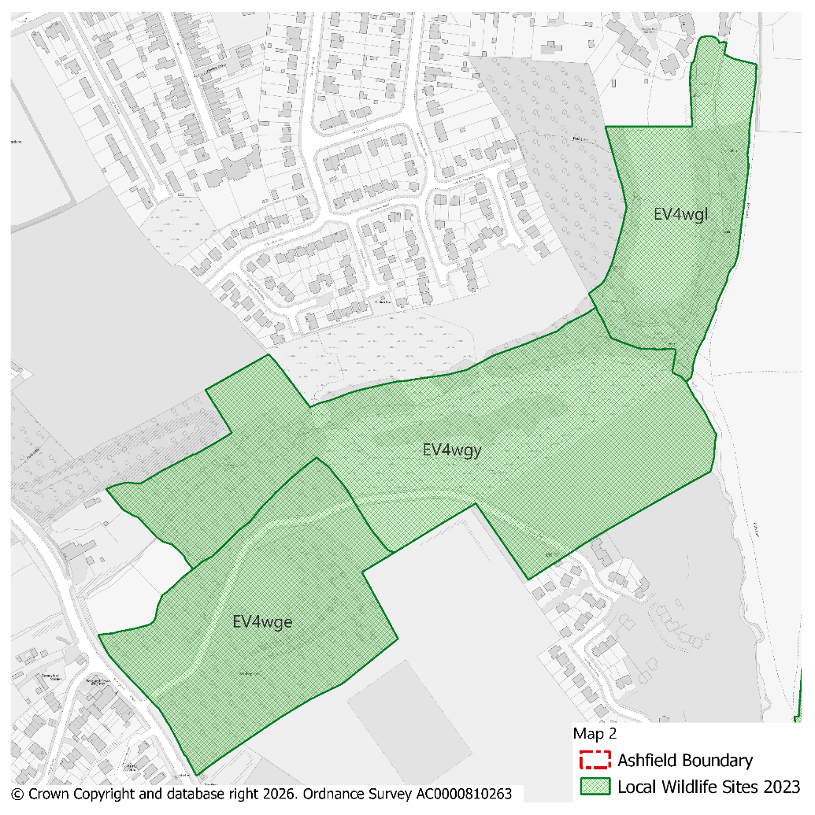 |  |  |  |  |  |  |  |  | Modifications Version  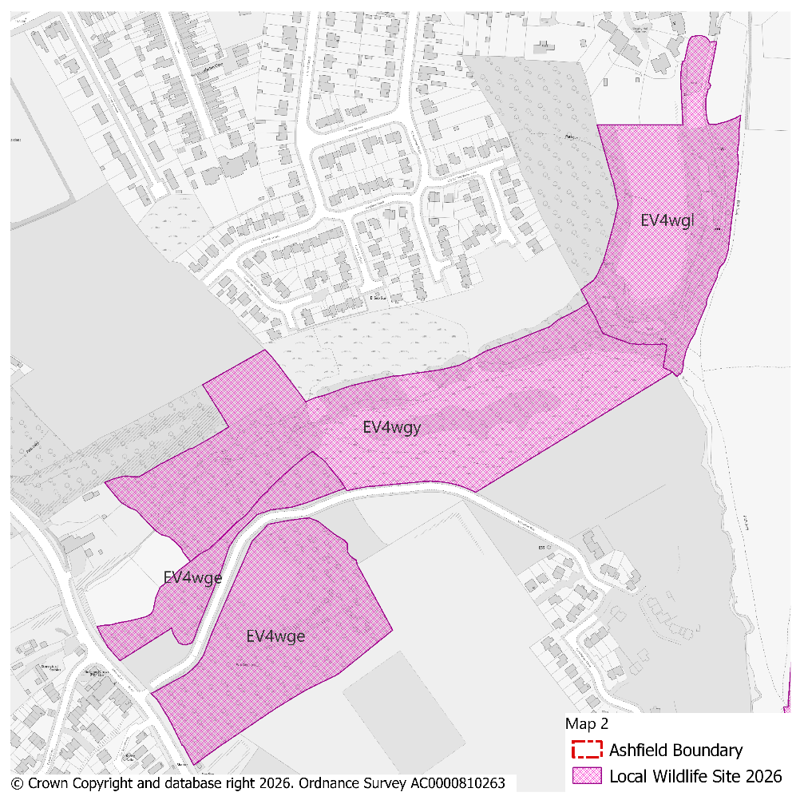
PMM Ref. | Local Plan Policy Ref. |  |  | Proposed Policies Map Modification
PMM25 | EV4: GI, Biodiversity & Geodiversity |  |  | Amend site boundary of Local Wildlife Site(s) EV4wgx to reflect more up to date information provided by the Nottinghamshire Biodiversity and Geodiversity Records Centre.  (Note: Any comments made in respect of this modification will be required to quote the PMM reference number and the relevant LWS reference number)
Submission Plan Version  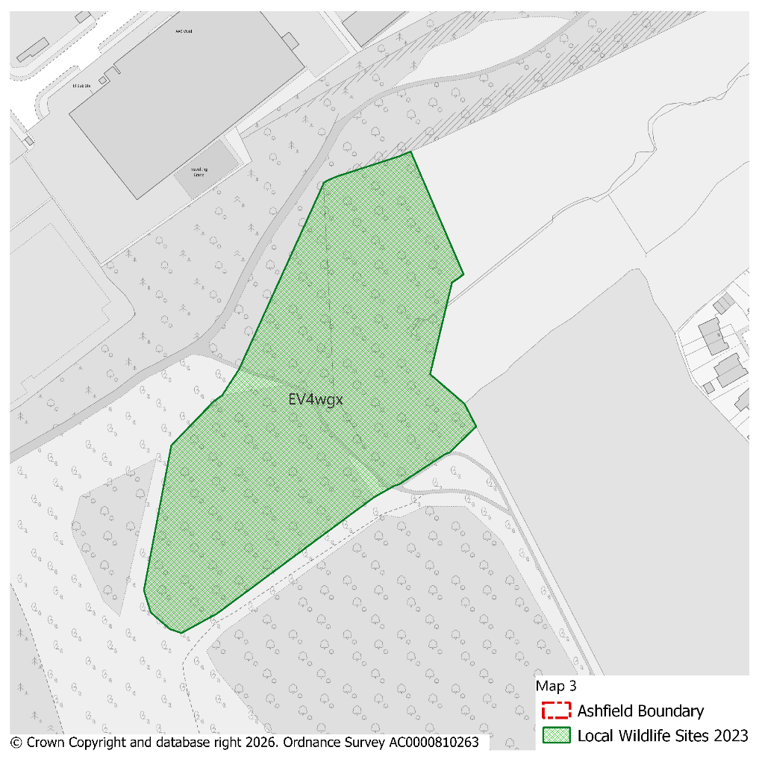 |  |  |  |  |  |  |  |  | Modifications Version  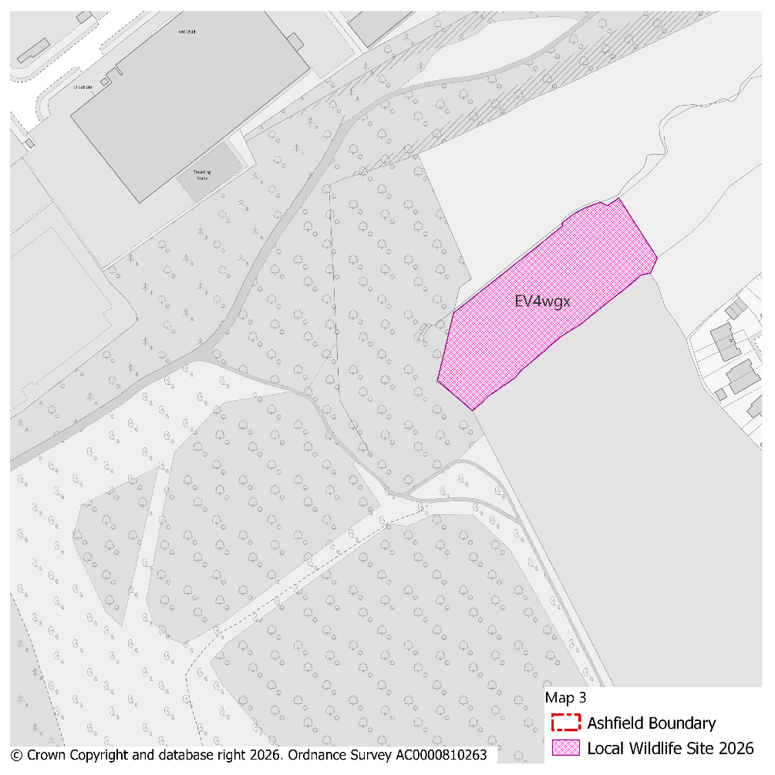
PMM Ref. | Local Plan Policy Ref. |  |  | Proposed Policies Map Modification
PMM26 | EV4: GI, Biodiversity & Geodiversity |  |  | Amend site boundary of Local Wildlife Site(s) EV45wab to reflect more up to date information provided by the Nottinghamshire Biodiversity and Geodiversity Records Centre.  (Note: Any comments made in respect of this modification will be required to quote the PMM reference number and the relevant LWS reference number)
Submission Plan Version  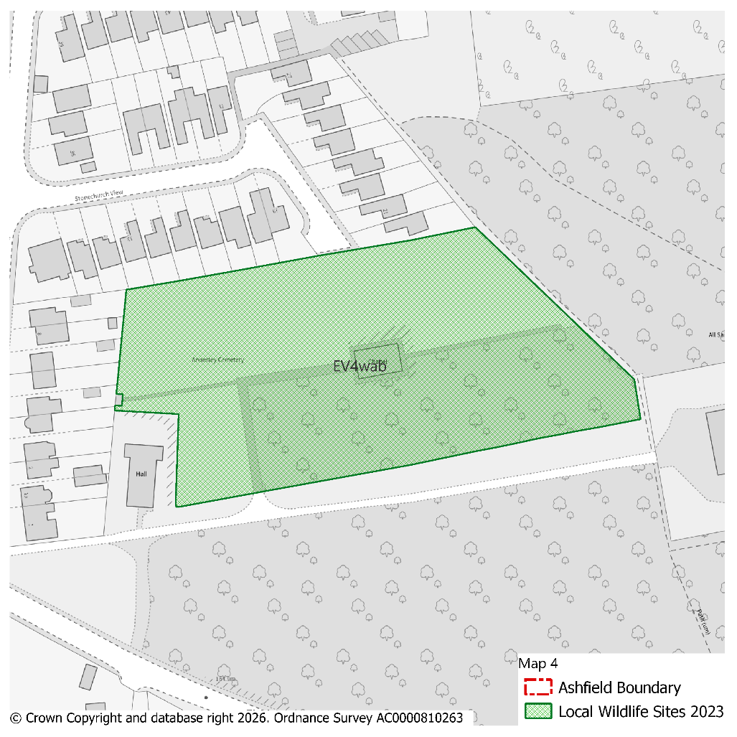 |  |  |  |  |  |  |  |  | Modifications Version  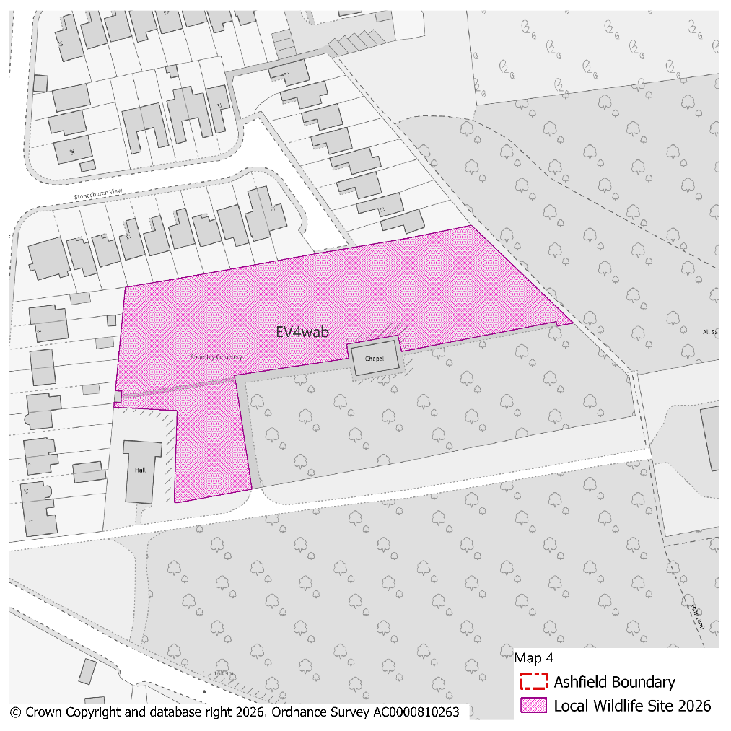
PMM Ref. | Local Plan Policy Ref. |  |  | Proposed Policies Map Modification
PMM27 | EV4: GI, Biodiversity & Geodiversity |  |  | Amend site boundary of Local Wildlife Site(s) EV4wdg to reflect more up to date information provided by the Nottinghamshire Biodiversity and Geodiversity Records Centre.  (Note: Any comments made in respect of this modification will be required to quote the PMM reference number and the relevant LWS reference number)
Submission Plan Version  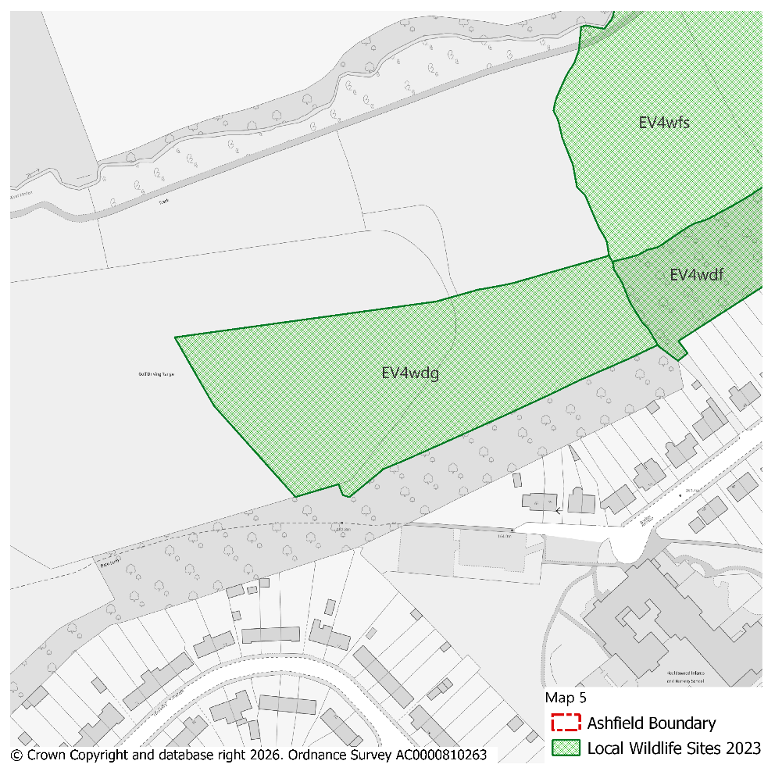 |  |  |  |  |  |  |  |  | Modifications Version  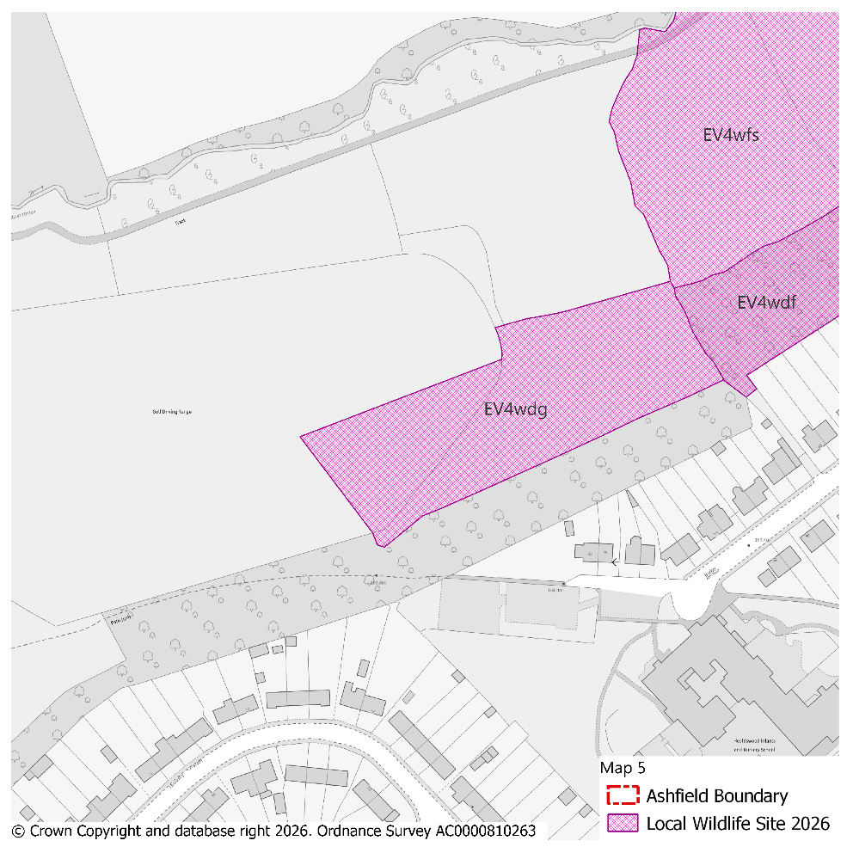
PMM Ref. | Local Plan Policy Ref. |  |  | Proposed Policies Map Modification
PMM28 | EV4: GI, Biodiversity & Geodiversity |  |  | Amend site boundary of Local Wildlife Site(s) EV4way, EV4wr EV4wee and EV4wal to reflect more up to date information provided by the Nottinghamshire Biodiversity and Geodiversity Records Centre.  (Note: Any comments made in respect of this modification will be required to quote the PMM reference number and the relevant LWS reference number)
Submission Plan Version  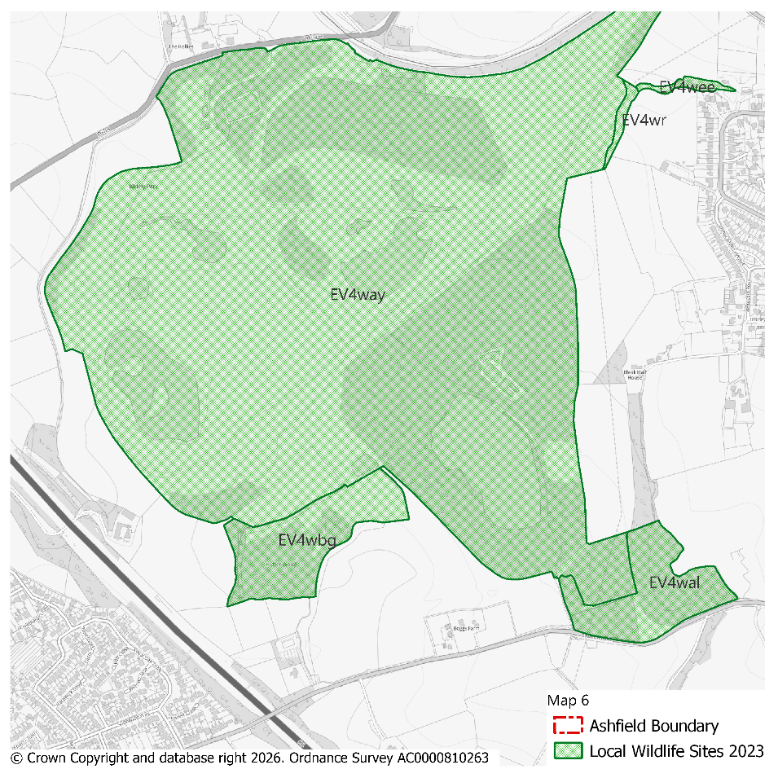 |  |  |  |  |  |  |  |  | Modifications Version  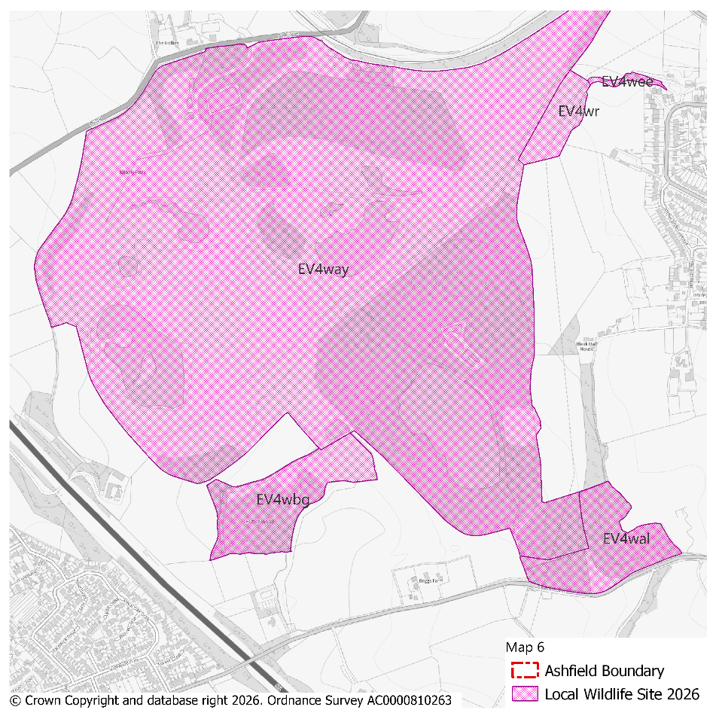
PMM Ref. | Local Plan Policy Ref. |  |  | Proposed Policies Map Modification
PMM29 | EV4: GI, Biodiversity & Geodiversity |  |  | Amend site boundary of Local Wildlife Site(s) EV4ae to reflect more up to date information provided by the Nottinghamshire Biodiversity and Geodiversity Records Centre.  (Note: Any comments made in respect of this modification will be required to quote the PMM reference number and the relevant LWS reference number)
Submission Plan Version  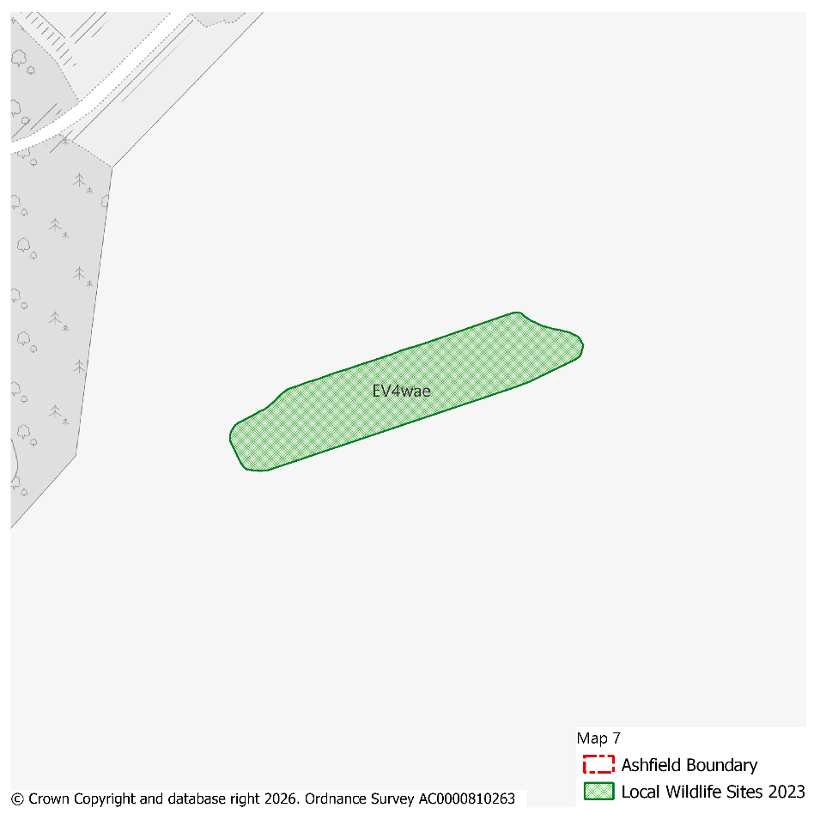 |  |  |  |  |  |  |  |  | Modifications Version  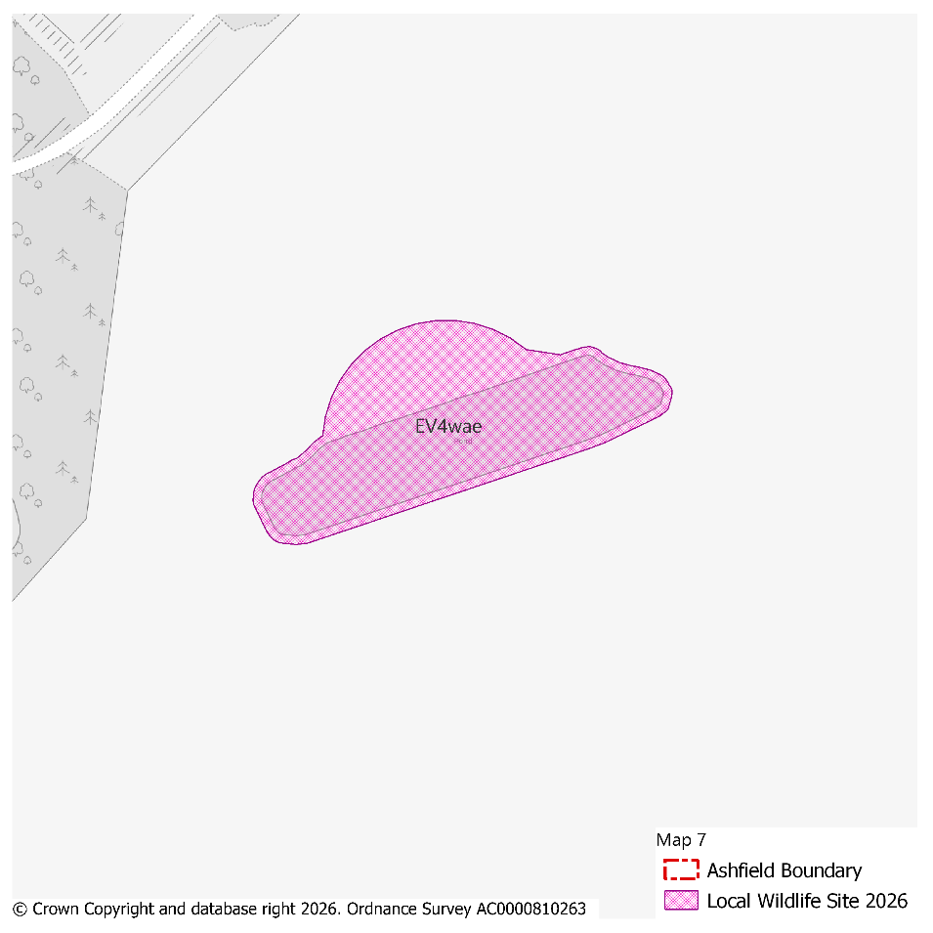
PMM Ref. | Local Plan Policy Ref. |  |  | Proposed Policies Map Modification
PMM30 | EV4: GI, Biodiversity & Geodiversity |  |  | Amend site boundary of Local Wildlife Site(s) EV4wgo to reflect more up to date information provided by the Nottinghamshire Biodiversity and Geodiversity Records Centre.  (Note: Any comments made in respect of this modification will be required to quote the PMM reference number and the relevant LWS reference number)
Submission Plan Version  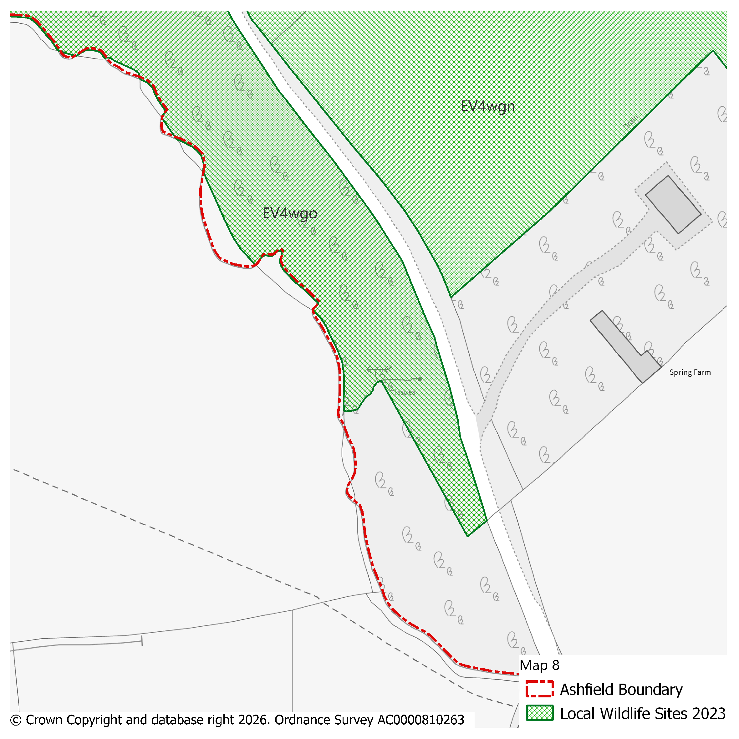 |  |  |  |  |  |  |  |  | Modifications Version  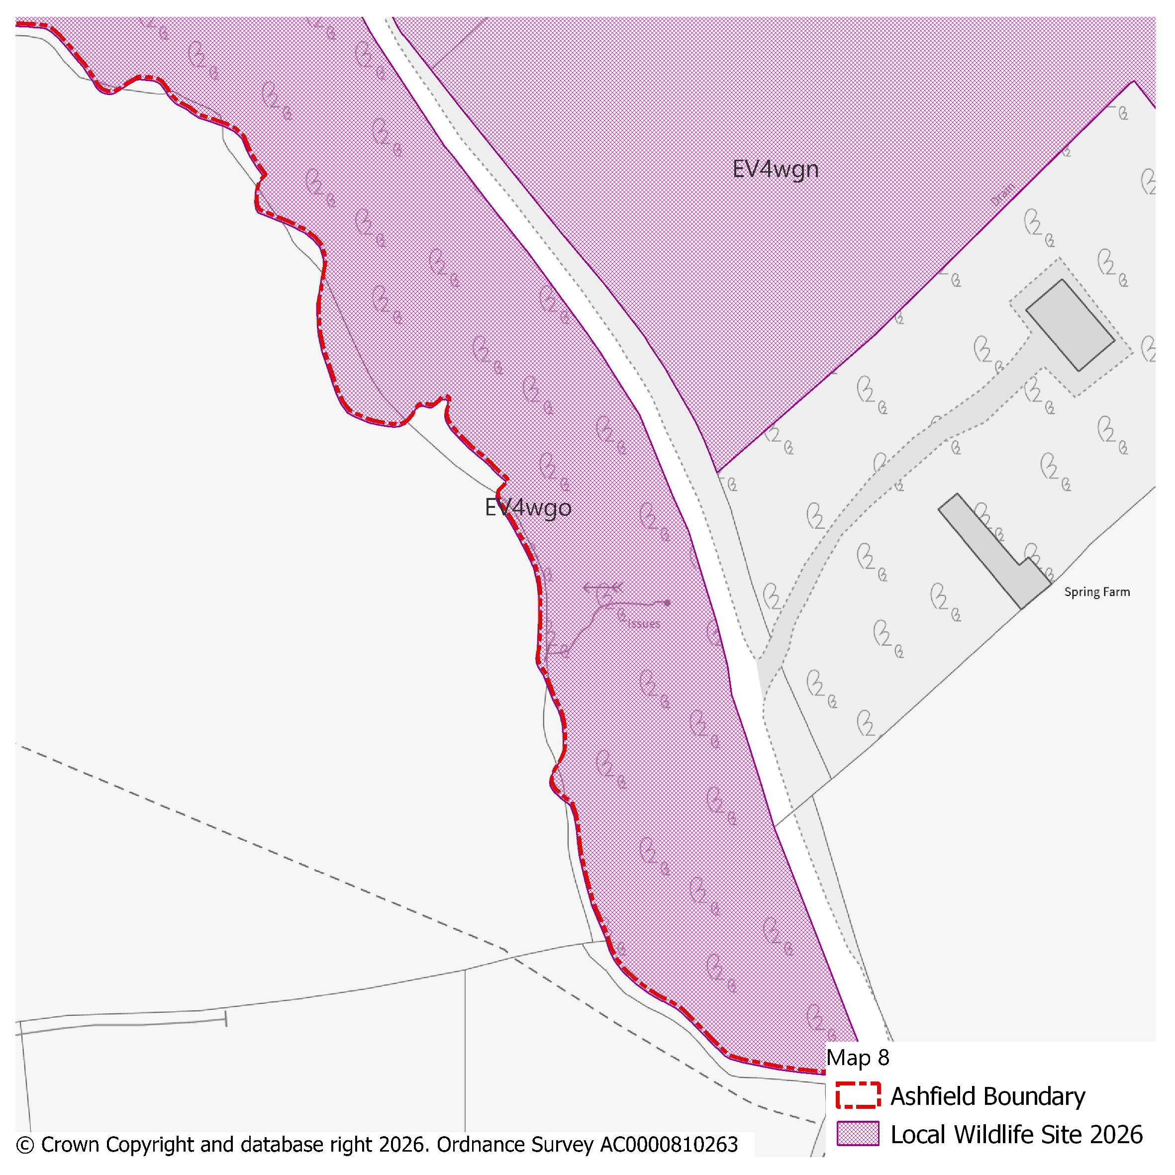
PMM Ref. | Local Plan Policy Ref. |  |  | Proposed Policies Map Modification
PMM31 | EV4: GI, Biodiversity & Geodiversity |  |  | Amend site boundary of Local Wildlife Site(s) EV4ww to reflect more up to date information provided by the Nottinghamshire Biodiversity and Geodiversity Records Centre.  (Note: Any comments made in respect of this modification will be required to quote the PMM reference number and the relevant LWS reference number)
Submission Plan Version  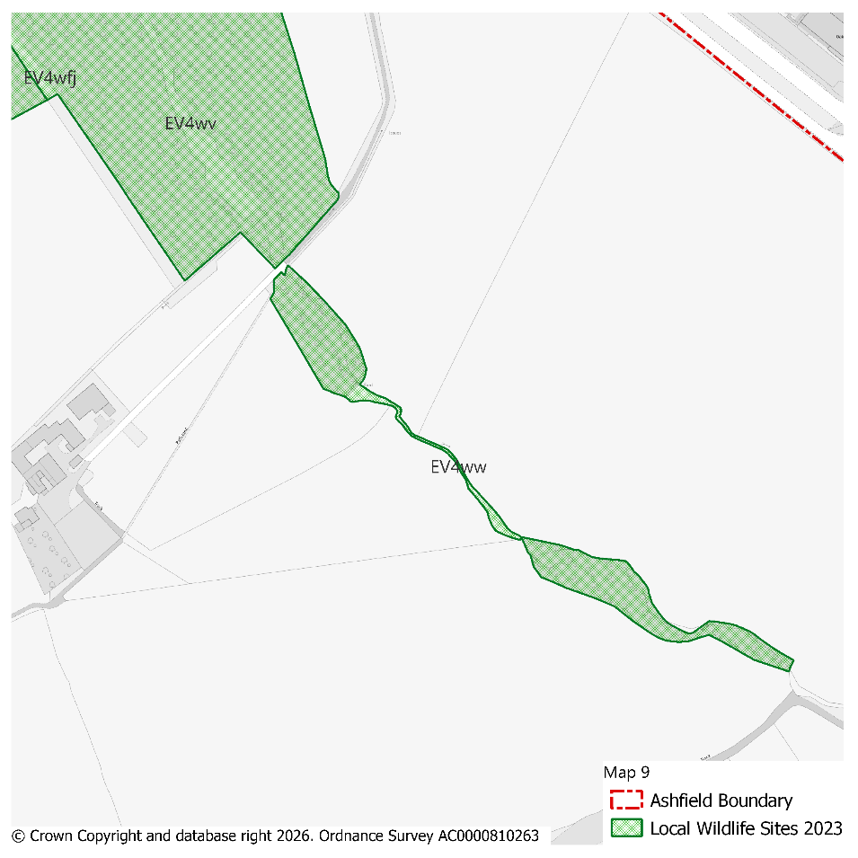 |  |  |  |  |  |  |  |  | Modifications Version  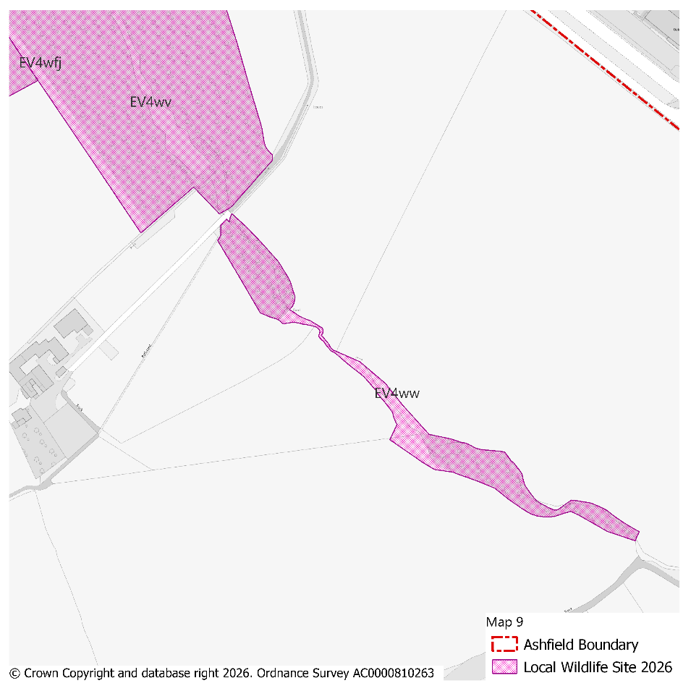
PMM Ref. | Local Plan Policy Ref. |  |  | Proposed Policies Map Modification
PMM32 | EV4: GI, Biodiversity & Geodiversity |  |  | Amend site boundary of Local Wildlife Site(s) EV4wfc and EV4wdo to reflect more up to date information provided by the Nottinghamshire Biodiversity and Geodiversity Records Centre.  (Note: Any comments made in respect of this modification will be required to quote the PMM reference number and the relevant LWS reference number)
Submission Plan Version  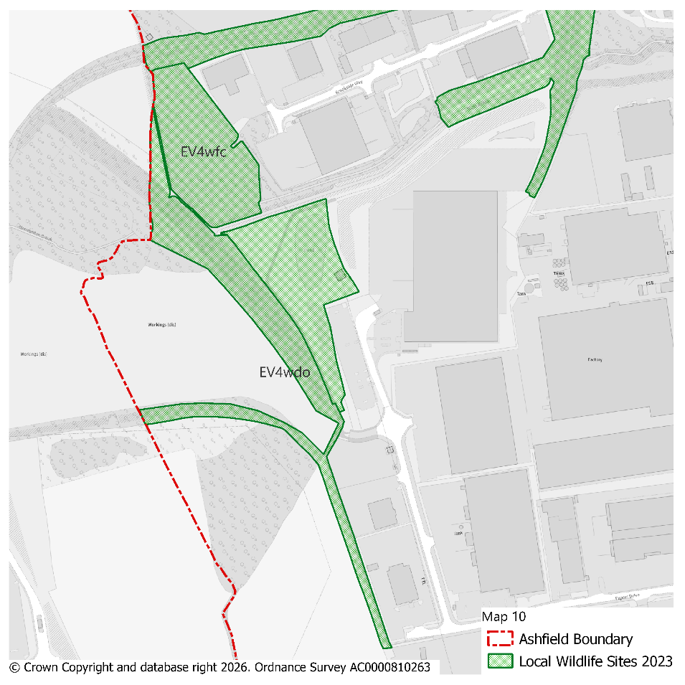 |  |  |  |  |  |  |  |  | Modifications Version  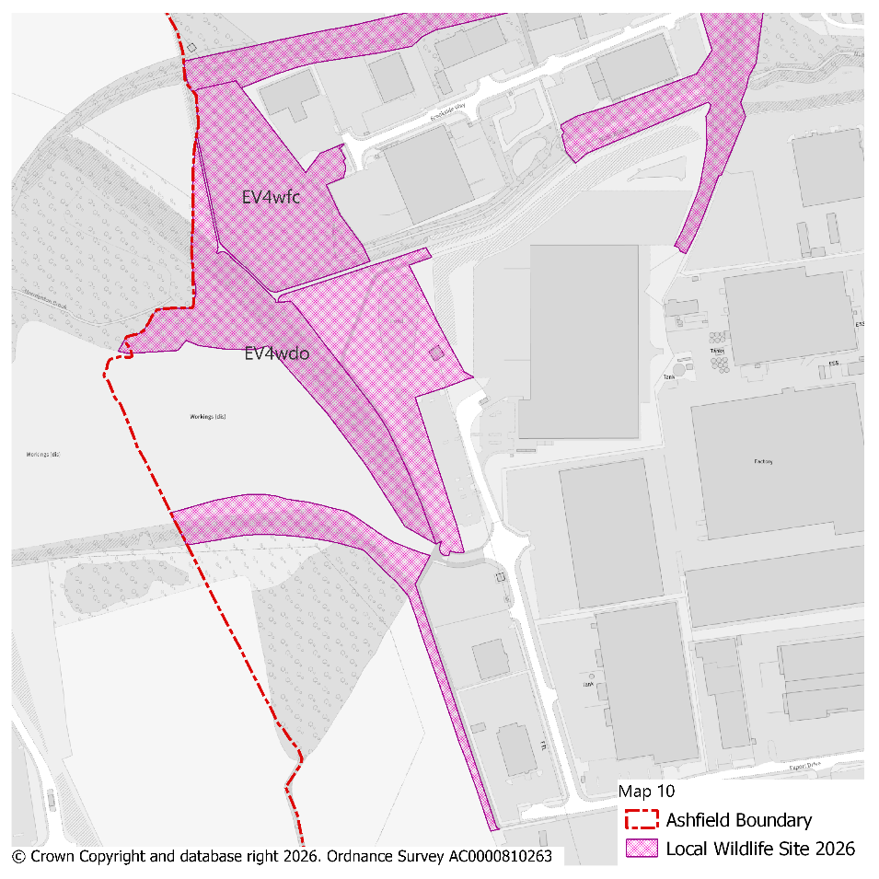
PMM Ref. | Local Plan Policy Ref. |  |  | Proposed Policies Map Modification
PMM33 | EV4: GI, Biodiversity & Geodiversity |  |  | Amend site boundary of Local Wildlife Site(s) EV4wgz and EV4wgp to reflect more up to date information provided by the Nottinghamshire Biodiversity and Geodiversity Records Centre.  (Note: Any comments made in respect of this modification will be required to quote the PMM reference number and the relevant LWS reference number)
Submission Plan Version  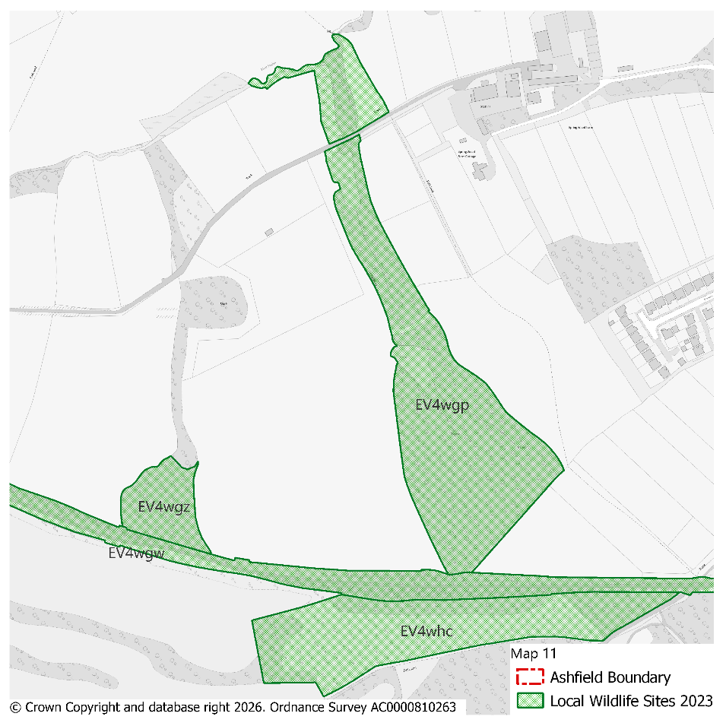 |  |  |  |  |  |  |  |  | Modifications Version  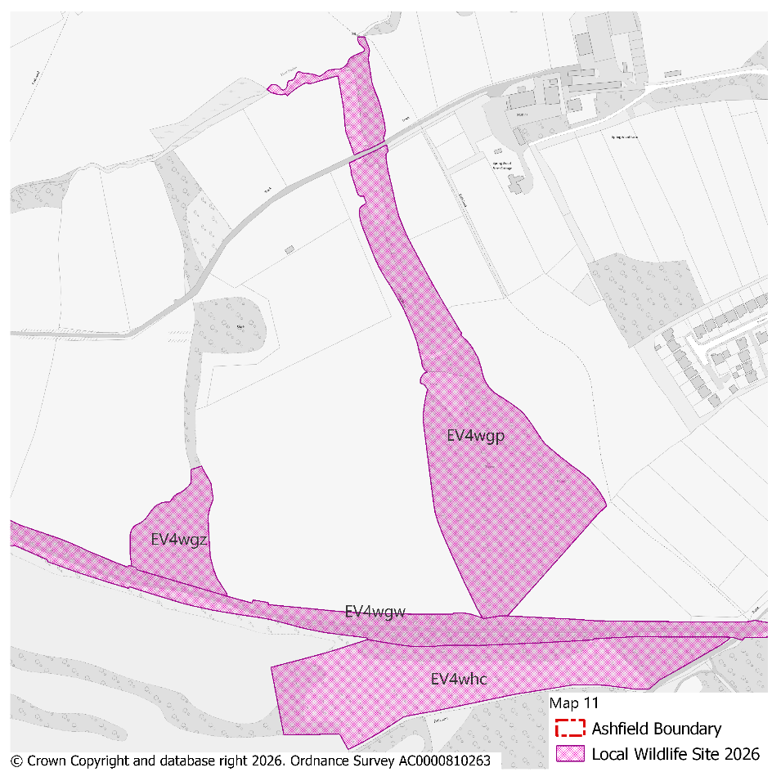
PMM Ref. | Local Plan Policy Ref. |  |  | Proposed Policies Map Modification
PMM34 | EV4: GI, Biodiversity & Geodiversity |  |  | Amend site boundary of Local Wildlife Site(s) EV4waz to reflect more up to date information provided by the Nottinghamshire Biodiversity and Geodiversity Records Centre.  (Note: Any comments made in respect of this modification will be required to quote the PMM reference number and the relevant LWS reference number)
Submission Plan Version  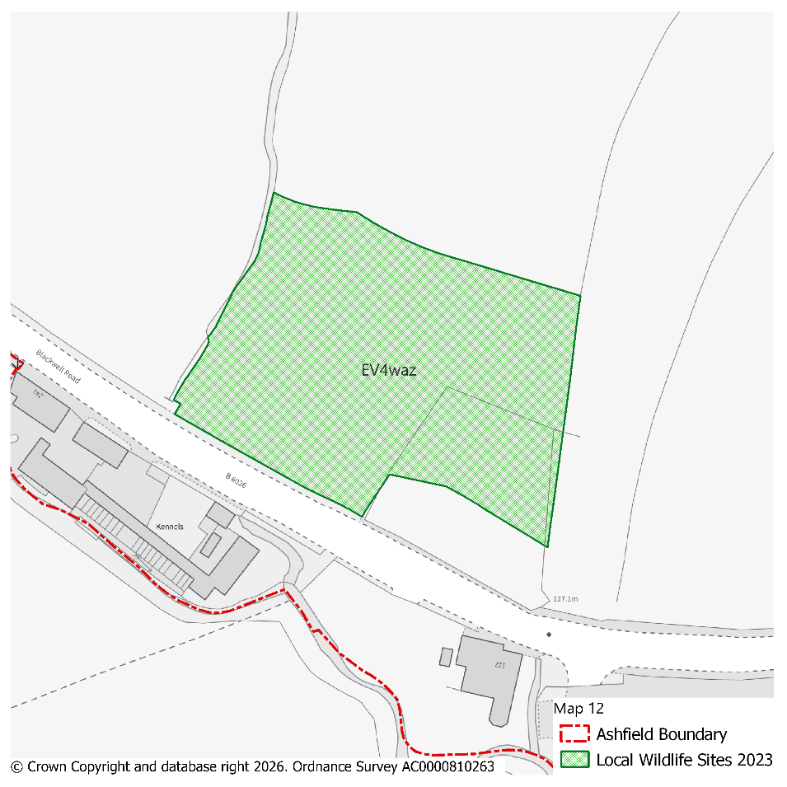 |  |  |  |  |  |  |  |  | Modifications Version  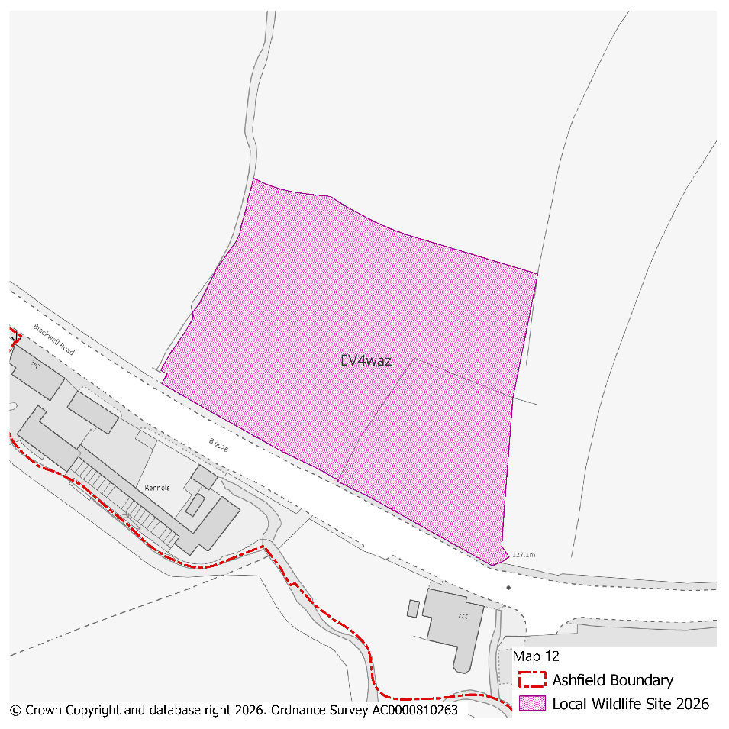
PMM Ref. | Local Plan Policy Ref. |  |  | Proposed Policies Map Modification
PMM35 | EV4: GI, Biodiversity & Geodiversity |  |  | Amend site boundary of Local Wildlife Site(s) EV4wc and EV4wel to reflect more up to date information provided by the Nottinghamshire Biodiversity and Geodiversity Records Centre.  (Note: Any comments made in respect of this modification will be required to quote the PMM reference number and the relevant LWS reference number)
Submission Plan Version  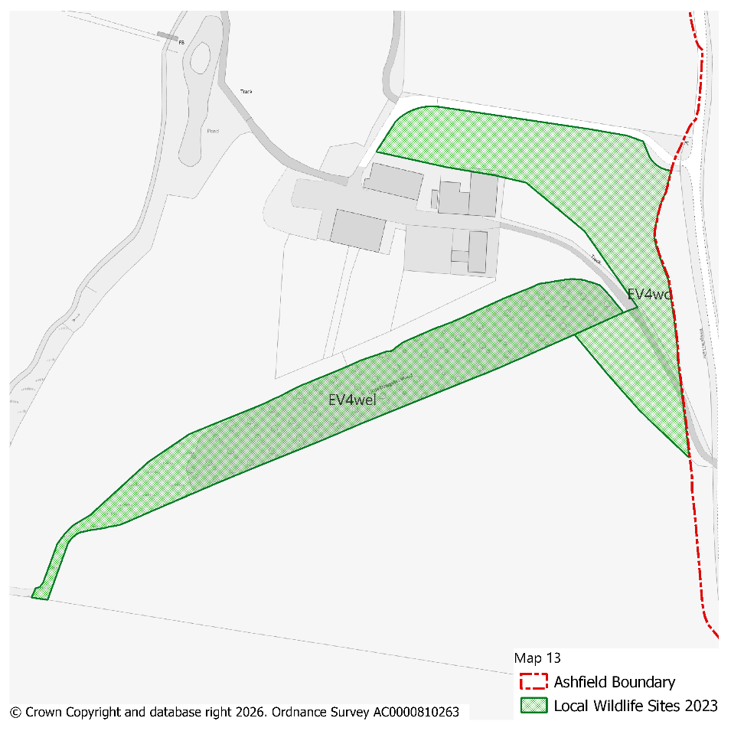 |  |  |  |  |  |  |  |  | Modifications Version  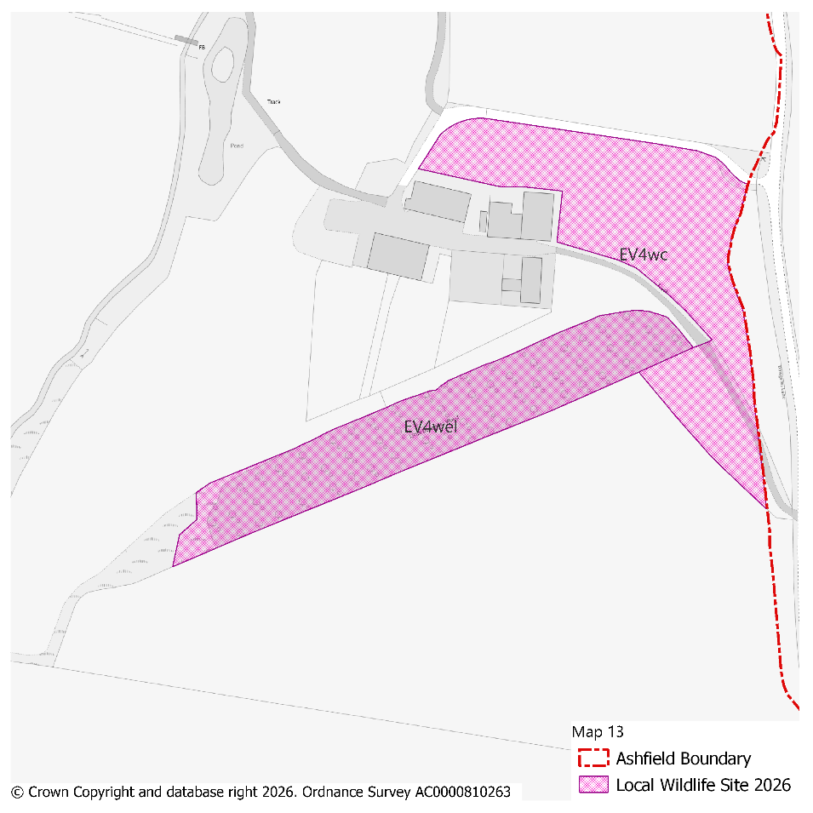
PMM Ref. | Local Plan Policy Ref. |  |  | Proposed Policies Map Modification
PMM36 | EV4: GI, Biodiversity & Geodiversity |  |  | Amend site boundary of Local Wildlife Site(s) EV4waq and EV4war to reflect more up to date information provided by the Nottinghamshire Biodiversity and Geodiversity Records Centre.  (Note: Any comments made in respect of this modification will be required to quote the PMM reference number and the relevant LWS reference number)
Submission Plan Version  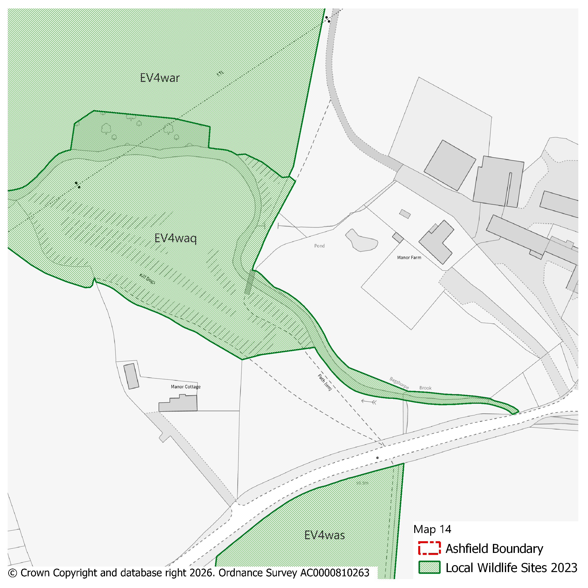 |  |  |  |  |  |  |  |  | Modifications Version  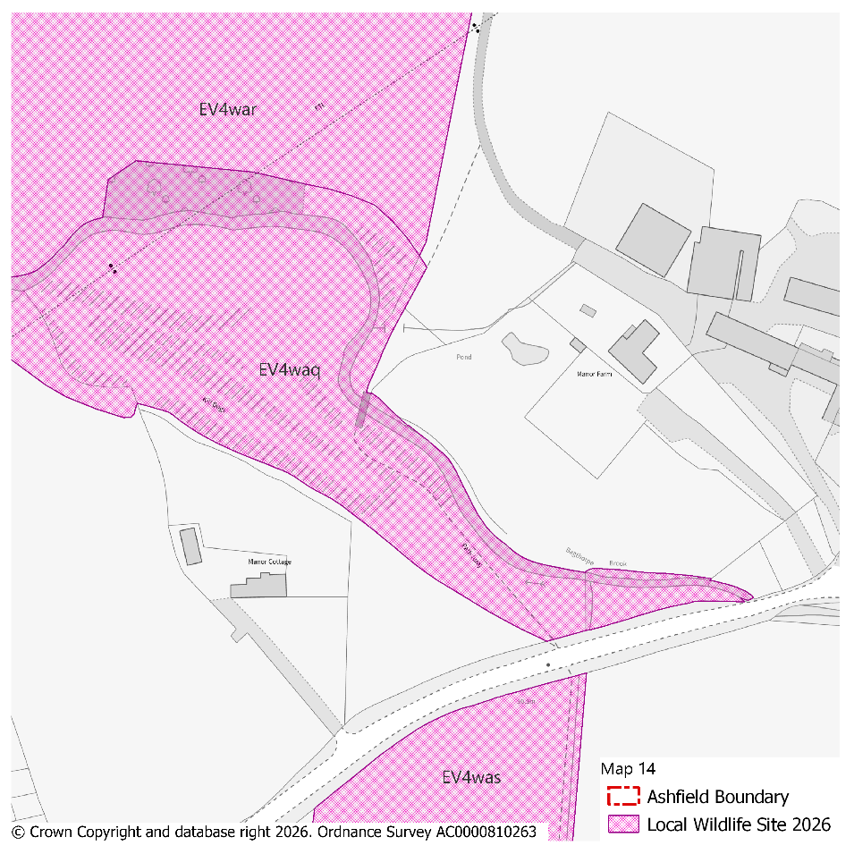
PMM Ref. | Local Plan Policy Ref. |  |  | Proposed Policies Map Modification
PMM37 | EV4: GI, Biodiversity & Geodiversity |  |  | Amend site boundary of Local Wildlife Site(s) EV4wf to reflect more up to date information provided by the Nottinghamshire Biodiversity and Geodiversity Records Centre.  (Note: Any comments made in respect of this modification will be required to quote the PMM reference number and the relevant LWS reference number)
Submission Plan Version  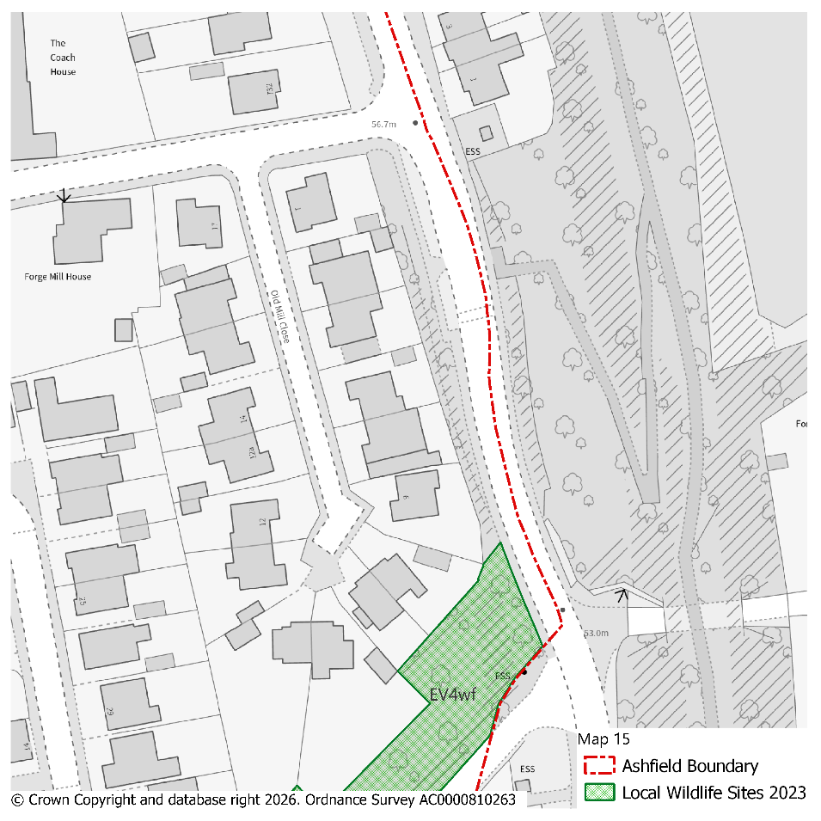 |  |  |  |  |  |  |  |  | Modifications Version  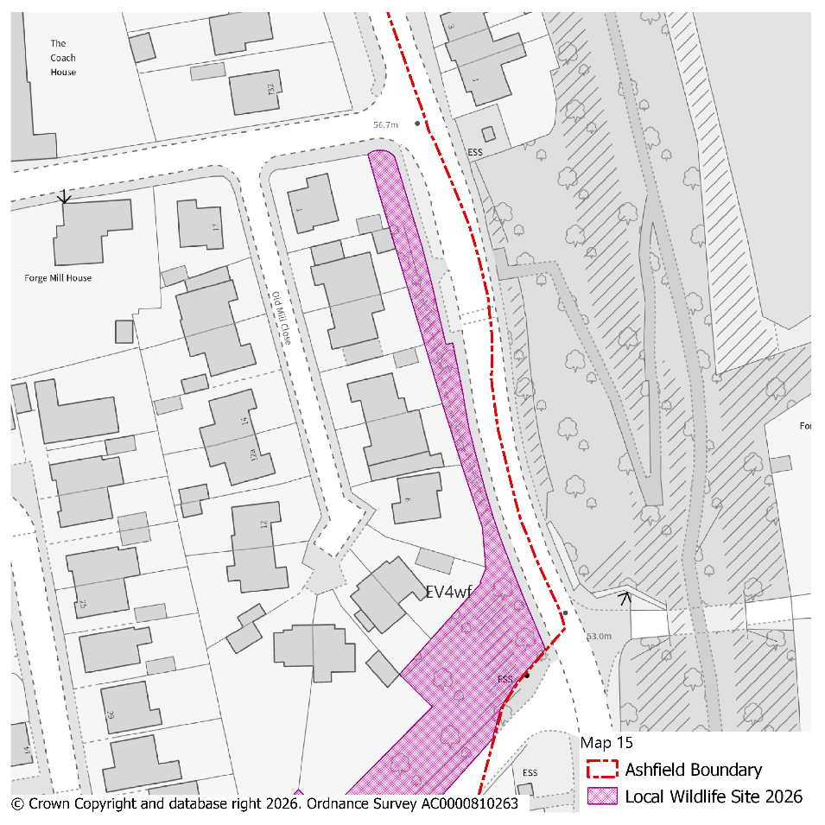
PMM Ref. | Local Plan Policy Ref. |  |  | Proposed Policies Map Modification
PMM38 | EV4: GI, Biodiversity & Geodiversity |  |  | Amend site boundary of Local Wildlife Site(s) EV4wec and EV4wcg to reflect more up to date information provided by the Nottinghamshire Biodiversity and Geodiversity Records Centre.  (Note: Any comments made in respect of this modification will be required to quote the PMM reference number and the relevant LWS reference number)
Submission Plan Version  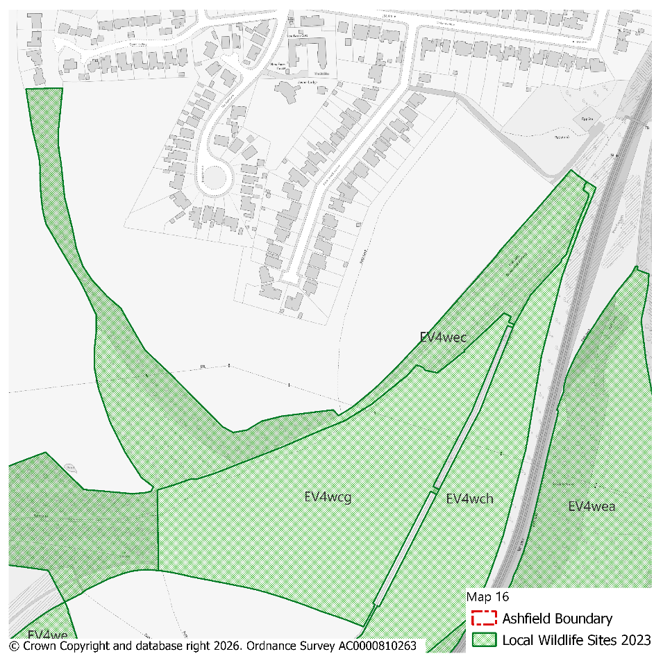 |  |  |  |  |  |  |  |  | Modifications Version  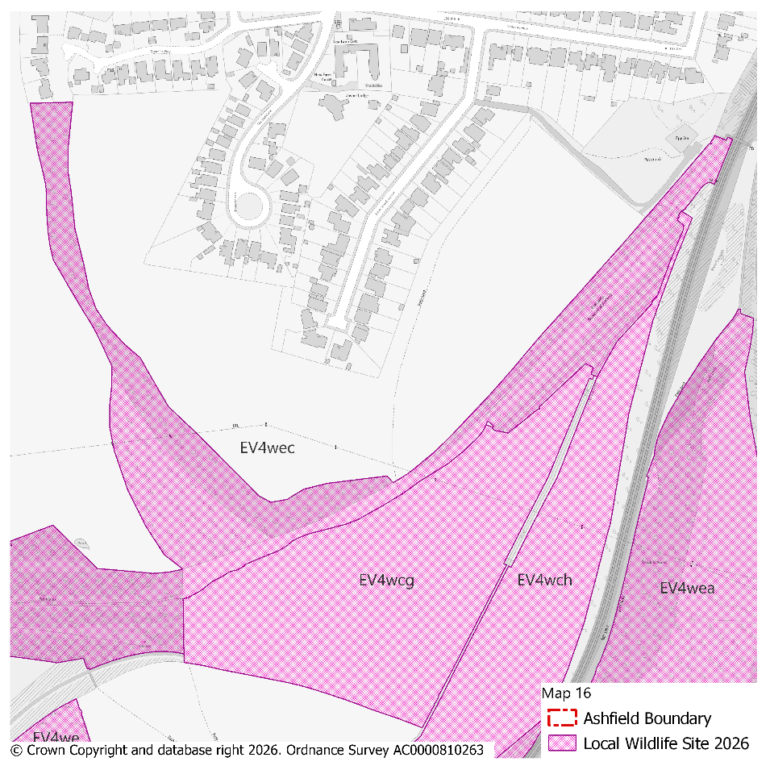
PMM Ref. | Local Plan Policy Ref. |  |  | Proposed Policies Map Modification
PMM39 | EV4: GI, Biodiversity & Geodiversity |  |  | Amend site boundary of Local Wildlife Site(s) EV4wt to reflect more up to date information provided by the Nottinghamshire Biodiversity and Geodiversity Records Centre.  (Note: Any comments made in respect of this modification will be required to quote the PMM reference number and the relevant LWS reference number)
Submission Plan Version  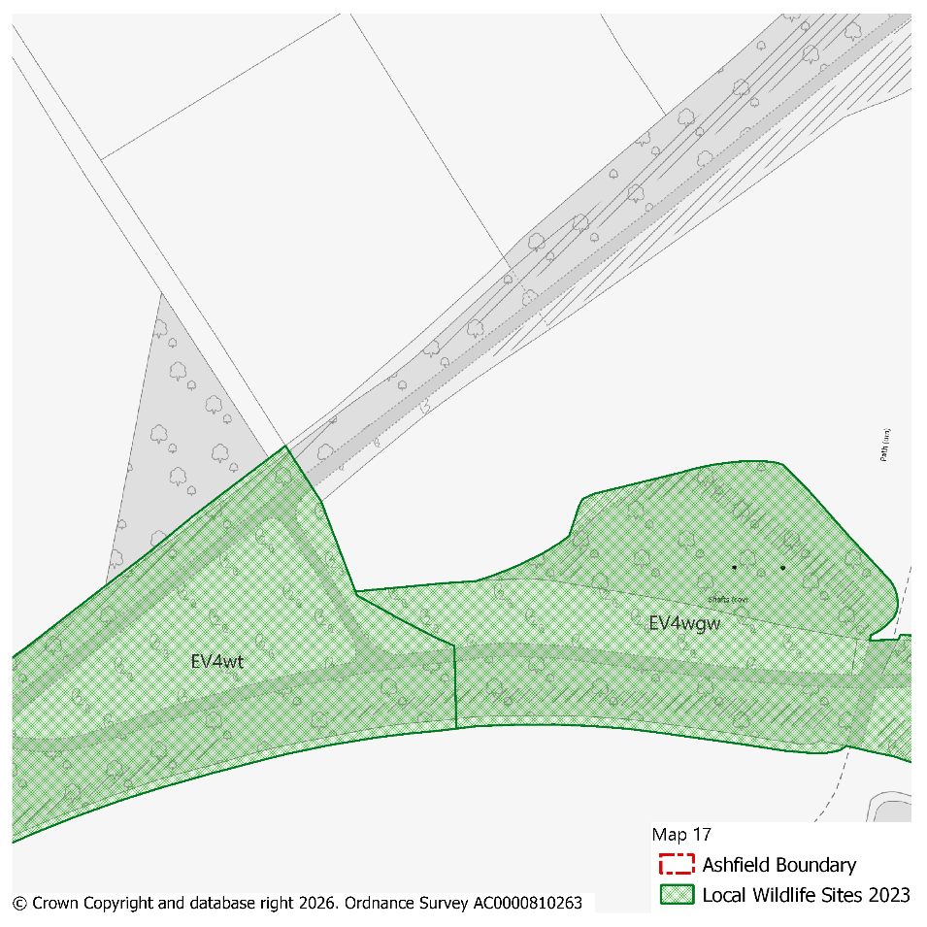 |  |  |  |  |  |  |  |  | Modifications Version  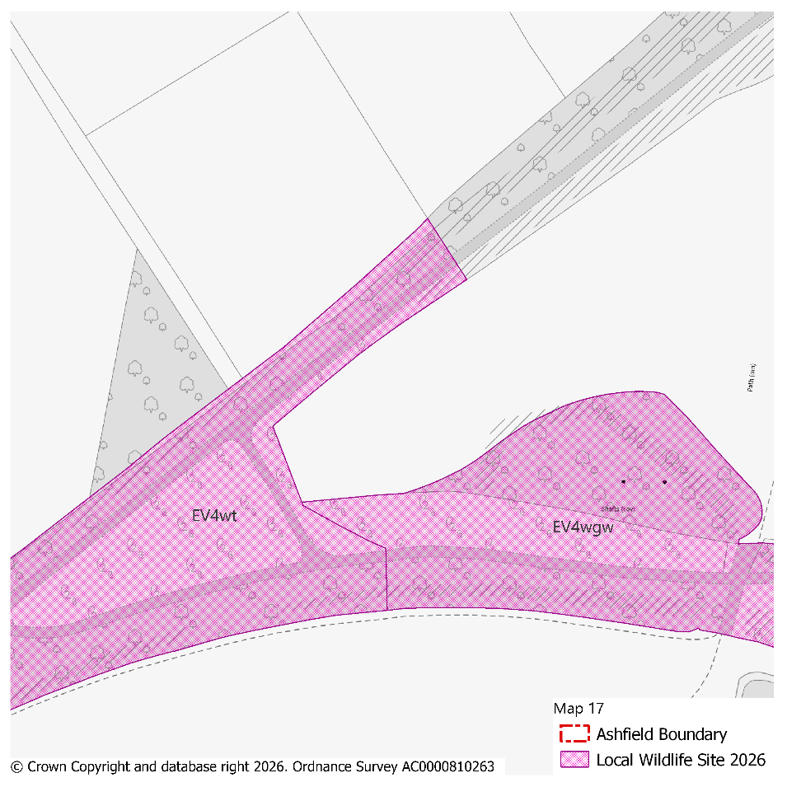
PMM Ref. | Local Plan Policy Ref. |  |  | Proposed Policies Map Modification
PMM40 | EV4: GI, Biodiversity & Geodiversity |  |  | Amend site boundary of Local Wildlife Site(s) EV4wfg and EV4wgm to reflect more up to date information provided by the Nottinghamshire Biodiversity and Geodiversity Records Centre.  (Note: Any comments made in respect of this modification will be required to quote the PMM reference number and the relevant LWS reference number)
Submission Plan Version  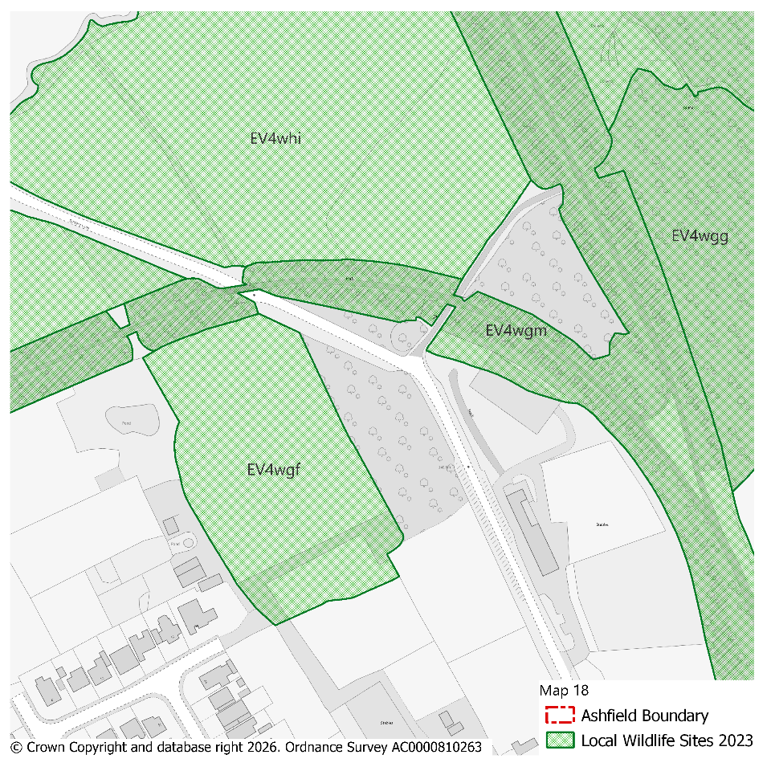 |  |  |  |  |  |  |  |  | Modifications Version  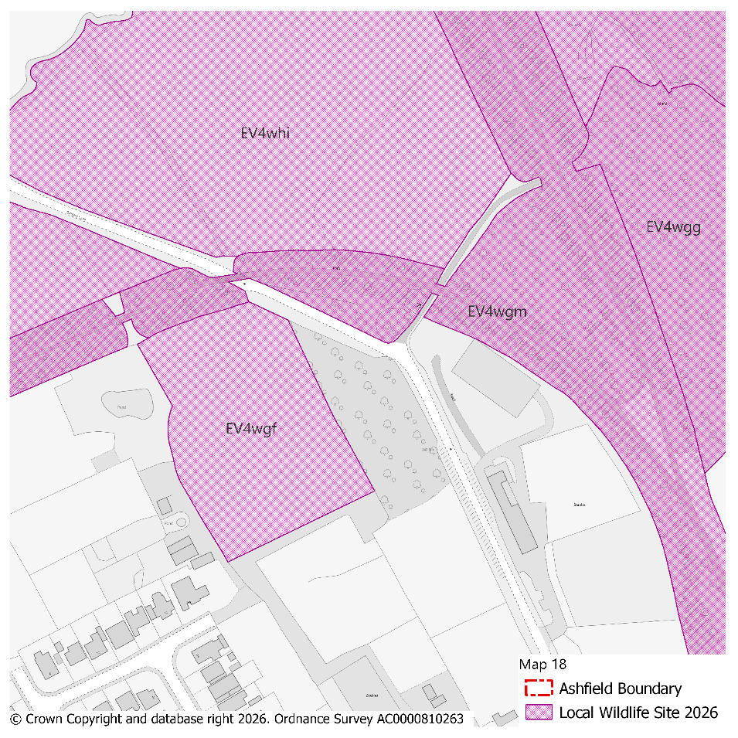
PMM Ref. | Local Plan Policy Ref. |  |  | Proposed Policies Map Modification
PMM41 | EV4: GI, Biodiversity & Geodiversity |  |  | Amend site boundary of Local Wildlife Site(s) EV4wl and EV4wcl to reflect more up to date information provided by the Nottinghamshire Biodiversity and Geodiversity Records Centre.  (Note: Any comments made in respect of this modification will be required to quote the PMM reference number and the relevant LWS reference number)
Submission Plan Version  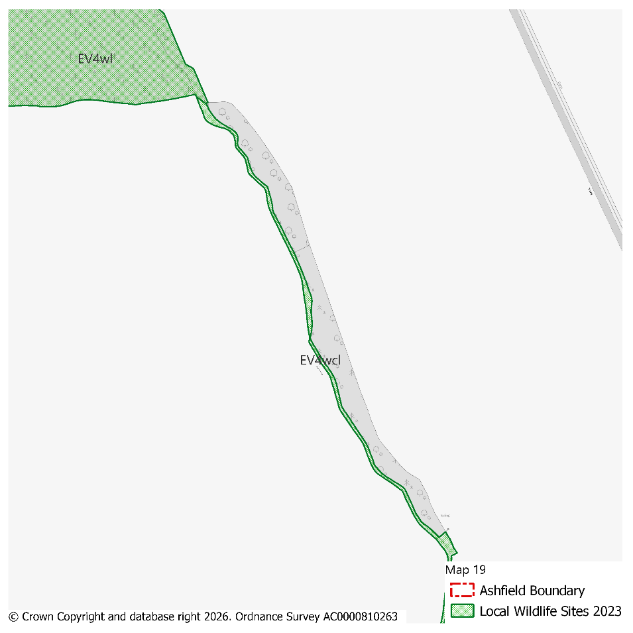 |  |  |  |  |  |  |  |  | Modifications Version  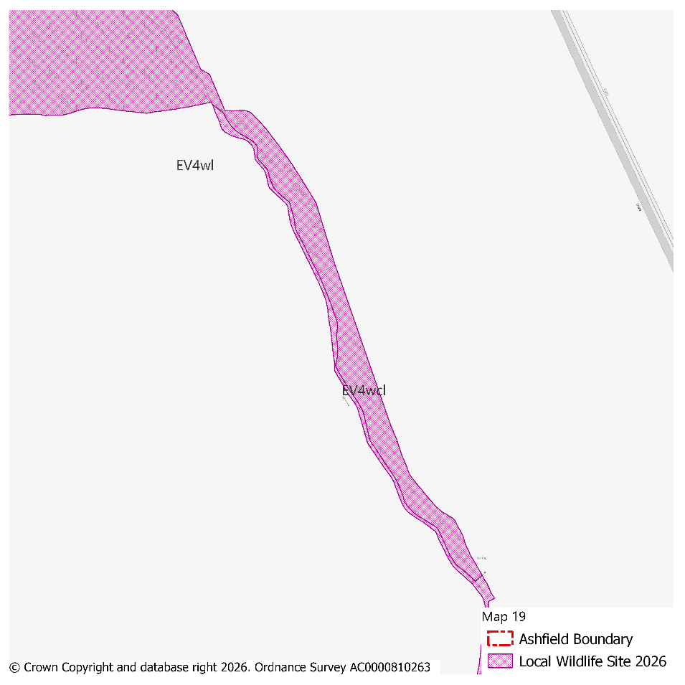
PMM Ref. | Local Plan Policy Ref. |  |  | Proposed Policies Map Modification
PMM42 | EV4: GI, Biodiversity & Geodiversity |  |  | Amend site boundary of Local Wildlife Site(s) EV4wfm, EV4wgb and EV4whg to reflect more up to date information provided by the Nottinghamshire Biodiversity and Geodiversity Records Centre.  (Note: Any comments made in respect of this modification will be required to quote the PMM reference number and the relevant LWS reference number)
Submission Plan Version  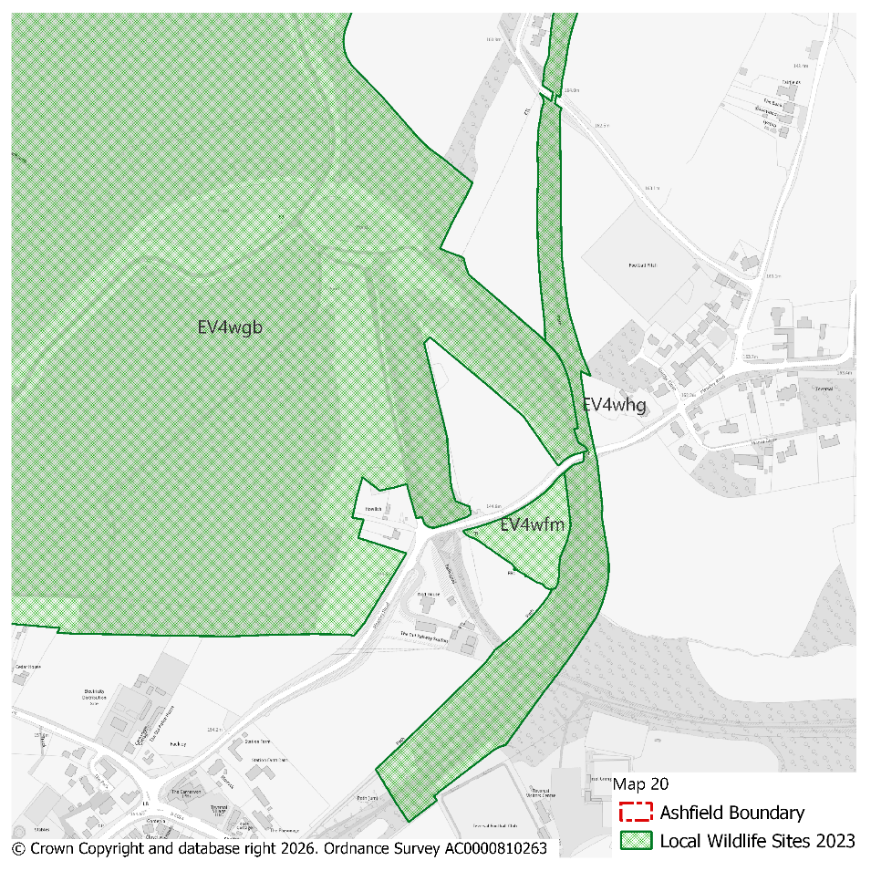 |  |  |  |  |  |  |  |  | Modifications Version  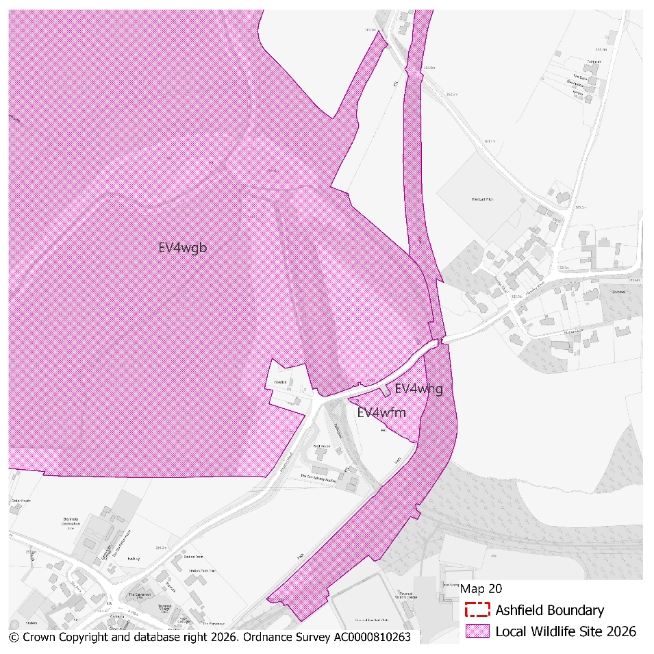
PMM Ref. | Local Plan Policy Ref. |  |  | Proposed Policies Map Modification
PMM43 | EV4: GI, Biodiversity & Geodiversity |  |  | Amend site boundary of Local Wildlife Site(s) EV4wao, EV4wcn, EV4wfa and EV4wfj to reflect more up to date information provided by the Nottinghamshire Biodiversity and Geodiversity Records Centre.  (Note: Any comments made in respect of this modification will be required to quote the PMM reference number and the relevant LWS reference number)
Submission Plan Version  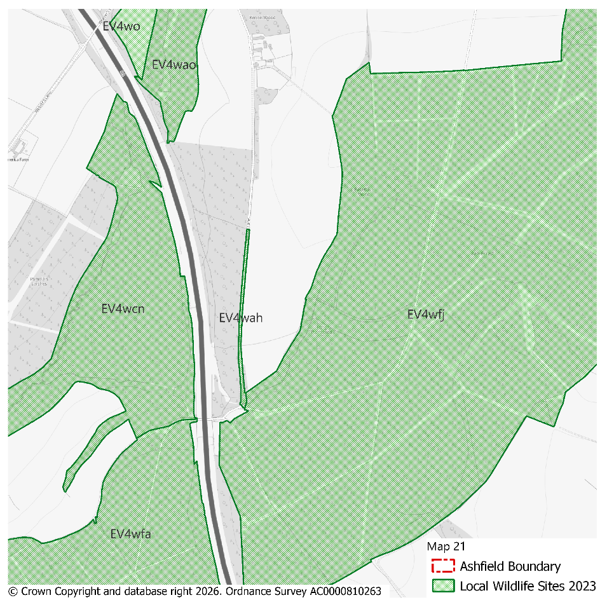 |  |  |  |  |  |  |  |  | Modifications Version  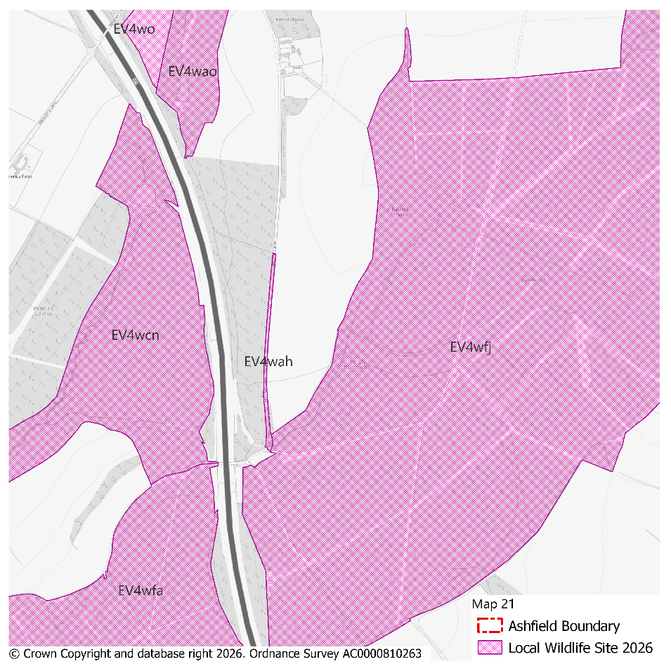
PMM Ref. | Local Plan Policy Ref. |  |  | Proposed Policies Map Modification
PMM44 | EV4: GI, Biodiversity & Geodiversity |  |  | Amend site boundary of Local Wildlife Site(s) EV4 wdk to reflect more up to date information provided by the Nottinghamshire Biodiversity and Geodiversity Records Centre.  (Note: Any comments made in respect of this modification will be required to quote the PMM reference number and the relevant LWS reference number)
Submission Plan Version  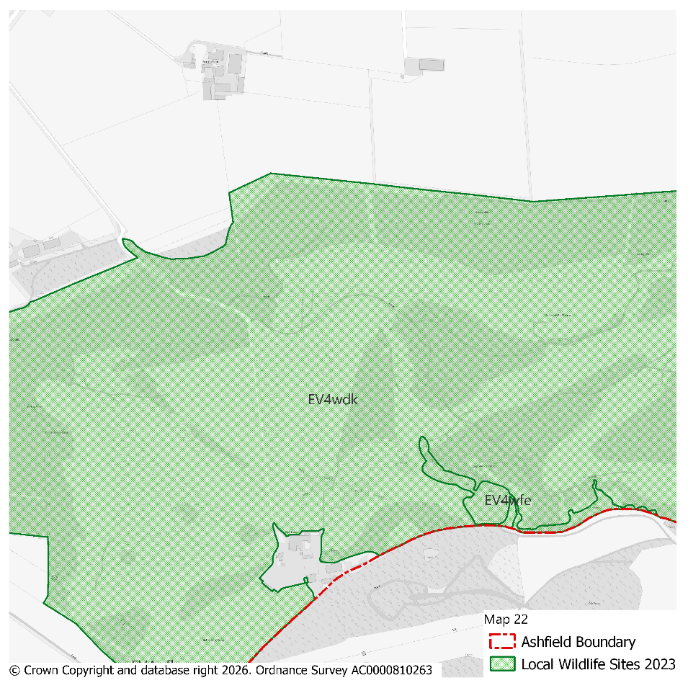 |  |  |  |  |  |  |  |  | Modifications Version  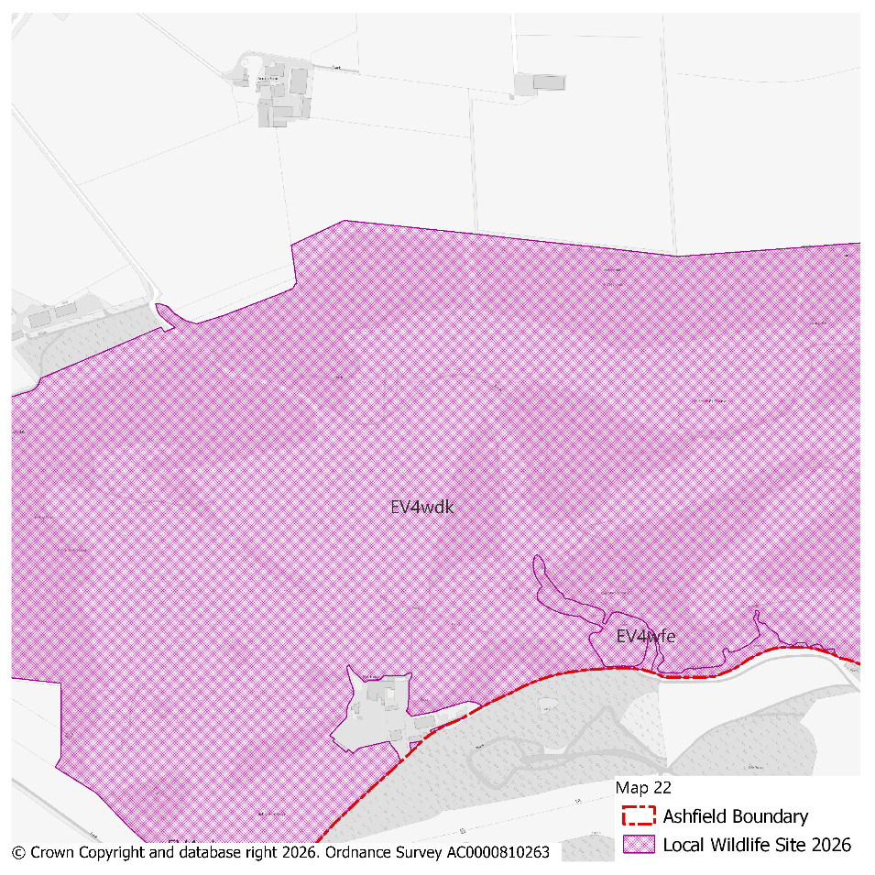
PMM Ref. | Local Plan Policy Ref. |  |  | Proposed Policies Map Modification
PMM45 | EV4: GI, Biodiversity & Geodiversity |  |  | Delete Local Wildlife Site(s) EV4wax to reflect more up to date information provided by the Nottinghamshire Biodiversity and Geodiversity Records Centre.  (Note: Any comments made in respect of this modification will be required to quote the PMM reference number and the relevant LWS reference number)
Submission Plan Version  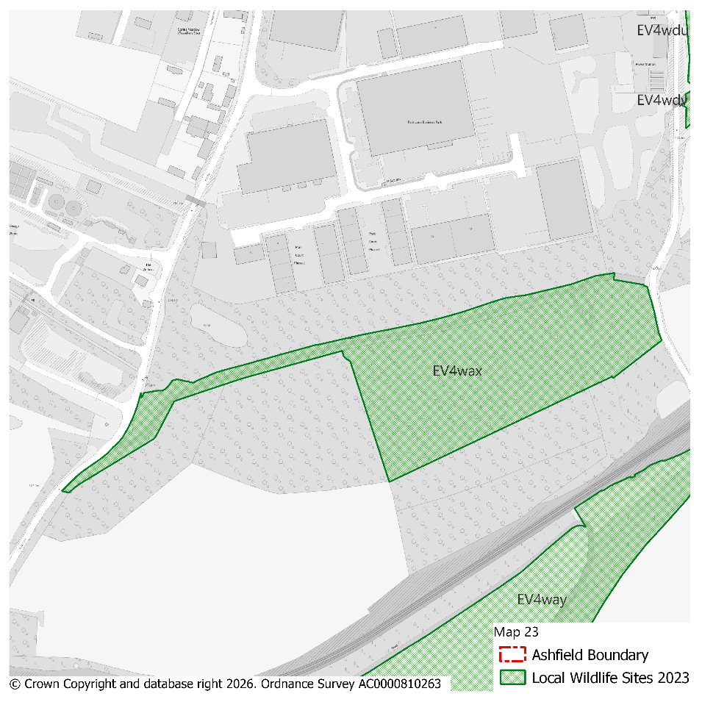 |  |  |  |  |  |  |  |  | Modifications Version  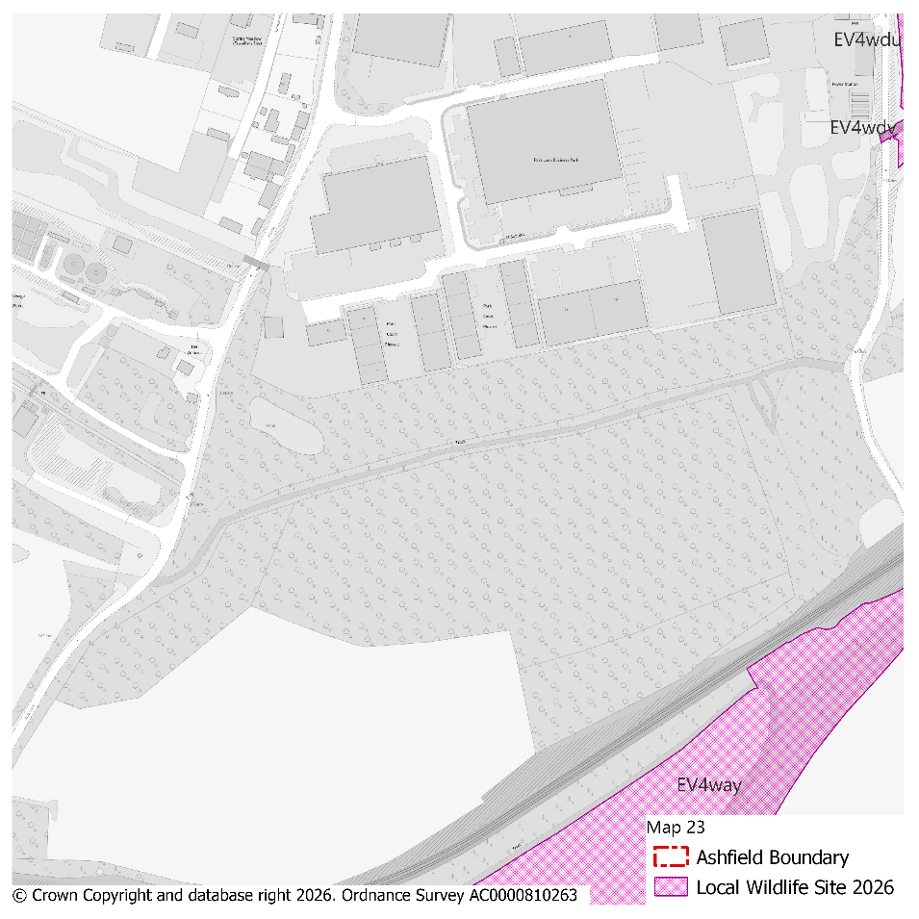
PMM Ref. | Local Plan Policy Ref. |  |  | Proposed Policies Map Modification
PMM46 | EV4: GI, Biodiversity & Geodiversity |  |  | Amend site boundary of Local Wildlife Site(s) EV4wcr, EV4wde and EV4whk to reflect more up to date information provided by the Nottinghamshire Biodiversity and Geodiversity Records Centre.  (Note: Any comments made in respect of this modification will be required to quote the PMM reference number and the relevant LWS reference number)
Submission Plan Version  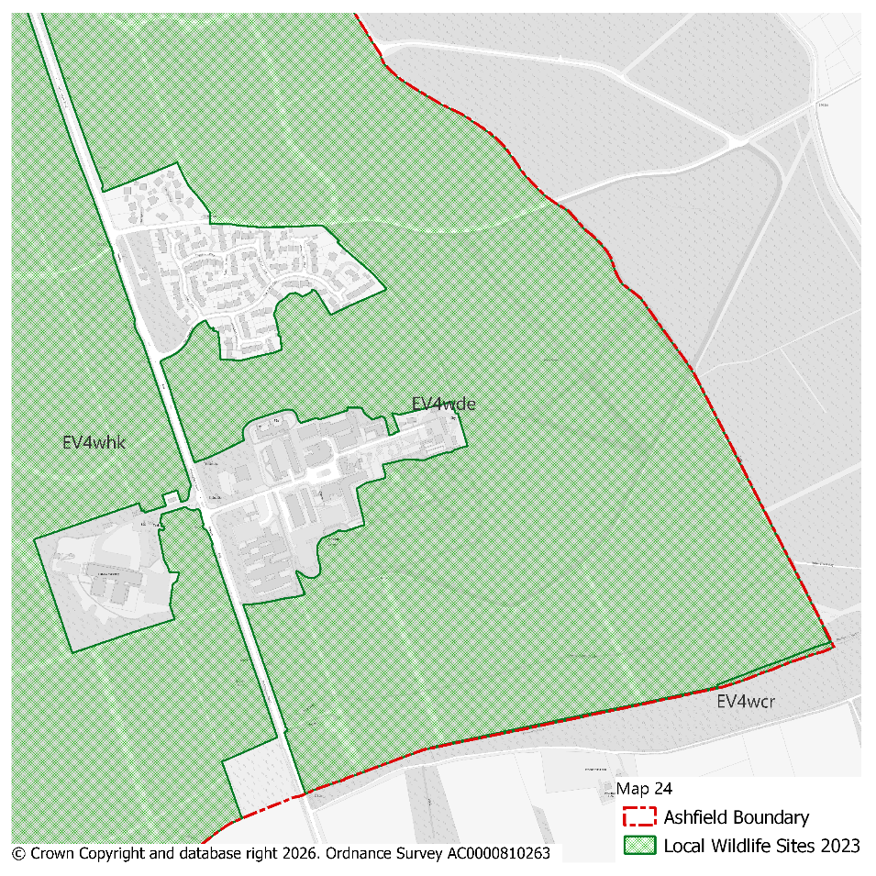 |  |  |  |  |  |  |  |  | Modifications Version  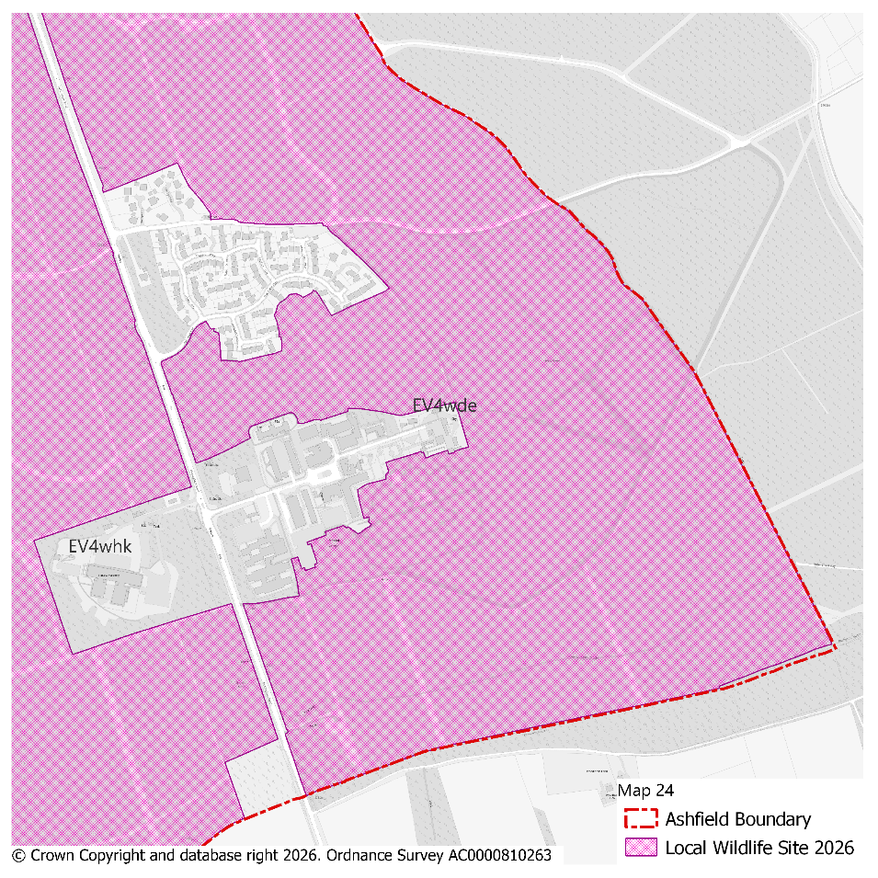
PMM Ref. | Local Plan Policy Ref. |  |  | Proposed Policies Map Modification
PMM47 | EV4: GI, Biodiversity & Geodiversity |  |  | Amend site boundary of Local Wildlife Site(s) EV4wfb, EV4waf and add new LWS EV4whm to reflect more up to date information provided by the Nottinghamshire Biodiversity and Geodiversity Records Centre.  (Note: Any comments made in respect of this modification will be required to quote the PMM reference number and the relevant LWS reference number)
Submission Plan Version  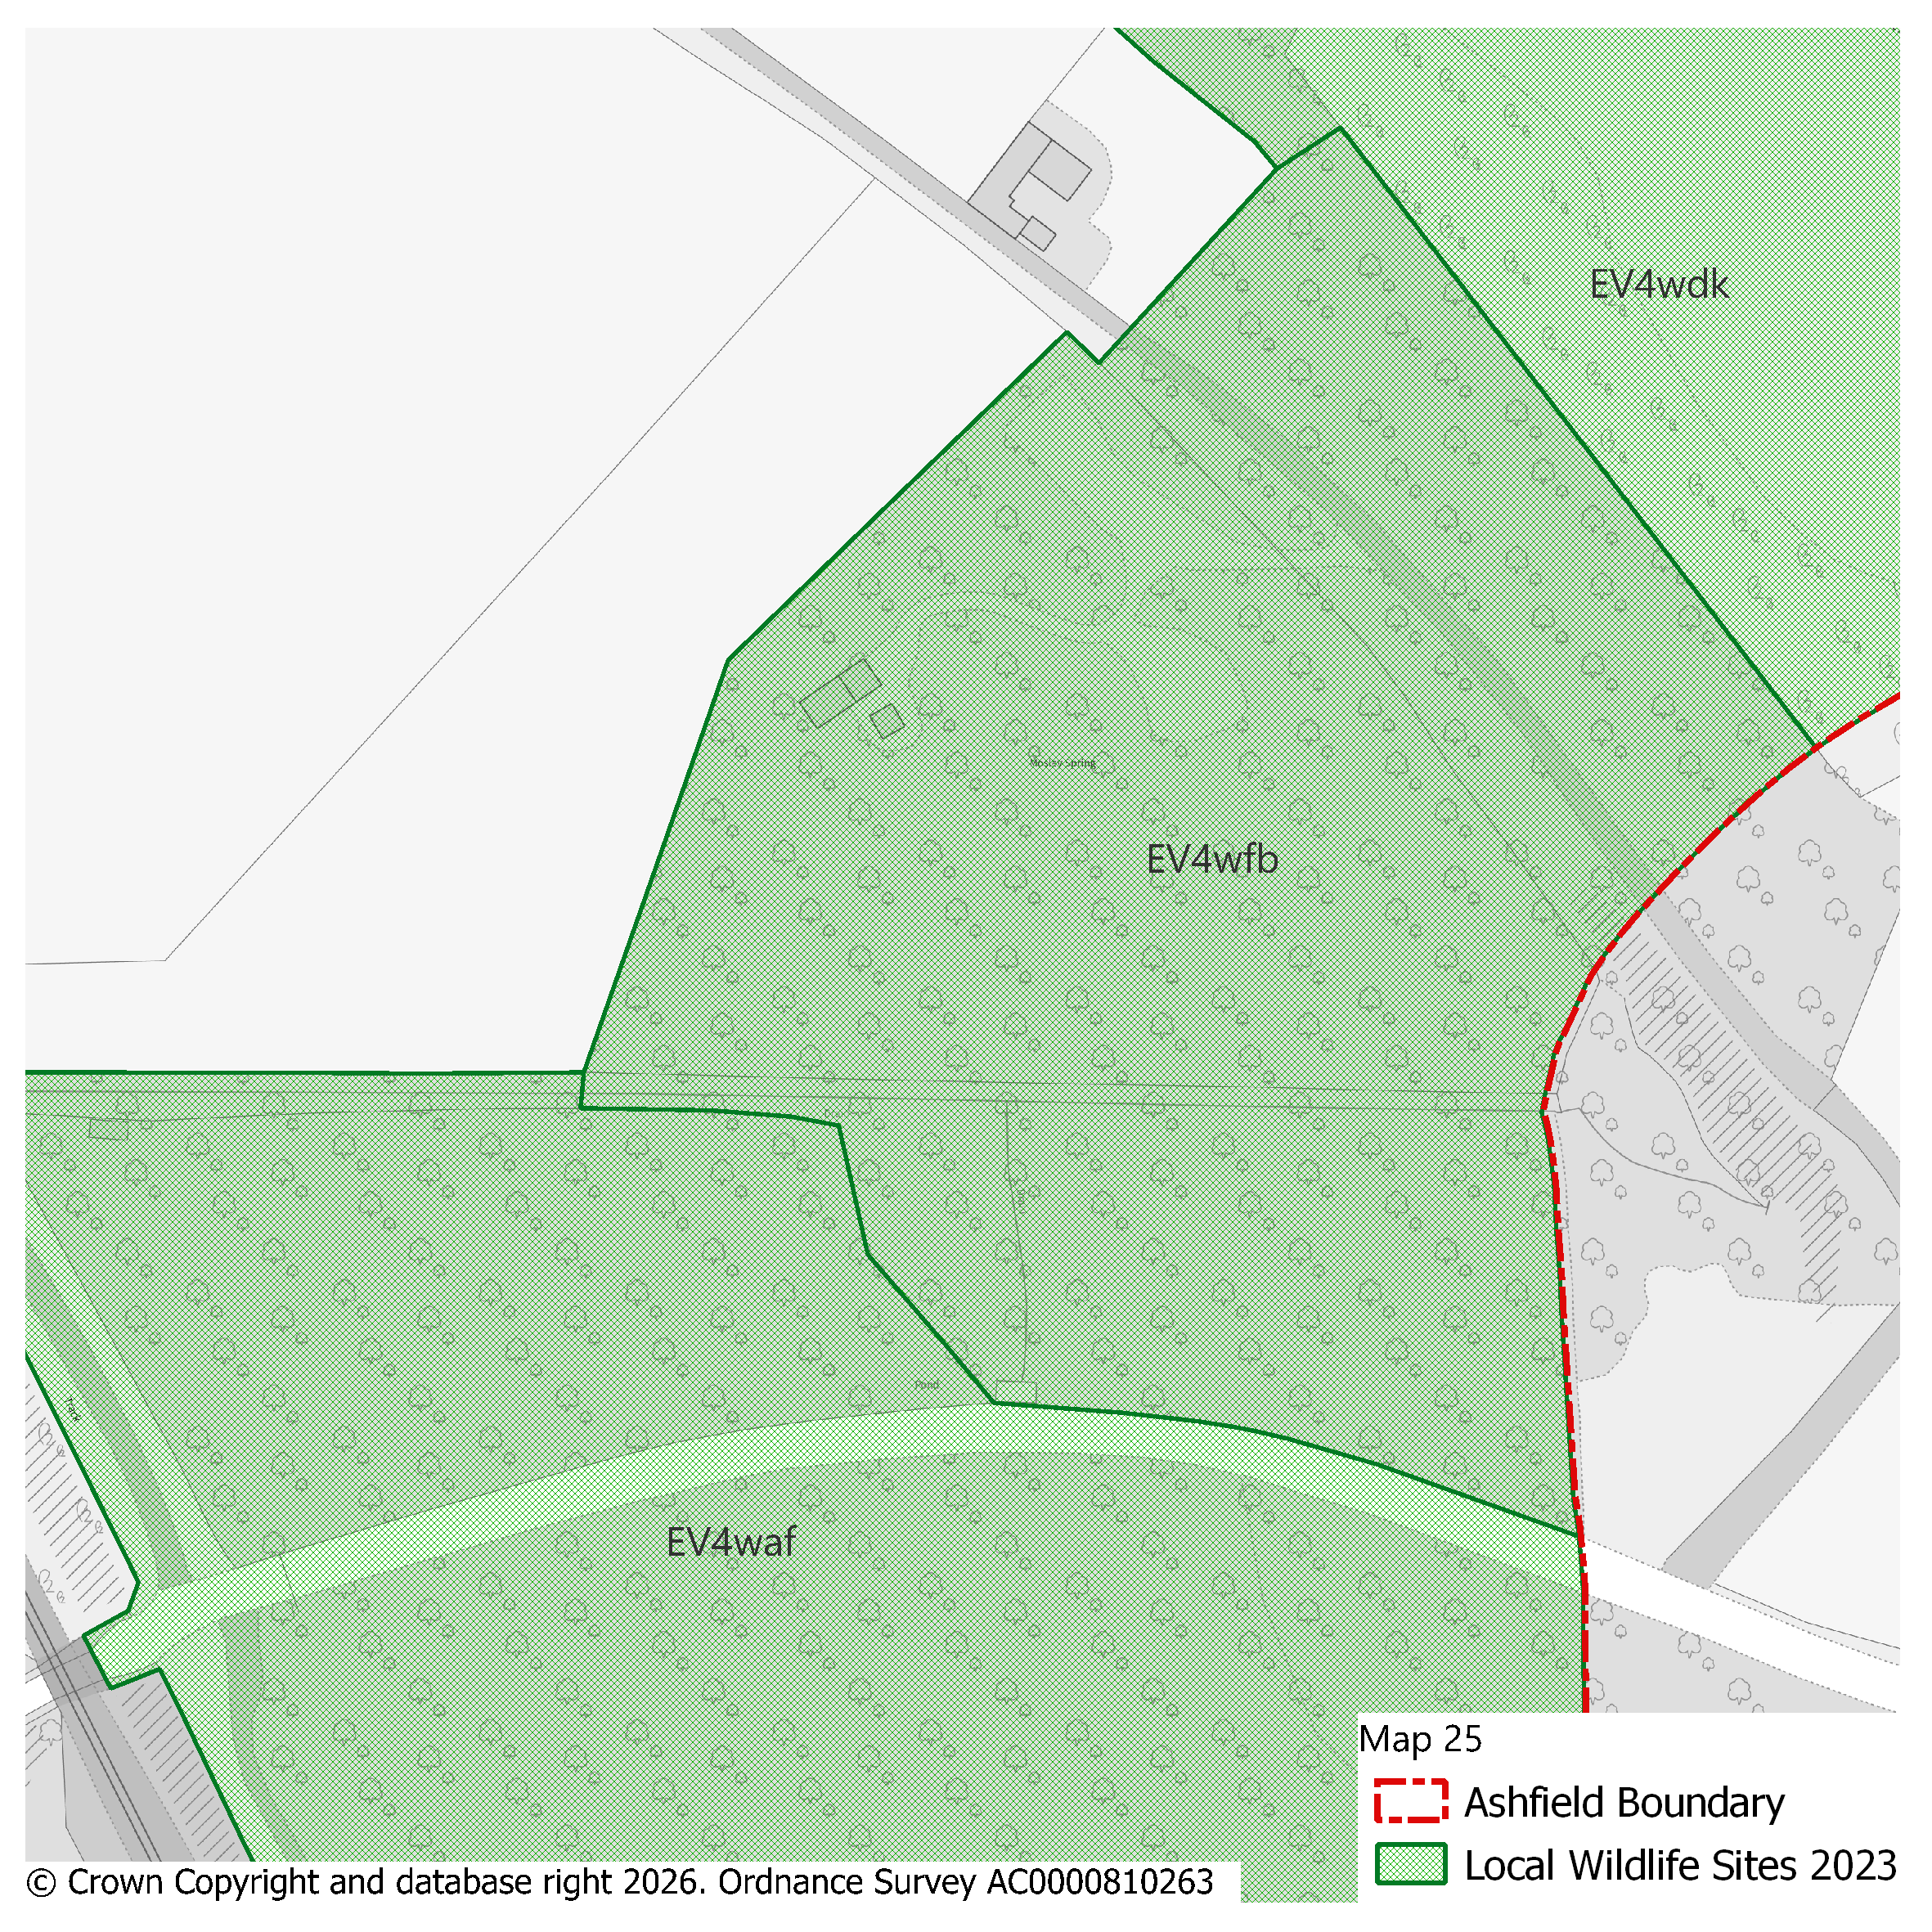 |  |  |  |  |  |  |  |  | Modifications Version  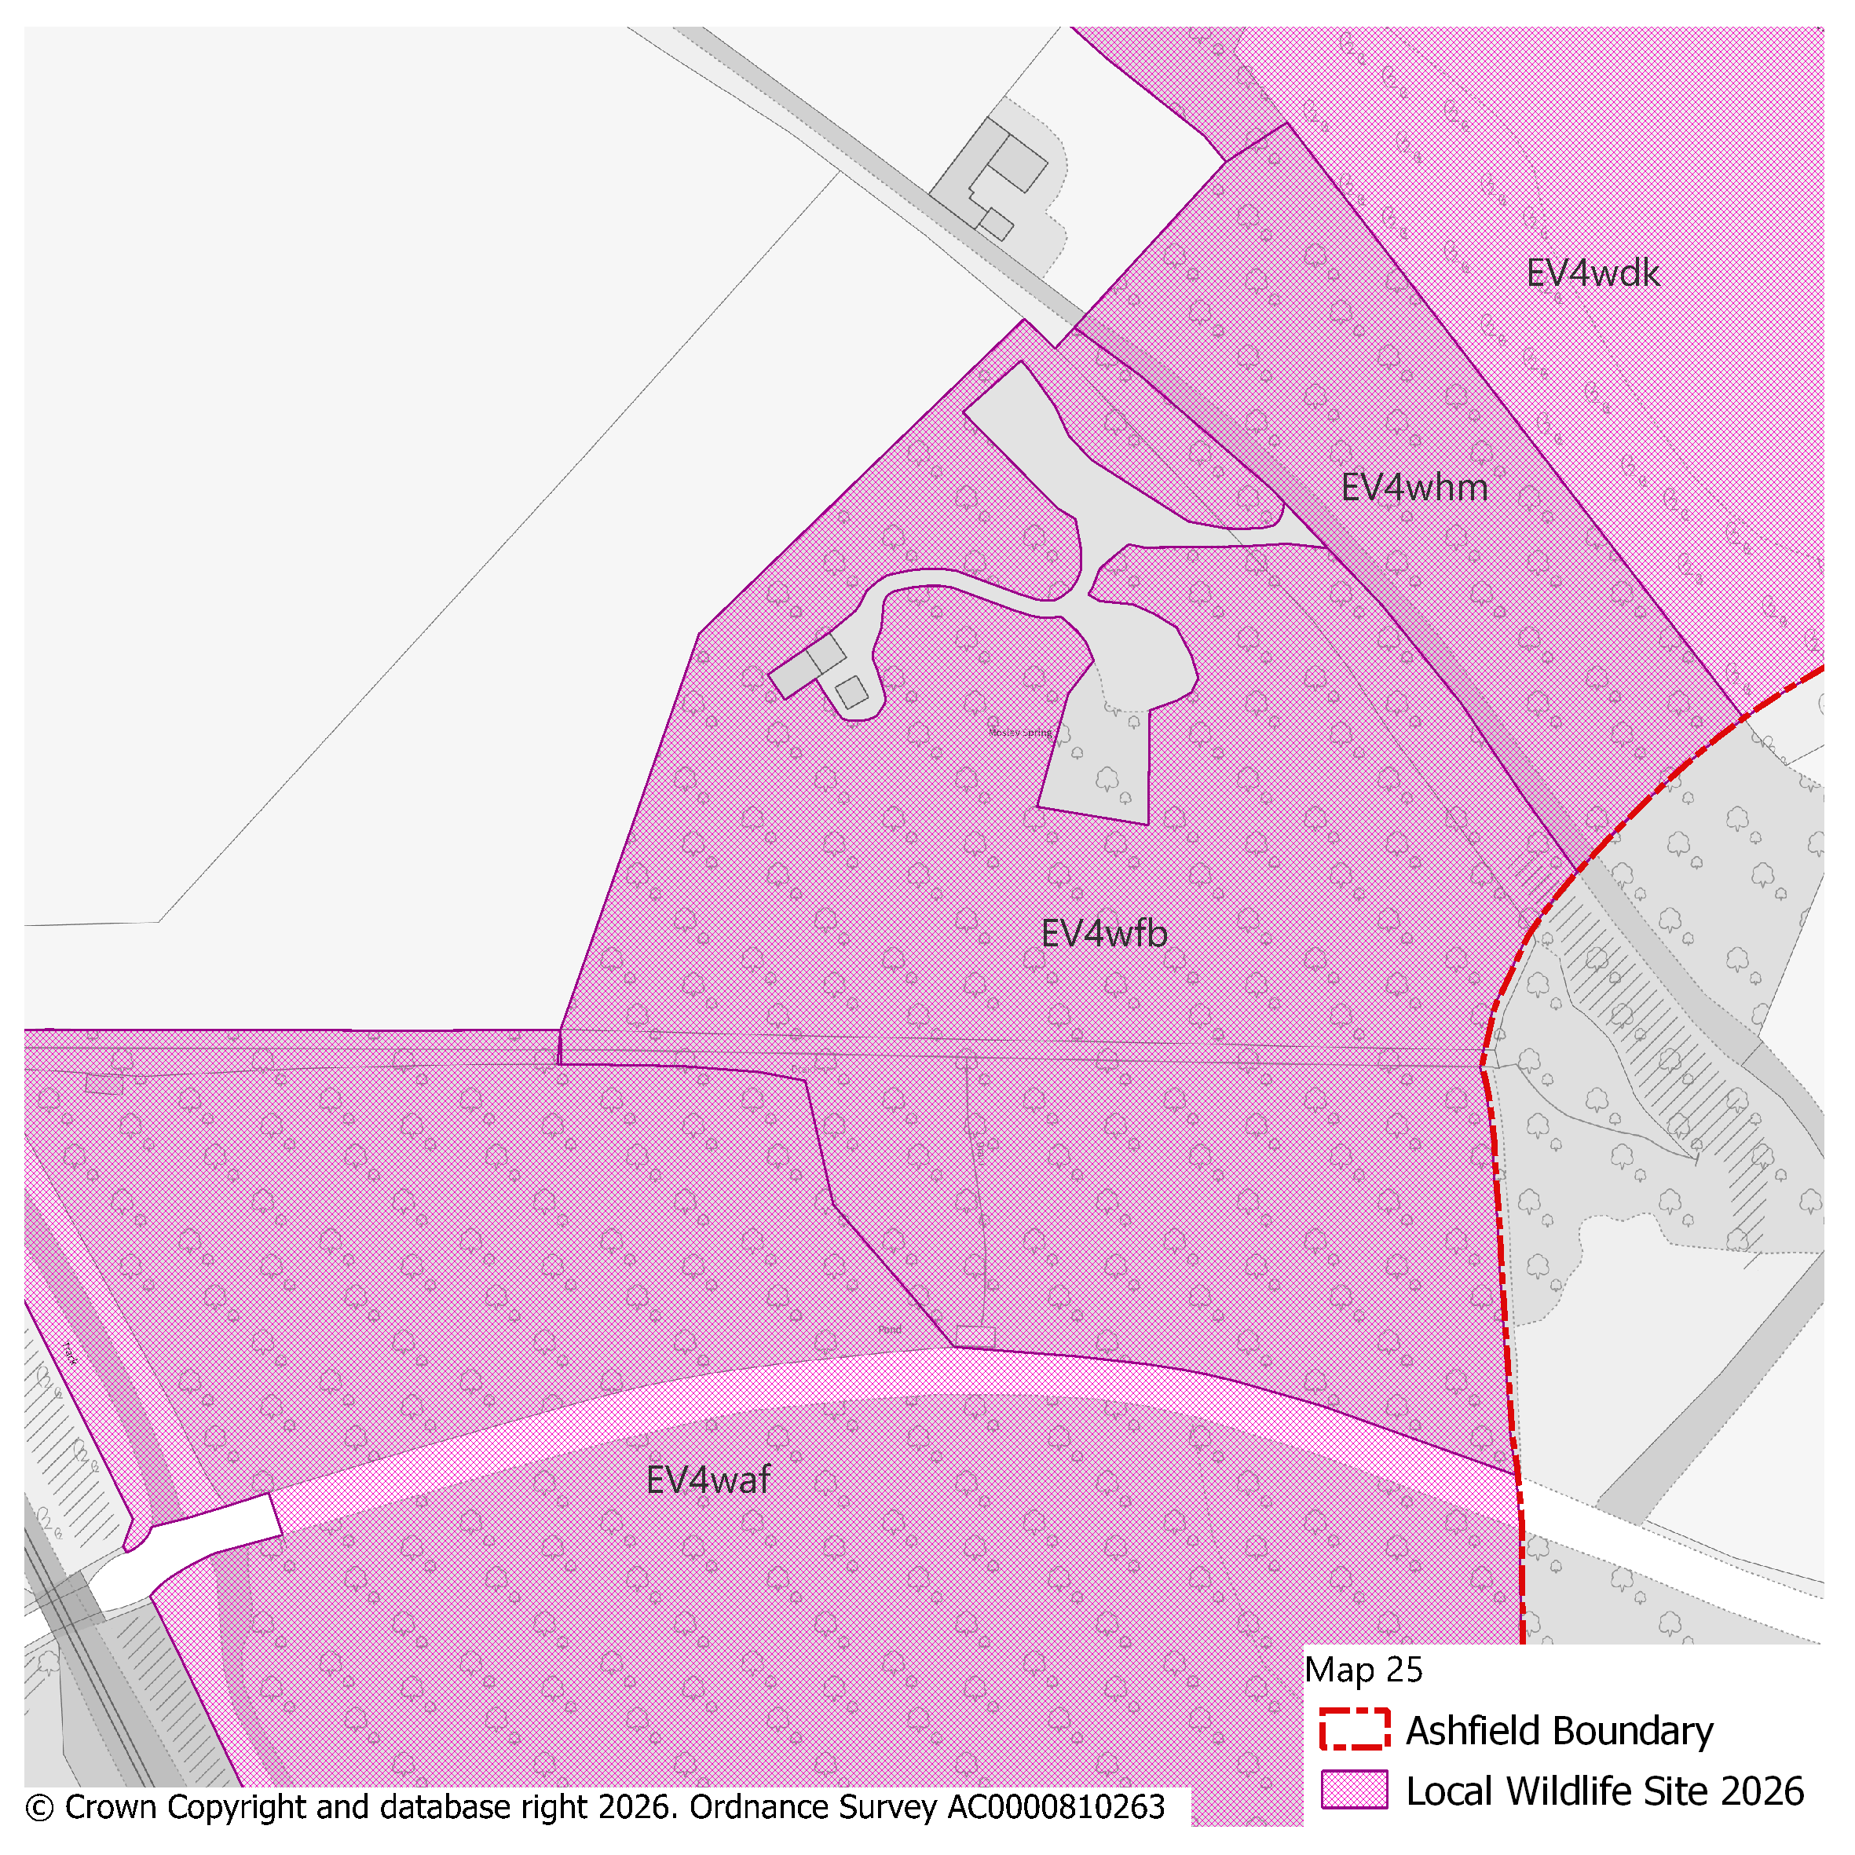
PMM Ref. | Local Plan Policy Ref. |  |  | Proposed Policies Map Modification
PMM48 | EV4: GI, Biodiversity & Geodiversity |  |  | Amend site boundary of Local Wildlife Site(s) EV4wda to reflect more up to date information provided by the Nottinghamshire Biodiversity and Geodiversity Records Centre.  (Note: Any comments made in respect of this modification will be required to quote the PMM reference number and the relevant LWS reference number)
Submission Plan Version  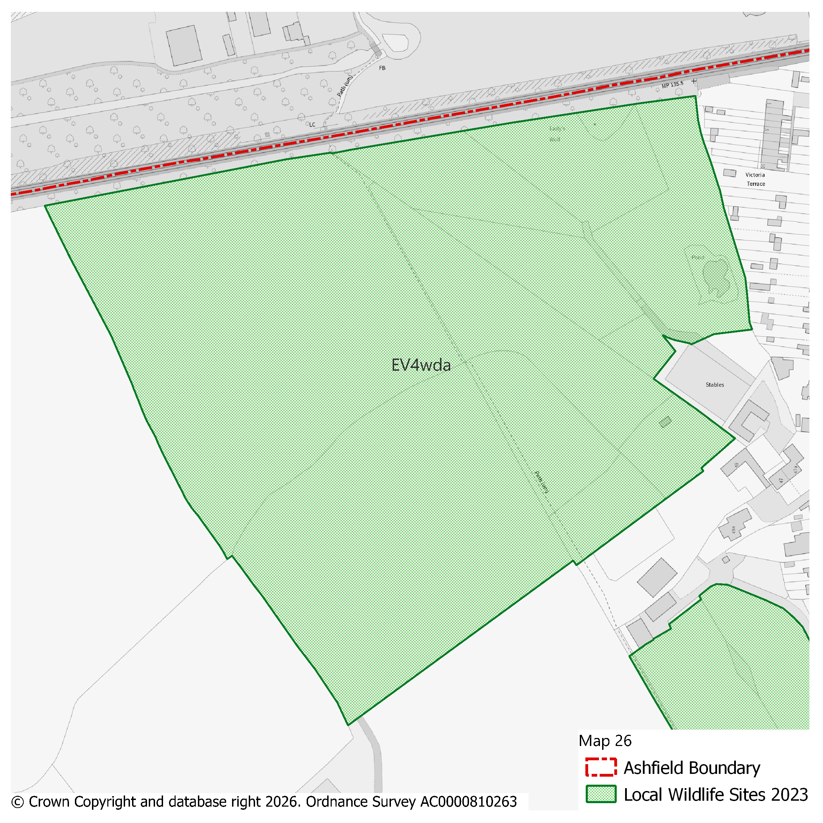 |  |  |  |  |  |  |  |  | Modifications Version  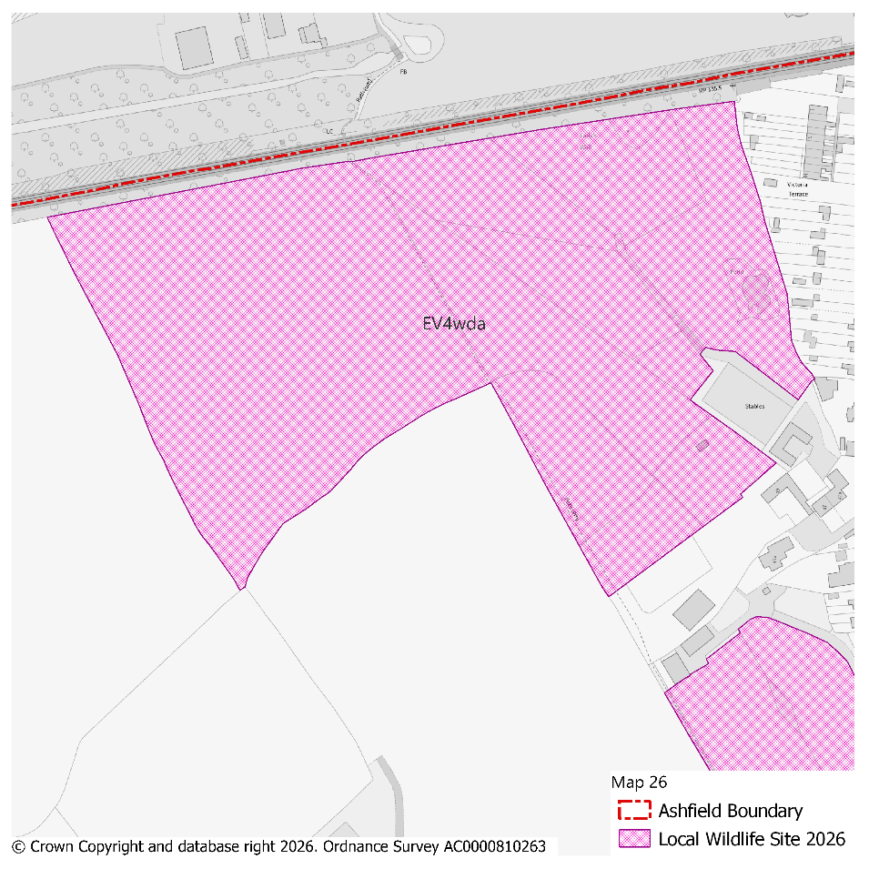
PMM Ref. | Local Plan Policy Ref. |  |  | Proposed Policies Map Modification
PMM49 | EV4: GI, Biodiversity & Geodiversity |  |  | Amend site boundary of Local Wildlife Site(s) EV4wff to reflect more up to date information provided by the Nottinghamshire Biodiversity and Geodiversity Records Centre.  (Note: Any comments made in respect of this modification will be required to quote the PMM reference number and the relevant LWS reference number)
Submission Plan Version  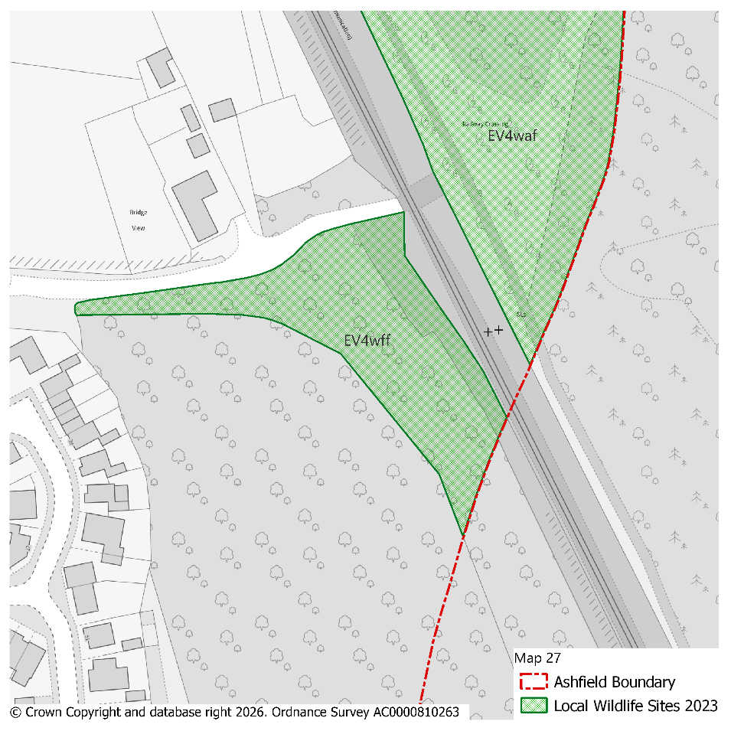 |  |  |  |  |  |  |  |  | Modifications Version  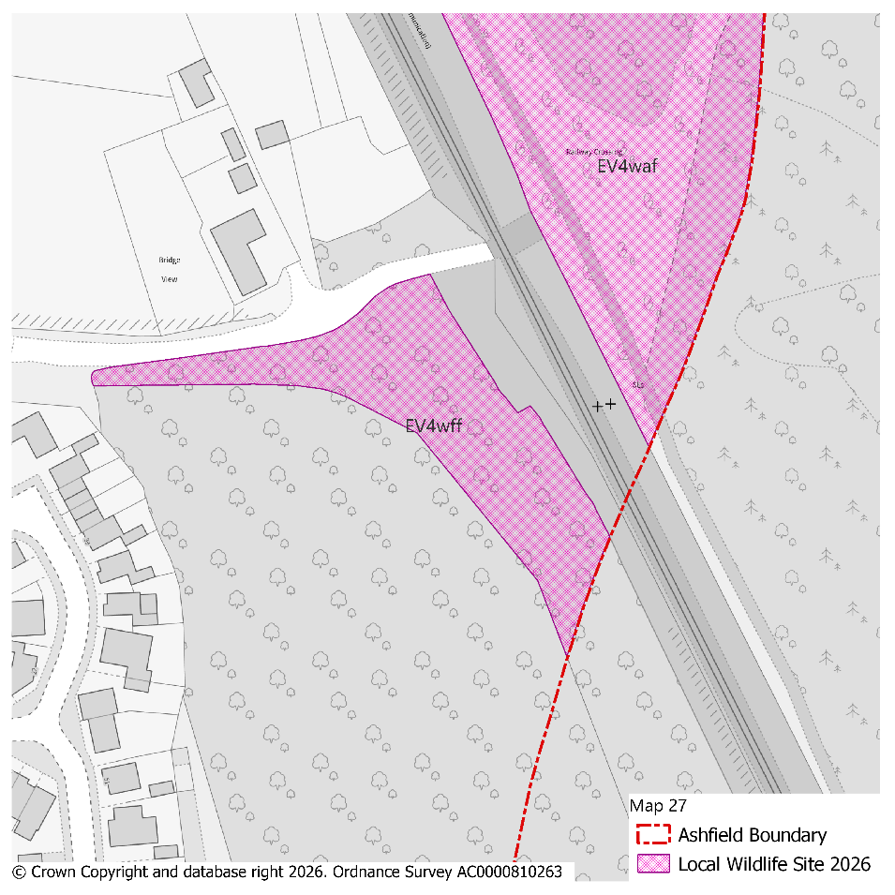
PMM Ref. | Local Plan Policy Ref. |  |  | Proposed Policies Map Modification
PMM50 | EV4: GI, Biodiversity & Geodiversity |  |  | Amend site boundary of Local Wildlife Site(s) EV4wg and EV4wfz to reflect more up to date information provided by the Nottinghamshire Biodiversity and Geodiversity Records Centre.  (Note: Any comments made in respect of this modification will be required to quote the PMM reference number and the relevant LWS reference number)
Submission Plan Version  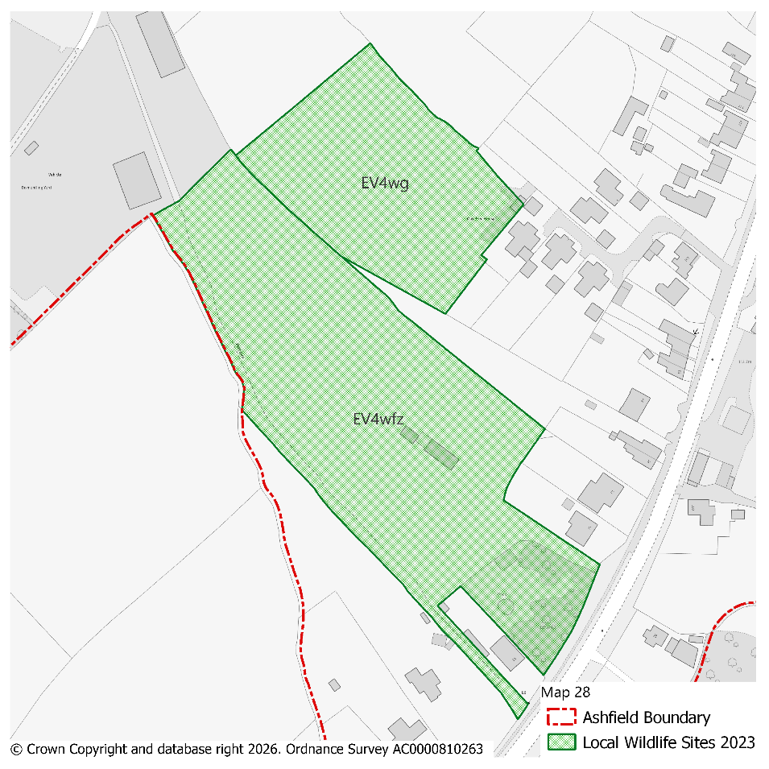 |  |  |  |  |  |  |  |  | Modifications Version  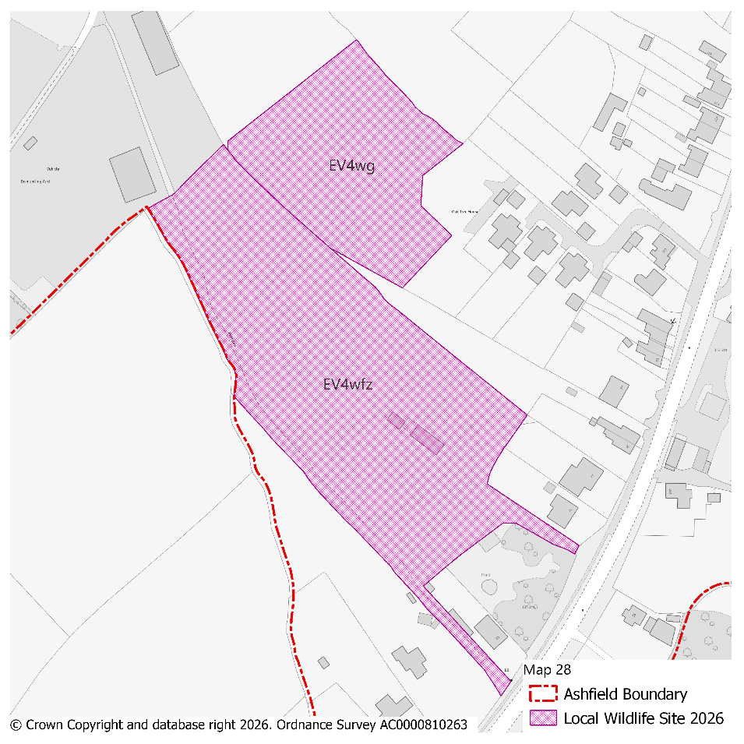
PMM Ref. | Local Plan Policy Ref. |  |  | Proposed Policies Map Modification
PMM51 | EV4: GI, Biodiversity & Geodiversity |  |  | Amend site boundary of Local Wildlife Site(s) EV4wb and EV4wdm to reflect more up to date information provided by the Nottinghamshire Biodiversity and Geodiversity Records Centre.  (Note: Any comments made in respect of this modification will be required to quote the PMM reference number and the relevant LWS reference number)
Submission Plan Version  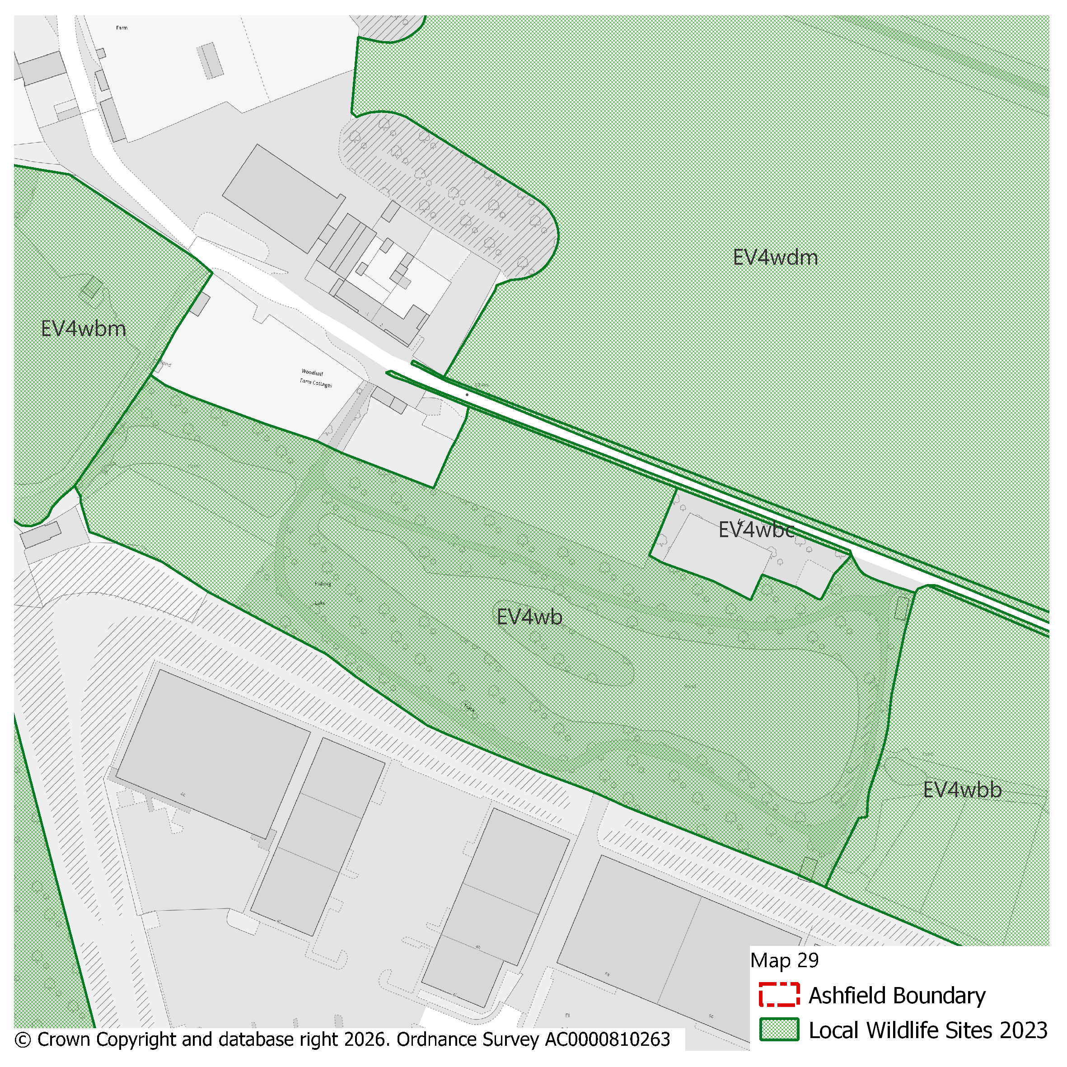 |  |  |  |  |  |  |  |  | Modifications Version  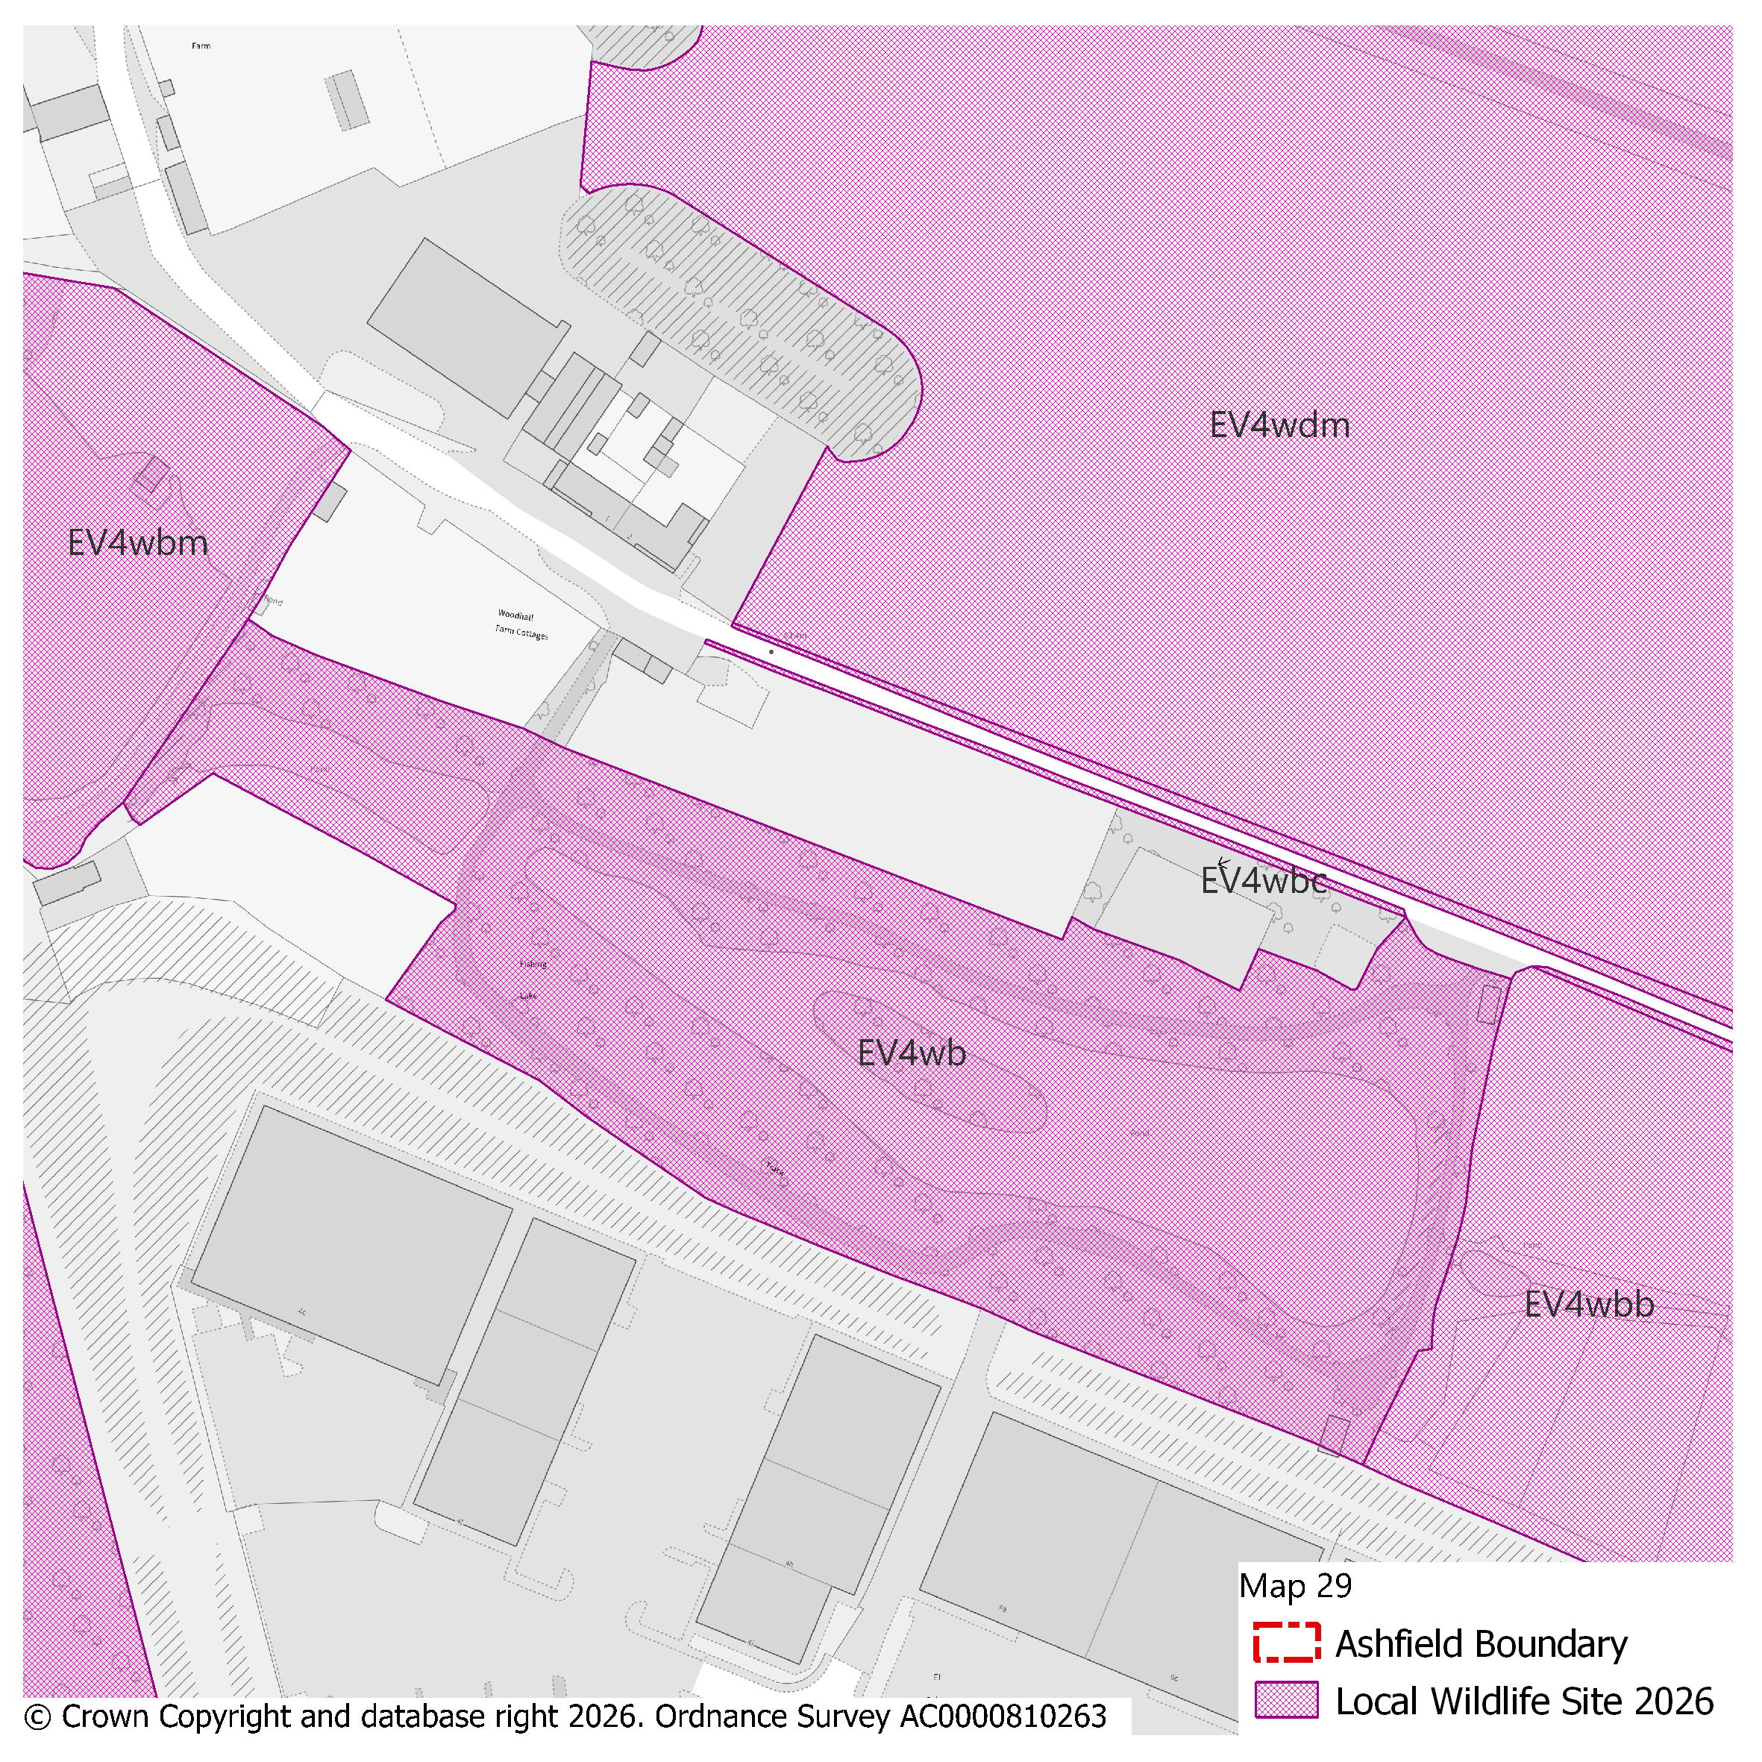
PMM Ref. | Local Plan Policy Ref. |  |  | Proposed Policies Map Modification
PMM52 | EV4: GI, Biodiversity & Geodiversity |  |  | Amend site boundary of Local Wildlife Site(s) EV4wds to reflect more up to date information provided by the Nottinghamshire Biodiversity and Geodiversity Records Centre.  (Note: Any comments made in respect of this modification will be required to quote the PMM reference number and the relevant LWS reference number)
Submission Plan Version  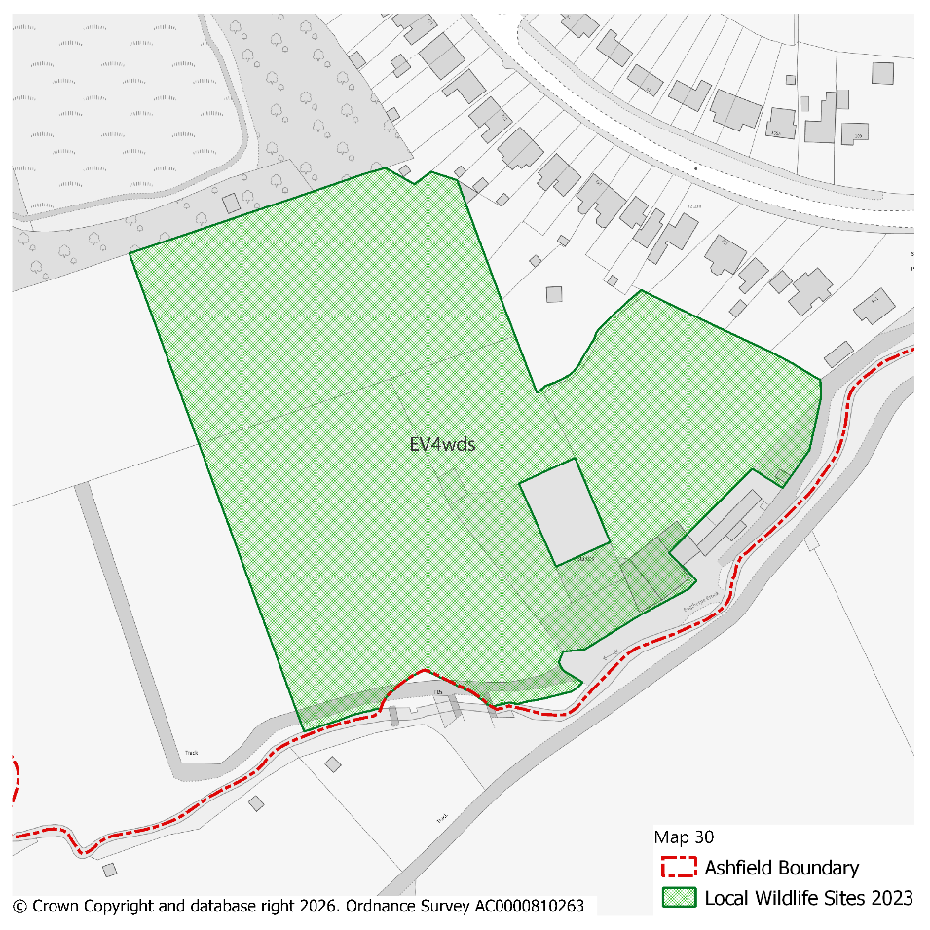 |  |  |  |  |  |  |  |  | Modifications Version  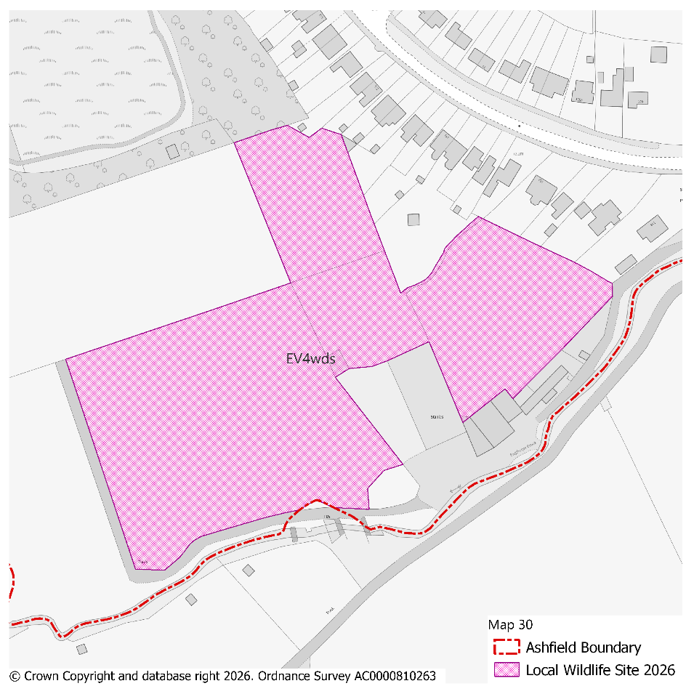
PMM Ref. | Local Plan Policy Ref. |  |  | Proposed Policies Map Modification
PMM53 | EV4: GI, Biodiversity & Geodiversity |  |  | Amend site boundary of Local Wildlife Site(s) EV4wgu to reflect more up to date information provided by the Nottinghamshire Biodiversity and Geodiversity Records Centre.  (Note: Any comments made in respect of this modification will be required to quote the PMM reference number and the relevant LWS reference number)
Submission Plan Version  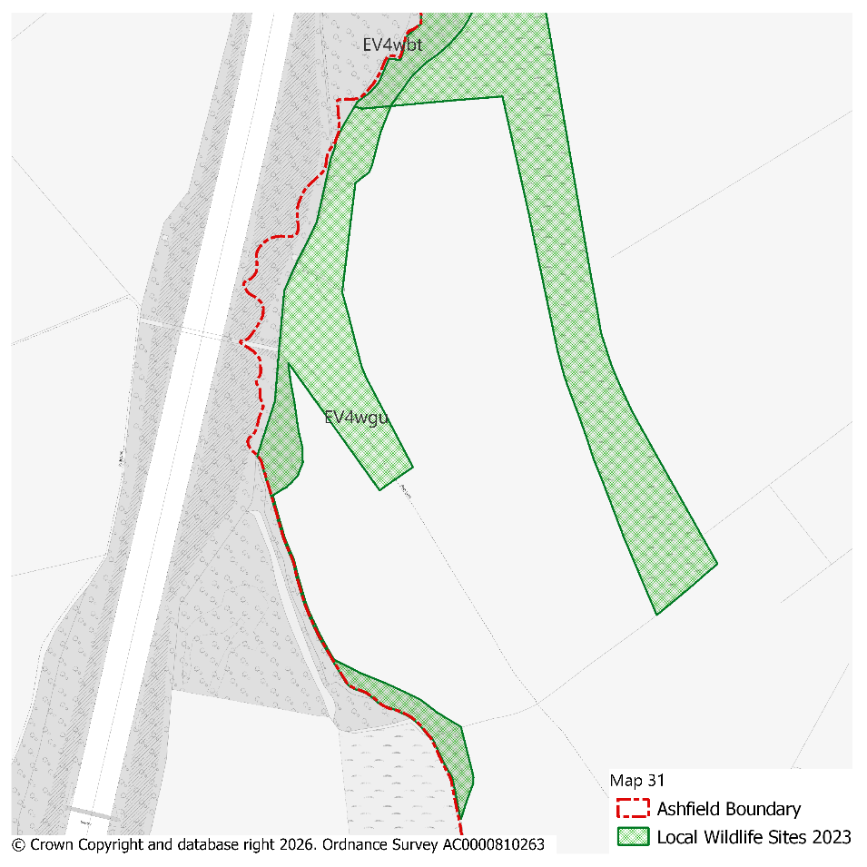 |  |  |  |  |  |  |  |  | Modifications Version  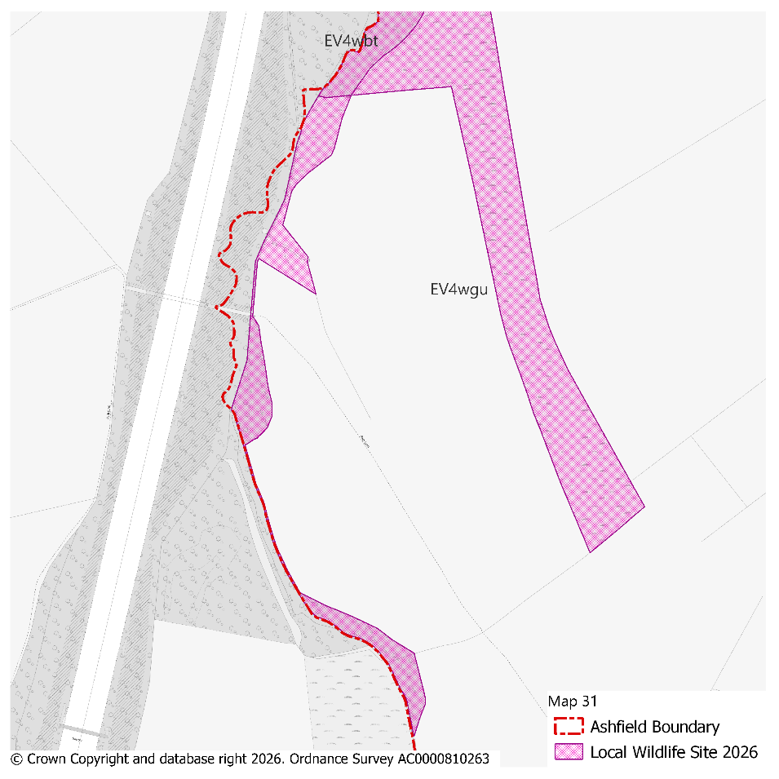
PMM Ref. | Local Plan Policy Ref. |  |  | Proposed Policies Map Modification
PMM54 | EV4: GI, Biodiversity & Geodiversity |  |  | Amend site boundary of Local Wildlife Site(s) EV4whl and EV4wl to reflect more up to date information provided by the Nottinghamshire Biodiversity and Geodiversity Records Centre.  (Note: Any comments made in respect of this modification will be required to quote the PMM reference number and the relevant LWS reference number)
Submission Plan Version  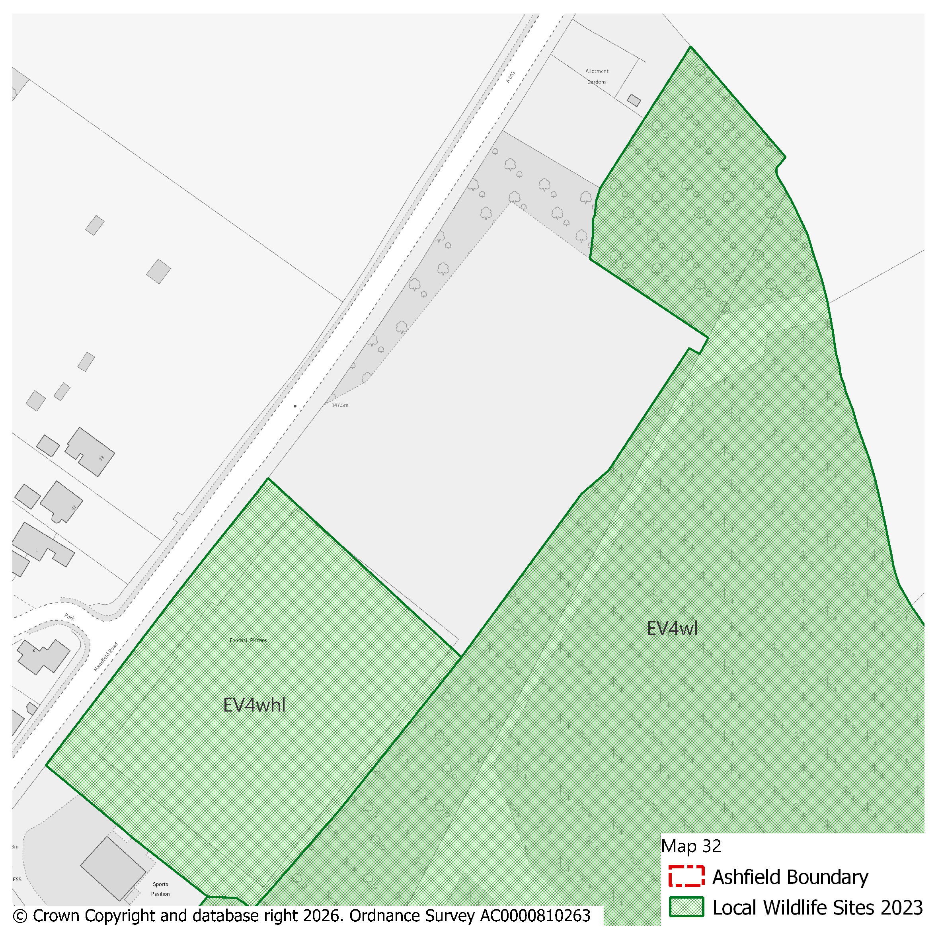 |  |  |  |  |  |  |  |  | Modifications Version  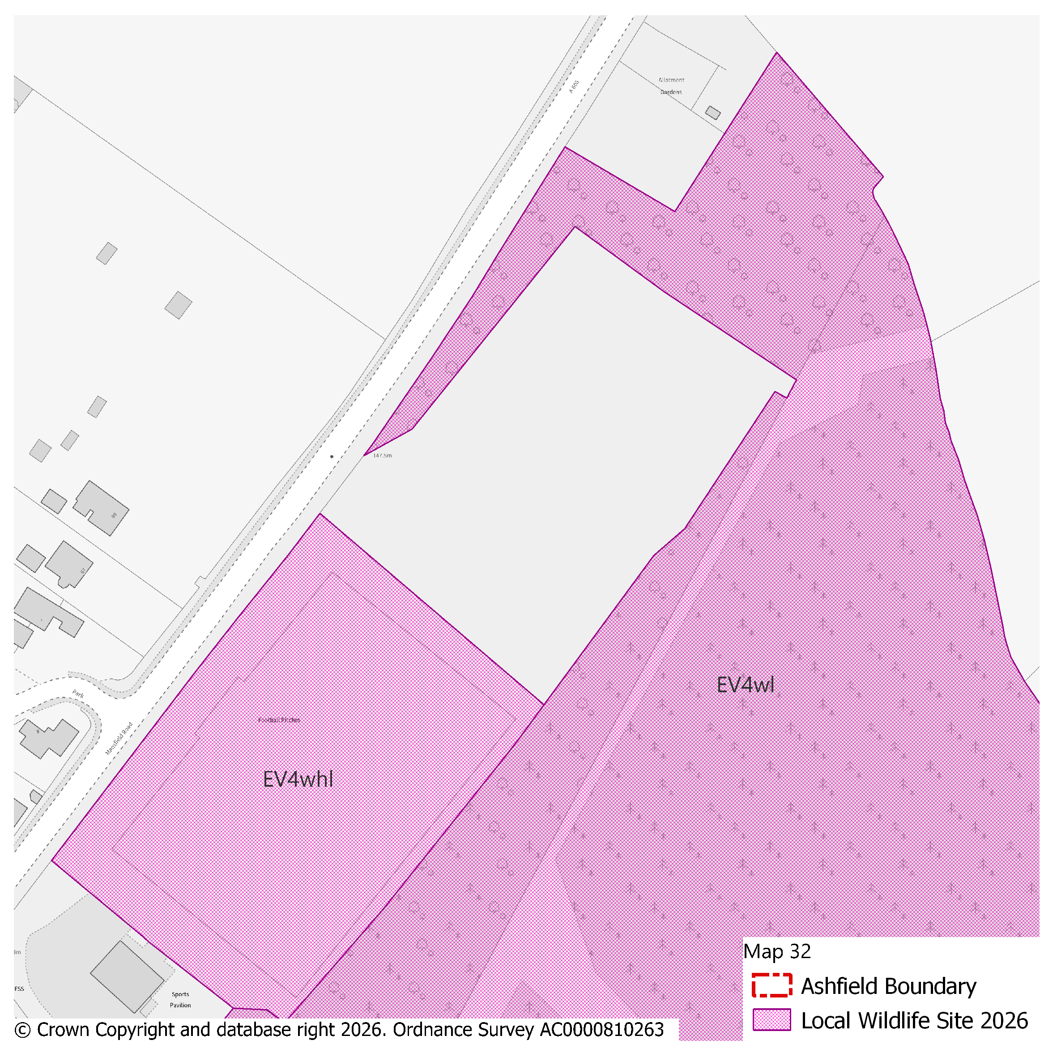
PMM Ref. | Local Plan Policy Ref. |  |  | Proposed Policies Map Modification
PMM55 | EV4: GI, Biodiversity & Geodiversity |  |  | Amend site boundary of Local Wildlife Site(s) EV4wp to reflect more up to date information provided by the Nottinghamshire Biodiversity and Geodiversity Records Centre.  (Note: Any comments made in respect of this modification will be required to quote the PMM reference number and the relevant LWS reference number)
Submission Plan Version  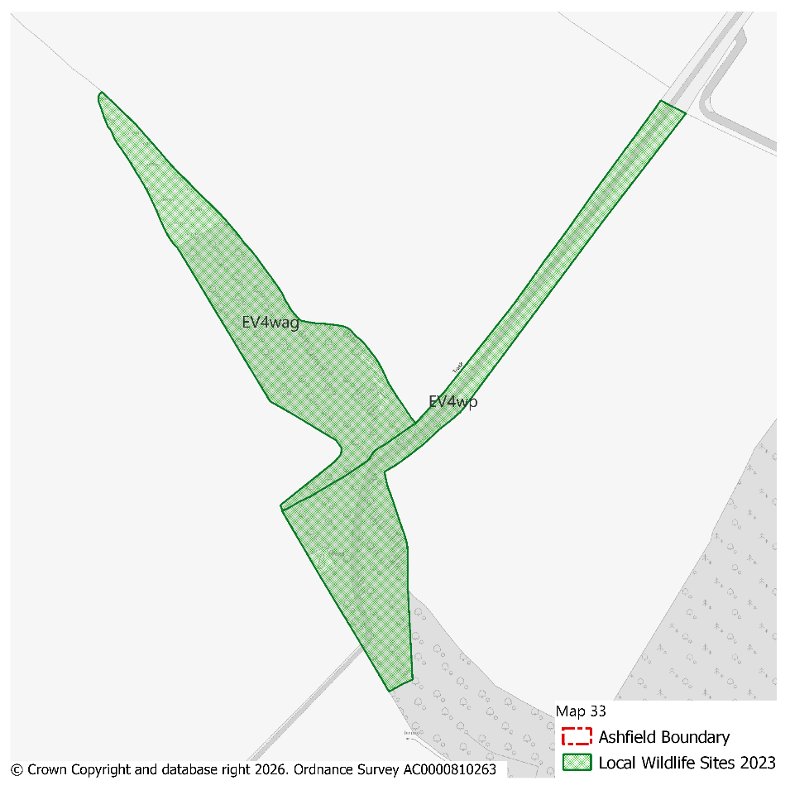 |  |  |  |  |  |  |  |  | Modifications Version  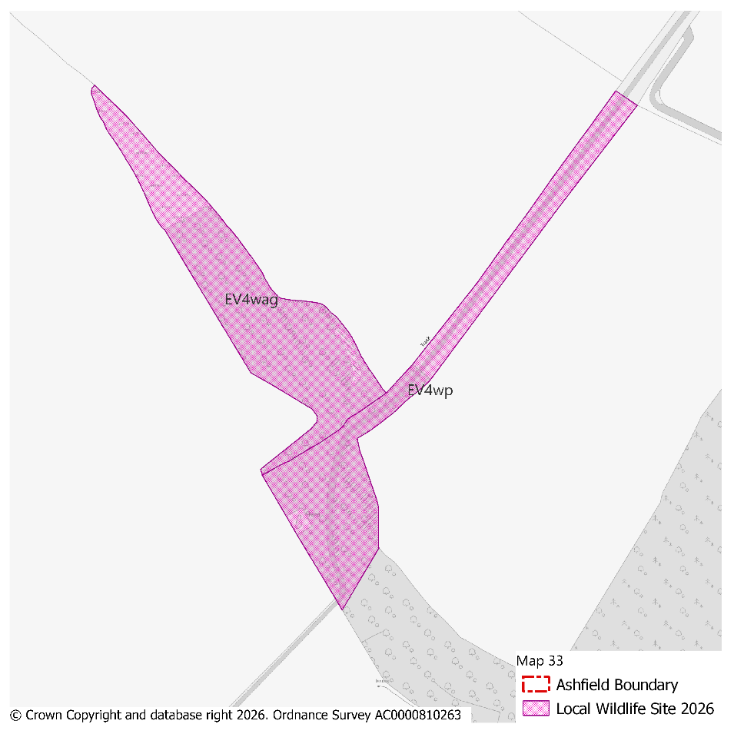
PMM Ref. | Local Plan Policy Ref. |  |  | Proposed Policies Map Modification
PMM56 | EV4: GI, Biodiversity & Geodiversity |  |  | Amend site boundary of Local Wildlife Site(s) EV4weq and EV4wcx to reflect more up to date information provided by the Nottinghamshire Biodiversity and Geodiversity Records Centre.  (Note: Any comments made in respect of this modification will be required to quote the PMM reference number and the relevant LWS reference number)
Submission Plan Version  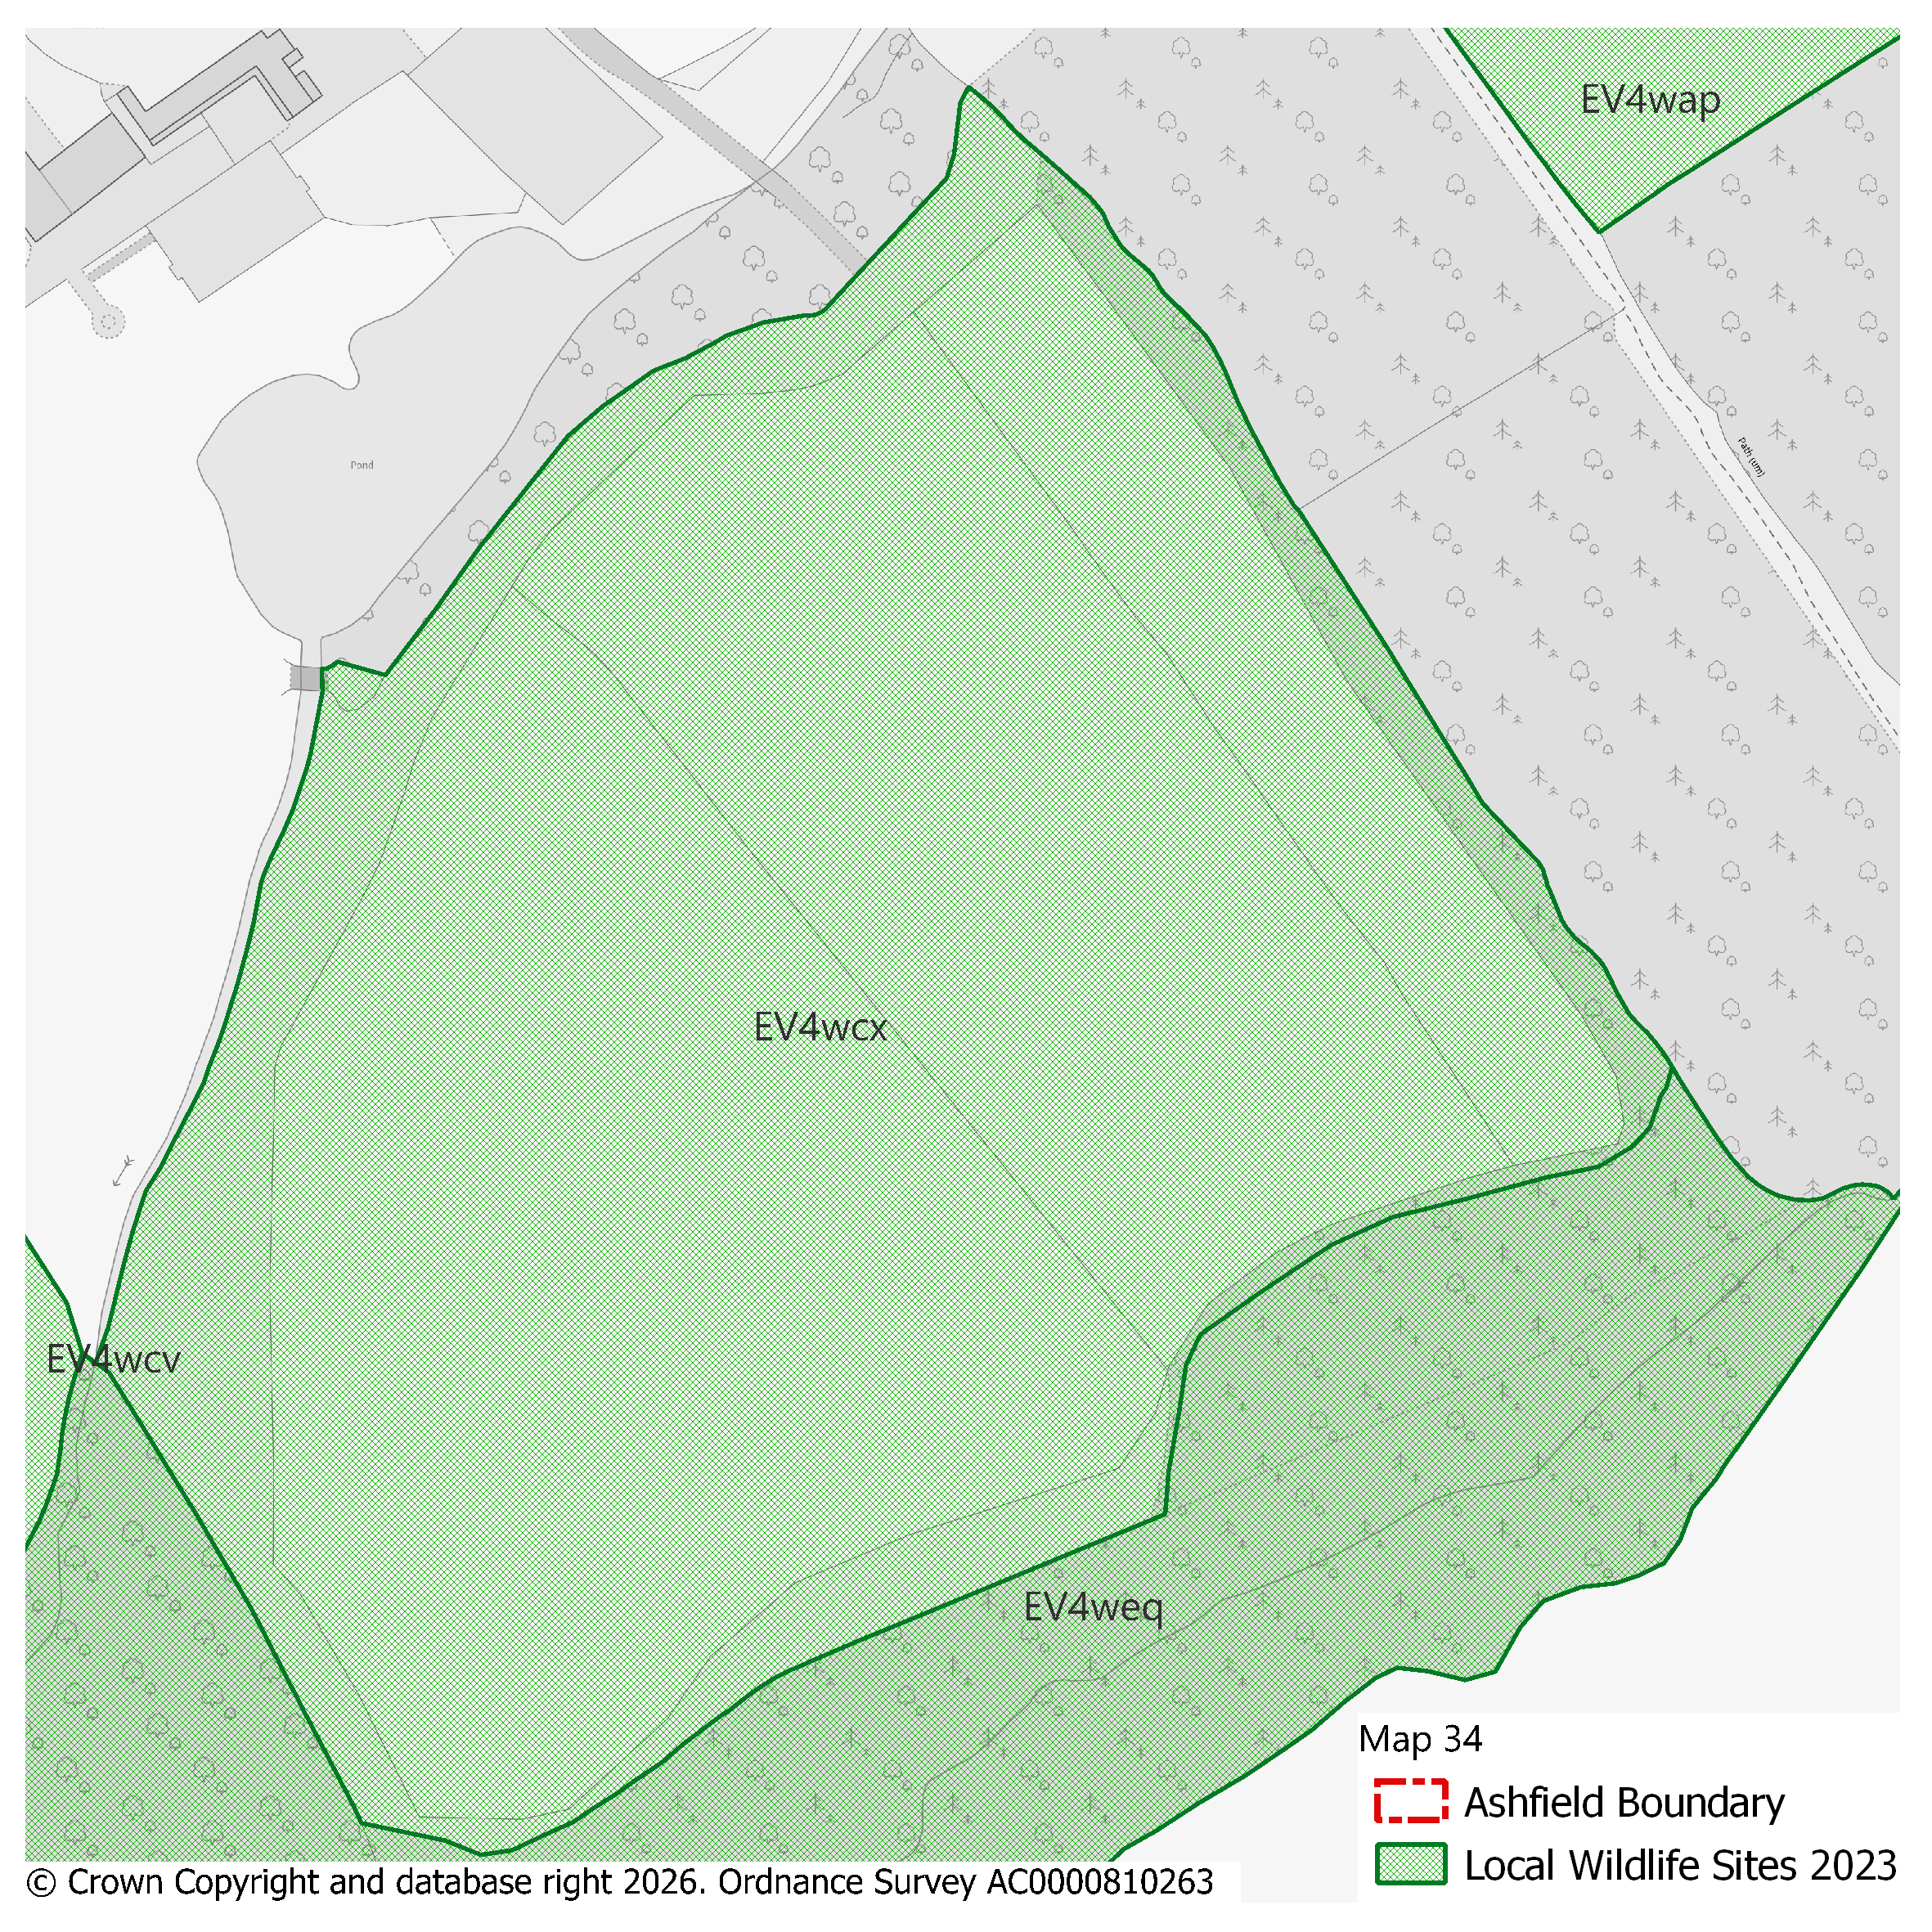 |  |  |  |  |  |  |  |  | Modifications Version  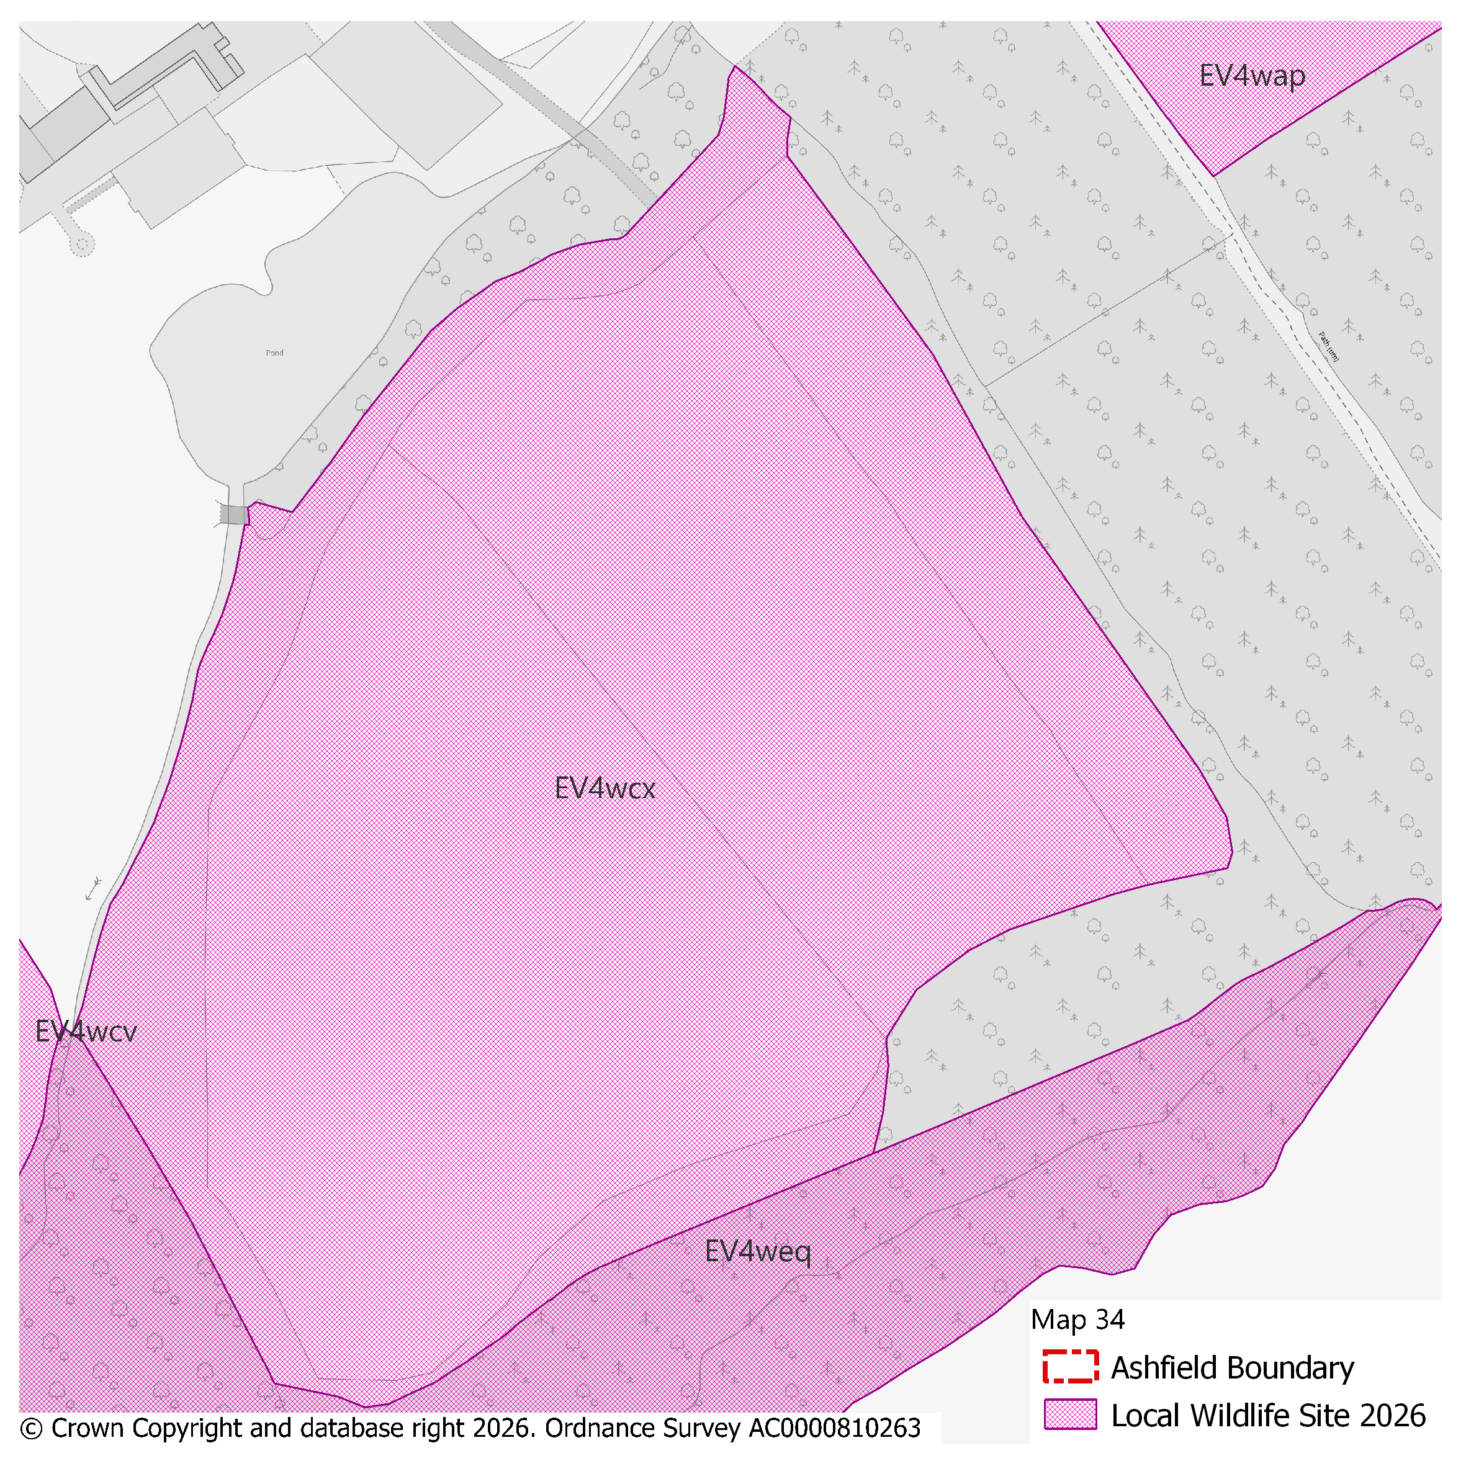
PMM Ref. | Local Plan Policy Ref. |  |  | Proposed Policies Map Modification
PMM57 | EV4: GI, Biodiversity & Geodiversity |  |  | Amend site boundary of Local Wildlife Site(s) EV4whe to reflect more up to date information provided by the Nottinghamshire Biodiversity and Geodiversity Records Centre.  (Note: Any comments made in respect of this modification will be required to quote the PMM reference number and the relevant LWS reference number)
Submission Plan Version  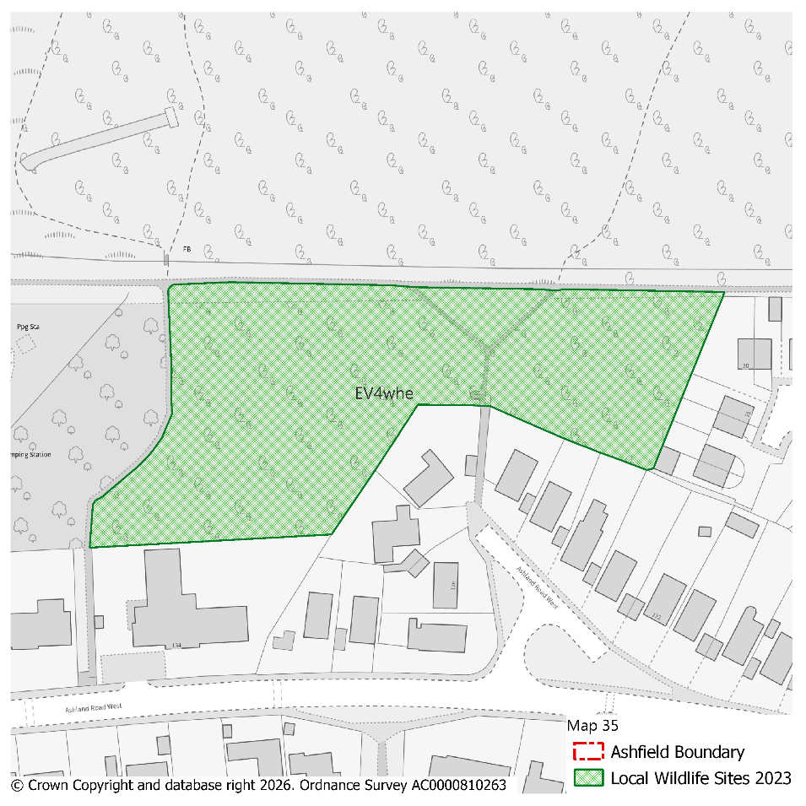 |  |  |  |  |  |  |  |  | Modifications Version  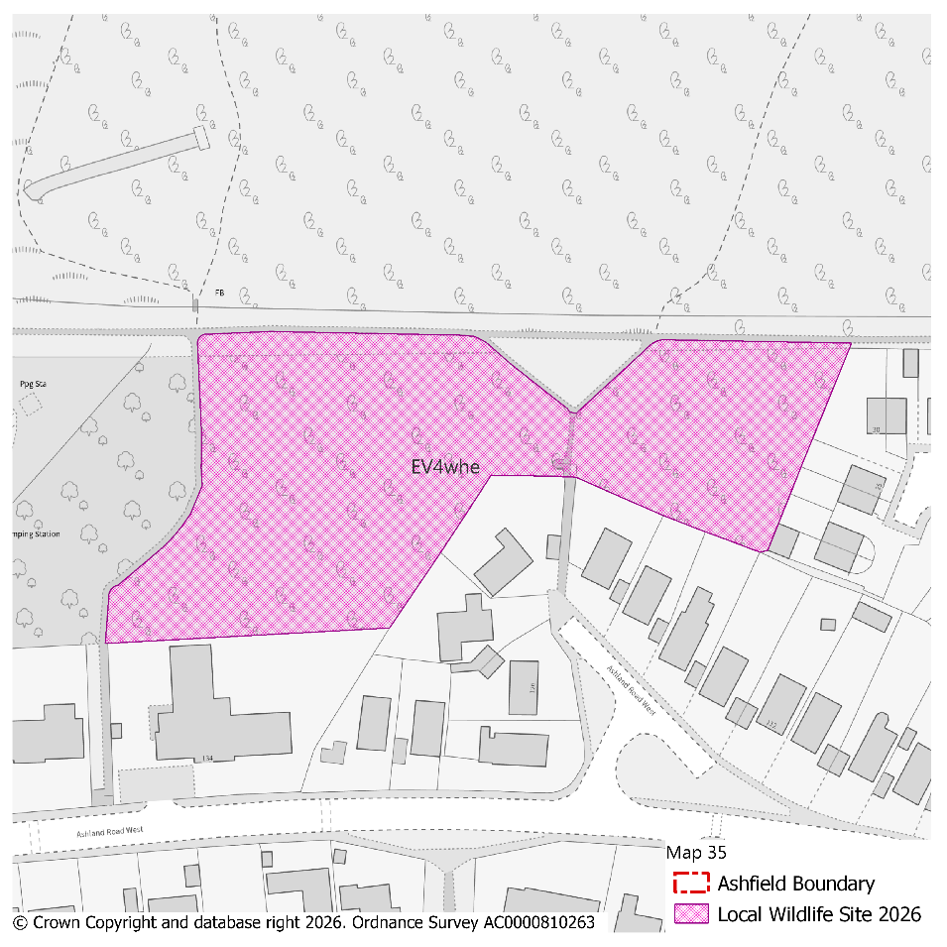
PMM Ref. | Local Plan Policy Ref. |  |  | Proposed Policies Map Modification
PMM58 | EV4: GI, Biodiversity & Geodiversity |  |  | Amend site boundary of Local Wildlife Site(s) EV4wbh to reflect more up to date information provided by the Nottinghamshire Biodiversity and Geodiversity Records Centre.  (Note: Any comments made in respect of this modification will be required to quote the PMM reference number and the relevant LWS reference number)
Submission Plan Version  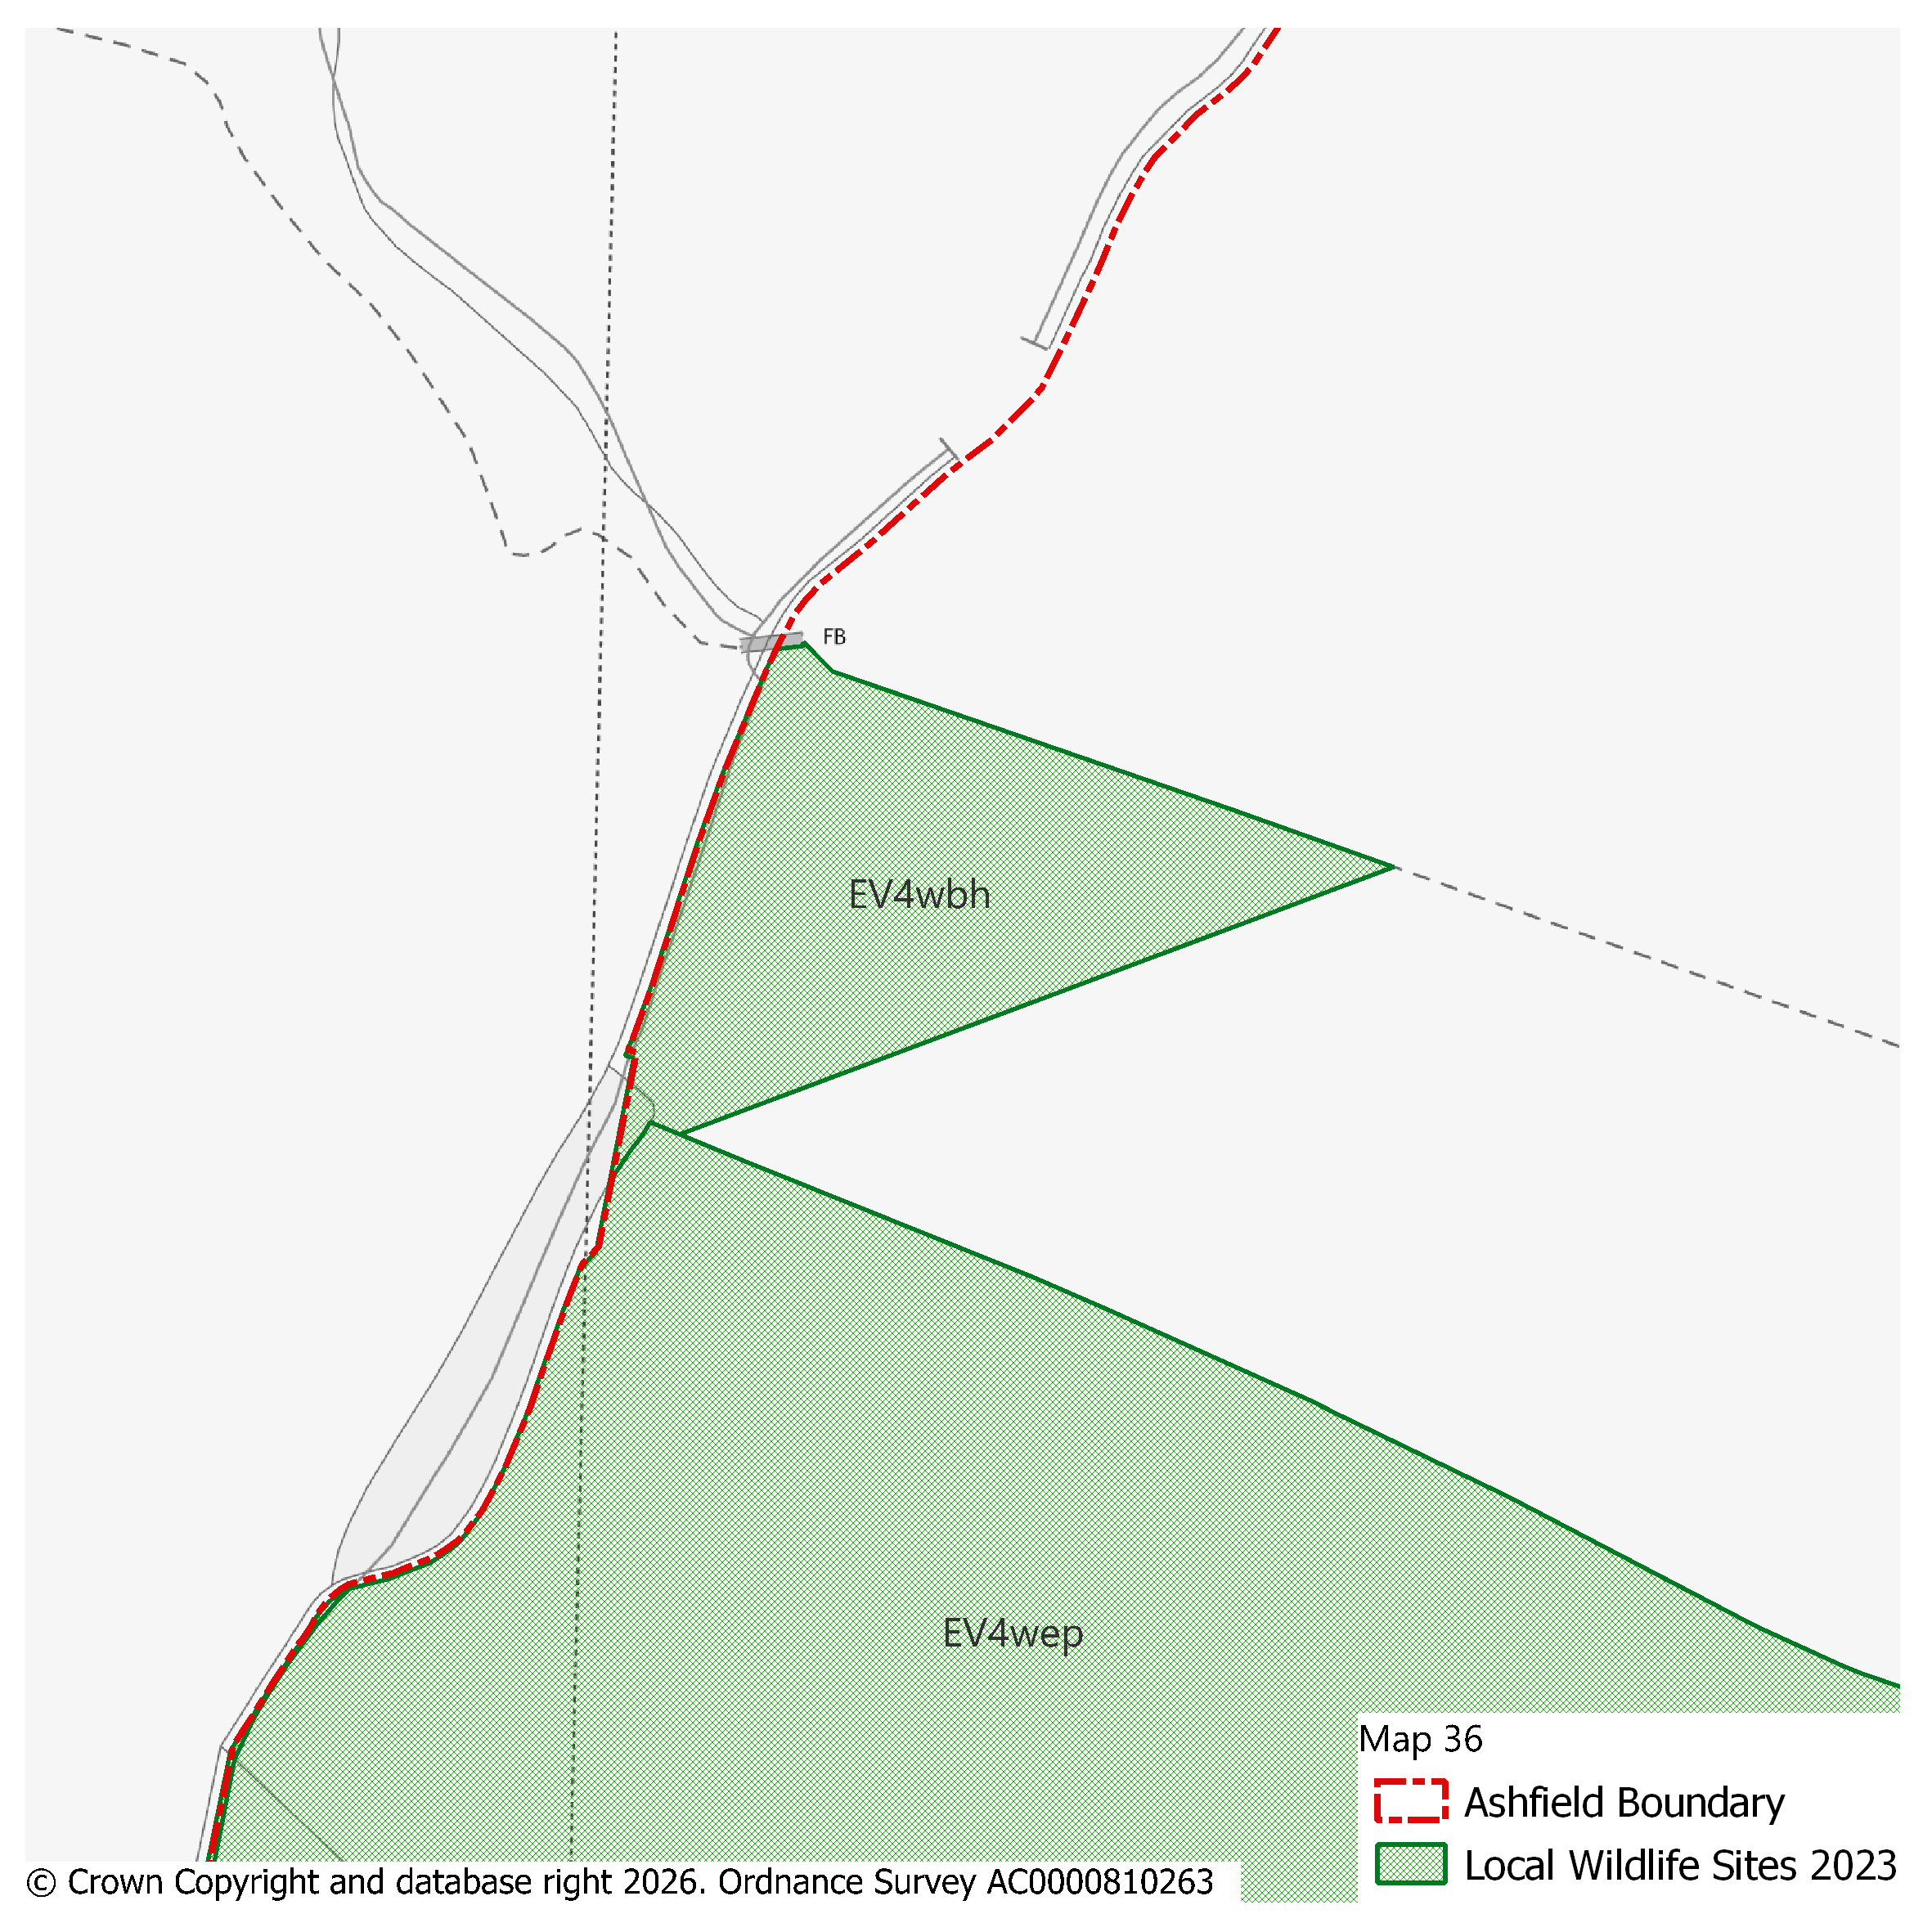 |  |  |  |  |  |  |  |  | Modifications Version  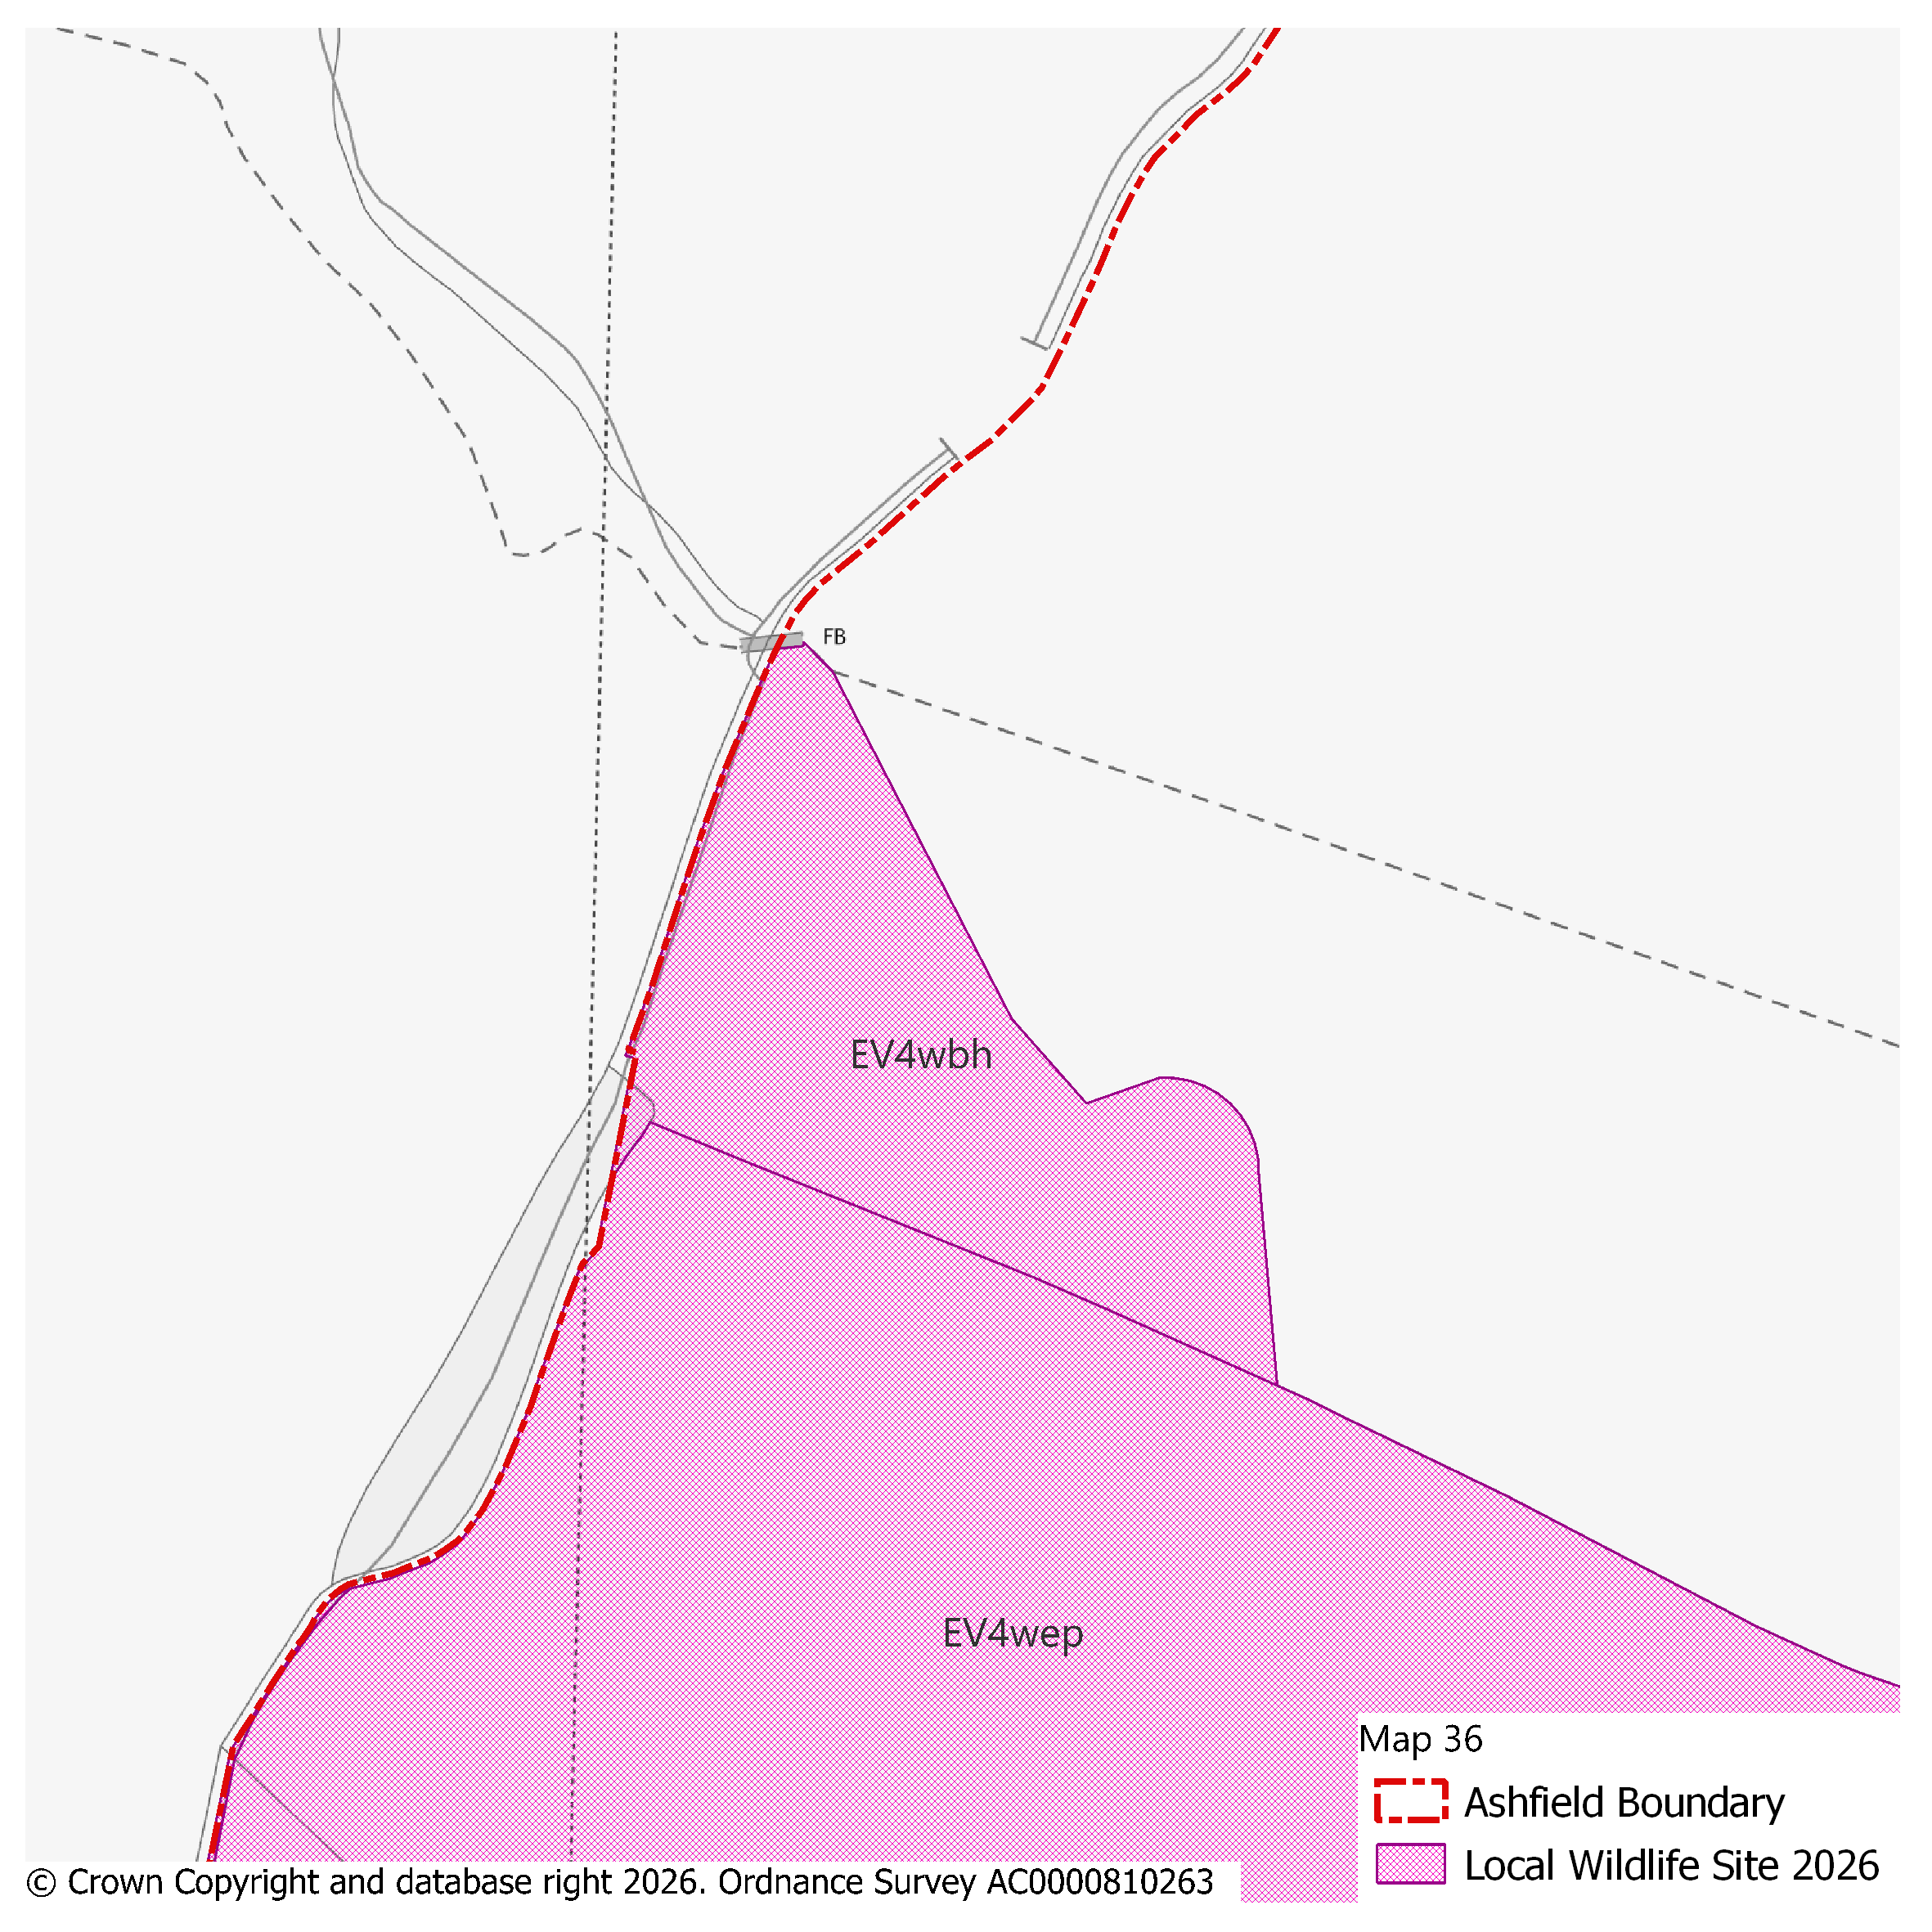
PMM Ref. | Local Plan Policy Ref. |  |  | Proposed Policies Map Modification
PMM59 | EV4: GI, Biodiversity & Geodiversity |  |  | Amend site boundary of Local Wildlife Site(s) EV4waj to reflect more up to date information provided by the Nottinghamshire Biodiversity and Geodiversity Records Centre.  (Note: Any comments made in respect of this modification will be required to quote the PMM reference number and the relevant LWS reference number)
Submission Plan Version  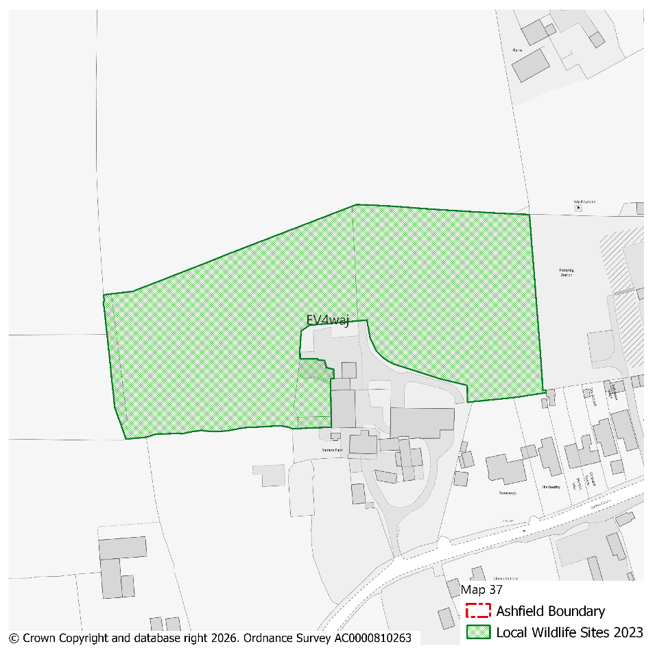 |  |  |  |  |  |  |  |  | Modifications Version  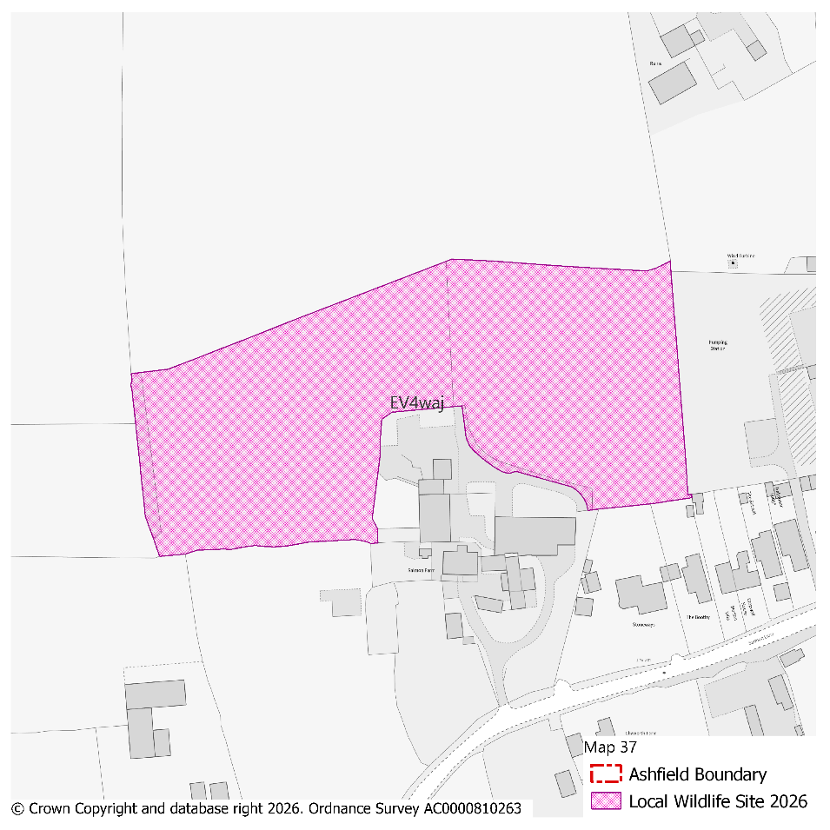
PMM Ref. | Local Plan Policy Ref. |  |  | Proposed Policies Map Modification
PMM60 | EV4: GI, Biodiversity & Geodiversity |  |  | Amend site boundary of Local Wildlife Site(s) EV4wet to reflect more up to date information provided by the Nottinghamshire Biodiversity and Geodiversity Records Centre.  (Note: Any comments made in respect of this modification will be required to quote the PMM reference number and the relevant LWS reference number)
Submission Plan Version  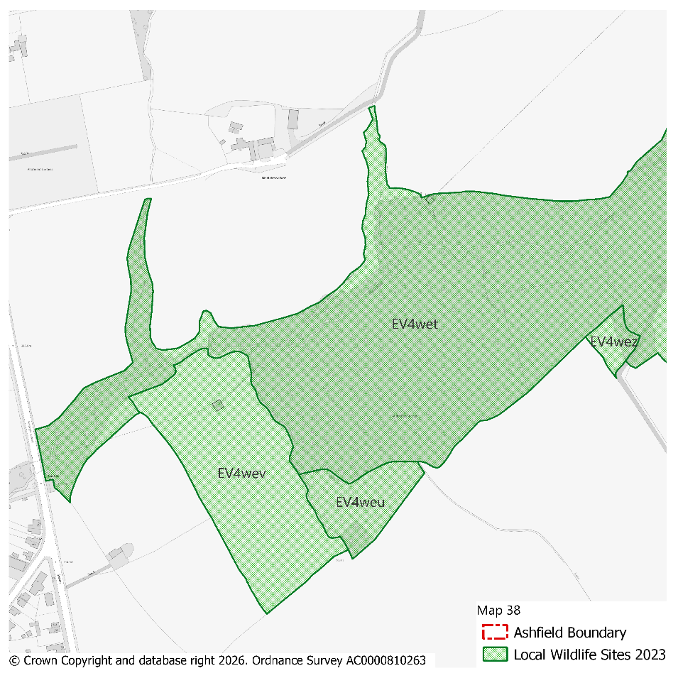 |  |  |  |  |  |  |  |  | Modifications Version  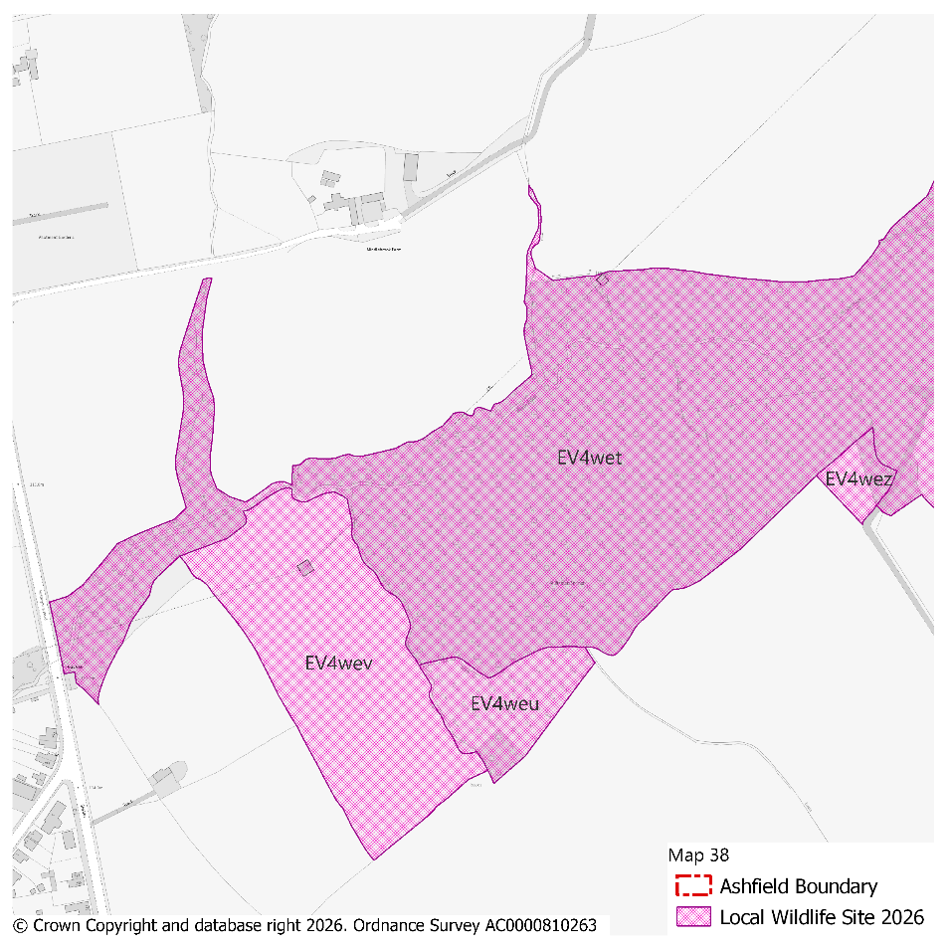
PMM Ref. | Local Plan Policy Ref. |  |  | Proposed Policies Map Modification
PMM61 | EV4: GI, Biodiversity & Geodiversity |  |  | Amend site boundary of Local Wildlife Site(s) EV4weo to reflect more up to date information provided by the Nottinghamshire Biodiversity and Geodiversity Records Centre.  (Note: Any comments made in respect of this modification will be required to quote the PMM reference number and the relevant LWS reference number)
Submission Plan Version  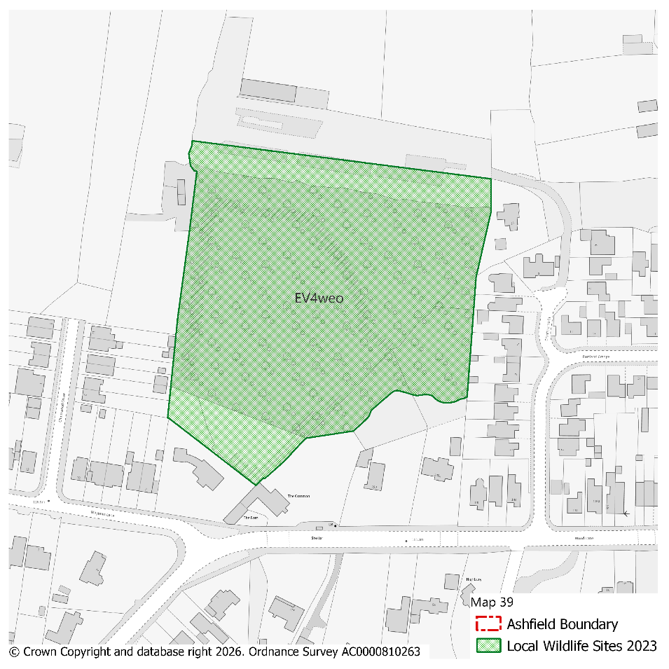 |  |  |  |  |  |  |  |  | Modifications Version  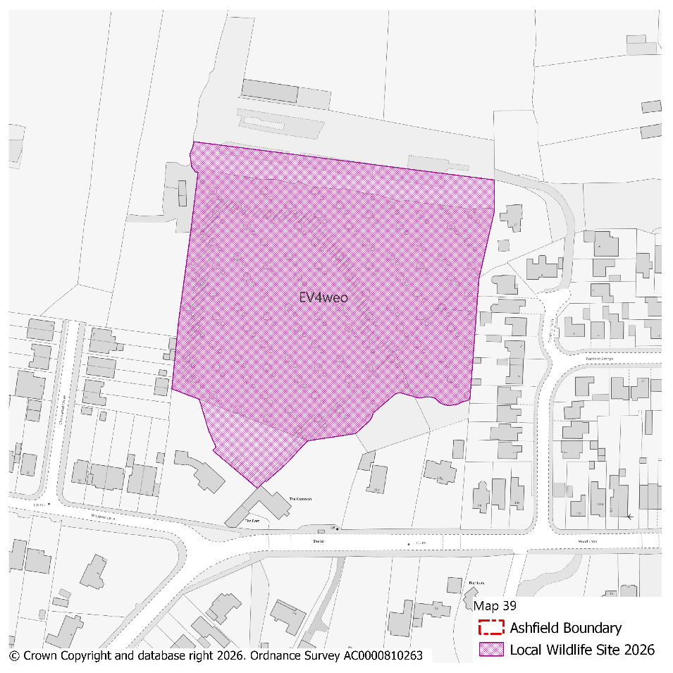
PMM Ref. | Local Plan Policy Ref. |  |  | Proposed Policies Map Modification
PMM62 | EV4: GI, Biodiversity & Geodiversity |  |  | Amend site boundary of Local Wildlife Site(s) EV4wft to reflect more up to date information provided by the Nottinghamshire Biodiversity and Geodiversity Records Centre.  (Note: Any comments made in respect of this modification will be required to quote the PMM reference number and the relevant LWS reference number)
Submission Plan Version  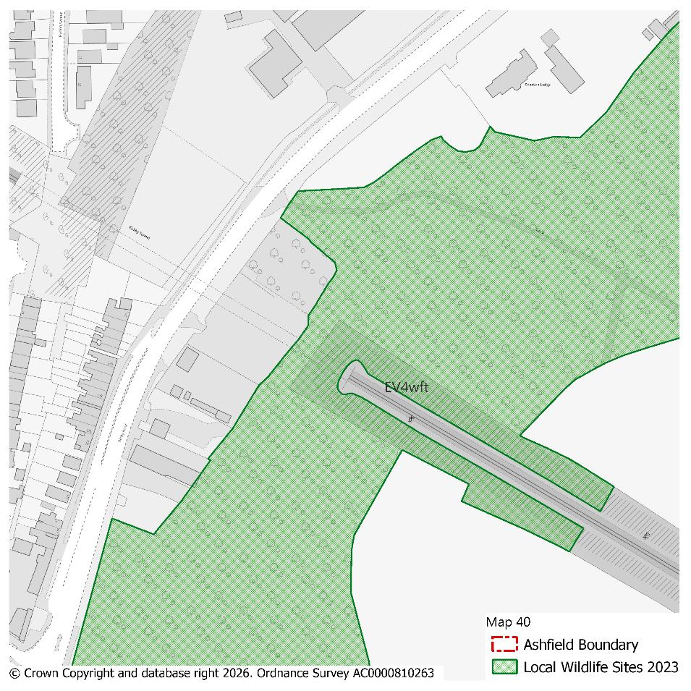 |  |  |  |  |  |  |  |  | Modifications Version  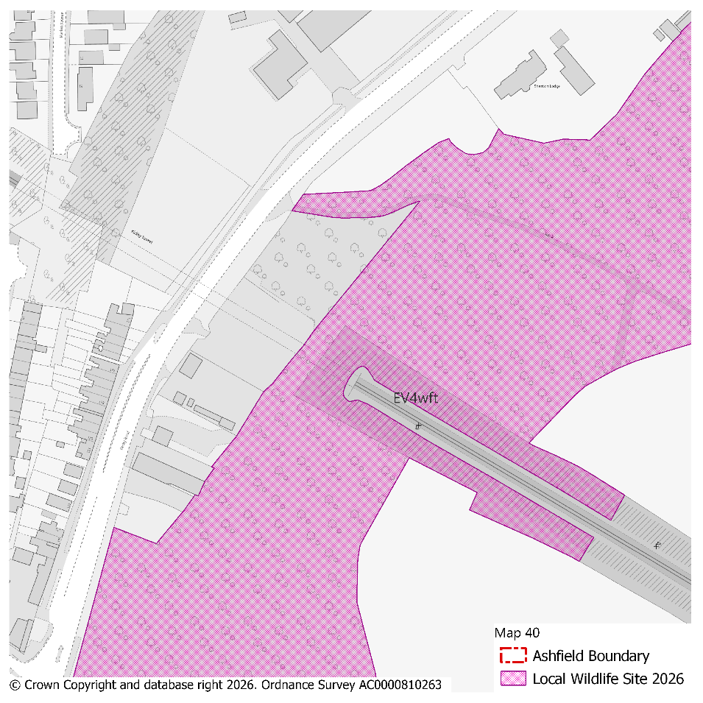
PMM Ref. | Local Plan Policy Ref. |  |  | Proposed Policies Map Modification
PMM63 | EV4: GI, Biodiversity & Geodiversity |  |  | Amend site boundary of Local Wildlife Site(s) EV4wgk and EV4wgj to reflect more up to date information provided by the Nottinghamshire Biodiversity and Geodiversity Records Centre.  (Note: Any comments made in respect of this modification will be required to quote the PMM reference number and the relevant LWS reference number)
Submission Plan Version  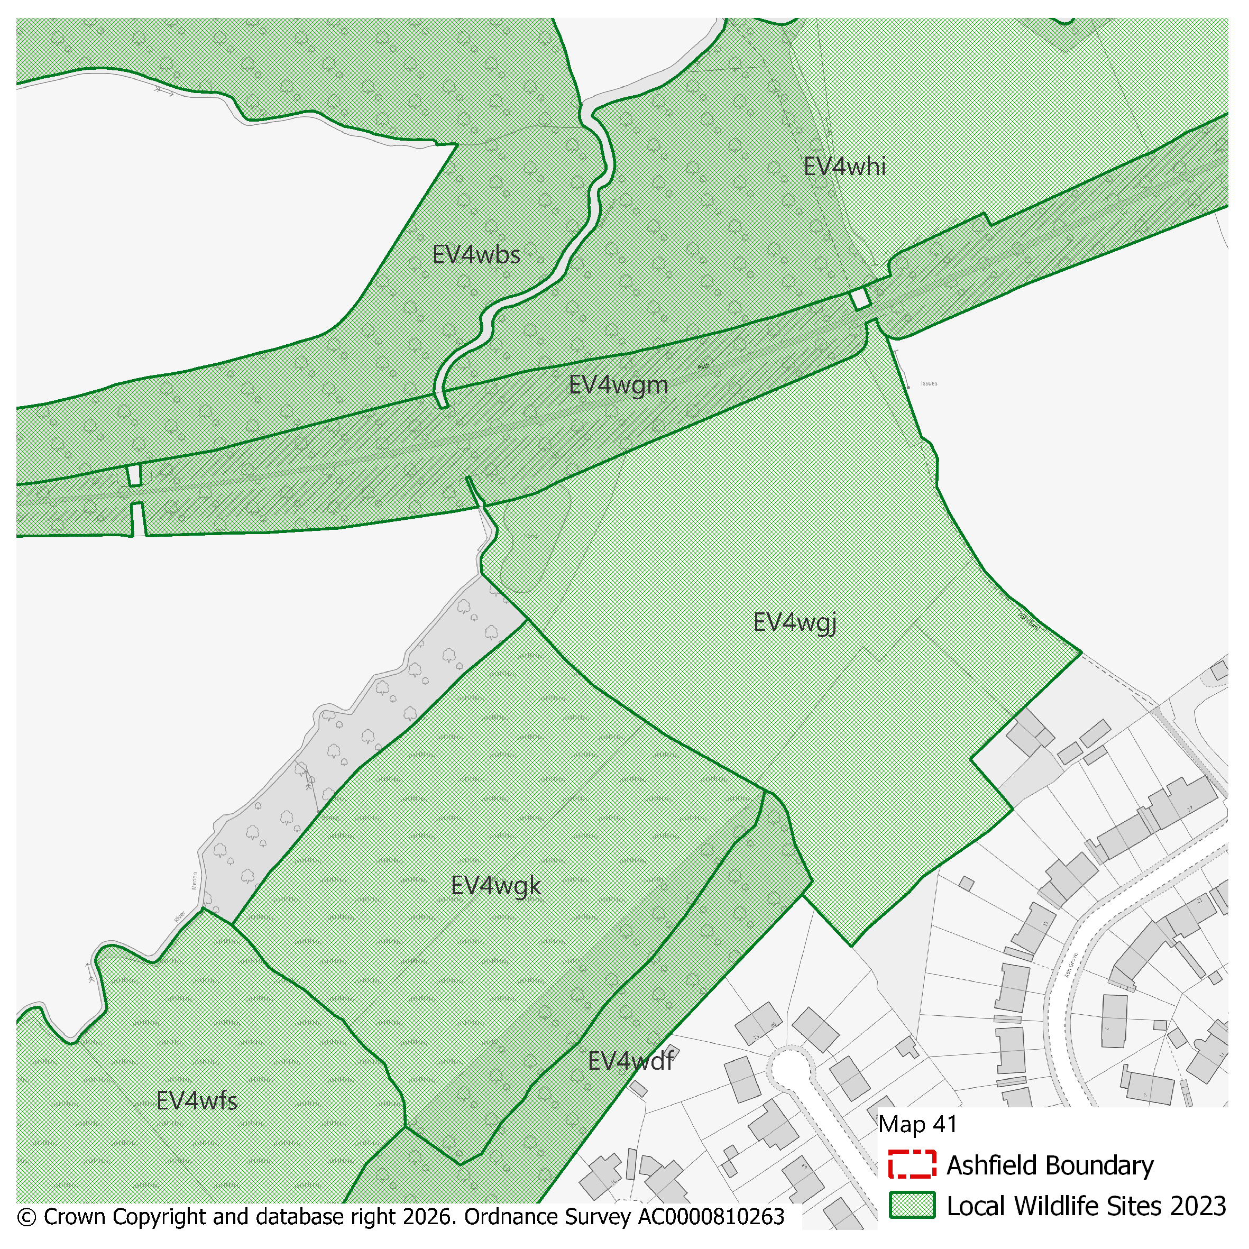 |  |  |  |  |  |  |  |  | Modifications Version  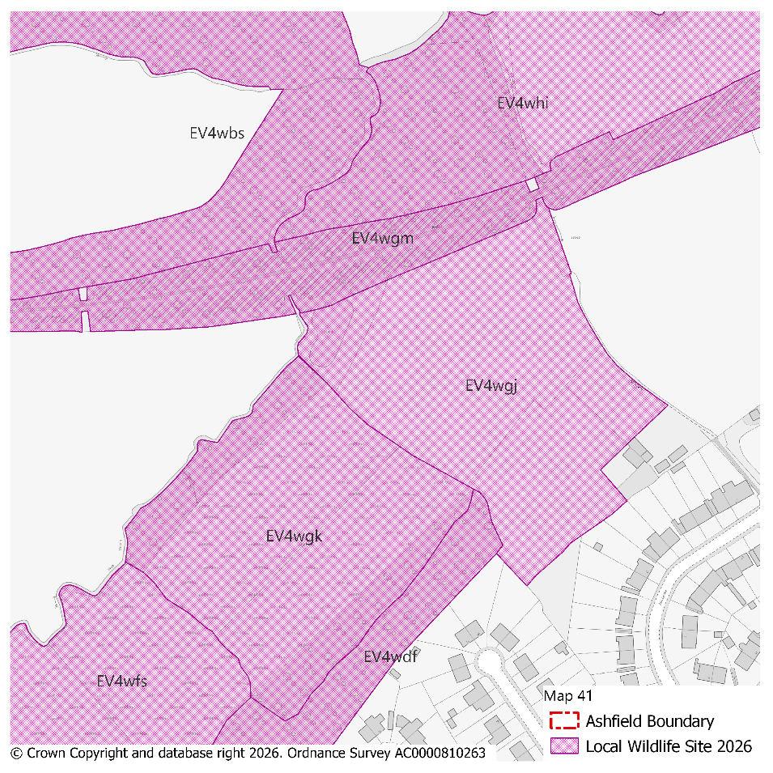
PMM Ref. | Local Plan Policy Ref. |  |  | Proposed Policies Map Modification
PMM64 | EV4: GI, Biodiversity & Geodiversity |  |  | Amend site boundary of Local Wildlife Site(s) EV4wat to reflect more up to date information provided by the Nottinghamshire Biodiversity and Geodiversity Records Centre.  (Note: Any comments made in respect of this modification will be required to quote the PMM reference number and the relevant LWS reference number)
Submission Plan Version  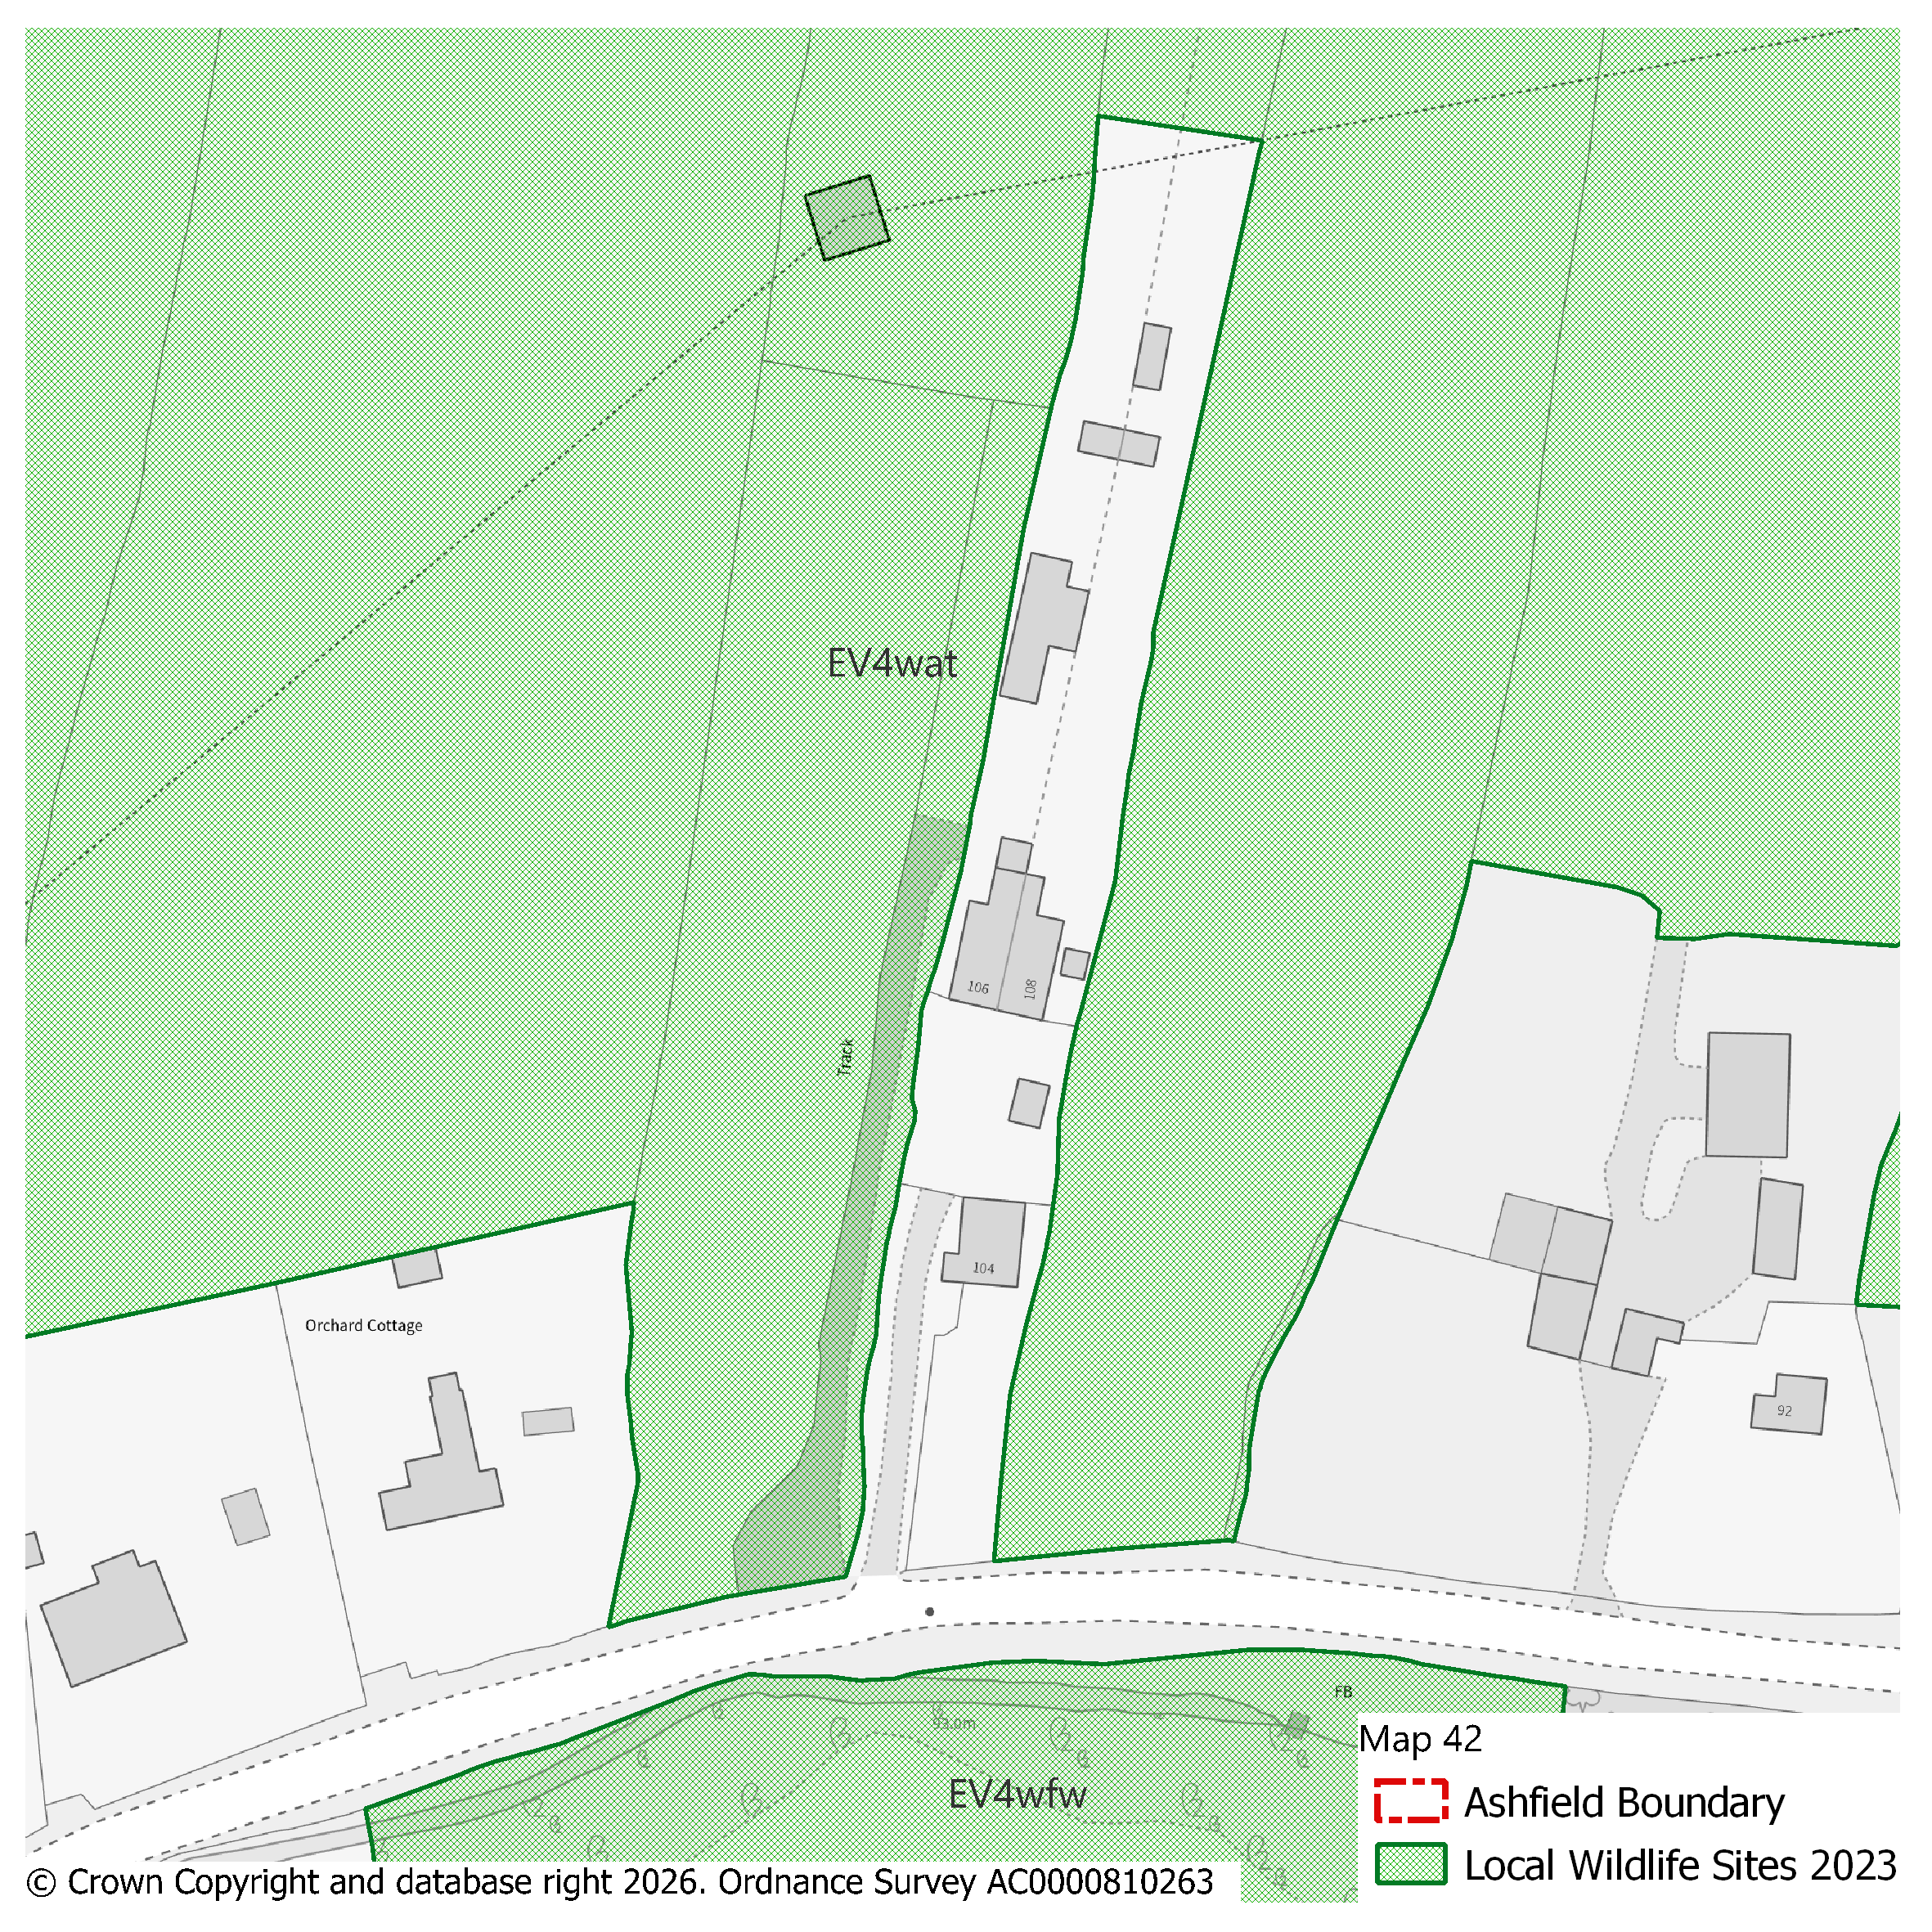 |  |  |  |  |  |  |  |  | Modifications Version  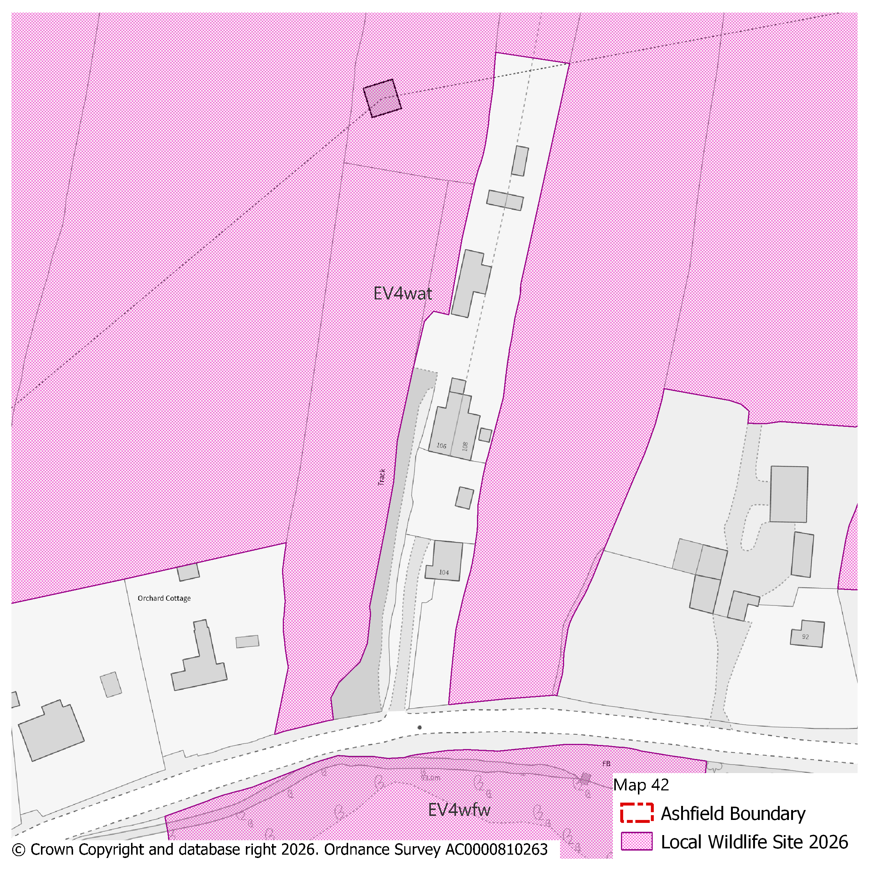
PMM Ref. | Local Plan Policy Ref. |  |  | Proposed Policies Map Modification
PMM65 | EV4: GI, Biodiversity & Geodiversity |  |  | Amend site boundary of Local Wildlife Site(s) EV4wby and EV4wbx to reflect more up to date information provided by the Nottinghamshire Biodiversity and Geodiversity Records Centre.  (Note: Any comments made in respect of this modification will be required to quote the PMM reference number and the relevant LWS reference number)
Submission Plan Version  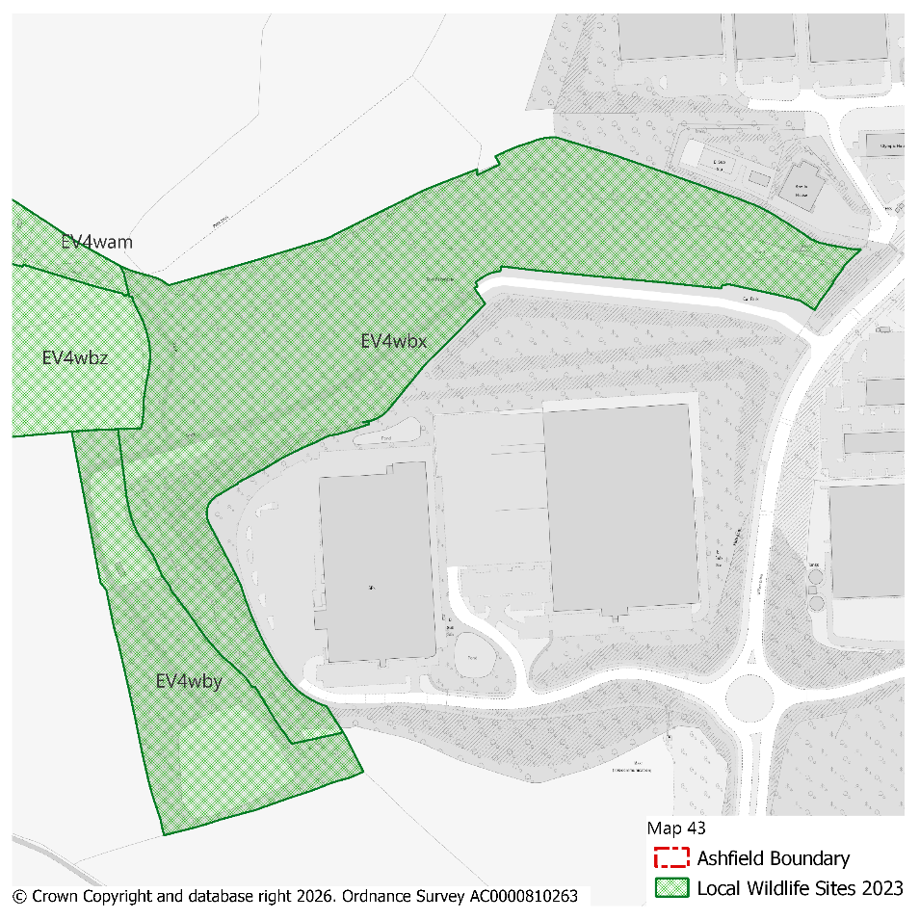 |  |  |  |  |  |  |  |  | Modifications Version  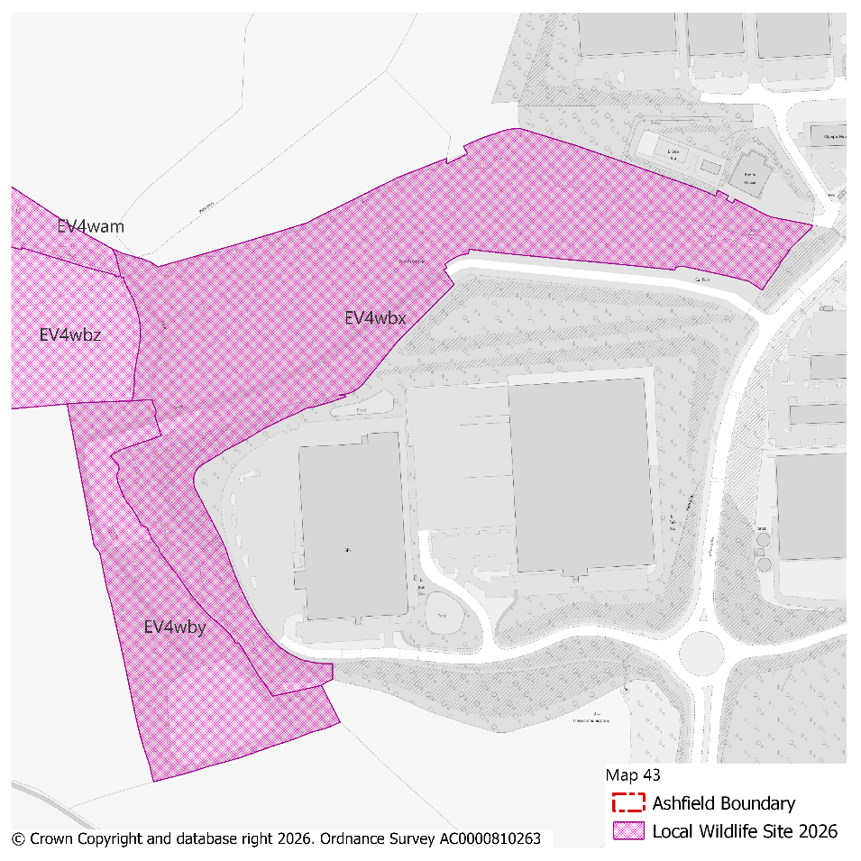
PMM Ref. | Local Plan Policy Ref. |  |  | Proposed Policies Map Modification
PMM66 | EV4: GI, Biodiversity & Geodiversity |  |  | Amend site boundary of Local Wildlife Site(s) EV4wfu to reflect more up to date information provided by the Nottinghamshire Biodiversity and Geodiversity Records Centre.  (Note: Any comments made in respect of this modification will be required to quote the PMM reference number and the relevant LWS reference number)
Submission Plan Version  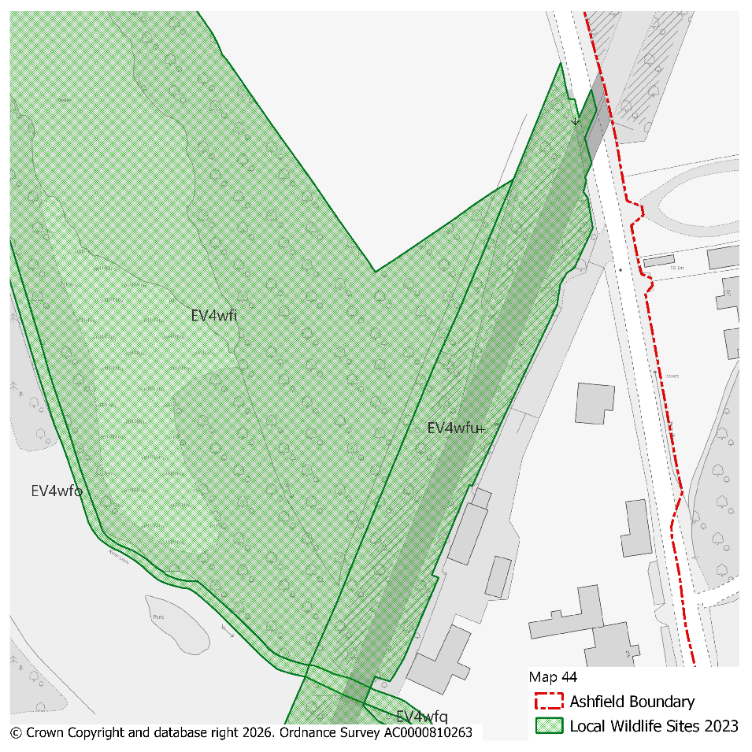 |  |  |  |  |  |  |  |  | Modifications Version  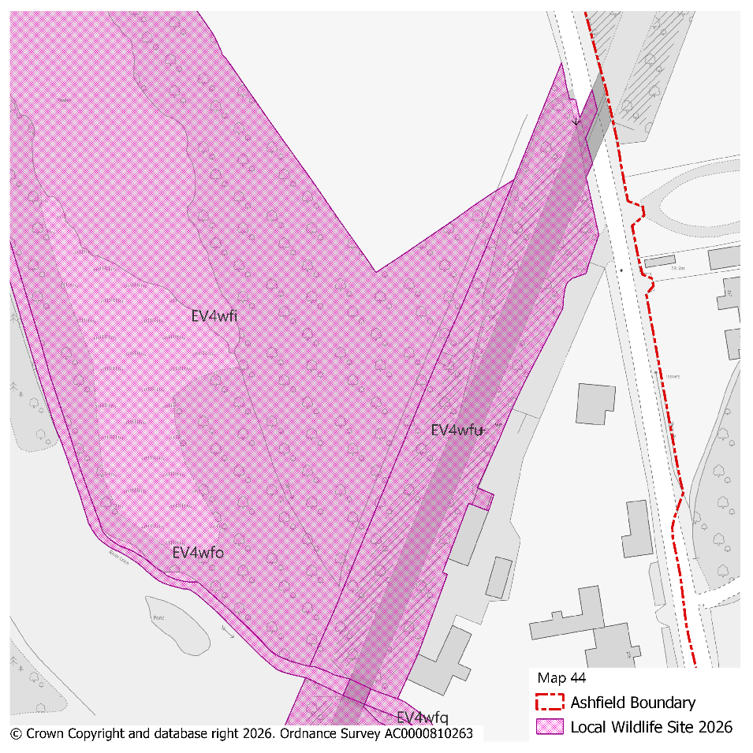
PMM Ref. | Local Plan Policy Ref. |  |  | Proposed Policies Map Modification
PMM67 | EV4: GI, Biodiversity & Geodiversity |  |  | Amend site boundary of Local Wildlife Site(s) EV4wav and EV4waw to reflect more up to date information provided by the Nottinghamshire Biodiversity and Geodiversity Records Centre.  (Note: Any comments made in respect of this modification will be required to quote the PMM reference number and the relevant LWS reference number)
Submission Plan Version  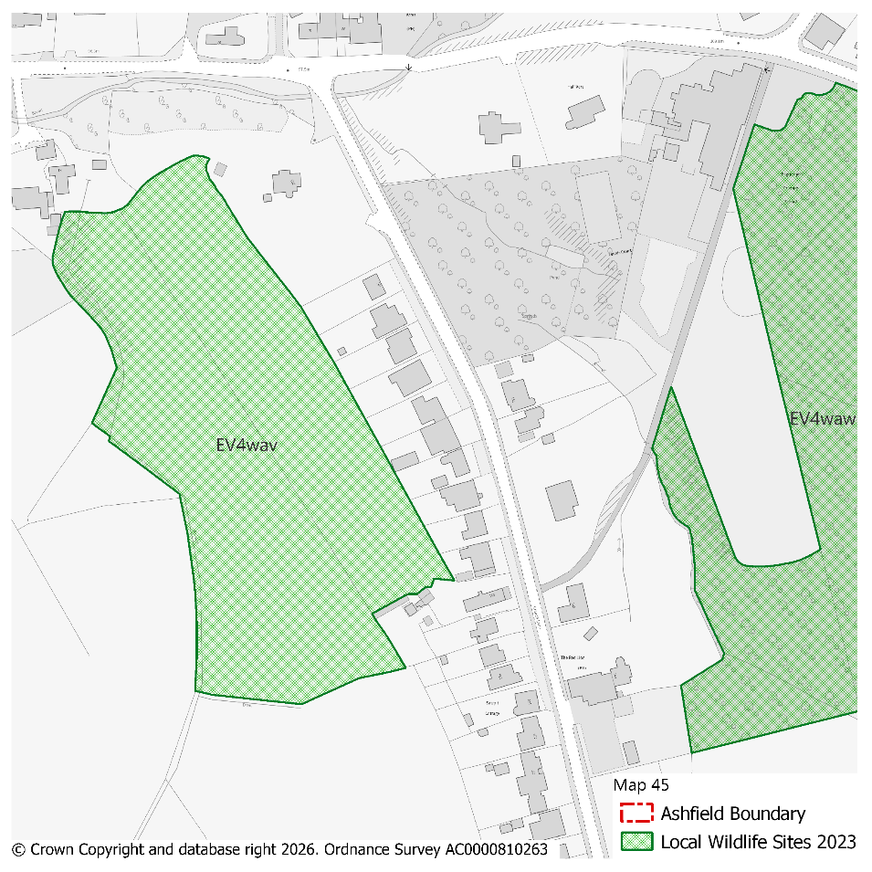 |  |  |  |  |  |  |  |  | Modifications Version  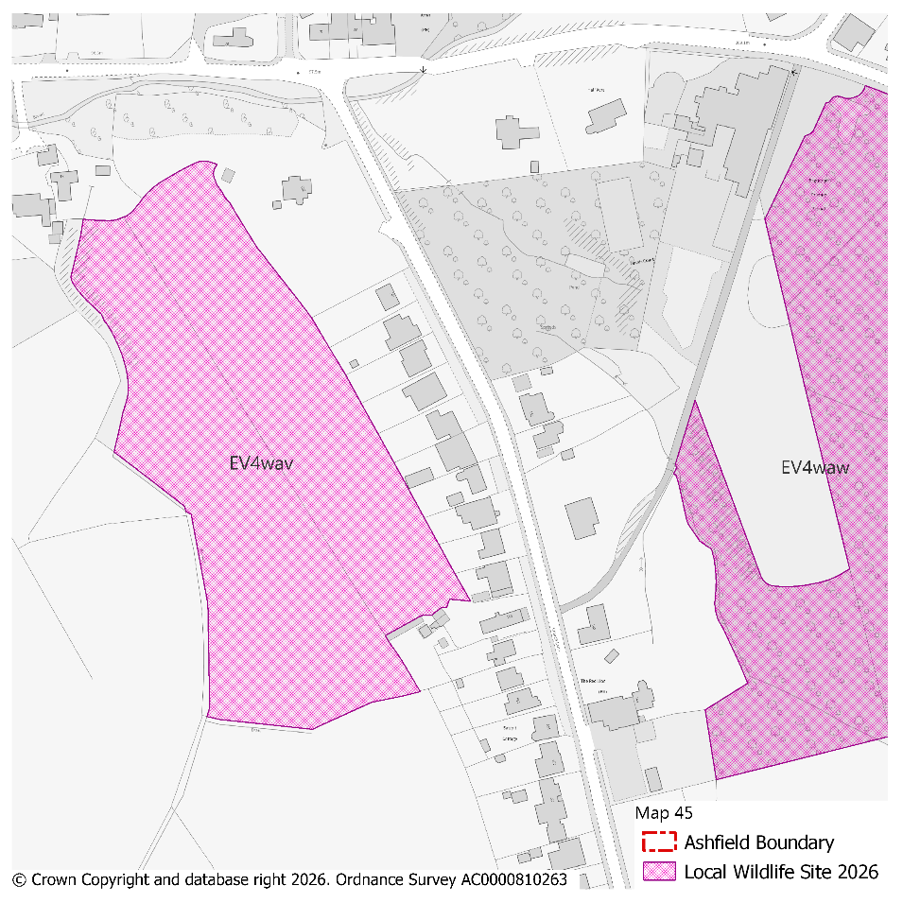
PMM Ref. | Local Plan Policy Ref. |  |  | Proposed Policies Map Modification
PMM68 | EV4: GI, Biodiversity & Geodiversity |  |  | Amend site boundary of Local Wildlife Site(s) EV4wek and EV4wdn to reflect more up to date information provided by the Nottinghamshire Biodiversity and Geodiversity Records Centre.  (Note: Any comments made in respect of this modification will be required to quote the PMM reference number and the relevant LWS reference number)
Submission Plan Version  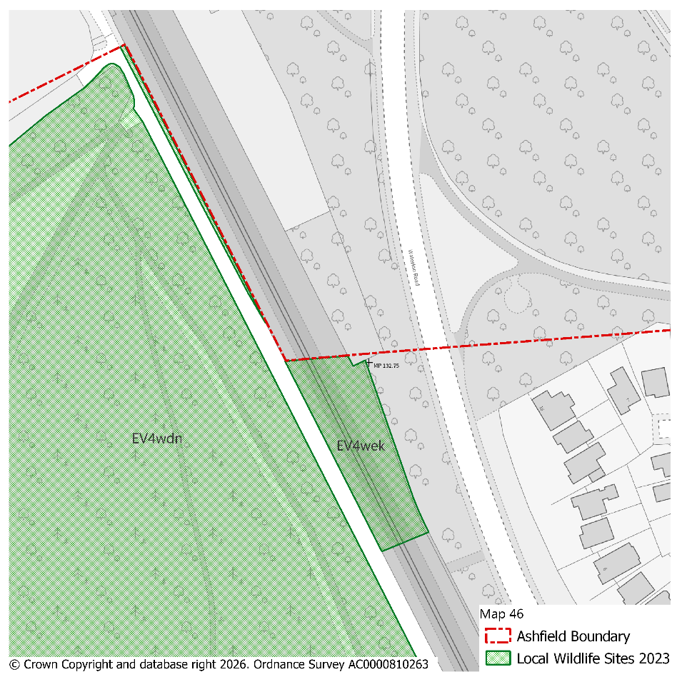 |  |  |  |  |  |  |  |  | Modifications Version  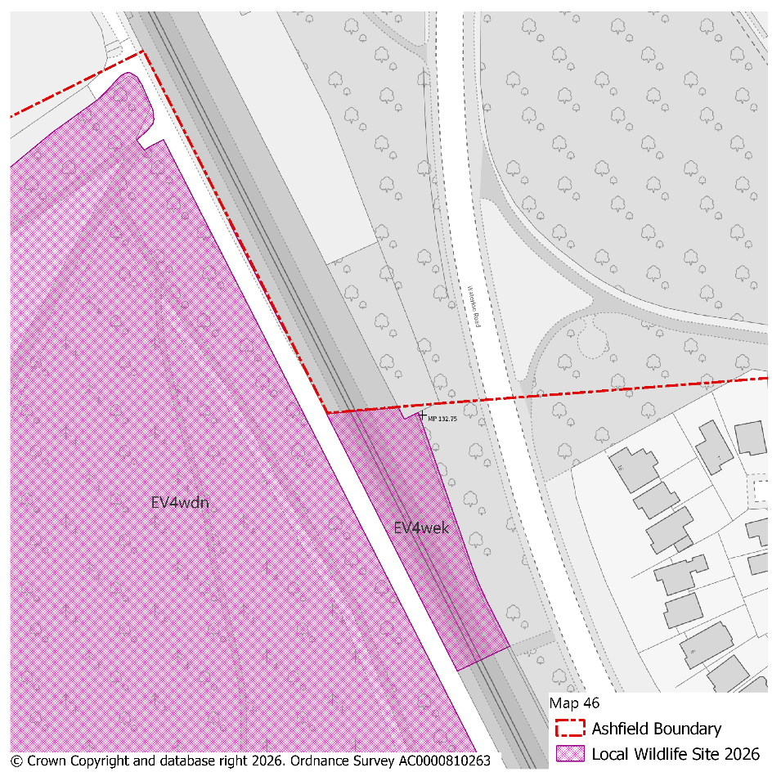
PMM Ref. | Local Plan Policy Ref. |  |  | Proposed Policies Map Modification
PMM69 | EV4: GI, Biodiversity & Geodiversity |  |  | Amend site boundary of Local Wildlife Site(s) EV4wfn to reflect more up to date information provided by the Nottinghamshire Biodiversity and Geodiversity Records Centre.  (Note: Any comments made in respect of this modification will be required to quote the PMM reference number and the relevant LWS reference number)
Submission Plan Version  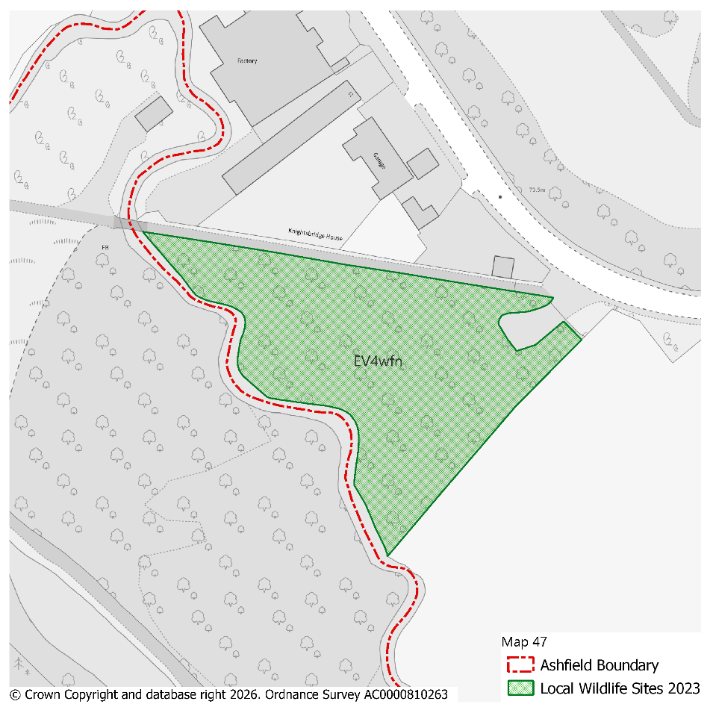 |  |  |  |  |  |  |  |  | Modifications Version  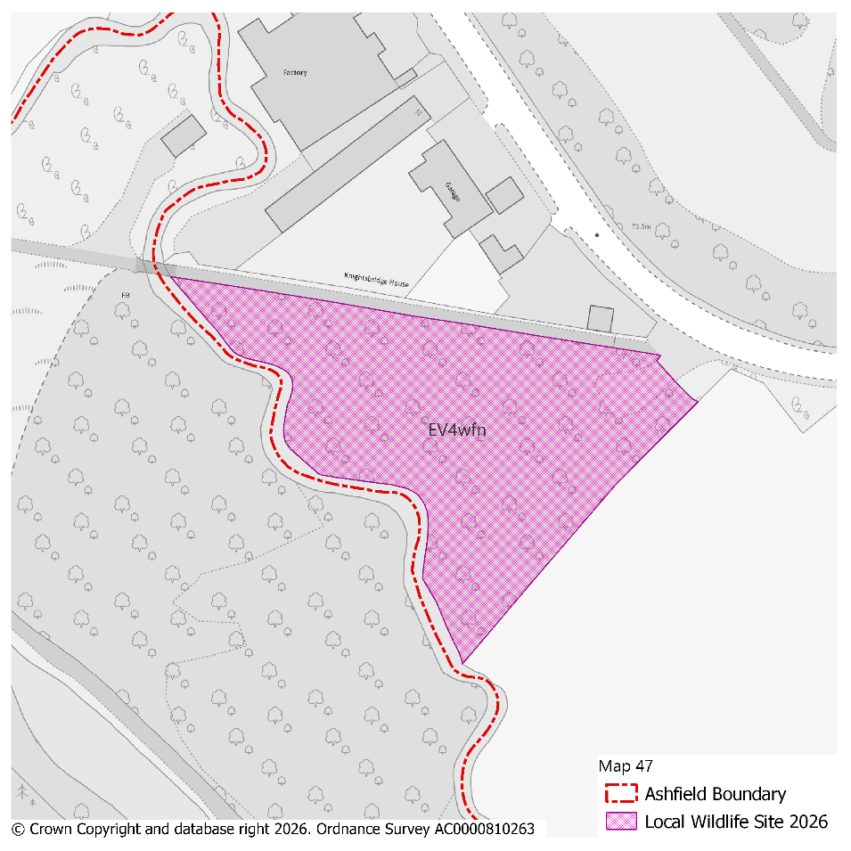
PMM Ref. | Local Plan Policy Ref. |  |  | Proposed Policies Map Modification
PMM70 | EV4: GI, Biodiversity & Geodiversity |  |  | Amend site boundary of Local Wildlife Site(s) EV4wcy to reflect more up to date information provided by the Nottinghamshire Biodiversity and Geodiversity Records Centre.  (Note: Any comments made in respect of this modification will be required to quote the PMM reference number and the relevant LWS reference number)
Submission Plan Version  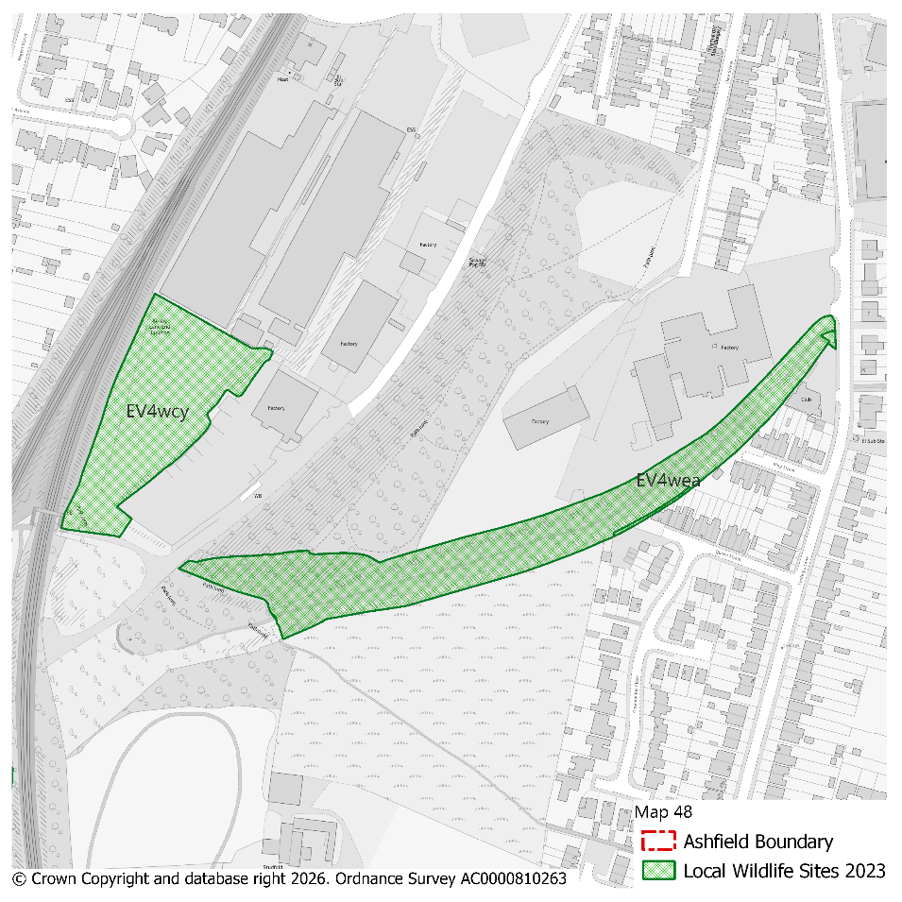 |  |  |  |  |  |  |  |  | Modifications Version  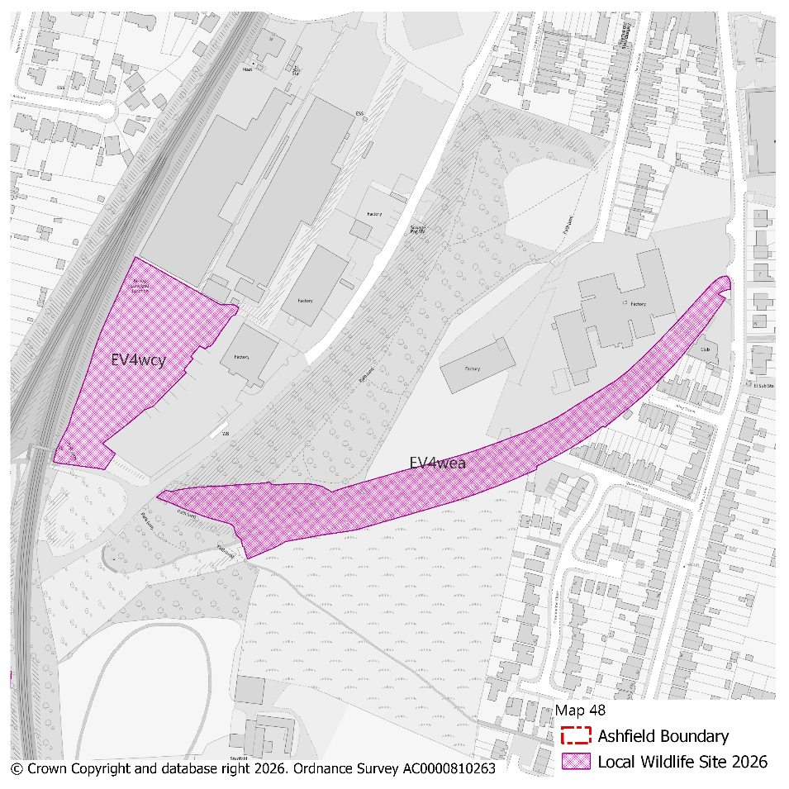
PMM Ref. | Local Plan Policy Ref. |  |  | Proposed Policies Map Modification
PMM71 | EV4: GI, Biodiversity & Geodiversity |  |  | Amend site boundary of Local Wildlife Site(s) EV4wan to reflect more up to date information provided by the Nottinghamshire Biodiversity and Geodiversity Records Centre.  (Note: Any comments made in respect of this modification will be required to quote the PMM reference number and the relevant LWS reference number)
Submission Plan Version  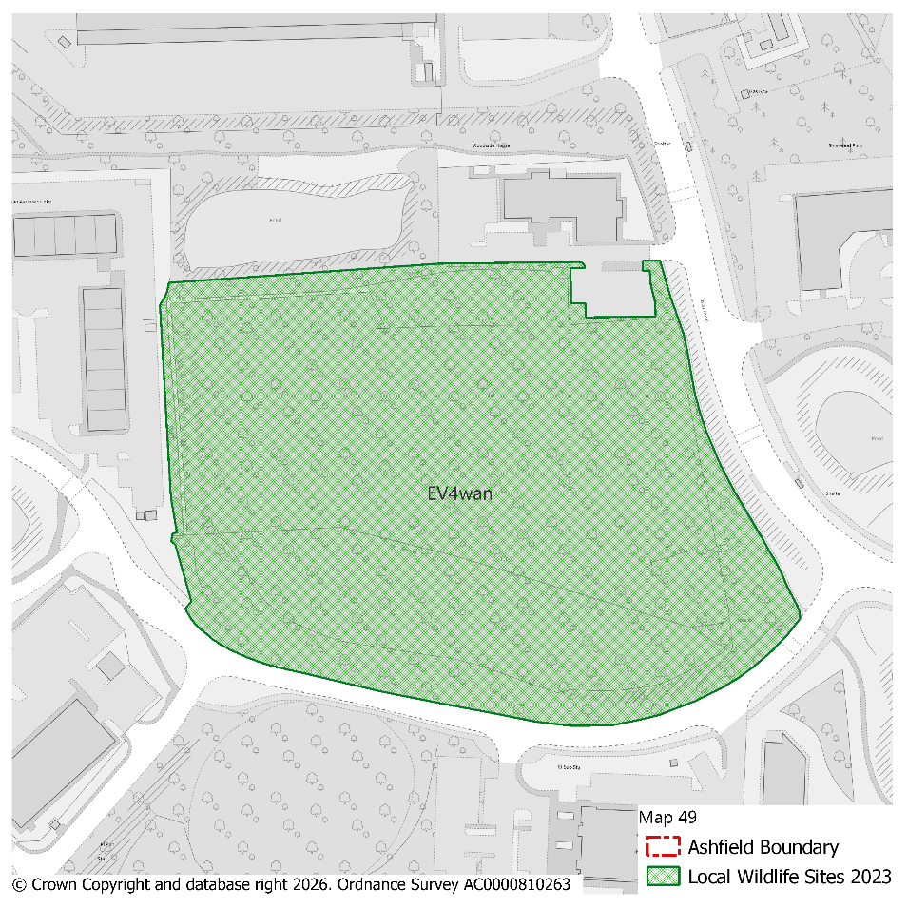 |  |  |  |  |  |  |  |  | Modifications Version  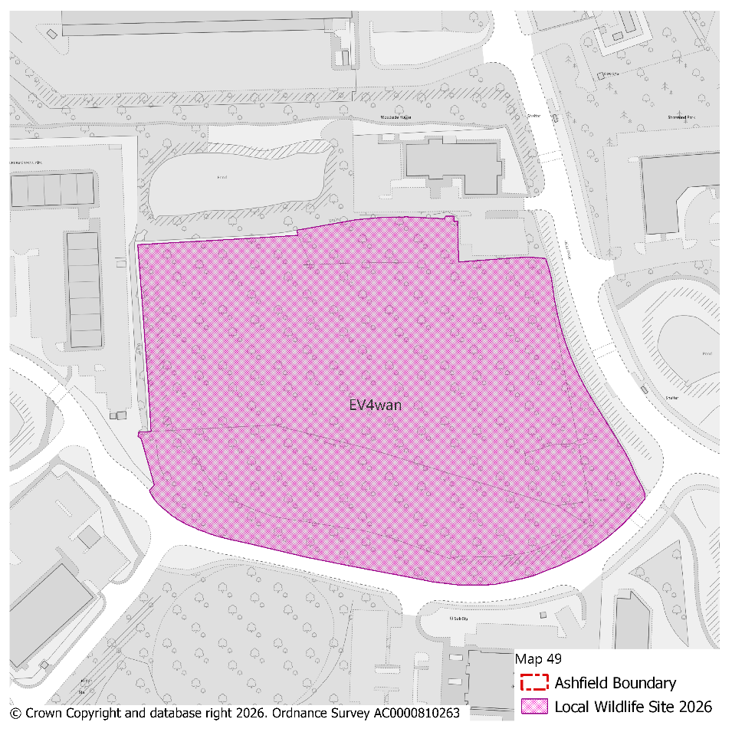
PMM Ref. | Local Plan Policy Ref. |  |  | Proposed Policies Map Modification
PMM72 | EV4: GI, Biodiversity & Geodiversity |  |  | Delete Local Wildlife Site(s) EV4wcf to reflect more up to date information provided by the Nottinghamshire Biodiversity and Geodiversity Records Centre.  (Note: Any comments made in respect of this modification will be required to quote the PMM reference number and the relevant LWS reference number)
Submission Plan Version  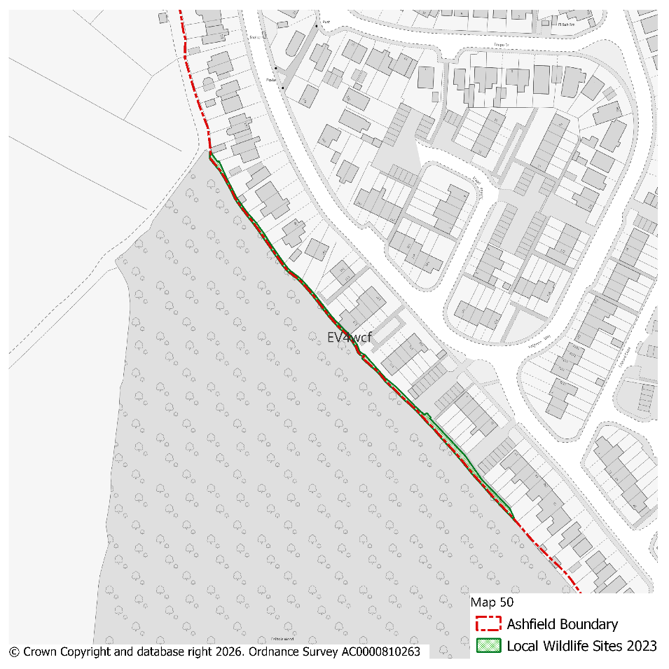 |  |  |  |  |  |  |  |  | Modifications Version  