

Advice Note to Local Planning Authorities regarding the consideration of likely effects on the breeding population of nightjar and woodlark in the Sherwood Forest region November 2025
This advice note updates and replaces the previous note dated March 2014 following the recent publication of the UK SPA Review Phase II report by JNCC in May 2025.

Summary
While no decision has been made about the future classification of parts of Sherwood Forest as a Special Protection Area (SPA) for its populations of breeding nightjars and woodlarks, Natural England advise those affected Local Planning Authorities (LPAs) to be mindful of the Secretary of State’s decision in 2011, following Public Inquiry, to refuse to grant planning permission for an Energy Recovery Facility at Rainworth where the potential impacts on these birds and their supporting habitats was given significant weight.
In light of this decision Natural England continues to recommend a precautionary approach should be adopted by LPAs which ensures that reasonable and proportionate steps have been taken in order to avoid or minimise, as far as possible, any potential adverse effects from development on the breeding populations of nightjar and woodlark in the Sherwood Forest area. This will help to ensure that any future need for LPAs to comply with the provisions of the Habitats Regulations is met with a robust set of measures already in place.
This Advice Note provides a brief explanation of the background to the current situation and suggests a ‘risk-based’ approach that could be followed to help futureproof decision-making on plans and projects. In addition, a summary of the current LPA statutory duties in relation to birds is provided for clarity and there are links to further information relating to the legislation and policy that affects SPAs. The document is set out as follows:
- Background – including reference to planning case law
- Current situation
- The recommended ‘risk-based’ approach
- Existing statutory duties relevant to birds
- Further information
- Map highlighting the areas of greatest ornithological interest for breeding nightjar and woodlark

Background – the possibility of a new protected area (Special Protection Area) for nightjar and woodlark in Sherwood and Rufford Energy Recovery Facility planning case law
In 2011, following a Public Inquiry, the Secretary of State decided to refuse to grant planning permission for an Energy Recovery Facility on land at the former Rufford Colliery site at Rainworth. The likely effect on the breeding populations of woodlark and nightjar was a key consideration in the Secretary of State’s decision.
The Secretary of State agreed that whilst the application site was not within an area currently identified as a Special Protection Area (SPA), there was a credible possibility of this in the future and therefore merit in following the formal approach required for SPAs. He agreed that when considering the impact of the development on the use of the area by the bird species listed on Annex 1 of the European Wild Birds Directive – in this case woodlark and nightjar - an approach similar to that set out in the relevant legislation (now regulation 63 of the Habitats Regulations) should be adopted. The Secretary of State concluded that he could not be sure that the proposed development would not harm the integrity of the area used by the birds and that the conflict this created with the aims of the Regional Spatial Strategy and the potential harm to the integrity of the habitat used by woodlark and nightjar weighed significantly against the proposal.

Current situation
The UK government must continue to contribute to the conservation of wild birds across their natural range in Europe through the protection of the most suitable sites in the UK as Special Protection Areas (SPAs). The current review of the UK network of SPAs being led by the Joint Nature Conservation Committee (JNCC) has identified that the populations of nightjar and woodlark in Sherwood Forest may warrant such protection.
Whilst a final decision has not been made by Government, JNCC and the statutory nature conservation bodies have recently advised Government that it should consider the option of a new Sherwood Forest SPA to address the current insufficiencies in the network for these birds.
Until the UK SPA Review concludes and provides further clarity as to whether new SPAs for nightjar and/or woodlark will be classified, there continues to be a possibility of an area of Sherwood Forest being classified as a SPA.
The possibility of the area becoming an SPA creates a risk for spatial planning in the Sherwood area. This is because any formalisation of the site as a Special Protection Area (SPA) would place a legal obligation on decision-taking bodies to review extant permissions and decisions and potentially modify them should there be any significant risks to the SPA.
We recognise that in the interim this creates difficulty for LPAs in how they should consider land allocations and policies in Development Plans and individual planning applications within the Sherwood Forest area. How local authorities choose to confront this issue is ultimately a matter for them, however Natural England advise that LPAs should take a ‘risk-based approach’ or similar of the kind taken by the Secretary of State in the case referred to above. This should provide decision-making with a degree of future-proofing until such a time that there is greater certainty on whether the Sherwood Forest area is to be proposed as a SPA and whether the provisions of the National Planning Policy Framework and the Habitats Regulations are to take effect.

The recommended ‘risk-based’ approach
The ‘risk based’ approach advocated by Natural England in 2011 was endorsed by the Secretary of State in coming to his decision on the development proposal at the former Rufford Colliery.
Natural England suggest that in taking a risk-based approach to development plan making and decision-making, LPAs seek to ensure that plans and proposals are accompanied by an additional and robust assessment of the likely impacts arising from the proposals on breeding nightjar and woodlark in the Sherwood Forest area. This should ideally cover the potential direct, indirect and cumulative impacts which may include, but may not be limited to, the following;
- disturbance to breeding birds from people, their pets and traffic
- loss, fragmentation and/or damage to breeding and/or feeding habitat
- bird mortality arising from domestic pets and/or predatory mammals and birds
- bird mortality arising from road traffic and/or wind turbines
- pollution and/or nutrient enrichment of breeding habitats
No formal assessments of the boundary of any future SPA have been made; therefore, it is not possible to definitively identify whether individual application sites would fall inside or outside any possible future designated area. However, the enclosed map, which highlights the areas of greatest ornithological interest for breeding nightjar and woodlark, was submitted as evidence to the Rufford ERF Public Inquiry and could be of assistance to your Authority in this regard. It is worth noting that the Inspector at the Rufford ERF Inquiry decided it appropriate to consider both boundaries to inform his recommendations.
We also advise that LPAs should seek to satisfy themselves that planning applications contain sufficient objective information to ensure that all potential impacts on the breeding nightjar and woodlark populations have been adequately avoided or minimised as far as is possible using appropriate measures and safeguards. It may be necessary to obtain ecological advice in relation to the potential impacts of a proposal and any possible avoidance or mitigation measures.
Natural England would encourage those LPAs in the Sherwood Forest area to work together, in compliance with the duty to cooperate, to consider the combined effect of their plans and proposals in order to gain a strategic overview and develop a collaborative approach. We are of the view that taking the approach outlined above represents good planning practice which will assist your Authority should the site be classified as SPA in limiting the number of plans and projects which would need to be re-considered as part of the review of consents process required by the Habitats Regulations.

Existing biodiversity and wild bird duties
In addition to advising that a risk-based approach will assist LPAs in future-proofing plans and decisions, Natural England advises that there are other relevant duties in legislation and policy that direct you to consider the protection and enhancement of nightjar and woodlark populations in the Sherwood area.
Your Authority must discharge its statutory duty given under Section 40 of the Natural Environment and Rural Communities Act 2006 to conserve and enhance biodiversity when exercising its functions. It follows that your authority should have regard to conserving nightjar and woodlark, owing to their inclusion as Species of Principal [conservation] Importance in England.
Your Authority should also have regard to duties given under regulation 9A of the Habitats Regulations, which requires LPAs to apply all reasonable endeavours to avoid the deterioration of wild bird habitat (including that of nightjar and woodlark) when exercising their statutory functions. The presence of either or both species and any effects on them is a material consideration when considering planning applications, regardless of whether the Sherwood area is put forward for classification as an SPA in due course.

Further information
- Information on the legislation, policy and classification process affecting Special Protection Areas (SPAs) is available at Special Protection Areas | Advisor to Government on Nature Conservation | JNCC
We hope this advice is helpful and provides further assistance. Should Natural England be in a position to update these views and advice, we will do so and notify you accordingly.
If you have any queries about this advice, please contact: consultations@naturalengland.org.uk

Natural England
East Midlands
2025

Map highlighting the areas of greatest ornithological interest for breeding nightjar and woodlark, submitted as evidence to the Rufford ERF Public Inquiry 2010
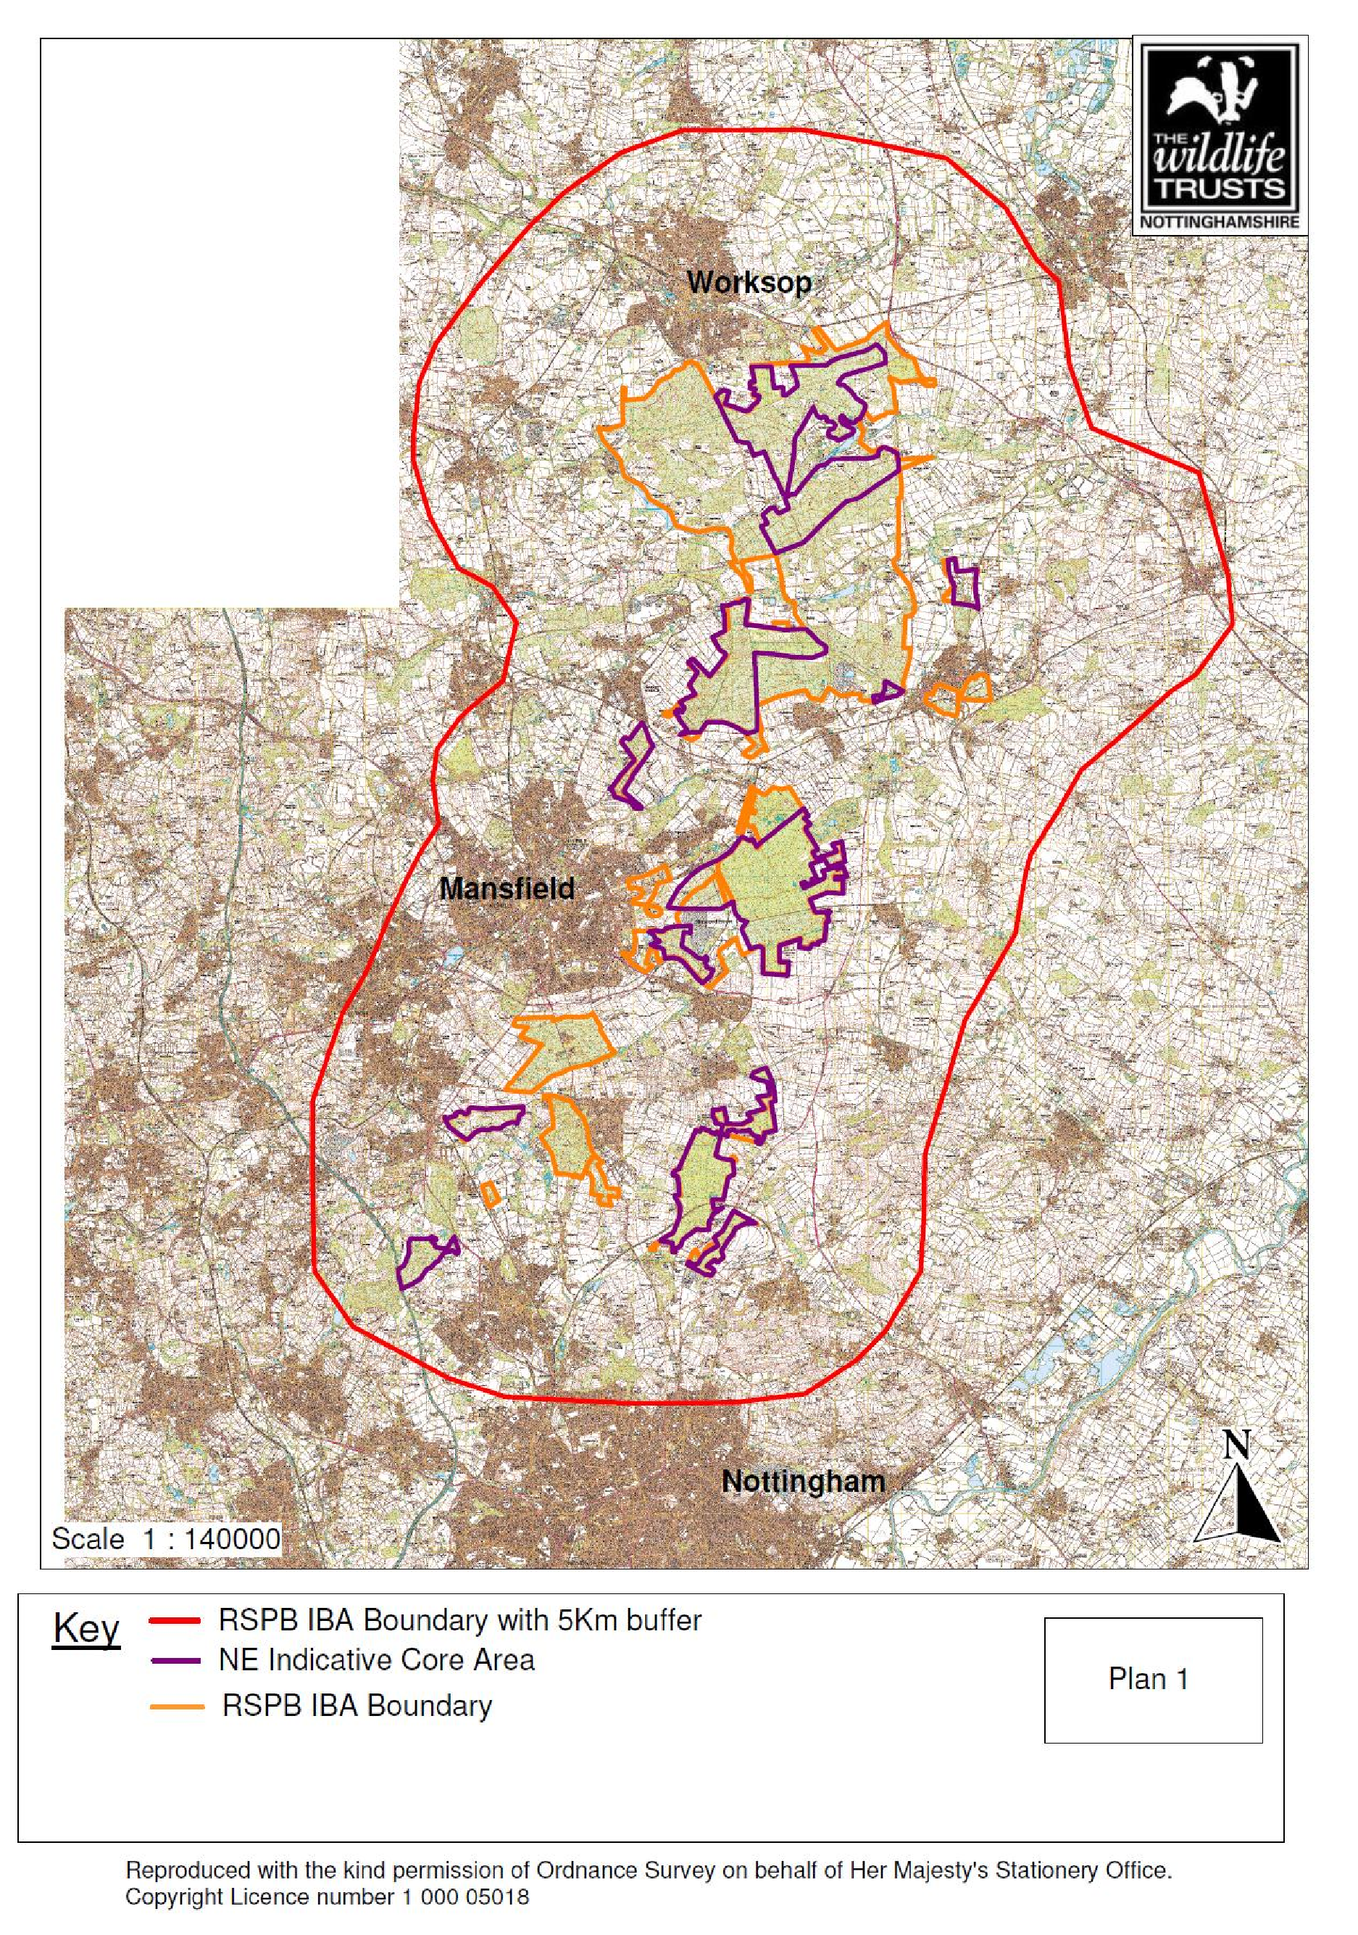

See Application: Land at former Rufford Colliery - National archives
See The Conservation of Habitats and Species Regulations 2017 - Legislation.gov.uk
See Report on UK Special Protection Areas for birds published - JNCC
Planning Application for: ES/1144 - Nottinghamshire County Council
As listed in section 41 of the Natural Environment and Rural Communities Act 2006 to guide decision-makers such as public bodies, including local and regional authorities, in implementing their duty under section 40 of that Act

