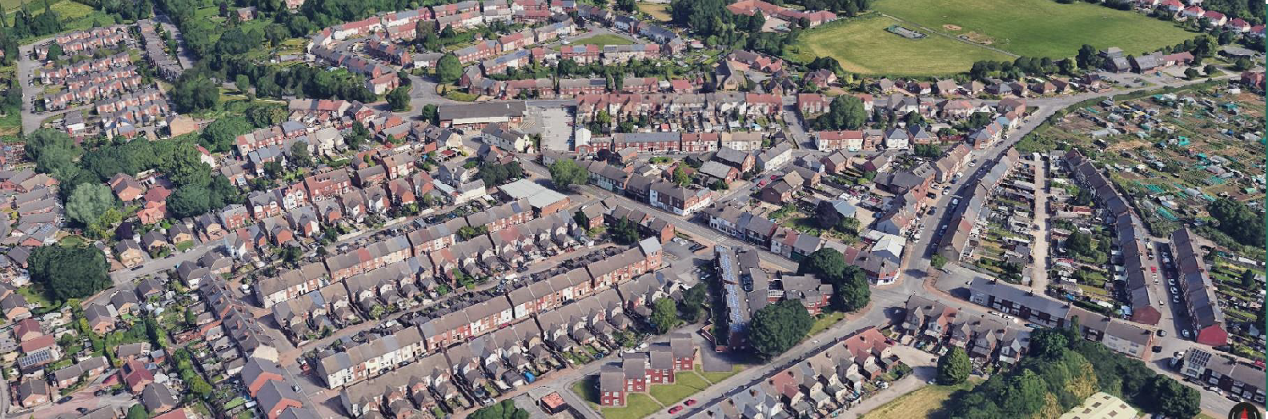

Stanton Hill Investment Plan

February 2025

## Contents

Executive Summary 2

1. Introduction 4

2. Opportunities and Challenges 8

3. Our Vision for Stanton Hill 11

4. Investment Plan 12

5. Working in Partnership 30

6. Next Steps 32

7. Appendix: Economic Profile 35

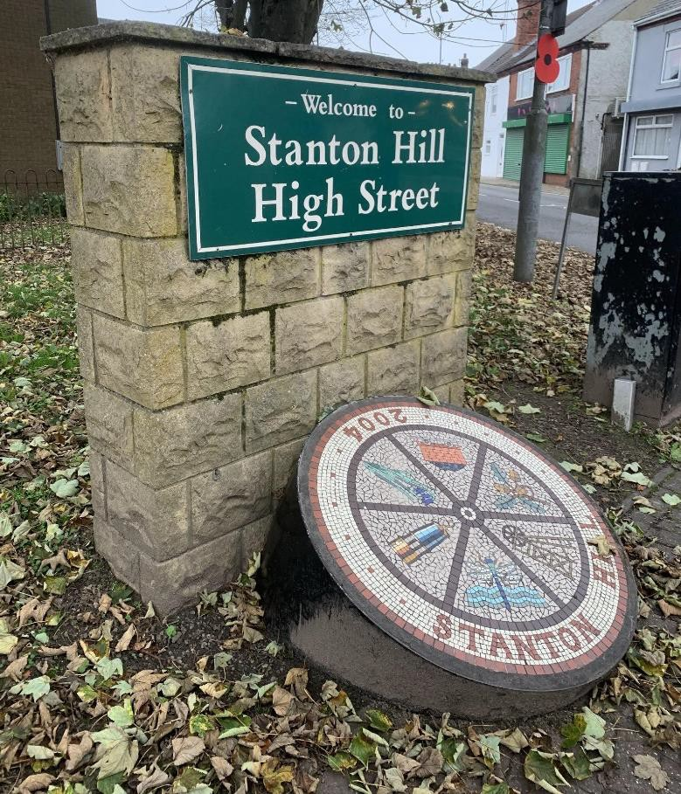

# Executive Summary

This Investment Plan sets out a 10-year programme of priorities and interventions for Stanton Hill. It has been developed in partnership by the community and Ashfield

District Council, informed by extensive engagement with residents.

**The purpose of this Plan is to make Stanton Hill a more attractive and prosperous place, while improving wellbeing and engagement for residents**. To do this, we have identified five themes for investment. Against each of these themes we have outlined a series of actions to achieve our objectives, and broad timescales for delivery over the short / medium / long term.

Community Spirit

Objective: Build stronger community connections and enhance local identity through improved spaces and activities

* Ensure adequate community space on or near the High Street
* Run community support programmes through facilities on the High Street.
* Run a programme of events to facilitate engagement and build community spirit.
* Develop a Stanton Hill ‘Story’ with the community that helps define Stanton Hill’s identity.

Rebuilding the High Street

Objective: Revitalise the High Street to boost appeal, encourage investment, and support businesses

* Support engagement with local businesses.
* Signpost high street businesses to sources of funding that are relevant for them, and help with applications where needed.
* Invest in visual improvements to the High Street (e.g. planters, street art, etc.).
* Work with the Co-op to improve the interface with the High Street.
* Consider active intervention in High Street properties to boost long-term attractiveness.

Cleaner, safer, healthier

Objective: Make Stanton Hill cleaner, safer, and more attractive by tackling issues such as litter, crime, health and housing

* Address littering and fly-tipping.
* Use enforcement orders to address eyesore properties.
* Work with police and community safety teams to address ASB (anti-social behaviour) and crime issues.
* Encourage energy saving retrofit uptake to improve housing standards.
* Increase health centre provision.

Connected Stanton Hill

Objective: Improve accessibility and connections for residents, visitors, and tourists.

* Work with the County Council / EMCCA to improve bus services.
* Develop cycle path proposals.
* Work with the County Council to review crossings on the High Street and to manage existing traffic issues.
* Explore ways to improve connections with surrounding housing estates to integrate these properly into Stanton Hill.

Skills for Stanton Hill

Objective: Empower residents with skills and aspirations for high-quality jobs

* Work with partners to develop skills provision on the High Street, using community premises.
* Support greater outreach from businesses and further education into local schools, to raise aspirations.

The community and Ashfield District Council will work together to realise this Plan, building on successful initiatives to date. In particular, there is a clear aspiration to involve a larger segment of the community in helping deliver the objectives, recognising that one of the challenges of the Covid period has been a reduction in engagement and volunteering. This Plan is a living document which will be updated as progress is made over time.

# Introduction

This Investment Plan sets out a 10-year programme of priorities and interventions for Stanton Hill. It has been developed in partnership by the community and Ashfield

District Council, with the objective of improving the quality of life in Stanton Hill for its residents, and improving the attractiveness of the area for residents, businesses and visitors.

## About Stanton Hill

Stanton Hill is a local centre near Sutton-in-Ashfield within the Ashfield district in Nottinghamshire. The town is one of seven local centres and has historic roots in coal mining and industry. Stanton Hill is located to the northwest of Sutton-in-Ashfield town centre, which is approximately two kilometres away.

### The Investment Plan Area

The area for this Investment Plan is defined as the High Street and immediate

surrounding Stanton Hill area. As shown by the map below, the Investment Plan area includes the High Street, as well as important assets such as the Healdswood Infant

and Nursery School, Brierley Park Medical Centre, Skegby & Stanton Hill library, and All Saints’ Church. The area also encompasses recent housing developments to the southwest of the High Street.

Figure 1: Investment Plan Area

A map of Stanton Hill



Brierley Park Industrial Estate is located at the south edge of the study area whilst Teversal Trails Visitor Centre and the trails are located just to the north of the study area boundary. Other nearby assets include Silverhill Woodland Retreats & Teversal

Campsite, Brierley Forest Park, Teversal Village conservation area, Hardwick Hall, and Quarrydale Academy secondary school. More broadly, Stanton Hill has strong links with neighbouring Skegby, as well as nearby Teversal.

Figure 2: Asset Map

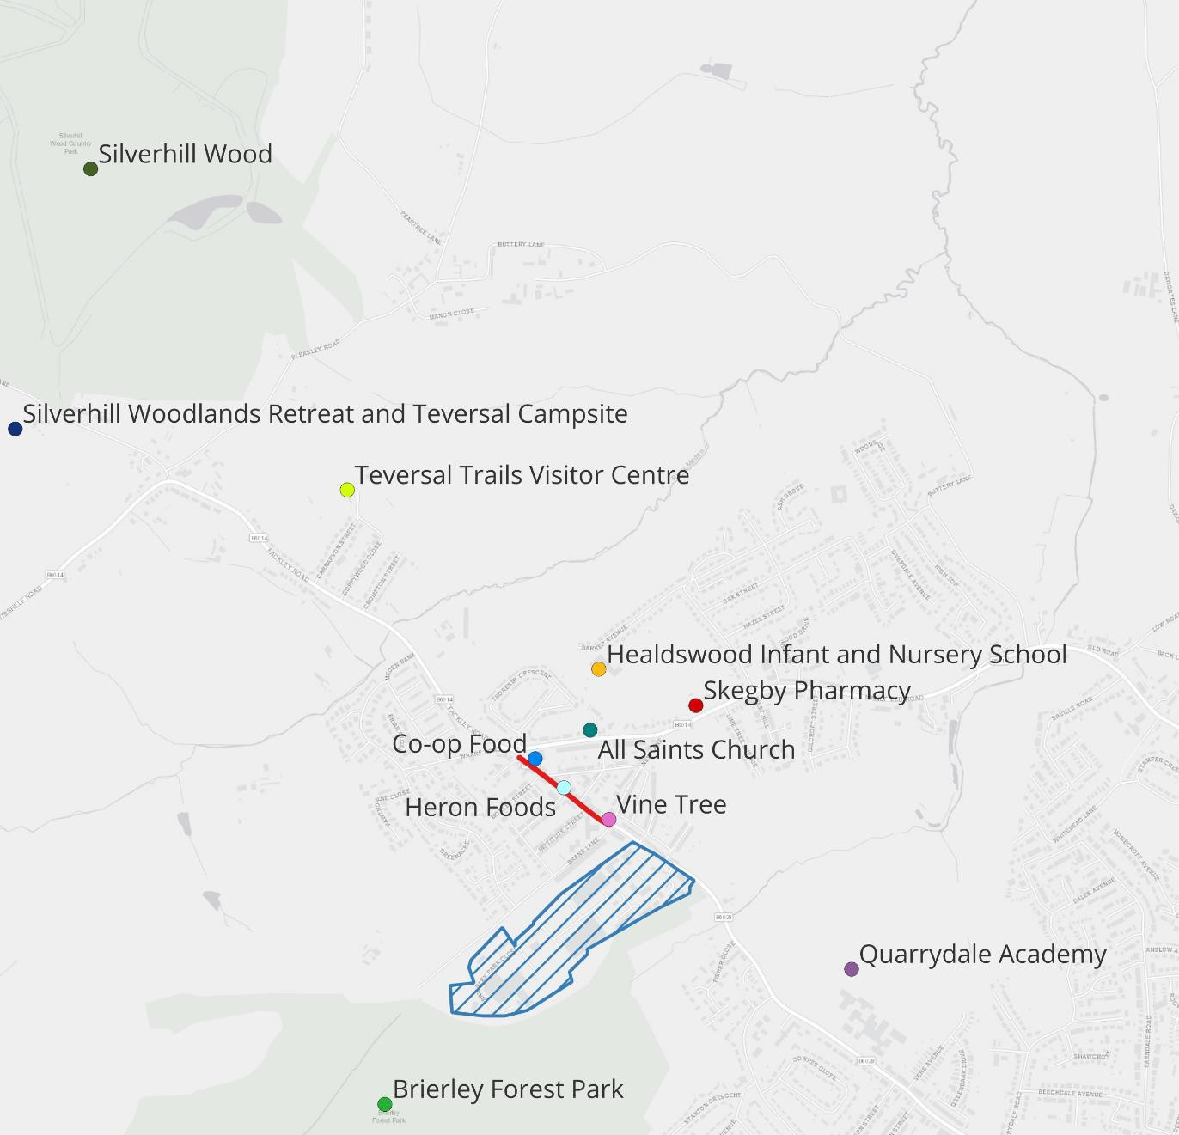

## How this plan has been developed

In August 2024, members of the Stanton Hill Neighbourhood Forum and representatives from Ashfield District Council agreed to initiate the process of developing the Stanton

Hill Investment Plan.

Between November 2024 and February 2025, consultants led a process of evidence gathering, stakeholder engagement, and working with the Neighbourhood Forum and the Council to develop this Investment Plan. In December 2024 and January 2025, ADC also led a parallel process of community engagement, with a large number of residents representing the diversity of the community in Stanton Hill. This engagement has informed the development of the actions in this Investment Plan.

This Plan was formally agreed by partners in February 2025 and will be taken forward as a collaborative effort following adoption at Ashfield District Council’s Cabinet in 2025.

## How we will take this plan forward

This Plan has been developed with a number of key principles:

* This Plan is **a living document**. We fully expect that in due course partners will want to update this to reflect changing context and new ambitions.
* A key part of this is our objective to **increase the involvement of a greater proportion of the community in the Plan over time**. We want to work in a way that encourages a diverse group of community members to engage and lead this Plan.
* The expectation that **the community and Ashfield District Council will work together in partnership to achieve the objectives of the Plan**. Community involvement and leadership is essential to secure the long-term success of this Plan. The role of the Council will be to support the community through access to funding, supporting enforcement, and helping access Council services.
* We recognise that we are part of a wider geography that includes Skegby and Teversal, as well as Ashfield as a whole. Therefore, **we welcome working in partnership with organisations from other areas** where this supports the Stanton Hill Investment Plan.

## Structure of the Plan

The Plan is structured as follows:

* Section 2 - Opportunities and Challenges - describes the current issues, challenges and opportunities facing Stanton Hill which this Plan seeks to address.
* Section 3 - Our Vision for Stanton Hill - sets out what we want to achieve through implementing this Plan.
* Section 4 - The Investment Plan - sets out the specific actions and interventions that we will seek to bring forward.
* Section 5 - Working in Partnership - describes how the community and the Council will work together to achieve the objectives of the Plan.
* Section 6 - Next Steps - summarises the Plan for the first year.
* Appendix: Economic Profile – provides some additional economic context and data which has informed the development of this Plan.

# Opportunities and Challenges

Stanton Hill faces a range of opportunities and challenges. This section summarises the key issues that the Investment Plan will seek to address. A more thorough analysis of key data is provided in the appendix to this report.

## Opportunities

Stanton Hill has some key opportunities. **The area is growing, with significant new housing developments planned**. 134 new homes have already been delivered at Fackley Way, Honey Bee Gardens, and Red Fox Avenue to the south west of the High

Street, with 38 more homes to be delivered1. Major new developments have planning permission to the south of the Investment Plan area off Stoneyford Road, with 79 homes delivered already and permission for 211 further homes2. When these sites are fully developed, this will represent an increase of approximately 33% on the total dwelling

stock in Stanton Hill3. Further to this, there are large sites allocated for housing within the Local Plan, totaling nearly 400 homes4.

Collectively these developments are adding hundreds of new homes to the Stanton Hill area. Because these new homes are of a higher quality than some of the existing stock, these new homes are also changing the composition of the population in Stanton Hill, as well as significantly increasing the size of the community.

New residents could help contribute to the success of the High Street by providing a larger catchment area. Nonetheless, this won’t happen automatically, as residents on these developments will travel to amenities elsewhere if the offer on the High Street is not sufficiently strong.

A related opportunity is the **strong visitor economy in the surrounding area**,

exemplified by the key assets of Silverhill Woodland Retreats & Teversal Campsite, Brierley Forest Park, Teversal Village conservation area, and Hardwick Hall. These attractions draw in visitors from across the country (in the case of Hardwick Hall) and from surrounding areas of Nottinghamshire. These visitors could be attracted to the High Street in Stanton Hill if the offer were stronger.

Another potential market for the High Street is the nearby Brierley Park Industrial Estate, which is home to several companies in a range of sectors, and an estimated 200+ jobs.

1 Data sourced from Ashfield District Council.

2 Ibid.  
3 Existing housing stock estimated based on household data.

4 Ashfield District Council

## Challenges

Despite these opportunities, Stanton Hill faces some **deep-rooted community challenges**, with deprivation, crime, and poor health undermining community

wellbeing. The area north of High Street is among the top 10% most deprived areas in England, while the High Street itself falls within the top 20%. Only 22.5% of residents

hold qualifications at Level 4 or higher (approximately degree level), significantly below the national average of 33.9%, limiting access to better job opportunities. Poor public transport access also makes it difficult to access work and other services.

Health outcomes are poor - 7.3% of residents report bad or very bad health, exceeding the national average (5.2%), while only 40.4% describe their health as very good, compared to nearly half of residents nationally (48.5%). Demand on Skegby Family Medical Centre, the nearest health facility, is expected to rise sharply as the local population grows and ages.

Crime rates are also relatively high. With 370 recorded crimes in the past year (108 per 1,000 residents), Stanton Hill outpaces neighbouring Skegby (88) and the national average (93). Violent crime accounts for 30.5% of crimes, followed by anti-social

behaviour (ASB) at 18.4%, significantly above England and Wales at 15.5%.

Beyond this, feedback from the consultation to prepare this Investment Plan suggests that **community ties have weakened, and many local residents feel less pride in place** than they used to. Residents refer to a ‘transient community’ of people who have a more transactional / circumstantial relationship with the area. In turn, indicators of community pride, such as the upkeep of housing and public spaces, have worsened, with visible issues around littering and fly-tipping, along with reports of vandalism in

public spaces.

At the centre of Stanton Hill, **the High Street suffers from dilapidation, vacancies, poor layout, and the impact of residential infill** which breaks up the flow of the street. Some road crossings are challenging due to poor infrastructure and fast-moving traffic, and on-street parking at certain times can create challenges. The lack of attractiveness limits investment and means that the High Street does not benefit from the visitor

economy activity in the surrounding area. Because the dilapidation is across the High Street, there are limited incentives for individual businesses to invest in a higher quality offer.

These issues are interconnected. It is difficult to increase the attractiveness of the High Street without community and business involvement and investment, and at the same time it is difficult to raise community involvement when littering, ASB, etc. can make effort feel pointless, and when residents feel increasingly disconnected from the place.

## Transforming Stanton Hill

Given the above, it will be essential to use the Investment Plan to:

* Strengthen community involvement and sense of ownership, belonging, and pride– including amongst local business owners.
* Make the initial investments in the High Street that can catalyse change and identify others over the long term that will support an improved offer.
* Address some of the challenges in the area (e.g. littering, fly tipping etc.)

In doing this, we are aiming to increase the attractiveness of the area, to increase

participation by the community and therefore open up new opportunities for residents and businesses.

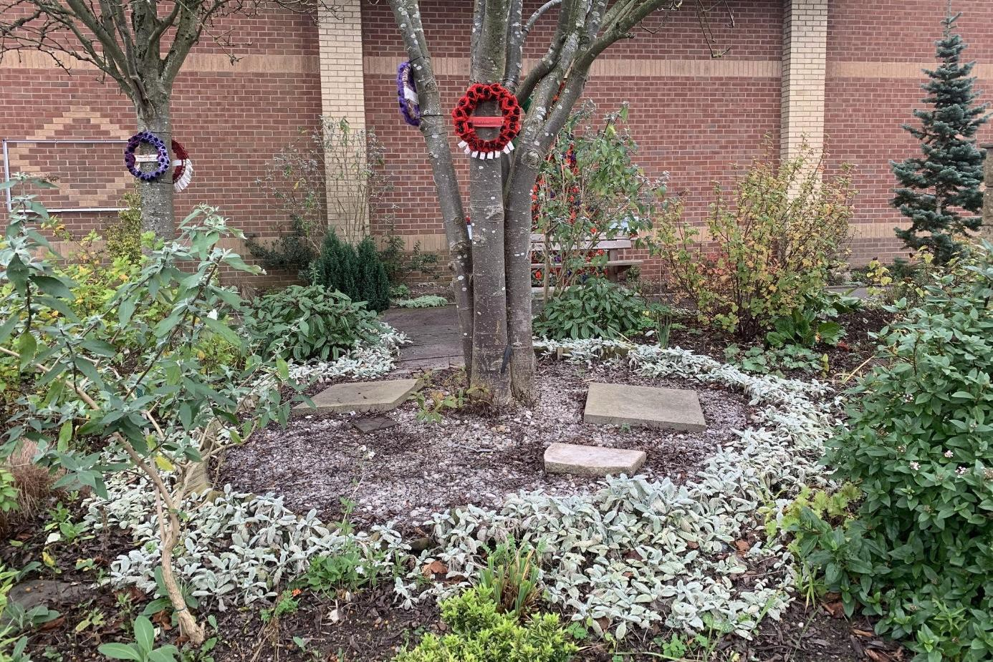

*Stanton Hill Community Garden*

# Our Vision for Stanton Hill

##### The purpose of this Plan is to make Stanton Hill a more attractive and prosperous place, while improving wellbeing and engagement for residents.

Our vision for Stanton Hill is an ambition for our **community** and Stanton Hill as a

##### place.

We want Stanton Hill to be a **community** where:

* People feel a sense of belonging and pride in place.
* People have opportunities to participate in meaningful activities and be connected with others in the community.
* People are supported to live healthy lives, learn new skills, and gain long-term employment.

We want Stanton Hill to be a **place** that:

* Is attractive and well-maintained.
* Provides amenities and a retail and services offer which benefits residents and draws in visitors.
* Is well-connected to surrounding areas.

We see this as a virtuous circle: by helping build a stronger community, we can draw on the support of residents to ensure that Stanton Hill is a vibrant and attractive place.

A stronger community will help build a more attractive and prosperous place, which encourages greater participation, which will create a stronger community.



How we work in partnership as a community, and with the Council, and how we sustain this effort over the long term will be key to the success of this plan.

The following sections describe how we want to achieve this vision (Section 4) and how we choose to work together (Section 5).

# Investment Plan

The Investment Plan is structured around five themes that together will ensure that we deliver on our vision. These themes are:  
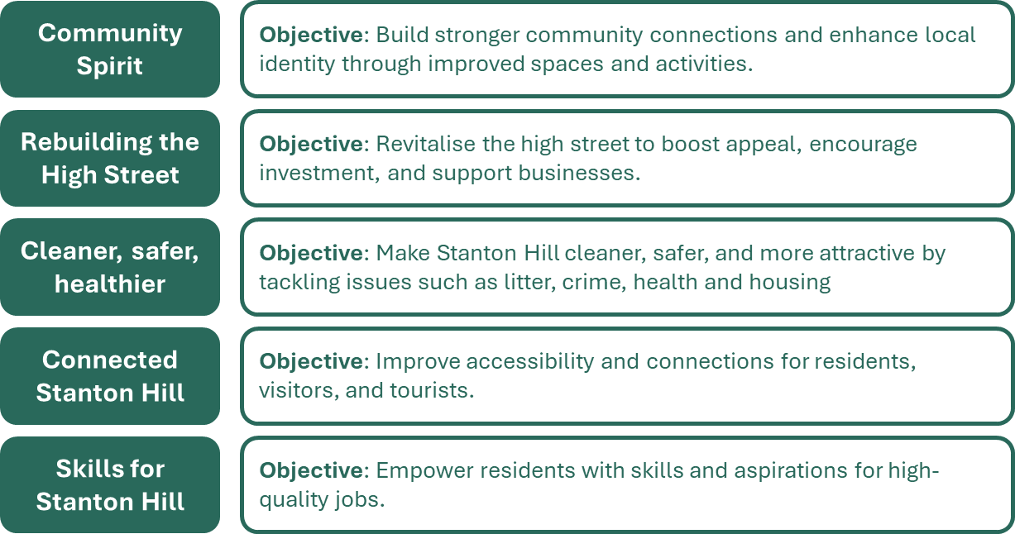

For each of the themes we have defined actions and timescales. Timescales for each action are rated as being either Short Term (within the first year of the Plan), Medium Term (within the first three years of the Plan), or Long Term (to be phased over the 10 years of the Plan). Some of the actions require new processes to be put in place that will then become part of the standard way of doing things. These are noted as requiring ‘ongoing’ actions.

## Community Spirit

##### Objective: Build stronger community connections and enhance local identity through improved spaces and activities

There are a series of challenges which might be summed up as 'a lack of community spirit'. This is affecting the area by limiting

volunteering and participation, and through anti-social behaviour. There is a sense among consultees that a lack of pride in place leads to lack of engagement and apathy. The pandemic has reduced levels of engagement and volunteering, which is a common issue across the country. Unless there can be a positive change in community involvement, it will be difficult to maintain the physical fabric in a way which attracts investment. Stronger community links will also support positive social outcomes (e.g. helping tackle social isolation).

The community requires a place to meet, as there isn't a suitable venue with sufficient meeting space. The Vine Tree has a valued offer, but does not have meeting space. Other potential venues include the Healdswood Centre, and All Saints Church, though there may be challenges booking these spaces. There is a particular concern raised by the community about a lack of activities for young people.

Early indications suggest a simple, **flexible meeting space** will be sufficient for the majority of requirements. With this in place, an **effective range of provision** is needed which might include: social clubs, young children / toddlers, provision for older children / teenagers. This provision should build on successful offers / groups, not only in Stanton Hill, but across Ashfield and surrounding areas. It will be important to consider how existing food bank activity and places of welcome fit into this.

In the past, events have been held successfully. This includes Christmas events and a music festival. However, a lack of engagement has blunted enthusiasm to organise and hold these events. Therefore, a renewed **programme of events** (e.g. Spring Fair, Summer Fair, Halloween, Christmas, a market, etc.) is needed to bring people together and emphasise the area's identity. Events are also an opportunity to provide information to the community, e.g. in terms of warmer homes / retrofit funding opportunities.

Strengthening the identity of the town through the development of a **Stanton Hill Story** - a programme to help define and tell the story of Stanton Hill, and sharing this via local schools and groups – will help to re-engage people around a positive vision for the area. Practical projects, such as **urban greening projects**, will also help provide a focus for community efforts and address dilapidation in the area, building on the community garden outside of the Co-op. A community orchard project is one active suggestion. There is the opportunity to build on expertise in relevant local groups, the Quarrydale gardening club, and the proposed community farm near Skegby.

These actions can collectively bring together the community to leverage local enthusiasm, interest, and effort to improve Stanton Hill.

### Objective: Build stronger community connections and enhance local identity through improved spaces and activities

|  |  |  |  |
| --- | --- | --- | --- |
| **Action** | **Timescales** | **Resources Required** | **Responsibility** |
| **Ensure adequate community space on or near the High Street** |  |  |  |
| 1. Build on community engagement to establish what the need is (i.e. type of provision):    * identify the space requirements.    * identify the options for securing space, including the funding requirements.    * ADC to work with the Neighbourhood Forum and the community to develop a business case for investment and the operational/ revenue model. | **Short Term** | Capital investment – including potentially drawing on Section 106/ UKSPF funding.  Short term funding for the hire of All Saints Church. | ADC lead / supported by Neighbourhood Forum and community groups. |
| **2.** Ensure active management of facilities so that there is a high-quality offer which appeals to different groups. Use the community space to support wider Investment Plan aspirations (i.e. increased engagement etc.) | **Long-term / Ongoing** |  |  |
| **Run community support programmes through facilities on the High Street** |  |  |  |
| **1.** Work with providers of local community support activities to identify needs and how they might be able to operate at local community facilities. Identify quality local providers. | **Short Term** | To be determined. | Neighbourhood Forum at first, then to be led by broader community groups working with ADC. |
| **2.** Following the securing of community space, look to incorporate these wider offers within this space. Promote these new offers to increase uptake and cross-promote other events. | **Short-Medium Term** |  |

|  |  |  |  |
| --- | --- | --- | --- |
| **Action** | **Timescales** | **Resources Required** | **Responsibility** |
| **Run a programme of events to facilitate engagement and build community spirit** |  |  |  |
| **1.** Agree a programme of events for the coming year and a budget . Establish clear responsibilities for organisation. Neighbourhood Forum and the community to get access to High Street noticeboard. | **Short Term** | Initial work should establish where funding is needed for decorations / reusable event  assets, though ideally much of this would come from the community / sponsorship. | Neighbourhood Forum to establish organisation committee  working with ADC and local businesses. Over time engage wider members of the community. |
| **2.** Review impact of events and refine approach. | **Short-Medium Term** |  |  |
| **3.** Develop events which have broader appeal beyond Stanton Hill and / or link in with local tourism (e.g. events at Hardwick Hall), in order to attract visitors. | **Medium - Long Term / Ongoing** |  |  |
| **Develop a Stanton Hill ‘Story’ with the community that helps define Stanton Hill’s identity** |  |  |  |
| **1.** Identify some partners to work with e.g. local historians, and local creatives (e.g Ashfield Creates). Consider what an output for this might look like (e.g. talks, video / digital resources, interactive sessions, etc.) | **Short-Medium Term** | Small amounts of funding may be required to develop a programme and approach. There may be opportunity to secure funding from cultural sources. | Neighbourhood Forum and the community to work with ADC to commission the right support. |
| **2.** Develop and test initial materials. | **Medium Term** |  |  |
| **3.** Refine and deepen approach over time. | **Medium-Long Term / Ongoing** |  |  |

|  |  |  |  |
| --- | --- | --- | --- |
| **Action** | **Timescales** | **Resources Required** | **Responsibility** |
| **Use local greening projects to drive community engagement** |  |  |  |
| 1. Develop an approach to greening projects by:    * Engaging with other relevant groups.    * Identifying potential spaces and projects.    * Ensuring that plans consider how to prevent vandalism etc. which have affected other projects.   A first focus should be ensuring the long-term continuity of the community garden by ensuring a broader volunteer approach to maintenance. | **Short Term** | Depending on the project(s), funding may be needed for equipment / plants. Equally, it may be possible to source the latter from the community / sponsors.  ADC can support with maintenance to existing Council- owned spaces. | Neighbourhood Forum to lead on community / partner engagement and managing  projects.  ADC to support where needed to secure sites, provide funding support. |
| **2.** Agree a priority space / approach and draw other members of the community in. | **Short-Medium Term** |  |  |
| **3.** Develop improvement approaches to other green spaces in Stanton Hill. Consider opportunities to get e.g. schoolchildren involved. | **Medium-Long Term / Ongoing** |  |  |

## 4.2 Rebuilding the High Street

##### Objective: Revitalise the high street to boost appeal, encourage investment, and support businesses

The High Street currently suffers from a range of issues, including poor appearance and dilapidation, lack of consistent shop frontages due to permitted development, several vacant premises, and lack of connectivity with Co-op (which faces away from the High Street).

There is a core of anchor businesses: the Co-op and Heron Foods which are consistent attractors to the area, as well as the Vine Tree

which provides a high quality local service. The increase in local population due to housing development, and the scale of tourism in the surrounding area, mean that there are opportunities if the attractiveness of the High Street can be improved.

There is an ongoing Save the High Street (STHS) project. This will involve outreach to local businesses and so provides an opportunity to **improve links with local high street businesses**. This engagement would strengthen complementary work on community events and improving the attractiveness of the High Street. It will be important to support businesses to make investments, through **attracting grant funding for improvements** – e.g. shop front improvements, as well as business process improvements like improved websites etc. It will be important to help businesses to understand the availability of these funds and access them.

There are likely to be small-scale opportunities to **improve the attractiveness of the High Street**, building on the success of the

Community Garden. Similar work is happening in other parts of Ashfield, and so there is an opportunity to learn lessons from these

schemes. There are also other initiatives that are looking to promote local art / street art through the Council’s 10-year Cultural Strategy that could complement the Plan for Stanton Hill. One specific issue to be explored further is **improving the interface between the Co-op and the High Street**. The front of the Co-op currently faces away from the High Street, which reduces the connectivity with the rest of the Street. This could be improved by e.g. creating a better pedestrian interface with the High Street.

Over the long-term, it will be important to improve the attractiveness of the High Street through **active management**, which might involve helping landlords to invest in upgrading their premises or may involve ADC using its investment powers to purchase key retail premises where this can catalyse change. This might involve: (1) signposting interested partners to available premises, (2) supporting

refurbishment where there is a funding gap, (3) purchasing properties directly with the aim of refurbishing these to get them into use. The new High Street Rental Auction powers granted to local authorities provide an opportunity in this regard too.

### Objective: Revitalise the High Street to boost appeal, encourage investment, and support businesses

|  |  |  |  |
| --- | --- | --- | --- |
| **Action** | **Timescales** | **Resources Required** | **Responsibility** |
| **Support engagement with local businesses** |  |  |  |
| **1.** Use STHS programme to catalyse better links with businesses. | **Short Term** | No funding expected beyond current allocations. This is primarily about long- term relationship building and maintenance | Neighbourhood Forum working with STHS initially.  Potentially a dedicated Traders' Group over the long- term. |
| **2.** Seek to engage businesses in the development of the events programme (see above). | **Short-Medium Term** |  |  |
| **3.** Continue to manage the engagement with businesses so that links are strong and effective. | **Long Term / Ongoing** |  |  |
| **Signpost high street businesses to sources of funding that are relevant for them, and help with applications where needed** |  |  |  |
| **1.** Agree how ADC will update local businesses on new sources of funding. | **Short Term** | Ongoing funding streams through ADC, Nottinghamshire CC, EMCCA, and central government. | Local businesses / future Trader's Group, with support from ADC to highlight and signpost known support. |
| **2.** Work with businesses to publicise sources of funding. | **Long Term / Ongoing** |  |  |
| **Invest in visual improvements to the High Street (e.g. planters, street art, etc.)** |  |  |  |
| **1.** Identify potential quick wins for improvement, based on engagement with community and other groups, and creative opportunities such as Ashfield Creates. Neighbourhood Forum to work with ADC to agree initial quick wins. | **Short Term** | Resources will need to be determined following the initial review, but there should be an expectation of capital investment. | ADC co-ordinating with NF to decide what is needed. ADC support to commission and invest in needed improvements. |
| **2.** Neighbourhood Forum to develop community engagement which supports the maintenance of these investments. | **Medium Term** |
| **3.** Seek investment from relevant funders to continue local improvements. | **Long Term / Ongoing** |  |  |

|  |  |  |  |
| --- | --- | --- | --- |
| **Action** | **Timescales** | **Resources Required** | **Responsibility** |
| **Work with the Co-op to improve the interface with the High Street.** |  |  |  |
| **1.** Engage with Co-op management to discuss these issues and potential solutions. Identify whether this is something Co-op could lead on and/or whether other resources are needed. | **Short Term** | To be considered in light of discussions with Co-op. | Neighbourhood Forum and ADC to engage with Co-op. Co-op to lead on works. |
| **2.** Implement physical investments that address the current issues. | **Medium Term** |  |  |
| **Consider active intervention in High Street properties to boost long-term attractiveness** |  |  |  |
| **1.** Put in place a process to review property movements on the High Street, and keep track of potential demand. Review these at Investment Plan meetings and consider whether intervention would support the aims of the Plan. | **Short-Medium Term / Ongoing** | Will be dependent on approach. Ongoing work needed to understand fund availability – e.g. the ADC High Street Property Fund. | Neighbourhood Forum to work with ADC to review.  ADC to lead where investment is needed. |

### Cleaner, Safer, Healthier

##### Objective: Make Stanton Hill cleaner, safer, and more attractive by tackling issues such as litter, crime, health and housing

High levels of littering and fly-tipping are present in Stanton Hill. It will be important to **address littering and fly-tipping** to signal a change in the area. This will require making best use of existing services (ADC response to reports of fly-tipping, the Big Spring Clean initiative, and large item collections). The role of the Neighbourhood Forum and the community in identifying and communicating

problem issues to ADC will be important. Alongside this, community litter-picking activities can help, though there is a need to rebuild community engagement on this as this has declined over the last few years.

Several properties in Stanton Hill are poorly maintained and / or have litter in gardens which reduces attractiveness and creates sanitation issues. Selective licensing has helped ADC respond in areas where this is in force. However, enforcement times are still dependent upon timely reporting of issues by the community. There is therefore a need to **use enforcement powers to address**

**problem properties.** The Neighbourhood Forum and ADC will need to work together to ensure that relevant issues are being picked up and acted upon. Consideration should be given to whether the selective licensing area needs to expand.

The most recent data suggests relatively high levels of crime in Stanton Hill, and there is a perception that the area is unsafe, with

residents being highly concerned about anti-social behaviour (ASB) and drug dealing / drug use. There is a need to **work with police and community safety teams to address ASB and crime issues**. This should include increasing the provision of infrastructure and support to boost public safety. There are two CCTV cameras in Stanton Hill at present. They are used by police to help prosecute crimes, but signage is limited, so they may not act as a deterrent. ADC is investigating the opportunity for two new CCTV cameras. These should be put in place with appropriate signage to deter ASB and crime. Other public safety considerations include addressing service roads

between existing streets which appear to facilitate burglary. For some key routes between outlying estates and the High Street, improved lighting should be considered to increase safety and encourage people to walk in to the High Street.

The community also need to be supported to live healthy lives. Existing homes have issues with insulation which affect warmth, comfort, and health. There is ongoing work which will establish feasibility of **retrofitting the local housing stock**, to be progressed with Nottingham Energy Partnership. There is also a need to **increase local health centre provision**, given that the existing health centre is overburdened, which poses challenges given the expanding population. ADC are currently working with the Health Centre on this.

### Objective: Make Stanton Hill cleaner, safer, and more attractive by tackling issues such as litter, crime, health and housing

|  |  |  |  |
| --- | --- | --- | --- |
| **Action** | **Timescales** | **Resources Required** | **Responsibility** |
| **Address littering and fly-tipping** |  |  |  |
| **1.** Information programme to ensure that residents understand large item collection and recycling options, and to promote behaviour change to reduce littering. ADC to ensure that Neighbourhood Forum and community can easily report issues and that these are acted upon in a timely way. | **Short Term** | Existing budgets | ADC to lead on formal litter collection, and to ensure the system is responsive to incidents. |
| **2.** Neighbourhood Forum and ADC to work together to ensure timely response to problem areas and incidents. | **Medium-Long Term**  **/ Ongoing** |  | Neighbourhood Forum to lead and co- ordinate community litter-picking. |
| **Use enforcement orders to address eyesore properties** |  |  |  |
| **1.** ADC to ensure that Neighbourhood Forum and community can easily report issues and that these are acted upon in a timely way. | **Short Term** | Existing budgets | ADC to lead on formal processes, and to ensure the system is responsive to incidents. |
| **2.** Neighbourhood Forum and ADC to work together to ensure timely response to problem areas and incidents. | **Medium-Long Term**  **/ Ongoing** |  |  |
| **Work with police and community safety teams to address ASB and crime issues** |  |  |  |
| **1.** ADC to invest in additional CCTV and supporting signage. | **Short Term** | ADC has costed  additional CCTV and is seeking PCC funding.  Other measures will need to be costed with funding secured. | ADC |
| **2.** Neighbourhood Forum and ADC to consider other measures that would enhance local safety (e.g. lighting and safe spaces). | **Short-Medium Term** |  |  |
| **3.** Review alleys and unadopted roads and consult with residents to put measures in place to enhance security. | **Medium-Long Term** |  |  |

|  |  |  |  |
| --- | --- | --- | --- |
| **Action** | **Timescales** | **Resources Required** | **Responsibility** |
| **Encourage energy saving retrofit uptake to improve housing standards** |  |  |  |
| **1.** Determine options to use Warmer Homes Fund or similar funding to address fuel poverty / retrofit, working with Nottingham Energy Partnership. | **Short Term** | Draw on resourcing from existing external retrofit funds, as well as any funding secured by ADC for this purpose. | Neighbourhood Forum leading the initial study.  ADC to lead the  promotion of retrofit options, working with relevant partners. |
| **2.** ADC to review funding options and work with landlords and homeowners to encourage uptake of retrofit measures. | **Medium Term – Ongoing** |  |  |
| **Increase health centre provision** |  |  |  |
| **1.** Review healthcare requirements arising from growing population. | **Short Term** | To be determined. | ADC with the ICB (Integrated Care Board) |
| **2.** Invest in appropriate health provision for the Stanton Hill area. | **Medium Term – Long Term** |  |  |

### Connected Stanton Hill

##### Objective: Improve accessibility and connections for residents, visitors, and tourists.

There is a major opportunity to attract more people - existing and future residents, and visitors - into the High Street. Doing so will require addressing connectivity challenges that hamper access to and from the area, specifically:

* + 1. **Improving bus services**: Local bus services are extremely poor with hourly bus services from Stanton Hill running from 6:30am - 5:30pm, and no bus services on Sundays. This service is also very slow - over 1.5 hours from Nottingham to Stanton Hill – and the timetable does not match up well with connections via onward buses. Bus service provision is transitioning to EMCCA control, with the new Mayor putting a strong emphasis on buses. This creates an opportunity to lobby for an improved service that gives residents greater access to key nearby centres, as well as making it easier for people to visit Stanton Hill.
    2. **Improving cycle routes and clearly marked walking routes for visitors and those using the surrounding trails**: To maximise the benefits of the visitor economy, it needs to be easy for visitors to walk and cycle to the High Street. The Neighbourhood Forum have previously developed cycle path proposals. There is a need to revisit these, with particular consideration for ensuring that any future proposals include the High Street. Where possible, making links with new housing developments will maximise the benefits of these investments.
    3. **Addressing local crossing and traffic issues**: The High Street can pose challenges in terms of crossing due to fast-moving traffic and lack of crossing places in some locations. There is also a challenge with on-street parking which would benefit from more proactive enforcement measures.
    4. **Improving walking links with surrounding housing estates**: Current connections to the newer housing estates are poor. Given the importance of attracting more footfall to the High Street, it should be a priority to improve access so as to increase the likelihood of residents using the High Street. The three key routes to the west of the High Street are Wharf Road, the alley between Fackley Way

and Morley Street, and Brand Lane. All have issues with quality of access / perceived safety. Where there are plans for future housing, these plans must be reviewed to ensure that new housing links up well with the town centre to avoid the issues experienced with current estates.

### Objective: Improve accessibility and connections for residents, visitors, and tourists

|  |  |  |  |
| --- | --- | --- | --- |
| **Action** | **Timescales** | **Resources Required** | **Responsibility** |
| **Work with the County Council / EMCCA to improve bus services** |  |  |  |
| **1.** Neighbourhood Forum and ADC to consider what the request is in relation to Stanton Hill’s bus service. | **Short Term** | TBC | EMCCA / ADC |
| **2.** Lobby for improved service. | **Short Term / Ongoing** |  |  |
| **3.** Review usage using community feedback and adjust approach as needed. | **Long Term** |  |  |
| **Develop cycle paths proposals** |  |  |  |
| **1.** ADC and Neighbourhood Forum to review cycle path proposals. | **Short Term** | Additional resource to be sought from appropriate funding pots. | NCC / ADC |
| **2.** Develop business cases for new infrastructure. | **Short-Medium Term** |  |  |
| **Work with the County Council to review crossings on the High Street and to manage existing traffic issues** |  |  |  |
| **1.** Review connectivity issues and develop priority list. Work with ADC to identify sources of funding. | **Short-Medium Term** | Additional resource to be sought from appropriate funding pots. | NCC / ADC |
| **2.** Carry out relevant works to improve connectivity along the High Street. | **Medium Term** |  |  |
| **3.** Review traffic issues as footfall increases to ensure that the High Street remains accessible and safe. | **Long Term / Ongoing** |  |  |

|  |  |  |  |
| --- | --- | --- | --- |
| **Action** | **Timescales** | **Resources Required** | **Responsibility** |
| **Explore ways to improve connections with surrounding housing estates to integrate these properly into Stanton Hill** |  |  |  |
| **1.** Review the connectivity of outlying estates and propose appropriate interventions where needed. | **Short-Medium Term** | Additional resource to be sought from appropriate funding pots. | ADC |
| **2.** Deliver investments to improve key walking routes that connect to the High Street. | **Medium Term** |  |  |

### Skills for Stanton Hill

##### Objective: Empower residents with skills and aspirations for high-quality jobs

Skill levels in Stanton Hill are relatively low, and there are challenges with low aspirations. It is important for the community that people are able to succeed, and particularly that young people have clear pathways for long-term, high-skilled work. There are long-term opportunities in Ashfield and surrounding areas, including the forthcoming Automated Distribution and Manufacturing Facility and wider opportunities around the energy sector and major infrastructure development. These offer the potential for long-term employment and upskilling pathways.

There is a range of existing skills-related provision in the area, including initiatives like Future Skills. One barrier to making the most of this provision is a lack of suitable space to hold activities. Consideration should be given to whether there is an opportunity **increase skills provision in Stanton Hill**, including on the High Street.

This might even include utilising currently vacant space where there is budget available from external funding to do so. This would

address two issues, (1) improving the quality of the High Street and potentially tackling vacant space and (2) improving access to skills training. The Government’s Get Britain Working policy proposals are supportive of the aspirations of this intervention, and may help with securing funding.

More broadly, there is a perception that aspirations are low. It will be important to **better communicate new economic opportunities to young people in Stanton Hill**. This could include talks and visits about the nearby Observatory for younger children, and talks from / visits to relevant businesses and colleges for older students. There are opportunities around important thematics like STEM skills

(Science, Technology, Engineering, Mathematics), and arts and culture. This work links to the above action on the Stanton Hill Story.

### Objective: Empower residents with skills and aspirations for high-quality jobs

|  |  |  |  |
| --- | --- | --- | --- |
| **Action** | **Timescales** | **Resources Required** | **Responsibility** |
| **Work with partners to develop skills provision on the High Street, using community premises** |  |  |  |
| **1.** Consult with skills providers about the concept to understand their requirements. Consider what is needed and whether existing spaces are adequate. | **Short Term** | Dependent on long-term approach.  Potential to tap into a number of funding streams. | ADC |
| **2.** Deliver skills via community premises, including any capital improvements needed to secure this. | **Medium Term** |  |  |
| **3.** Work to ensure sustainability of provision over the long-term. | **Long Term** |  |  |
| **Support greater outreach from businesses and further education into local schools, to raise aspirations** |  |  |  |
| **1.** Identify partners to help engagement with schools. Work with schools to arrange visits etc. | **Short-Medium Term** | Organisational time to set up talks and visits. | Neighbourhood Forum and the broader community with support from ADC |

# Working in Partnership

The Neighbourhood Forum and ADC will work in partnership to ensure the delivery of this Investment Plan. We have established a series of principles that will govern how we will work together:

* The **Neighbourhood Forum** has a key role in engaging with the community, helping to draw other members of the community into delivering the Plan, and leading on parts of the Plan that require community input and involvement.

At the heart of this is a recognition that our community contains people with a range of skills and talents, and that collectively we are able to draw on a range of assets to improve our community. This is consistent with the concept of Asset Based

Community Development.

Over the next ten years it will be important to grow and broaden the membership of the Neighbourhood Forum to meet the aims of the Plan and to ensure

representation of a cross-section of the community.

It will also be important to reach out to other local groups with similar objectives and values, and complementary skills.

* **Ashfield District Council** (ADC) has an important role in providing day-to-day support for the implementation of the Plan. Dedicated support will be made available to help progress the Plan with the help of the community.

The Council has a key role in using its powers and ability to access funding to support the plan. It will be important for ADC to:

* + Support access to Council services that will help deliver the plan (e.g. ensuring responsive street cleaning and property enforcement). The Council’s Town Centres Manager will lead on delivery of the plan and coordinate Council resources.
  + Ensure participation by relevant officers at Investment Plan meetings (see below).
  + Highlight new funding opportunities (e.g. funding from Government, EMCCA, etc.).
  + Deliver agreed projects.
* **The Neighbourhood Forum and ADC will share responsibility for checking progress** against the Investment Plan.
* It is important that the community understands the Plan and opportunities to engage with it. **The Neighbourhood Forum and ADC will work together to engage the community on the Plan.**
* As well as engaging the community about the Plan it will be important to

##### communicate successes as part of the Plan so that residents understand when progress has been made.

* **The Investment Plan will be revised and updated at regular intervals** to reflect achievements and to ensure that it remains fit for purpose.

The Neighbourhood Forum and ADC will meet on a six-eight weekly basis to review progress and discuss priorities. Where additional discussions and work are needed the Neighbourhood Forum and ADC will consider how to ensure that sufficient time is made available to complete these tasks.

# Next Steps

The first year of this Plan is critical to build momentum and demonstrate intent – to both the community and wider stakeholders. In the first year partners will focus on the

following actions:

## Community Spirit

* Build on community engagement to establish what community space provision is needed. Specifically:
  + identify the space requirements.
  + identify the options for securing space, including the funding requirements.

ADC to work with the Neighbourhood Forum to develop a business case for investment and the operational / revenue model.

* Work with providers of local community support activities to identify needs and how they might be able to operate at local community facilities. Identify quality local providers.
* Agree a programme of events for the coming year and a budget. Establish clear responsibilities for organisation.
* Neighbourhood Forum to get access to the local noticeboard.
* Identify partners to develop the Stanton Hill ‘Story’. Define what the outputs of this should be.
* Develop an approach to greening projects by:
  + Engaging with other relevant groups.
  + Identifying potential spaces and projects.
  + Ensuring that plans consider how to prevent vandalism etc. which have affected other projects.

A first focus should be ensuring the long-term continuity of the community garden by ensuring a broader volunteer approach to maintenance.

## Rebuilding the High Street

* Use STHS programme to catalyse better links with businesses. Use these to understand issues on the High Street and the development of the events programme.
* Agree how ADC will update local businesses on new sources of funding.
* Identify potential quick wins for visual improvements to the High Street, based on engagement with community and other groups, and creative groups.

Neighbourhood Forum to work with ADC to agree initial quick wins and ensure financing.

* Engage with Co-op management to discuss connectivity with the High Street and potential solutions. Identify whether this is something Co-op could lead on and/or whether other resources are needed.
* Put in place a process to review property movements on the High Street, and keep track of potential demand.

## Cleaner, Safer, Healthier

* Information programme to ensure that residents understand large item collection and recycling options, and to promote behaviour change to reduce littering.
* ADC to ensure that Neighbourhood Forum and community can easily report littering and fly-tipping issues and that these are acted upon in a timely way.
* ADC to ensure that Neighbourhood Forum and community can easily report property enforcement issues and that these are acted upon in a timely way.
* ADC to invest in additional CCTV and supporting signage.
* Neighbourhood Forum and ADC to consider other measures that would enhance local safety (e.g. lighting and safe spaces).
* Determine options to use Warmer Homes Fund or similar funding to address fuel poverty / retrofit, working with Nottingham Energy Partnership.
* ADC to review healthcare requirements with ICB arising from growing population.

## Connected Stanton Hill

* Develop an ask for local bus services .
* ADC and Neighbourhood Forum to review cycle path proposals.
* Review local crossing and traffic management issues and develop priority list.
* Review the connectivity of outlying estates and propose appropriate interventions where needed.

## Skills for Stanton Hill

* Consult with skills providers about potential local provision / provision on the High Street to understand their requirements. Consider what is needed and whether

existing spaces are adequate.

* Identify partners to help engagement with schools. Work with schools to arrange visits etc.

## Working in Partnership

* ADC to put in place dedicated support to help progress the Plan with the help of the community.
* Communicate the Plan to the community and engage them as to how best to achieve the objectives.

# Appendix: Economic Profile

Stanton Hill is a local centre located near Sutton-in-Ashfield within the Ashfield district in Nottinghamshire. The town is one of seven local centres and has historic roots in coal mining and industry. Key assets include Stanton Hill High Street, Brierley Park Industrial Estate, a local primary school and secondary academy, and recent and upcoming

housing developments.

Stanton Hill is located to the northwest of Sutton-in-Ashfield town centre, which is approximately two kilometres away and is approximately five kilometres away from Mansfield. Sutton-in-Ashfield, one of Ashfield's main urban centres, offers

employment, retail, and leisure opportunities for residents.

Stanton Hill’s primary road connection is through B6028 Stoneyford Road, which links it directly with Sutton-in-Ashfield to the southeast. The route is also the main High Street with two-way traffic and single yellow lines along the street. Parking at the high street is therefore more limited with visitors often parking on side streets or using the Co-op car park. The High Street is accessible by foot from nearby areas, though narrow pavements and limited pedestrian crossings, which poses challenges with high-speed traffic creating difficulties for pedestrians.

Stanton Hill is also served by nearby thoroughfares like the A38, which runs east-west, and the M1 motorway to the west, facilitating regional connectivity. These major roads connect Stanton Hill to larger towns and cities, such as Mansfield to the north and Nottingham to the south. Stanton Hill does not have a rail service; the nearest stations are in Mansfield and Sutton Parkway.

This analysis primarily uses the Stanton Hill and Teversal ward area to define the study area when analysing local level data. It should be noted that the ward area covers a wider geography than the study area including the areas of Teversal, Fackley and Stanley.

## History

Stanton Hill is a former coal mining area which was established in the nineteenth century by the Stanton Ironworks Company to house the growing local workforce for the nearby collieries including Teversal, Silverhill and New Skegby Collieries. Coal mining

was the basis of Stanton Hill’s economy and community, with generations of families working in the mines and depending on them for their livelihoods. Stanton Hill was

initially part of Skegby, however developed its own identity as demand for housing continued to rise with the population of Skegby increasing from 805 in 1869 to over 3,000 in 1884.

Figure 3: Map showing collieries around Stanton Hill in the 1950s

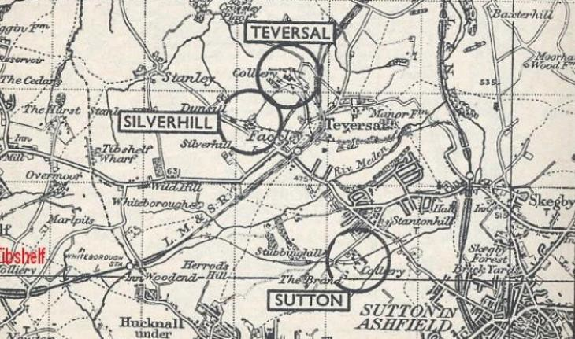

*Source: 1952 Guide to the Coalfields, via Mining Heritage (2024)*

The Stanton Ironworks Company began constructing a total of 150 homes in 1877 on what are now known as Cooperative Street, Institute Street, and Cross Row. The company built a further 120 homes on Meden Bank alongside allotments for the workforce. The Blackwell Colliery Company also contributed to the housing in the Stanton Hill area, building the terraces of houses named Longden, Bainbridge, Marshall, Gardiner, Cochrane and Scott's – named after the company’s Directors.

Figure 4: Silverhill Colliery (Meden Bank in foreground and Fackley Road in centre

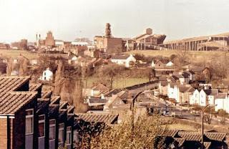

*Source: Trail Trekking, Blogspot (2011)*

However, like other mining communities in Britain, the area experienced decline in the 1980s with the closure of the three pits. Teversal Colliery closed in 1980, followed by Sutton Colliery in 1989 and finally Silverhill Colliery closed operations in 1993. After

demolition, the sites were vacant until they were transformed into sites for wildlife and

recreation. Today, Silverhill Wood covers the former Teversal and Silverhill pits whilst the Sutton Colliery site is now home to Brierley Forest Park. The closure of the mines

resulted in high unemployment rates and social challenges as residents adjusted to life after mining which remains a key part of Stanton Hill’s legacy and heritage. Groups such as Teversal Heritage Group work to research, record and preserve the area’s heritage,

recognising its importance to future generations.

Figure 5: Testing for Gas statue, Silverhill Wood

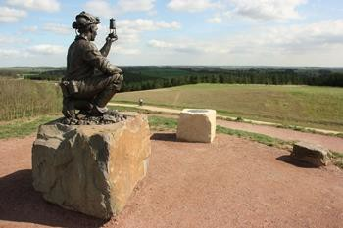

*Source: Nottinghamshire County Council (2024)*

## Demographics/Local Population

Stanton Hill and Teversal ward has a total population of approximately 3,352 people who reside within approximately 1,413 households5. In terms of age, the ward has a

similar age profile to the wider Ashfield district and within England, with a slightly higher proportion of children (aged 0 to 15) and a slightly lower working age population (aged 16 to 64). In Stanton Hill and Teversal ward, 60.8% of residents are aged 16 to 64, 20.2% of residents are aged under 16 and 19.0% of residents are aged 65 and over.

Population forecasts for Ashfield6 suggest that the district’s population will grow by 11.9% between 2024 and 2043, significantly outpacing the national growth rate of 6.8%. A notable increase in the number of residents aged 65 or over in Ashfield between 2024 and 2043 is forecast (forecasted to rise by 33.1%). This demographic shift alone does not account for the overall population growth forecast in Ashfield. Factors such as new housing developments and migration into the area will contribute towards the growing

local population. Assuming Stanton Hill mirrors the broader Ashfield district, it is likely to experience a rapidly growing and ageing population over the next two decades.

5 TS007 - Age by Single Year, Census 2021 (Office for National Statistics, 2022)

6 Population Projections - Local Authority Based by Single Year of Age (Office for National Statistics, 2023)

Similar to the wider Ashfield district, Stanton Hill has a low level of diversity in ethnicity with 95.4% of residents identifying as White7, which is below the England rate of 81.0%. In terms of other ethnicities, approximately 2.0% of residents were Asian, Asian British or Asian Welsh, 1.2% were from Mixed or Multiple ethnic groups, 0.8% were Black,

Black British, Black Welsh, Caribbean or African, and 0.6% were from other ethnic groups.

Educational attainment and qualification rates in Stanton Hill and Teversal are low with 25.3% of individuals aged 16 or over holding no formal qualifications8, surpassing the rates in Ashfield (23.6%), the East Midlands (19.5%) and England (18.1%).

Correspondingly, the proportion of residents with Level 4 or higher qualifications

(equivalent to Higher National Certificates or degree-level courses) in Stanton Hill and Teversal (22.5%) is significantly below the rate in England (33.9%).

The Stanton Hill study area includes Healdswood Infants’ and Nursery School which received a ‘Good’ rating from Ofsted in 2021, indicating a positive performance in relation to early education. However, Quarrydale Academy, the nearest secondary school, was rated by Ofsted as ‘Requires Improvement’ in 2022 which suggested a worsening in education quality following a previous rating of ‘Good’ in 2013. The

academy also provides sixth-form provision which was rated as ‘Good’ by Ofsted. In terms of academic results, the school had a Progress 8 score9 of -0.65 which is classed as ‘Well below average’, compared to average scores of -0.01 in Nottinghamshire and -

0.03 in England.

The nearest further education provision to Stanton Hill is based in Sutton-in-Ashfield

town centre, with other providers available in Mansfield. Key further education providers include Vision West Nottinghamshire College located in Mansfield and the Academy Transformation Trust Further Education College in Sutton-in-Ashfield. Individuals

looking to continue onto higher education would have to travel into Nottingham, approximately 15 miles away, for access to courses offered by both Nottingham Trent University and the University of Nottingham.

Recent data from the English Indices of Deprivation10 shows that Stanton Hill faces significant challenges in relation to poverty and lack of resources. The index measures deprivation across small areas in England, known as Lower-layer Super Output Areas (LSOAs), using several factors such as income, employment, education, and health. In Stanton Hill, the area north of the High Street (between Meden Bank and Fackley Road,

LSOA Ashfield 001B) is among the top 10% most deprived areas in England. Meanwhile, the High Street area itself (LSOA 001C) falls within the top 20% most deprived areas

7 TS021 - Ethnic Group, Census 2021 (Office for National Statistics, 2022)

8 Highest Level of Qualification, Census 2021 (Office for National Statistics, 2023)

9 Progress 8 score measures the academic progress that pupils make from the end of Key Stage 2 to the end of Key Stage 4 based on eight qualifications. Quarrydale Academy has a ‘well below average’ ranking because the score is lower than -0.5.

10 Index of Multiple Deprivation (Office for National Statistics, 2019)

nationally. The town shows particularly high levels of deprivation in the Employment

and Education, Skills and Training categories, highlighting the need for targeted support and resources to improve the community’s wellbeing and living standards.

## Local community and social issues

### The High Street

The primary retail tenants in Stanton Hill are two supermarkets. A Co-op Food store

which is located at the junction of High Street and Fackley Road which it faces out onto. A Heron Food supermarket opened in Stanton Hill in 2023 on the High Street. Other

High Street outlets include a charity shop, four takeaways, a salon, two barbers, a

sandwich shop and two convenience stores. In terms of car parking both supermarkets have car parks for their customers, however there is limited space elsewhere along the High Street with visitors instead having to park on nearby residential side roads.

The number of retail tenants in Stanton Hill has been in decline since the closure of the collieries thirty years ago. The local centre has a vacancy rate11 of 25% which is high compared to the national average of 13.8%. The vacancy rate in Stanton Hill is the

highest of all local centres assessed in Ashfield and is significantly greater than the rates in Sutton-in-Ashfield town centre (18.4%), Huthwaite (8.3%) and Outram Street (21.3%).

In addition to retail tenants, the High Street also includes a number of residential properties and former retail properties which have been converted into flats and

housing. The properties along the High Street have poor aesthetics and there is a lack of trees and greenery along the route with narrow pavements limiting the ability to

introduce planted areas. Save The High Street are leading a separate piece of work engaging with local businesses following a successful pilot in nearby Hucknall.

CoStar analysis of Stanton Hill High Street identifies a mix of retail and light industrial uses. Lease rates across the properties vary depending on use and location, with retail spaces typically ranging from £12.70 to £16.17 per square foot per year, while light

industrial spaces typically having lower rates of £4.46 to £5.45 per square foot annually.

### Local employment

In 2023, there were approximately 800 jobs12 in Stanton Hill and Teversal ward, of which approximately two thirds worked full-time and one third worked part-time. Employment in the ward in 2023 was 11.1% lower than in 2019 which contrasts with the wider district

11 Town Centre - Local Centre Study, SEV.32 (Nexus Planning on behalf of Ashfield District Council, 2023)

12 Business Register and Employment Survey (Office for National Statistics, 2024)

and nationally where total employment has increased by 5.5% and 4.0%, respectively. This decline in Stanton Hill may be explained by relatively large falls in employment in sectors including business administration and support services and construction

between 2019 and 2023 though caution should be taken when analysing employment estimates in Stanton Hill given the small population and sample size.

The largest sectors in terms of employment counts in Stanton Hill and Teversal were Construction (25.8%), Transport and Storage (22.6%), and Accommodation and Food Services (12.9%). These sectors are over-represented in local employment relative to Ashfield and nationally. One of the key sites for local employment in Stanton Hill is Brierley Park Industrial Estate. The estate hosts a number of modern industrial and warehousing units supporting industries including manufacturing, logistics and

services.

CoStar analysis of the Industrial Estate suggests that the units range in size from 924

square feet up to 51,162 square feet. The estate has high occupancy rates with the most recent developments at the site completed in 2009. Rental rates vary across the estate, typically between £3.96 and £14.43 per square foot per year, depending on the property’s purpose and class, with industrial units priced lower than office space. Each property is well-maintained with classifications ranging from Class B to Class C.

### Visitor economy

The high proportion of employment in the accommodation and food services sector relates to the range of local assets that support the visitor economy within Stanton Hill and the wider area. The Teversal Trails Visitor Centre and the trail itself, located just north of the study area, attract outdoor enthusiasts for walking, cycling, and exploring the scenic routes. Brierley Forest Park, with its extensive walking and cycling paths,

fishing areas, and picnic spots, provides additional recreational opportunities. The Teversal Village conservation area and historic sites like Hardwick Hall further enrich the visitor experience, drawing those interested in heritage and history.

Figure 6: Teversal Trails

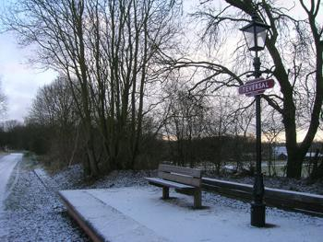

*Source: Nottinghamshire County Council (2024)*

Nearby, Silverhill Woodland Retreats & Teversal Campsite offers accommodation options for tourists, enhancing the area's appeal as a destination for nature lovers. There are a number of other accommodation options for tourists in the vicinity of Stanton Hill with the High Street forming a key route through to the local visitor attractions and assets. This through-traffic is a potential opportunity area, with

anecdotal evidence suggesting local visitors often use Stanton Hill’s supermarkets on their route through to attractions or their accommodation.

### Housing context

Stanton Hill primarily consists of terraced properties, with many rented out by private landlords. Compared to England, Stanton Hill and Teversal ward has a greater

proportion of three-bedroom households13 (55.2% compared to 40.0% nationally) and a lower proportion of households with four or more bedrooms (15.8% compared to 21.1% of households in England). There are, however, more recent housing developments on the outskirts of Stanton Hill which are increasing the tenure mix by providing more semi- detached and detached properties ranging from two to four bedrooms and aimed at families. Analysis of these developments suggests a shift towards more upmarket properties and living options in the wider area.

Recent housing developments around Stanton Hill include:

13 TS017 – Household size, Census 2021 (Office for National Statistics, 2023)

* **Brierley Heath** – this recent development is located on the edge of Brierley Forest Park (within the study area) and will feature 58 homes, offering a range of 3- and 4-bedroom properties;
* **St Andrews Heights** – this development is scheduled to open in 2025 and will consist of 112 2,3- and 4-bedroom properties and is located to the west of the study area; and
* **Stoneycroft Green** – this is set to feature approximately 100 properties when it opens in 2025 and is located to the south of the study area. This will include a mix of 2, 3, and 4-bedroom homes, catering to a variety of family sizes and preferences.

Residential properties in Stanton Hill had an average sale price of £154,083 over the last year14 which was 32% lower than the previous year and 26% lower than in 2021. The majority of sales in Stanton Hill during the last year were terraced properties, selling for an average price of £93,312 whilst detached properties sold for an average of £235,110. Property prices at the newer developments are above these levels with house prices at the Brierley Heath development ranging £289,000 to £385,000 for 3- and 4-bedroom properties.

There are several recently approved and submitted planning applications within Stanton Hill and the surrounding areas, highlighting the scale of proposed future residential developments and the potential expansion of the town. An application was submitted in 2022 for the development of 124 homes on a site north of Fackley Road along the River Meden; however, it was refused due to concerns about environmental impacts and lack of infrastructure capacity in Teversal and Stanton Hill.

### Teversal, Stanton Hill, and Skegby Neighbourhood Plan

The Teversal, Stanton Hill, and Skegby (TSS) Neighbourhood Plan15 was formally

accepted by Ashfield District Council in December 2017. The plan outlines the vision and recommendations for sustainable development and community enhancement in the area, running from 2016 to 2032. Key recommendations for Stanton Hill include improving the High Street's aesthetics and functionality by increasing green spaces, enhancing pedestrian pathways, and promoting local businesses to reduce vacancy rates.

The plan emphasises the importance of preserving Stanton Hill’s historical heritage while encouraging new housing developments that cater to diverse needs, including affordable housing options. Additionally, it recommends the need for better connectivity through improved public transport links and safer road crossings,

14 Rightmove Data Services (Rightmove, 2024)

15 Teversal, Stanton Hill and Skegby Neighbourhood Plan 2016-2032 (Teversal, Stanton Hill and Skegby Neighbourhood Forum, 2023)

especially on the High Street. The plan also highlights the need for community facilities and services in the area to support the growing and ageing population, ensuring that Stanton Hill remains a vibrant and inclusive place to live.

Policy NP 7: Strengthening the Retail Centre in Stanton Hill states that planning permission will be granted for developments that supports the vibrancy and vitality of Stanton Hill by diversifying and enhancing the range of local shops and related

commercial services, along with improving public spaces. The policy further states that development proposals in the local centre to increase the provision of off-street parking will be supported – recognising the existing limited parking within the High Street area.

### Town Centre / Local Centre Study

The Town Centre / Local Centre Study16 was commissioned in 2024 by Ashfield District Council to inform the emerging Local Plan reflecting the current condition of local centres in the district, including Stanton Hill. The study assesses Stanton Hill and highlights its role as a small but essential local centre. The assessment finds that Stanton Hill has a high vacancy rate of 25%, which is significantly above the national average of 13.8%. Despite this, the centre remains popular due to its convenience

stores, such as Co-op Food and Heron Foods, which attract steady footfall and should be leveraged further to attract more footfall and additional businesses.

Key recommendations include improvements to shop frontages and additional greening and street planting to enhance the local centre's appeal to visitors and potential

businesses. Although the centre has some natural surveillance and street lighting, maintaining and increasing these measures would enhance safety for visitors. The key aim of these measures is to make the High Street a more attractive destination to visit, increasing footfall and encouraging more businesses to open in Stanton Hill, reducing vacancy rates.

16 Town Centre - Local Centre Study, SEV.32 (Nexus Planning on behalf of Ashfield District Council, 2023)