

DISCLAIMER

This document or some parts of it may not be accessible when using adaptive technology.

If you require assistance with accessing the content of the document, please contact us and quote the document name and the web page you found it on:

- email: Regeneration – place@ashfield.gov.uk

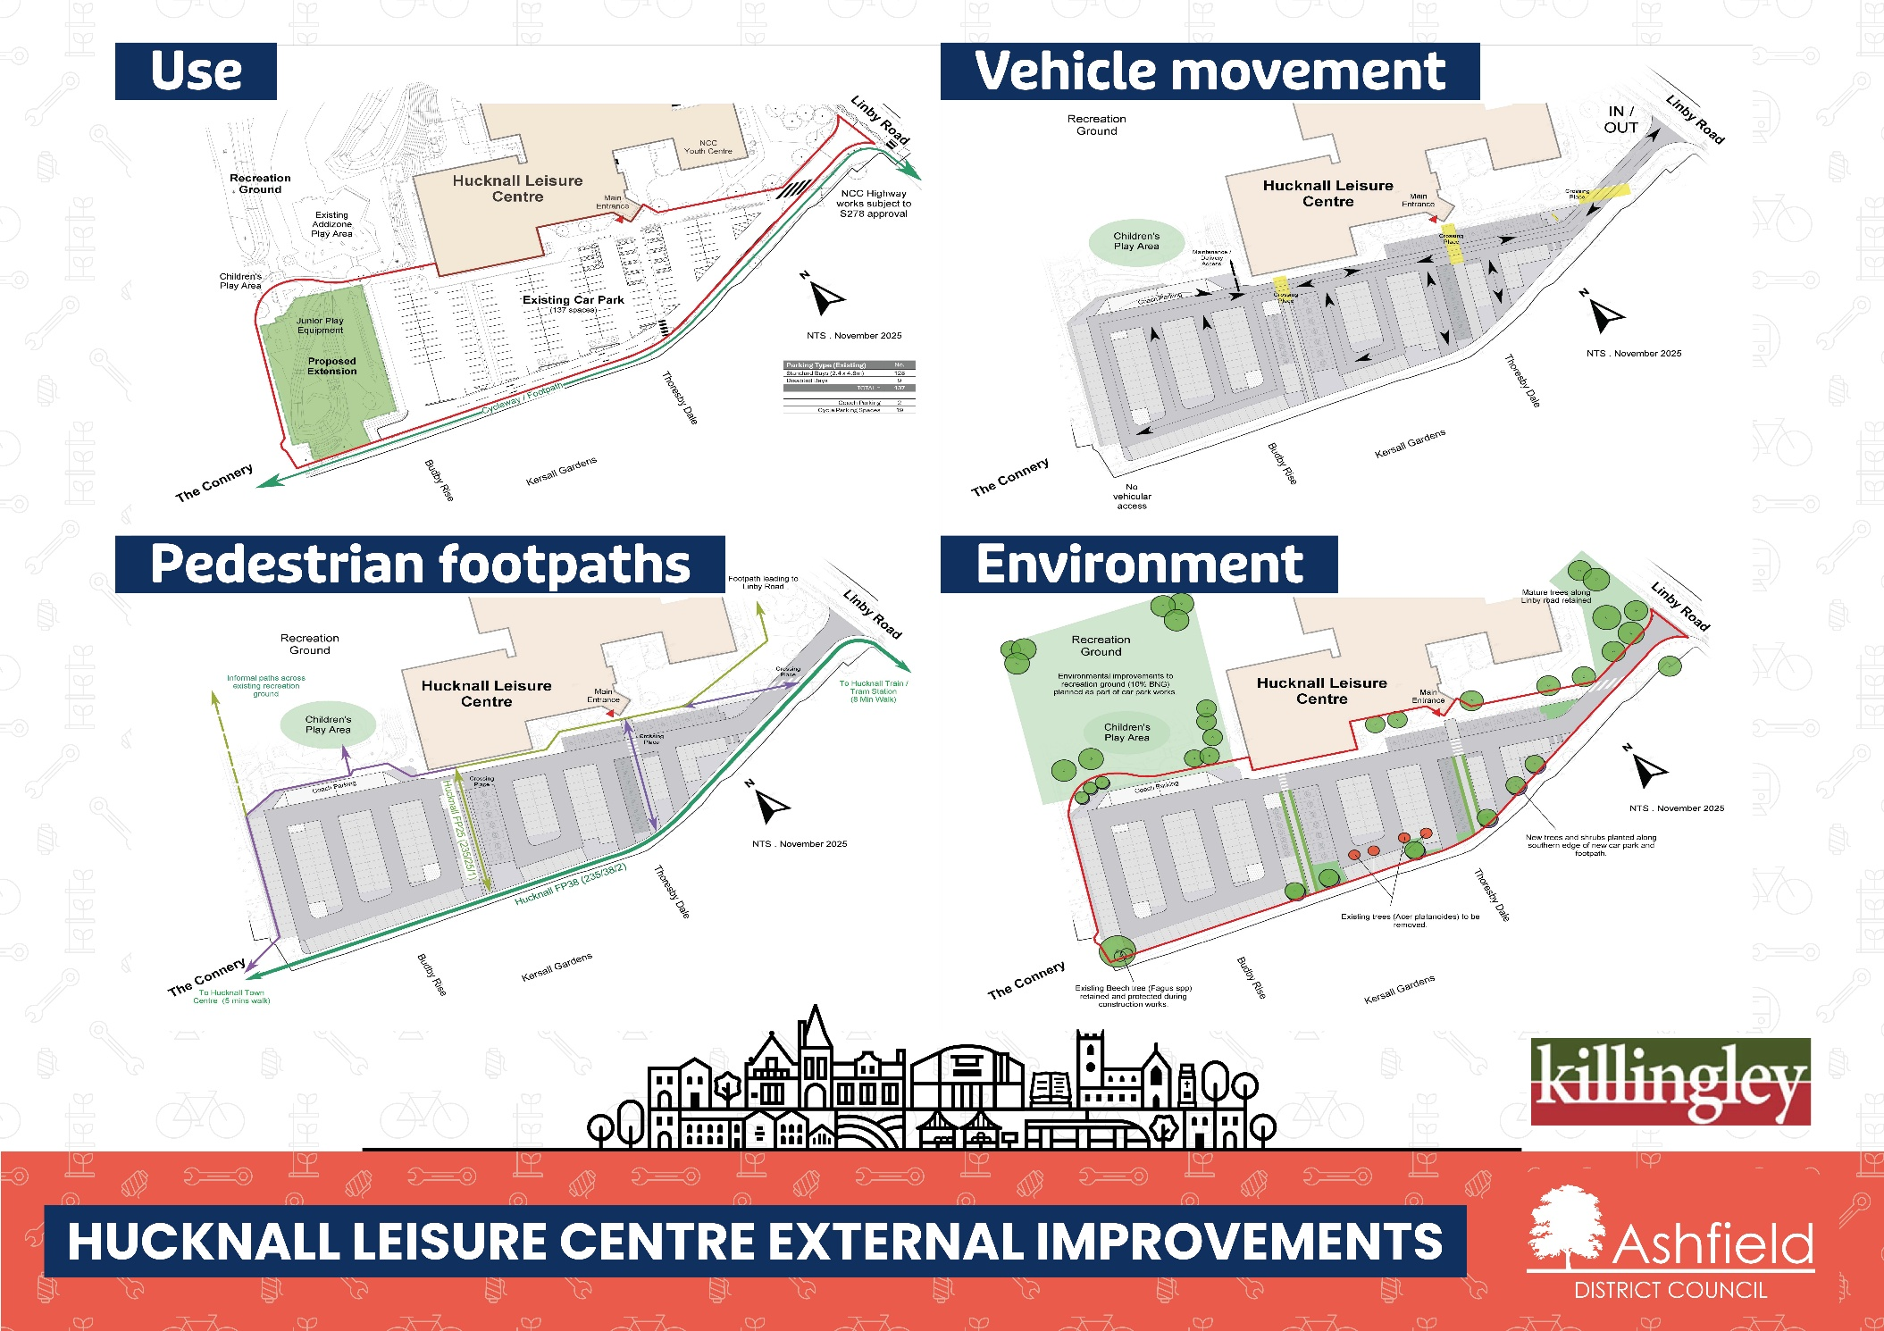

Hucknall Leisure Centre car park Vehicle Movement, Pedestrian Footpaths and Environment
The plans show four different plans. The first is the existing car park. It shows the location of:
- Hucknall Leisure Centre
- Recreation Ground
- Children’s play area
- Junior play equipment
- Proposed extension
- Existing Car Park
- Nottingham County Council (NCC) Youth Centre
- NCC Highway works subject to S278 approval
These items are displayed on each of the four diagrams:
- Main Entrance
- Linby Road
- Thoresby Dale
- Kersall Gardens
- Budby Rise
- The Connery

Vehicle Movement
This plan shows the movement of vehicles in the proposed car park. It shows the location of:
- Children’s play area
- Maintenance/deliveries access
- Crossing place
- Coach Parking
- IN/OUT

Pedestrian Footpaths
This plan shows the public right of ways for the proposed car park. It shows the location of:
- Informal paths across existing recreation ground
- To Hucknall Town Centre (5 mins walk)
- Hucknall FP25 (235/25/1)
- Footpath leaning to Linby Road
- Hucknall FP38 (235/38/2)
- To Hucknall Train/ Tram Station (8 mins walk)

Environment
This plan shows the environmental considerations for the proposed car park. It shows the location of:
- Recreation Ground
- Environmental improvements to recreation ground (10% BNG) planned as part of car park works
- Children’s Play Area
- Existing Beech tree (Fagus spp) retained and protected during construction works
- Existing trees (Acer platinoids) to be removed
- New trees and shrubs planted along southern edge of new car park and footpath

