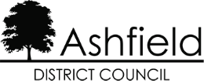

DISCLAIMER

This document or some parts of it may not be accessible when using adaptive technology.

If you require assistance with accessing the content of the document, please contact us and quote the document name and the web page you found it on:

- email: Impact graduate support – ngdpteam@ashfield.gov.uk

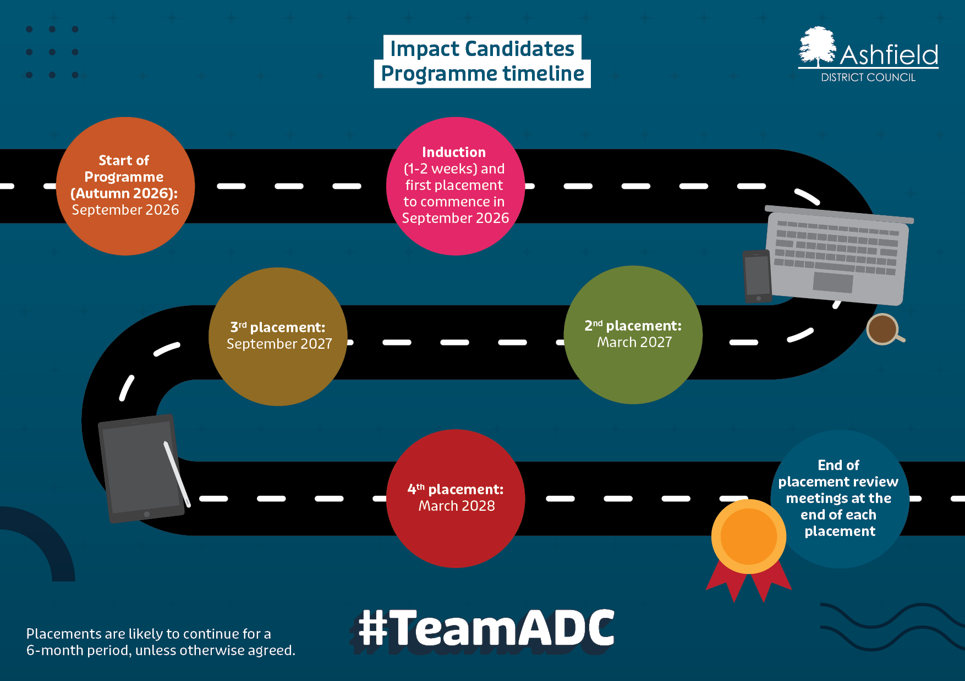
Impact Candidate
Programme timeline:
- Start of programme (Autumn 2026): September 2026
- Induction (1-2 weeks) and first placement to commence in September 2026
- 2nd placement: March 2027
- 3rd placement: September 2027
- 4th placement: March 2028
- End of placement review meetings at the end of each placement
Placements are likely to continue for a 6-month period, unless otherwise agreed.
#TeamADC

