**Matter 10 – Site allocations**

***H1Sq – Hardwick Lane recreation ground, Sutton-In-Ashfield***

***10.60 What evidence is there that the site is no longer needed for open space?***

There is insufficient evidence to support the premise that this open space is no longer required. This representation addresses the lack of evidence for the removal of this green space.

**1. Insufficient Evidence of Surplus Open Space**

The loss of Hardwick Lane Recreation Ground undermines its potential to meet current and future needs for playing pitches, as highlighted in:

* **Ashfield Playing Pitch Strategy (PPS) 2023**: The site is identified as a lapsed playing field, but paragraph 3.15 emphasises that ***“lack of use should not be taken as necessarily indicating an absence of need.***” Existing shortfalls for youth 11v11 and 9v9 pitches in Ashfield demonstrate the need to retain such spaces.
* **Sport England Objections**: Sport England evaluated the Council’s planning application (Ref: V/2024/0063) and determined it failed to comply with their Playing Fields Policy or National Planning Policy Framework (NPPF).
  + The Council did not demonstrate that the playing field is surplus to requirements according to paragraph 99 of the NPPF, Exception 1 of Sport England’s Playing Field Policy (and the Council’s EV5 policy).
  + No **new** area of playing field was proposed as a replacement (Exception 4).
  + Mitigation efforts, including the Sutton Lawn ‘hub’ site, rely on upgrading existing facilities, which does not meet Exception 4. Paragraph 69 of Sport England’s Playing Fields Policy confirms that the intensification or increasing the use of existing areas of playing field does not meet the requirements of Exception 4.

**2. Contradiction with Strategic Policies**

The proposed development conflicts with the Council’s own strategic priorities:

* **Infrastructure Delivery Plan (October 2024), Paragraph 14.11:** The Council claims that users of playing pitches rely on vehicular transport, reducing the importance of catchment areas. However, equally this could reflect a shortage of accessible local playing pitches.

The strategy to concentrate facilities at fewer sites has proven ineffective, as the Council’s PPS identifies most pitches in Sutton, including the multi-pitch site at Sutton Lawn, as overplayed and of poor quality. Retaining and utilising Hardwick Lane Recreation Ground as a playing pitch would alleviate pressures and enhance access to quality facilities.

* **Open Space Strategy (2016-2026)**: One priority is ***“increasing public satisfaction and use of public space.”*** Removing Hardwick Lane will leave some residents beyond the Council's standard of 480 meters from a green space. Our measurements confirm that dwellings at The Homelands exceed this threshold.
* **Natural England’s Green Infrastructure Framework**: The Council has not provided alternative doorstep or local natural green spaces within the recommended distances (200m or 300m, respectively).

***10.61 Is the allocation justified?***

The allocation of Hardwick Lane Recreation Ground (H1Sq) for development is not justified.

**3. Impact on Deprived Communities**

Hardwick Lane Recreation Ground serves the Leamington Estate, the **most deprived ward in Ashfield**, with:

* **Health Inequalities**: Public Health England (2019) data shows male life expectancy in Leamington is 71.1 years, 10 years lower than the least deprived ward. Fields in Trust research confirms that green spaces reduce health inequalities and promote well-being.
* **Council’s Health and Wellbeing Strategy (2021-2025)**: Removing this space contradicts its stated priorities to “reduce the gap in healthy life expectancy” and “develop healthy places.” The site supports older residents and dog walkers, contributing to physical and mental health.

**4. Evidence of Community Value**

Despite Council neglect to provide facilities at the site, the site remains a valued green space:

* **Community Use**: Photographs show well-worn grass paths, indicating regular use by residents for walking and exercise.

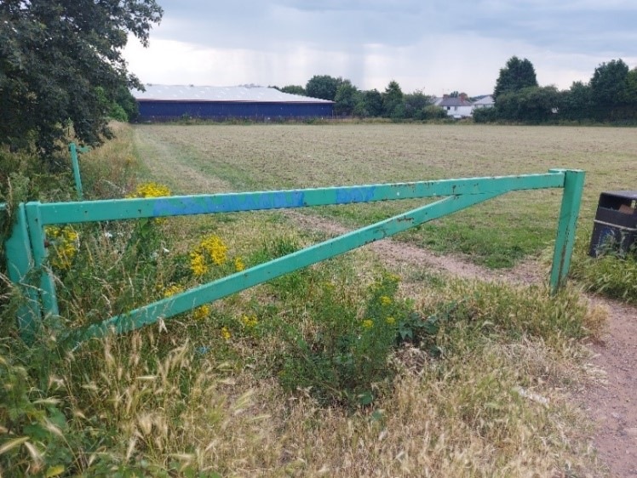

**Public Opposition**:

* + 68 objections to the public consultation to appropriate the land.
  + A petition with 586 handwritten names, addresses and signatures collected over a period of 10 days.
  + Over 100 objections to the planning application to build 40 dwellings on the site (V/2024/0063).
  + A strongly supported community campaign, ‘Protect the Rec’ to save Hardwick Lane Rec. formerly known as The Victoria Recreation Ground - opened in 1897 to celebrate the occasion of Queen Victoria's Diamond Jubilee.

**5. Procedural Impropriety**

During the public consultation to appropriate the land from recreational use to housing, the Cabinet minutes of 26th June 2023 clearly outlined a procedural stop: objections would be reviewed and brought back to Cabinet for consideration before any further steps. Residents were informed this review would occur at the Cabinet meeting on 18th September 2023, but it did not happen, and the land was not formally appropriated. Despite this, a planning application proceeded, incurring costs exceeding £116,000 (as of March 2023) without addressing residents' objections. This represents a clear breach of the defined procedure.

**Conclusion**

The allocation of Hardwick Lane Recreation Ground is not justified. It conflicts with strategic policies, ignores community needs, and fails to meet requirements for open space retention or replacement under Sport England’s Playing Fields Policy, NPPF Paragraph 99 and the Council’s EV5 policy. The Council should prioritise restoring and utilising this green space to address health inequalities, support community well-being, and align with its own stated values and priorities.

**Kerry Thornton 11.12.24**