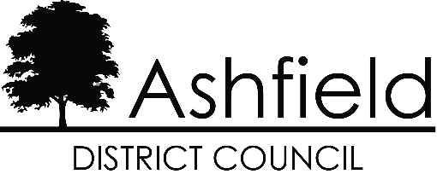
Revenue Services
Urban Road
Kirkby in Ashfield
Nottinghamshire
NG17 8DA
Telephone: 01623 457200
website: www.ashfield.gov.uk
email: businessrates@ashfield.gov.uk

APPLICATION BY A REGISTERED CHARITY OR NON-PROFIT MAKING ORGANISATION
CLAIMING RELIEF IN RESPECT OF BUSINESS RATES, UNDER SECTION 43, 45 AND 47 OF THE LOCAL GOVERNMENT FINANCE ACT 1988

Title of the Charity or Organisation
Address of the property for which the application is made for the relief
Property description
Business Rates Account Reference
- Particulars of the Charity or Organisation
a) What are its main objects and purposes? | a)
b) Is it registered under the Charities Act 1960? If so please state the Registration No. | b)
c) If exempt from registration, state grounds | c)
- Section(s) under which the relief is being claimed
a) Section 43/45 (Mandatory Relief) | YES/NO If answer is YES please see Note 5(a) to (e)
b) Section 47 (Discretionary Relief) | YES/NO If answer is YES please see Note 5(b) to (e)
- Details of hereditament for which relief is claimed
a) Purpose(s) for which it is used

b) If used for any purposes other than those of the claimant, please give details
- Additional Information (Discretionary Relief Only)
a) Is membership of your organisation/club open to all sections of the community or are there any restrictions?

b) Do you actively encourage membership from particular groups in the community? If so, which groups?
c) Are the facilities made available to people other than the members, eg: public sessions, etc?
d) Do you provide training or education for your members or any specific section of the membership?
e) Are you affiliated to any local or National Organisations?
f) Have your facilities been provided by self help or by grant aid?
g) Are your premises licensed for the sale of alcohol?
h) Any other information in support of this claim?

- IMPORTANT: The following documents should be forwarded with the application –
- Copy of the Notice of Registration under the Charities Act 1960
- Articles of Association / Constitution of the organisation
- Copies of the audited accounts and balance sheets for the last 2 years.
- Any leaflets distributed by the charity or organisation.
- Any written statement you may wish to make in support of your application.
- I hereby certify that the particulars given above are correct to the best of my knowledge and belief.
Signature
Capacity in which signed
Date
Address
Postcode
Telephone:
Contact email address:
- Please return this form as soon as possible to Business Rates, Revenue Services, Ashfield District Council, Urban Road, Kirkby in Ashfield, Nottingham NG17 8DA
NOTE: Have you included items required under section 5 above?

