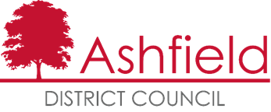    Food Hygiene Rating Scheme:  Request for a re-visit |  | 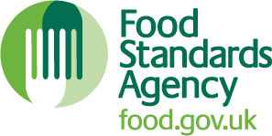

Notes for businesses:

- As the food business operator of the establishment you have a right to request a re-visit for the purposes of re-rating if you have taken action to rectify the non-compliances identified at the time of inspection.
- You may request a revisit for a re-score at any time following a food hygiene inspection or intervention where the premises is awarded a Food Hygiene Rating Score.
- Ashfield District Council applies a fee of £180.00 per visit to carry out an FHRS re-score, payment can be made over the phone to our Council Offices on (01623) 450000
- You must provide details of the improvements made with your request, including supporting evidence where appropriate.
- The officer will give you a ‘new’ food hygiene rating based on the level of compliance that is found at the time of the re-visit - you should be aware that your rating could go up, down or remain the same.
- To make a request for a revisit, please use the form below and return it to the food safety officer from your local authority and make the payment of £180.00 over the phone to our Council offices on (01623 450000) – contact details are provided with the written notification of your food hygiene rating.

Business details
Food business operator/proprietor

Business name

Business addresses

Business tel. number |  | Business email

Inspection details
Date of inspection |  |  |  | Food hygiene rating given

Action taken
Please describe the remedial action you have taken with reference to the issues identified in the inspection letter/report provided to you by your local authority with your score:
Compliance with food hygiene and safety procedures

Compliance with structural requirements

Confidence in management/control procedures

Please provide any other supplementary evidence (e.g. photographs, invoices, copies of relevant HACCP documentation etc.).

Signature
Name in capitals

Position |  | Date

Please now return this form to:

Council Offices, Urban Road, Kirkby-in-Ashfield, Nottingham. NG17 8DA

Tel: 01623 450000 Fax: 01623 457585

Email: food@ashfield.gov.uk

