 | 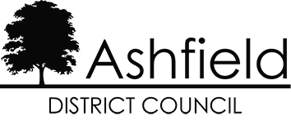 | 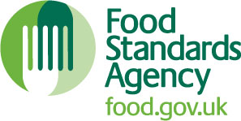

Food Hygiene Rating Scheme: Request for a re-visit

Notes for businesses:
- As the food business operator of the establishment you have a right to request a re-visit for the purposes of re-rating if you have taken action to rectify the non-compliances identified at the time of inspection.
- You may request a revisit for a re-score at any time following a food hygiene inspection or intervention where the premises is awarded a Food Hygiene Rating Score.
- Ashfield District Council applies a fee of £180.00 per visit to carry out an FHRS re-score, payment can be made over the phone to our Council Offices on (01623) 450000
- You must provide details of the improvements made with your request, including supporting evidence where appropriate.
- The officer will give you a ‘new’ food hygiene rating based on the level of compliance that is found at the time of the re-visit - you should be aware that your rating could go up, down or remain the same.
- To make a request for a revisit, please use the form below and return it to the food safety officer from your local authority and make the payment of £180.00 over the phone to our Council offices on (01623 450000) – contact details are provided with the written notification of your food hygiene rating

Business details
Food business operator/proprietor

Business name

Business addresses

Business telephone number

Business email

Inspection details
Date of inspection

Food hygiene rating given

Action taken
Please describe the remedial action you have taken with reference to the issues identified in the inspection letter/report provided to you by your local authority with your score:

Compliance with food hygiene and safety procedures

Compliance with structural requirements

Confidence in management/control procedures

Please provide any other supplementary evidence (e.g. photographs, invoices, copies of relevant HACCP documentation etc.).

Signature

Name in capitals

Position

Date

Please now return this form to:
Address: Council Offices, Urban Road, Kirkby in Ashfield, Nottingham. NG17 8DA
Telephone: 01623 450000
Email: food@ashfield.gov.uk

