

DISCLAIMER

This document or some parts of it may not be accessible when using adaptive technology.

If you require assistance with accessing the content of the document, please contact us and quote the document name and the web page you found it on:

- email: Impact graduate support – ngdpteam@ashfield.gov.uk

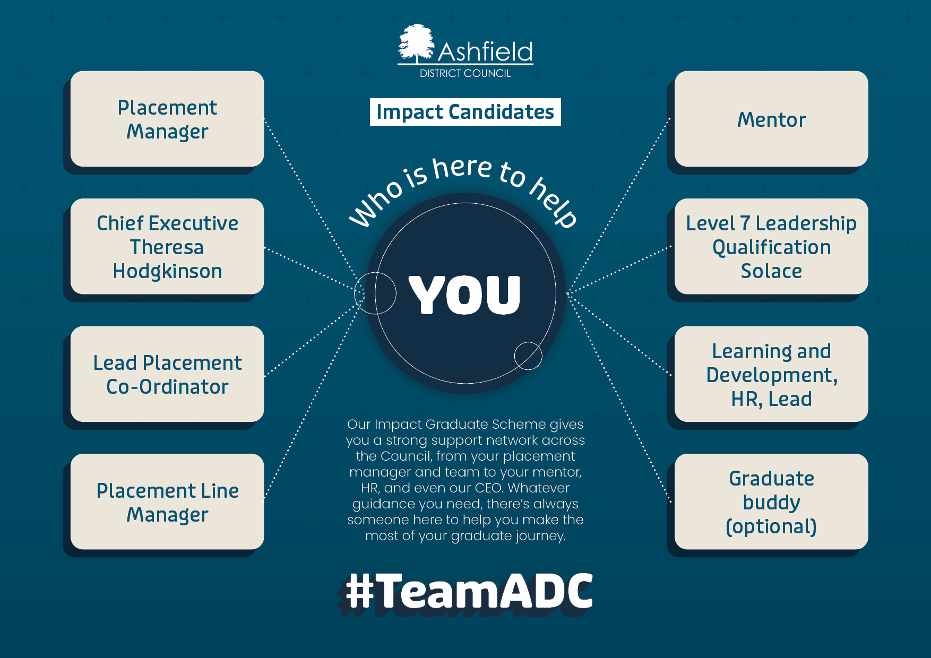

Impact Candidate
Who is here to help you:
- Placement Manager
- Chief Executive Theresa Hodgkinson
- Lead placement Co-Ordinator
- Placement Line Manager
- Mentor
- Level 7 Leadership Qualification Solace
- Learning and Development, HR, Lead
- Graduate Buddy (optional)
Our Impact Graduate Scheme gives you a strong support network across the Council, from your placement manager ad team to your mentor, HR and even our CEO. Whatever guidance you need, there’s always someone here to help you make the most of your graduate journey.
# TeamADC

