

**DISCLAIMER**

This document or some parts of it may not be accessible when using adaptive technology.

If you require assistance with accessing the content of the document, please contact:

* email: [scrutiny@ashfield.gov.uk](mailto:scrutiny@ashfield.gov.uk)
* telephone: 01623 457318

Quote the document name and web page you found it on.





OVERVIEW AND SCRUTINY ANNUAL REPORT 2015-16

TABLE OF CONTENTS

Foreword of the Chairman of Overview and Scrutiny Page 3 Introduction - Page 4

Scrutiny Activity and Achievements – Pages 5 - 17 Getting Involved – Page 17

CHAIRMAN’S FOREWORD

During 2015-16 local and national issues have continued to challenge Members on Overview and Scrutiny and Panels A & B. 2015- 16.

Our role to both consider, challenge, recommend and influence both decisions made internally and externally continues to shape the Scrutiny workplan and

strive for improved communications and working relationships with Members from all Political groups, officers and our partners.

This report provides an overview of the topics, issues and considerations of both the Overview and Scrutiny Committee and Panels A & B during 2015-16 and also includes details of our use of the Scrutiny Call-in Powers on 2 occasions during the year, whereby a decision taken by the Council has been challenged and discussed in further detail.

Furthermore, it also sets out some of the topics and issues that are scheduled to be considered by Scrutiny in the coming year as set out in the Scrutiny Workplan 2016-17.

I would once again like to take the opportunity to acknowledge and thank all those people who have contributed to and supported the work of Scrutiny in the last year, including officers, Members and partners who have taken the time to attend meetings and provide critical evidence enabling us to carry out reviews and consider important issues to both the community and the Council.

## COUNCILLOR LEE ANDERSON – CHAIRMAN OF OVERVIEW AND SCRUTINY

INTRODUCTION

Ashfield District Council has an Overview and Scrutiny Committee and two Scrutiny Panels ( A and B ). The Scrutiny function has an essential role in the democratic process. It was introduced under the Local Government Act 2000 which placed a requirement on all local authorities to have an Overview and Scrutiny function to hold Cabinet to account.

It is also about listening to the concerns of local people and can review how external partners are performing, recommending improvements where necessary.

The aim of the work of Scrutiny is to ultimately improve services and the quality of life of Ashfield residents. This is achieved in the following ways:

* Monitoring Council Performance;
* Developing and Reviewing policy;
* Reviewing issues of community concern;
* External Scrutiny

The workplan is developed in consultation with all elected Members, officers and the community. It is also a standing item on the Overview and Scrutiny Committee agenda to ensure that Members are updated on the progress of the reviews and allowing flexibility for additional items to be added if necessary.

Recent national legislation to strengthen the Scrutiny process has included the following which have been recognised by Scrutiny in Ashfield;

* The Local Democracy, Economic Development and Construction Act 2009 includes requirements for the Overview and Scrutiny Committee to receive certain petitions and review the Council’s responses to petitions at the request of the petition organiser in accordance with the Council’s Petition Scheme.
* The Police and Justice Act 2006 introduced requirements in April 2009 that all local authorities have in place arrangements, either individually or jointly with other local authorities, for committees which will review, scrutinise, and report on the decisions made and actions taken by Crime and Disorder Reduction Partnerships.
* “Councillor Call for Action” (CCfA) was introduced under Section 119 of the Local Government and Public Involvement in Health Act 2007 (the Act), and came into force on 1st April, 2009. The statutory requirement applies to all Councils in England (with the exception of Parish Councils) regardless of their Executive arrangements. The Act enables any Member of the Council to refer to an overview and scrutiny committee any local government matter which affects their ward or division. The power to refer a matter is available only where the matter is of direct concern to the ward or division which the Councillor represents.

**OVERVIEW AND SCRUTINY ACTIVITY**

The Overview and Scrutiny Committee’s main role during 2015/16 has been to oversee, challenge and address performance issues of the Council, manage the Scrutiny workplan and the overall activity of the Scrutiny process.

Scrutiny has considered a number of key issues throughout the year from both the scheduled workplan, issues raised throughout the year by residents of the District and through performance matters.

These include:

* **Ashfield Homes**
* **Local Plan Preferred Approach**
* **Disabled Facilities Grants**
* **Communications**
* **Selective Licensing Scheme**
* **Access to Homelessness Services.**
* **Leisure Review - Transformation Programme**

Those issues considered include issues raised by the community, Councillors and Officers and are aimed at adding value to both the community and quality of services delivered by the Council.



**Scrutiny Panel A Chair – Councillor Cathy Mason
Scrutiny Panel A Chair – Councillor Cathy Mason and Vice Chair – Joanne Donnelly**

**Scrutiny Panel B Chair – Councillor Amanda Brown
**

**Scrutiny Panel B Chair – Councillor Amanda Brown and Vice Chair – Councillor Lauren Mitchell**

# CALL- INS UNDERTAKEN DURING 2015-16



## Call – In of Decision to Bring Housing Services Provided by AHL In-House

The decision to bring the housing service provided by Ashfield Homes back in house, was scrutinised at an extraordinary meeting of the Overview and Scrutiny Committee on the 26 January 2016. The item was called in for the following reasons;

## Contrary to Budget

The council does not outline within the report exactly how the proposed savings are to be made. It also fails to clarify where and how the saved money will be spent, the council fails to outline the budgetary implications on this Authority once we have lost the technical expertise following AHL’s closure and an imminent re- structure is needed within Ashfield Council. The implications on the HRA budget and the subsequent impact on the maintenance repairs on properties has not been made clear.

## Inadequate or Inaccurate Information

The consultation that has taken place did not as stated ask any questions about the possible closure of AHL. Inadequate

information has been provided about how the District Council will manage the process and then manage the housing stock.

Insufficient detail in the Cabinet report to show how conclusion were reached including no information as to specific results of review or consultation. The results of the consultation with the tenants may contradict the Council’s conclusions based on the fact that tenants said AHL are brilliant and ADC gave them 3/5 how has this been justified.

At the meeting, the Committee were informed that that the proposed changes would help to improve the performance of the service and remove unnecessary layers of duplication by having only one organisation. It was further pointed out that the proposed savings would be achieved primarily by removing duplicated back office and senior staff posts from what would now be a single management structure.

The Portfolio Holder also commented that the number of front line housing posts would not be reduced and there would be no loss of technical expertise as Ashfield Homes would not be closed, but rather brought in-house. Any savings would be used to help maintain and improve the housing service.

Two motions were put forward at the meeting, these were;

That Cabinet be asked to directly consult the proposed change through a referendum or ballot of all tenants, and that the tenants and residents groups be involved in drawing-up the question.

That Cabinet be asked to establish a cross-party group to scrutinise the results of the consultation exercise.

Both motions fell and following further detailed discussion and debate, the Committee agreed that no further action be taken in relation to the called-in decision and it be implemented as planned.

There is inadequate information regarding the public consultation, which groups will be consulted or how wide other than the 1500 data base will be consulted. There are over 100,000 residents affected and to plan to consult less than 1% does not meet guidelines.



.

## Incorrect Information

**Call – In of Local Plan Preferred Approach**

A call – in of the decision to approve the Local Plan preferred approach and its subsequent consultation process was scrutinised at an extraordinary meeting of the Overview and Scrutiny Committee on the 26 January 2016. The item was called in for the following reasons;

## Contrary to Policy

The overarching National Framework Policies dictate that transparent and robust scoring must be demonstrated for all sites include and excluded from the draft plan. We have contradicted that policy.

## Inadequate or Inaccurate Information

Page 15/16 of the cabinet report state the previous plan was withdrawn following the Planning Inspectors concerns over the lack of clarity as to why the Council selected certain sites. The Council has made the same error. It has not made public or to elected members, clear the scoring process for sites and the method by which the final proposals were put together.

Budget implications are stated as £1000. Either the figure is wrong or the Council is preparing a woefully inadequate public consultation. It would cost 3/4 of that simply to write to the 1500 people on our list of interested parties.

The Portfolio Holder with responsibility for the Local Plan, responded to these concerns and explained how the Local Plan Preferred Approach was evidence-based and in line with the national planning policy guidance framework and the national planning practice guidance. These do not require the use of a formal scoring system, but do require evidence as to how sites had been selected. This information, he stated, was contained in the background papers to the Cabinet report

The Committee then discussed the decision. During this discussion a motion was proposed that Cabinet be asked to agree to the Local Plan Steering Group reconvening to further consider the Local Plan Preferred Approach, so that it could then submit its views and suggestions on sites to Cabinet. a vote was taken and the Motion subsequently fell.

Following a detailed discussion of the evidence. It was then suggested that given how important it was to make progress on developing and agreeing the Local Plan, the best approach would be for the Committee to raise no further objections to Cabinet’s decision and for the Local Plan Preferred Approach to now proceed to consultation, this was approved.

Members were advised during the review that extension projects have the biggest impact on the budget spend as some cases can cost up to £30,000.

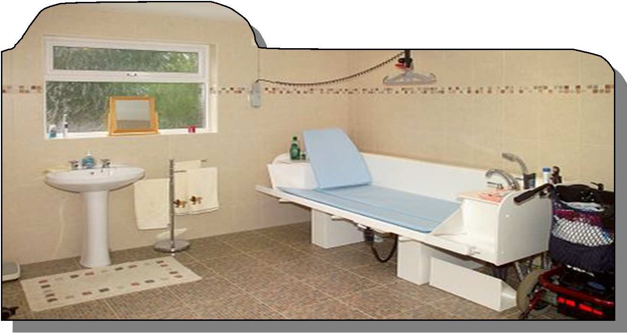

.

Over the previous two years, waiting times for the process of grant applications and the number of outstanding cases had been concerning. and that at this point in time the budget allocation for this service was considerably smaller and staffing resources were limited.

## Disabled Facility Grants

This topic was placed on the Scrutiny work plan to consider the process for the allocation of grants and to ensure that the service was both robust and effective following some concerns that were highlighted in 2015 with regards to waiting times. In considering this topic Members were advised that the Disabled Facilities Grants policy was approved in January, 2016 to provide a consistent and clear process for all grant applicants.

Members explored both the delivery of Disabled Facilities Grants (DGF’s) and examined the new Policy which aimed to improve the service and outline any recent improvements or concerns.

The Disabled Facilities Grants provide an important mechanism for supporting people with disabilities to live independently. The initial referral for a grant must come from the Occupational Therapy Team at Nottinghamshire County Council's Social Services Department. During the review Members considered the budget and casework load in respect of the waiting list/cancellations and completions for Disabled Facilities Grants for 2015/16.

Members were also asked to note that a number of factors could affect the data which measures performance for example, certain cases such as extension work can take longer to complete which consequently can delay the case being signed off. The introduction of the Governments ‘Better Care Fund’ has provided additional financial support to local authorities and NHS organisations to jointly plan and deliver local services.

The Better Care Fund allocated to the Council for 2015/16 was

£482,000 which considerably boosted the Disabled Facilities Grants budget. In addition, through the Better Care Fund the Council has been able to apply for ancillary costs which has funded the employment of an additional Technical Officer from November, 2015. This additional post has provided much need support to the Team and significantly improved the service provision.

In concluding consideration of this topic Members recognised the fact that the performance for this specific service had greatly improved since November, 2015 and gave the following comments and recommendations to the Portfolio Holder, who had assisted the Panel with their review.

* the achievements of the Disabled Facilities Grants Team in reducing waiting times be noted and commended;
* consideration be given to the impact of an aging population and the future demand for adaptions within Ashfield
* the referral system from Nottinghamshire County Council's Social Services Department be acknowledged;
* support be given to the work being undertaken to improve the delivery time of Disabled Facilities Grants and on the exploration of alternative solutions which allow for more timely installations of adaptions;
* it be noted that whist the Disabled Facilities Grants process is rigid, the outputs always have to be flexible;
* customer satisfaction should remain key with regular updates to highlight any issues and acknowledgment where positive action is being taken;
* consideration be given to what adjustments would need to be put in place should the Council decide to bring back ‘in- house’ the management arrangements for the housing stock.

## Communications

Scrutiny Panel B undertook a review of communications as the expectations of residents in finding out about the Council are fast pacing and it is important that the Council continues to communicate in the most effective and efficient way possible.

The Government’s transparency agenda and increased development of other communications channels such as social media and e-communications are also increasingly being used by residents. In carrying out this review, Members used the following methodology to explore the topic;

* Interviews with the Corporate Communications Manager, Web Development Officer and Corporate Performance Manager
* Reviewed best practice from other local authorities
* Reviewed current communication methods used by the Council
* Considered case studies from local government research
* Explored different methods of potential income generation from improving communications methods

Effective communications shape the way residents hear about achievements, provide a mechanism to consult and ask for

feedback, warn residents about local and national issues and much more. A positive public perception is crucial to any organisation. MORI research has found a direct link between how public services keep people well-informed and how satisfied they are with them.

Those who feel they are well-informed about the council tend to be more positive about the authority on a wide range of issues. They are much less likely to feel that the council is remote and impersonal or out of touch with local people, and are more likely to feel that the authority offers local people good value for money and provides a good quality of service overall.

Good external communications can have a positive impact on these specific image ratings and also on overall satisfaction levels.



The new Corporate Plan states that the Council recognises that continued development of the Technology offer is an underpinning critical success factor to achieving the corporate priorities. The growth of access needs information and engagement opportunities generated through the internet, mobile devices, and social media creating 24 hour/7 day access. The

Council will continue to develop its ability to enable resident’s greater choice in accessing the Council and obtaining key information in a method convenient to them including improving the Council’s web site and its functionality.

In considering ways in which the Councils communication platforms could support this, Members enquired about advertising. At present the Council generates some revenue for “All About Ashfield”, the Councils twice yearly publication delivered to every household in the district. This helps to offset some of the production costs.

In further consideration of this Members discussed whether there were any further advertising opportunities that could be explored for the communication platforms both in place and planned. One area for further discussion was advertising on the website. A number of local authorities are now utilising the revenue from advertising to maintain or enhance services.

In concluding his review, Members of the Panel recognise that effective communications and greater use of the technology available can provide the Council with opportunities to communicate with and reach far greater numbers of people than it could in conventional ways. It can shape the way residents hear about achievements, provide a mechanism to consult and ask for feedback, warn residents about local and national issues and much more.

The Panel agreed that Improving the website and embracing some social media to reach a greater demographic was a positive step forward and should be commended, however there were some further steps that they considered could be taken to enhance progress and improve the Councils presence in more innovative communication methods.

Furthermore, it was recognised that by embracing social media and improving the Councils website, this could potentially create a greater opportunity to consider income generation.

Recommendations

* Cabinet be requested to explore options relating to advertising including further investigation of the Council Advertising Network;
* in the event that significant advertising revenue is generated, consideration be given to how the Communications Service can be enhanced to further explore and develop social media as a communications channel.
* as part of any forthcoming service reviews undertaken, consideration be given to the role of social media as a valid communications tool;
* that case studies, such as ‘Walsall 24’, be examined and a similar exercise be considered for Ashfield to provide an interactive snapshot of ‘a day in the life’ of the Council;
* the Council asks the question relating to how people prefer to be consulted as part of any appropriate forthcoming consultation / feedback exercise;
* further exploration of an email opt-in service be undertaken and the results be reported back to the Scrutiny Panel in 6 months time;
* That the opportunities relating to digital community notice boards be explored to establish the financial viability, potential for advertising income and sponsorship backing;
* the roles of web authors be enhanced to enable them to develop their departmental web pages on social media;
* further exploration and development of a secure on-line facility for all Council applications be considered as part of the new Council internet site;



.

## Selective Licensing Scheme

Scrutiny revisited the Selective Licensing Scheme in 2016 as a follow up to a previous review carried out by Scrutiny Panel A in 2014 on empty homes. One of the recommendations to Cabinet from that review was for the Council to consider selective licensing as a way to drive improvements to the quality of housing within the privately rented sector.

Selective Licensing is compulsory and applies to all rented properties in a designated selective licensing area with the exception of those already subject to mandatory HMO Licensing or those managed or owned by Registered Social Landlords (also known as housing associations).

In the areas where selective licensing would be applied, all landlords will be required to hold a licence in order to rent out a property. The licence lasts for five years. To qualify for a licence a landlord must be able to demonstrate that they are acting within the law and taking adequate steps to manage their properties and keep them safe.

During the 5 year licence period a full Housing Health and Safety Rating System (HHSRS) inspection will be carried out by officers as a requirement of the licence to ensure the property is in compliance with required standards for residential accommodation.

It was acknowledged by the Panel that the main priority for the Scheme was to endeavour to alleviate the poor living conditions that many vulnerable families endure due to unscrupulous public sector landlords.

Members agreed that the Selective Licensing Scheme therefore remained a viable proposal for the Authority and through the Scheme the Council would be able to act more proactively (instead of reactively) and encourage investment to the

area. Furthermore, tenants would feel more secure and landlords could be offered ongoing support and advice.

Members held two formal meetings on the subject in July and September with expert officers and Service Director and also discussed the issue with the Portfolio Holder.

Meeting one was held prior to the consultation feedback being received and the follow up was held to discuss the comments that had come back from the community, stakeholders and partners.

The Panel concluded their review by making the making the following recommendations to Cabinet.

Recommendations

* The Council explores the possibility of carrying out EPC tests for landlords as part of its commercialisation agenda;
* If any financial surplus is made by the scheme (within the 6% designated as part of the scheme) this should be spent in the designated area;
* Subject to the success of the pilot scheme, this be used as a template to replicate in other areas to drive improvements to rented accommodation, landlord responsibility and a reduction in anti-social behaviour;
* Ward Councillors continue to be consulted, engaged and kept informed on the selection of any sites and boundary lines for the further roll out of the scheme in the future;
* Scrutiny be asked to review the topic again in approximately twelve months’ time.

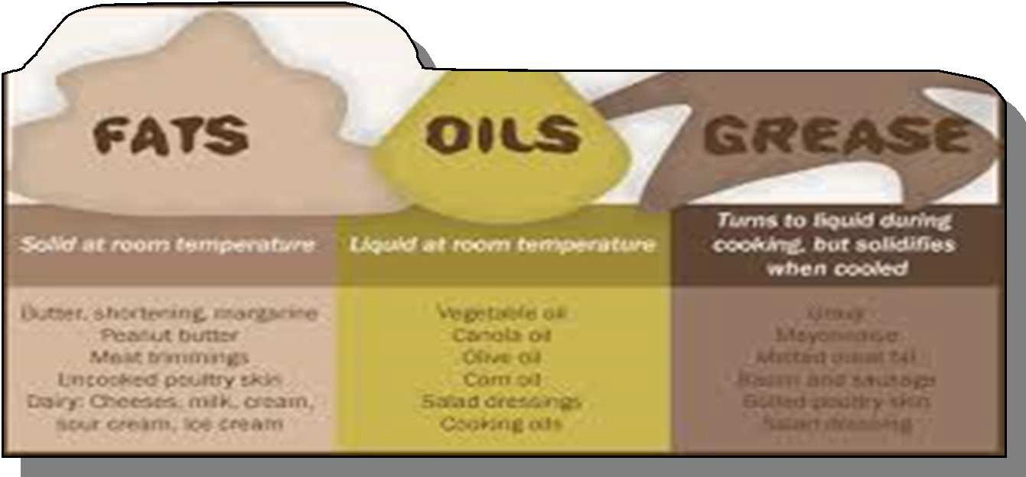

.

## Fats, Oils and Greases

Following consultation on items for the workplan 2015-16, Members agreed to review the problems caused by the disposal of cooking oils/fats down drains with an additional focus on the reuse of those materials as biofuel.

This was added following recent media reports regarding the flooding risks caused by inappropriate disposal of fats, oils and greases (FOGS) and the public education programme that was being rolled out by Severn Trent Water.

Members worked with both officers and Severn Trent Water to consider both the impact of the issue locally, possible solutions and how a coordinated approach to education on the issue could reduce the potential risks.

During the review Members were informed that In whole of the Nottinghamshire area Ashfield contains 6 of the Severn Trent Water top10 hotspot areas (26% of all incidents). Between April 2011 and April 2015 Severn Trent Water recorded 1,147 sewer incidents across the Ashfield area.

These incidents compromised of blockages caused by

FOG (fats, oils and greases) and sanitary items being flushed down into the sewers via sinks, drains and toilets. 5 of these ‘hotspot’ areas are located in Sutton-in Ashfield and 1 in Hucknall.

Members considered a range of options including FOG collections, Education and reusing waste products, however following the evidence It was ultimately agreed that whilst the issue of appropriate disposal of fats, oils and greases is an important one that has potential environmental impacts, at this particular time the details behind collaborative pilots between water companies and local authorities in dealing with the issue was not established enough for the Overview and Scrutiny Committee to endorse a more formal working partnership.

Recommendations

* Cabinet considers utilising the new Council ‘youtube’ channel to both highlight the issue and educate on how to sensibly dispose of used fats, oils and greases in collaboration with Severn Trent Water;
  + the Council uses its current communication channels to signpost Severn Trent Water, should any offers for localised education programmes and initiatives (such as free fat traps) become available;
* Cabinet explore with Severn Trent Water whether any opportunities exist for working with and encouraging local companies, such as supermarkets to develop ‘FOG’ collection points in the District.



.

## LEISURE REVIEW – TRANSFORMATION PROGRAMME

Scrutiny Panel A considered an overview on the findings from the Leisure Facilities Review in 2016. Consideration of this was scheduled in the Scrutiny workplan to discuss with Members the Targeted Wellbeing Activities Programme, the Sport England Pilot on Commissioning and other strategic work.

Included in this consideration was the Leisure Review outcomes and the feasibility for a replacement for the Festival Hall Leisure Centre (which would be informed by the final outcome of the Leisure Review and its accompanying consultation process).

The Leisure Review had been driven by the Council’s desire to continue to improve the health and wellbeing of Ashfield residents. It had been recognised that the health of people in Ashfield was generally worse than the England average, with a related reduction in life expectancies for both men and women. A number of diseases were also currently on the increase and affecting people at an earlier age including cancer, diabetes, obesity, hypertension and depression.

The review had focussed mainly on the leisure centres and had received assistance from Sport England and the Chief Leisure Officers’ Association (CLOA) who lent support to local Councils in relation to developing and building better relationships with commissioners and ensuring sport becomes a strategic partner that contributes to local commissioning priorities.

Specialist leisure consultants, FMG Consulting Limited, were commissioned to assist with the review of the Council’s leisure facilities. In summary the outcomes from the review had revealed that three of the leisure centres were performing well and/or adequately (Lammas/Hucknall/Festival Hall) with the remaining three falling short of their performance targets (Huthwaite/Edgewood/Selston).

For each leisure centre, high level analysis of income, expenditure and performance had been benchmarked against key performance indicators taking into account local competition, operational philosophy, age, quality and design of facilities, any programming restrictions such as joint use agreements, geographical differences and demographics. Following this exercise, it had been acknowledged that the four worst performing centres (Huthwaite/Edgewood/Selston/Festival Hall) were most probably struggling due to the age, quality and condition of their buildings as compared to the more modern facilities.

Members reviewed the issues and considered, amongst other things:-

* whether local people use their local leisure centres or travel further afield within the District to access the newer, improved leisure facilities;
* the importance of the consultation questionnaire reaching residents and capturing data from a range of demographics;
* the importance of the questions contained in the questionnaire being straightforward and not leading in any way;
* the potential sites for a new leisure centre in Kirkby and the legal processes to be undertaken to secure land from third parties;
* the concept of ‘community asset transfer’ and the potential for any local community groups to take over the leisure centre at Huthwaite;
* the importance of ensuring that the Council exhaust all avenues open to them prior to closing any leisure centres in the future;



* concerns regarding the accessibility of the main leisure centres to residents from Skegby, Stanton Hill, Huthwaite and the rural areas should the smaller leisure centres be eventually closed;
* the wealth of data that can be captured from the Access Ashfield card registration scheme including age, gender, locality and preferred sporting activities;
* the timeline for processing the data (once the consultation process has been completed), finalising the

report/recommendations and submitting to Cabinet for final approval;

* + Sport England’s Commissioning Project and its shift in focus towards investing in local grassroots facilities and opportunities (for 5 to 13 year olds) rather than the traditional commitment towards the more professional (and elite) athletes and clubs;
  + the decline in popularity of playing bowls and potential uses for the indoor bowling green at the Lammas Leisure Centre during the quiet summer months.

On conclusion of the issue, the Panel Made the following comments to the Portfolio Holder;

* the key projects within the Council’s Corporate Plan (2016-2019) including the Leisure Review outcomes, the feasibility for a replacement for the Festival Hall Leisure Centre and the targeted activities, as outlined in the report, be received and noted;
* the timetable for the Leisure Review public consultation process be received and noted;
* the Interim Service Director for Planning and Economic Development and the Portfolio Holder for Health and Wellbeing be requested to include the Panel’s views/comments, as discussed at the meeting, within the overall consultation process and any additional views to be submitted by individual Members through the agreed consultation mechanisms

achievement against priorities identified within the Corporate Strategy has improved significantly



Scrutiny of Performance is additionally supported by the Corporate Performance Manager. Issues raised during performance considerations have also been used to inform the 2015-16 Scrutiny Workplan.

## Performance Management

Performance management is one of the key roles of Overview and Scrutiny and provides Scrutiny Members with the opportunity to proactively review and challenge performance, add value to the Council’s services and monitor functions delivered with and by the Council’s partners that add quality of life to the citizens of Ashfield.

During 2015-16, the Overview and Scrutiny Committee monitored the performance of an agreed list of priority areas to assess where problems were arising and which aims and objectives

were being achieved.

Scrutiny Members held a number of meetings to discuss performance issues with relevant service lead officers and Portfolio holders to actively challenge where outcomes have not been achieved.

This has led to the establishment of a number of working groups, additions to the workplan and targeted considerations and further investigations of issues including economic regeneration and leisure facilities.

The Committee have been pleased to note that the level of

# FURTHER SCRUTINY ACTIVITY – WORKPLAN TOPICS 2016/17

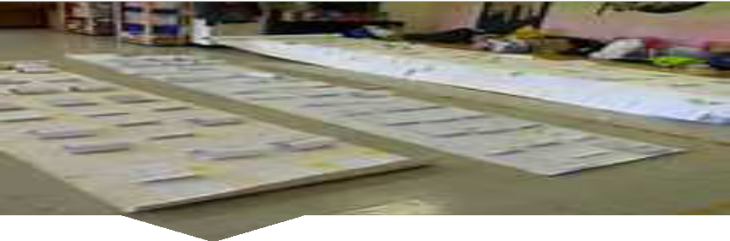

The Scrutiny workplan is a standing item on the Overview and Scrutiny Agenda. Ongoing consultation on the 2016/17 Scrutiny workplan will continue to be undertaken with Service Directors, Third Tier Officers and Members. Community engagement will also form part of an ongoing consultation process

The Scrutiny Work Plan outlines the areas of work which are expected to be scrutinised over the coming months / year by or on behalf of the Council’s Overview and Scrutiny Committee and Panels A and B. Topics added to the workplan should have expected outcomes to add value to the services delivered by the

Council and it’s partners and/or improve the quality of lives of Ashfield residents.



It is recognised that there is a need for flexibility in the work plan so as to allow relevant issues to be dealt with as and when they arise.Topic suggestions that have been submitted and for discussion for the Overview and Scrutiny Workplan for 2016/17 include.

There are a number of different ways in which members of the community can get involved in Scrutiny. These are:

**Topic Suggestions for 2016/17**

* Review into the extent of fuel poverty in the district.
  + Review of the impact of changes to wheelie bins.
* Enhancing community engagement in local issues.
* How are we working with other support services to tackle homelessness?
  + Use of Council facilities.
* Community Grant Process and Area Committees.
* Impact of car parking usage increase in town centres.

1. **Attend A Meeting** - All Scrutiny meetings are open to the public to come and listen to the debate. There may also be a chance to speak at the meetings at the discretion of the Chair. The meetings are publicised and can be found at: https://democracy.ashfield- dc.gov.uk/mgListCommittees.aspx?bcr=1
2. **Put Forward A Suggestion For A Topic To Be Considered By Scrutiny -** Any topic can be suggested for consideration for the Scrutiny workplan. To put forward a topic does not mean that you will have to become directly involved in the review if you do not wish to be. https://[www.ashfield.gov.uk/your-council/about-](http://www.ashfield.gov.uk/your-council/about-) the-council/councillors-and-meetings/overview-and-scrutiny- function/
3. **Speak To Your Local Councillor -** Your local Councillor details are located on the Council’s website at; https://democracy.ashfield- dc.gov.uk/mgMemberIndex.aspx?bcr=1

or you could attend one of the Councillor Surgeries which are listed on the above web address.

