Complaints by type

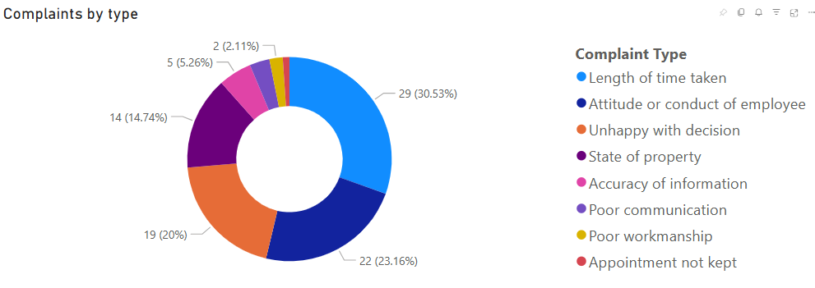

Data table
Complaint Type | 2023 to 2024 | 2024 to 2025
Attitude or conduct of employee | 22.22% | 23.16%
Length of time taken | 20.37% | 30.53%
State of property | 16.67% | 14.74%
Poor workmanship | 3.70% | 2.11%
Poor communication | 1.85% | 3.16%
Accuracy of information | 5.56% | 5.26%
Unhappy with decision | 22.22% | 20.0%
Conduct of neighbour | 5.56% | 0.00%
Appointment not kept | 1.85% | 1.05%

